甘井子区小学英语五年级下学期期末质量检测练习卷
姓 名
班 级
得 分
(时间：60分钟 总分：100分)
A | I | II | III | IV | V | 合计 | 综合  得分
得分 |  |  |  |  |  |  | 综合  得分
B | I | II | III | IV | V | 合计
得分
A. Listening Part听力部分（50分）
I．Listen and circle.听音圈出你所听到的单词。（10分）
1.A.present B. parent 2. A. sausages B. sandwiches
3.A.borrow B. brown 4. A. build B. buildings
5.A.drive B. drove 6. A. sent B. solve
7.A.piece B. place 8. A. take B. talk
9.A.history B. PE 10.A.fine B. five
II．Listen and choose.
听音，把所听到单词的序号写在相对应的横线上。（8分）
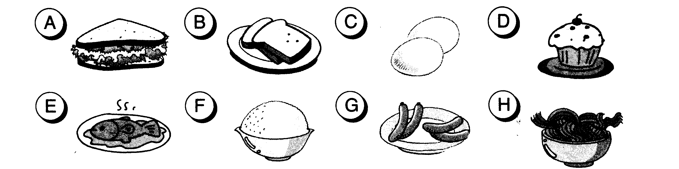
Daming: _______ Lingling _______ Sam_______ Amy _______
III．Listen and tick.
听音选择，用√将所听到正确的短语写在方框中。(12分)
1. Is your mother at home now?
A.At the office B.At school C.In the park

2. Can you go swimming in winter?
A.In summer. B.In winter. C.In spring

3.Where does your father work?
A.In a hospital. B.In a shop. C.In a factory.

4. How will we get to Xinghai Park?
A.By car. B.By Bus. C.By ship.

5.Where can Amy and Lingling find the books?
A.On Shelf A B.On shelf B C.On shelf C

6. When did Wang Fei go to Mount Tai?
A.Last summer B.Last year C.Last week

7.What time do English people usually have breakfast?
A.At 7:30 B.At 7:00 C.At 6:30

8.When should Daming return the Chinese book?
A.In two days. B.In two weeks. C.In two months.

9.Will you help me?
A.Of course B. Maybe C.Well down

10. Where’s the letter from?
From Australia. B.From China. C.From England.

11.Why does he love autumn?
A．Fly a kite B. Play with leaves. C．Have a picnic.

12.Which bag do they take?
A. The black one. B.The green one. C.The blue one.

Ⅳ．Listen and make the order.
听音，把所听到句子的先后顺序标出来。(10分)
（ ）Hi,Daming. Let’s talk about the pictures.
（ ）Ok.
（ ）He was a doctor.
（ ）What did he do?
（ ）What is he now?
（ ）What does he teach?
（ ）What was he before?
（ ）He helped children.
（ ）He’s a teacher.
（ ）He teaches English.
Ⅴ．Listen and judge.
听短文，判断句子正误，正确的写T，错误的写F。（10分）
（ ）1.Last Monday we went to a children’s theatre.
（ ）2.The men wore men’s clothes.
（ ）3.The women wore men’s clothes.
（ ）4.The actors told lots of jokes.
（ ）5.We cried a lot.
（ ）6.After the show we went to a restaurant.
（ ）7.We all ate hot dogs and chips.
（ ）8.We had a good day.
B. Written Part 基础知识与综合运用部分（50分）
I．Look and choose.从ABC三个选项中选择一个正确的答案，将序号写在括号内。(15分)
( ) 1. Yesterday Mary to a party.
A. go B. went C. goes
( ) 2.Sam will his grandma.
A. visit B. visits C. visited
( ) 3.My mother didn’t TV.
A. watch B. watched C. watches
( ) 4.____ _____ my parents.
A. This is B. That is C. These are
( ) 5.My bag is _____.I can’t lift ____.
A. light, it B. heavy, it C. new, them
( ) 6.Click on “_____”.Now click on “_____”.
A. Write, Email B. Email , Write C. email, write ( ) 7.I can see my eyes.
A. with B. on C. at
( ) 8. I ____ a white rabbit and it’s _____ very long ears.
A. has, get B. have, got C .has, gets
( ) 9. A bird _____ swim, but it ____ fly very high.
A. can, can’t B. can’t, can C. can’t, can’t
( ) 10.She often ____ English to her friends.
A. tells B. speaks C. talks
II．Put the words in the correct order.把下列的单词连成句子。(10分)
- broken/his/shoes/are./
- What/put/did/in/bag/your/you/?/
- of/see/lots/We’ll/stones/./
- lunch / have / did / What / she / for / ? /

- the / you /got / Have / videos / Harry Potter / ? /

III．Read and Fill in the blank.根据所给图示补全句子。（10分）
.
- The boy can play the drums. He’s a good ________.
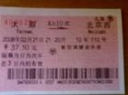
2. You must buy a before you get on a train.
3.The little girl wrote a ________ yesterday.
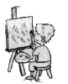
4.Bob got some _______from his sister.

5. Look at that boy. He_____ ______ a picture.
6. The panda is ___________and ________.
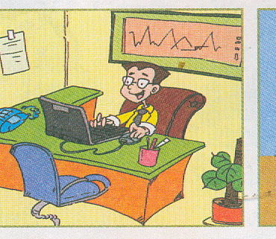
7.A: Look at the photo. This is my uncle.
He is a businessman.
B: Does he work in a(n)_________?
A: Yes, he does.
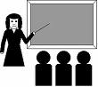
8.A:Who is this?
B: This is my aunt. She is a ________.
IV．Reading comprehension
A.看下面文字的描述是属于哪一幅图片的，请用序号标出。（6分）
( )
( )
( )
( )

① I love winter. It is cold. I can play with the snow. I can wear a coat and gloves.
② My favourite season is spring. It’s warm. I can see baby ducks. There are flowers on the trees.
③ I love summer. It’s hot .I can go swimming .I can wear shorts and sandals.
④ I love autumn. It’s cool. The leaves fall from the trees. I can play with them.
B.阅读短文，判断下列句子的对（T）错（F）,将答案写在括号内。(4分)
The 2008 Olympic Games will be held(举行) in Beijing .It will open on 8th of August in Beijing .Many people from different countries will get together in Beijing. Maybe they will come to Dalian to visit .We should welcome the foreign friends. We should be friendly to them. Now the Olympic Torch（火炬） are passing in China. The Olympic Torch will come to Dalian to pass on 26th of July. Will you go to watch it?
( )1.The 2008 Olympic Games is going to open in Beijing.
( )2.The players come from different countries .
( )3.No one will come to visit Dalian.
( )4.The Olympic Torch will pass in June in Dalian.
V.Writing小练笔(5分)。
暑假快要来了，Tom想和他的爸爸妈妈去北京度假。请你根据图片提示，完成Tom的旅游计划。
要求：1.句子通顺，书写工整、规范，标点正确。

2.不少于4句话。
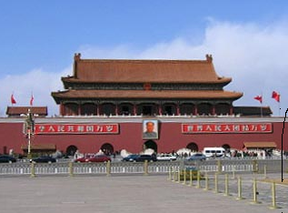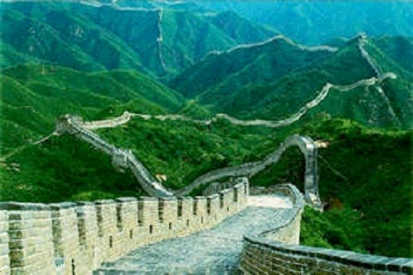
This summer I will______________________________________ ________________________________________________________
________________________________________________________________________________________________________________
甘井子区小学英语五年级下学期期末质量检测试题A.听力材料及参考答案：
I．Listen and circle.听音圈出你所听到的单词。每题读二遍。
1. What present can I take? What about chopsticks？
2. I had sandwiches for lunch on Sunday.
3. This brown bag is light. I can lift it.
4. I visited lots of very old buildings in London.
5. I was a train driver. I drove a train.
6. Maybe you can solve this mystery.
7. Stonehenge is an old place.
8. Your bag is old. You can’t take it to China.
9.PE is my favourite subject. How about you?
10.How are you, Mary? I’m fine, thank you.
II．Listen and choose.听音，把所听到单词的序号写在相对应的横线上。每题读二遍。
Daming has bread for breakfast. He eats noodles for lunch.
Lingling has eggs for breakfast. She has fish for lunch.
Sam has a cake for breakfast. He has some rice for lunch.
Amy has some sausages for breakfast. She has a sandwich for lunch.
III．Listen and tick.
听音选择，用√将所听到正确的短语写在方框中。每题读二遍。
1. Is your mother at home now?
No, she isn’t. She’s at school.
2. Can you go swimming in winter?
Yes, I can.
3.Where does your father work?
In a hospital.
4. How will we get to Xinghai Park?
I’ll get there by bus.
5.Where can Amy and Lingling find the books?
They can find the books on shelf B.
6. When did Wang Fei go to Mount Tai?
He went there last summer.
7.What time do English people usually have breakfast?
They usually have breakfast at 7:30.
8.When should Daming return the Chinese book?
He should return it in two weeks.
9.Will you help me?
Of course, I will.
10. Where’s the letter from?
It’s from Australia.
11.Why does he love autumn?
He can play with leaves.
12.Which bag do they take?
They take the blue one
Ⅳ．Listen and make the order.
听音，把所听到句子的先后顺序标出来。每题读二遍。
1.Hi,Daming. Let’s talk about the pictures.
2.Ok.
3.What was he before?
4.He was a doctor.
5.What did he do?
6.He helped children.
7.What is he now?
8.He’s a teacher.
9.What does he teach?
10.He teaches English.
Ⅴ．Listen and judge.
听短文，判断句子正误，正确的写T，错误的写F。每题读二遍。
Dear Xiaoxiao,
Last week we went to a children’s theatre. The men wore women’s clothes. The women wore men’s clothes. The actors told lots of jokes. It was very funny. We laughed a lot. English children love the theatre.
After the show we went to a restaurant. We all ate hot dogs and chips.
Are you ready for your trip to America?
From,
Amy

B.基础知识与综合运用部分参考答案
I．1. B. 2. A. 3. A. 4.C 5.B 6.B 7.A 8.B 9.B10.B
II．1. His shoes are broken.
2.Waht did you put in your bag?
3.We’ll see lots of stones.
4.What did she have for lunch ?
5. Have you got the Harry Potter videos?
III．1.player 2.ticket 3.letter/message(合理就对) 4.chocolates 5.is drawing 6. big, fat(合理就对)
7.office 8.teacher
IV． A.②④③①
B. 1.T 2. T 3.F 4. F
V. 参考文如下：
This summer I will go to Beijing with my parent. I will go there by plane. I will go there in August. I will visit the Great Wall. I will watch the Olympic Games.

