长海县2013~2014学年第二学期阶段质量检测
小学六年级 英语 完成时间：80分钟
题  号 | 听力部分 |  |  |  | 笔试部分 |  |  |  |  |  | 总 分
题  号 | Ⅰ | Ⅱ | Ⅲ | Ⅳ | Ⅴ | Ⅵ | Ⅶ | Ⅷ | Ⅸ | Ⅹ
得
分
听力部分（共四大题，30分）
Ⅰ.听音，找出句子中含有的单词，将序号写在前面的括号内。（每题2分，共8分）
C. soon
C. shine
C. angry
C. away

B. sents
B. funny
B. hungry
B. around

( ) 1. A. cents
( ) 2. A. sunny
( ) 3. A. heavy
( ) 4. A. arrive

Ⅱ.听音，标号。用数字标出图片的先后顺序。（每题1分，共8分）

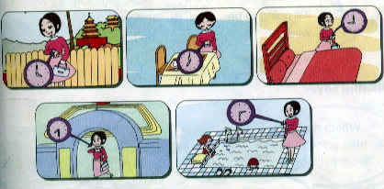
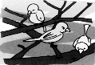
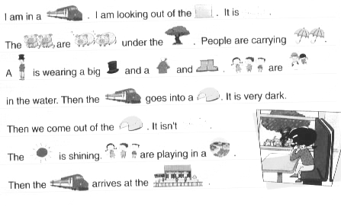

( ) ( ) ( ) ( )
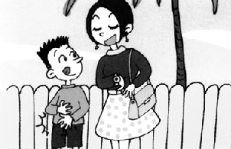
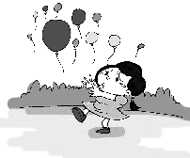
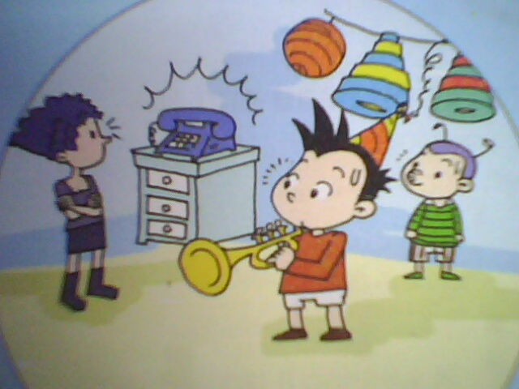


( ) ( ) ( ) ( )
Ⅲ.听问句，选答句。将正确答案序号填在括号内。 （每题2分，共8分）
A . I took some photos.
B. I will take some photos.
C. I’m taking some photos.

A. I want a football.
B. I want a hamburger.
C. I want a cola.

( ) 1. ( ) 2.

A. He’s ten.
B. I’m ten.
C. It’s ten cents, in all.

A. It’s going to snow.
B. It’s Monday.
C. It’s an apple.
( ) 3. ( ) 4.

Ⅳ.听短文，判断正误，对的写“T”，错的写“F”。（每题1分，共6分）

( ) 1. They went to a park on Sunday.
( ) 2. They took sandwiches and they wanted to have a picnic.
( ) 3. It rained and they ran quickly under a tree.
( ) 4. Then those naughty ducks ate all the sandwiches!
( ) 5. They were wet, hungry and angry with the ducks!
( ) 6. It’s a letter from Lingling to Daming.

笔试部分（共六大题，70分）
Ⅴ.单项选择。将正确的序号填写在前面的括号里。（每题1分，共15分）
（ ）1. I _______some photos yesterday. A. take B. took C. takes
（ ）2. I am looking _______ the window. A. out of B. into C. over
（ ）3. He’s riding his bike,_______ it starts to rain. A. and B. but then
（ ）4. Who can help ________ ? A. her B. his C. your
（ ）5. It’s going to_______. A. snow B. snowy C. snowing
（ ）6. He wants to _______ rice. A. some B. eat C. eating
（ ）7. He’s playing his favourite song and everyone is listening and ______.
A. clapped B. claping C. clapping
（ ）8. Daming is______a birthday party. A. having B. have C. had
（ ）9. She is_____things for your birthday. A. buys B. buy C. buying
（ ）10. We are going to have a picnic_____ half past twelve.
A. at B. on C. in
（ ）11. Everyone says hello _______ them. A. with B. on C. to
（ ）12. All the balloons are ________ away.
A. flying B. falling C. flew
（ ）13. What _____ you do last Sunday? A. did B. do C. doing
（ ）14. There ______ a big lake and there ______ lots of ducks here before.
A. was, were B. were, was C. is, are
（ ）15. This time, the door opens and Simon’s dog _____ in.
A. run B. running C. runs
Ⅵ.根据提示，完成下列句子。（每空1分，共5分）
1. I would like a __________ （热狗）and a __________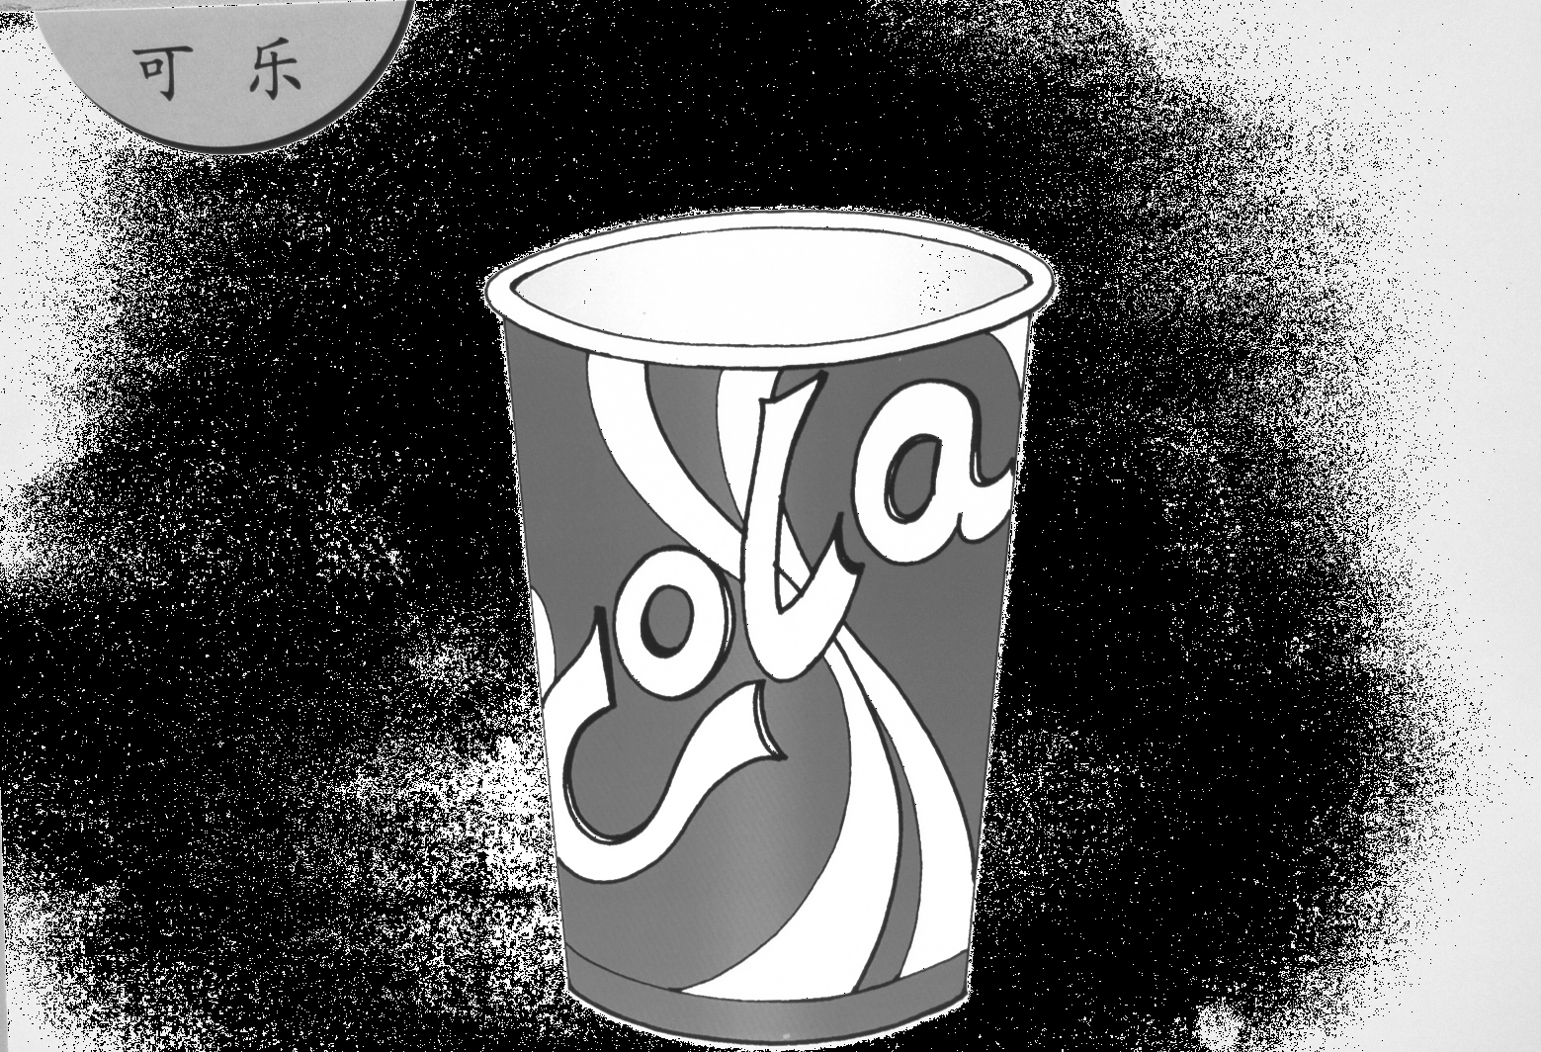.（可乐）
2. There are lots of __________in the park. 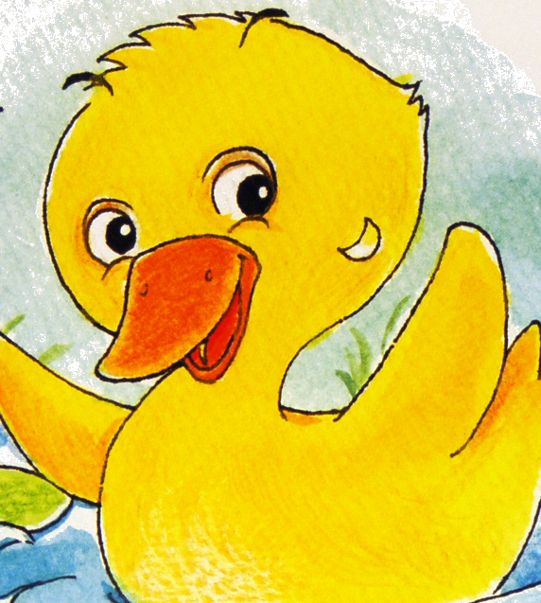（鸭子）
3. She is at the _____________.(超市)
4. This boy is __________.（生气）

Ⅶ.句子理解。（共2大题，计20分）
A.根据问句，找出相对应的答句，将序号填入题前括号内。（每题2分，共10分）
A. No, it isn’t.
B. I’m playing football.
C. It’s twelve o’clock.
D. It’s a sunny day.
E. I’m going to watch TV.

（ ）1. What are you going to do?
（ ）2. What are you doing?
（ ）3. Is it really a dog?
（ ）4. What time is it?
（ ）5. What’s the weather like?

B.根据提示，选词填空补全短文。（每空2分，共10分）
Yesterday, the family___________(go/ goes/ went) to a restaurant. Daming _________(wants/ wanted) a hot dog. Simon _______ (eat / ate / eats) a hamburger and Dad _________ (has / had/ have) a hamburger, too. All the family ________ (drink / drank / drinks) cola. It was 13 dollars and 25 cents, in all.

Ⅷ.情景交际。从所给的选项中选择恰当的句子补全对话, 将答案序号写在横线上。（每题2分，共10分）

A. It’s ten dollars and twenty cents.
B. Yes, I want a hamburger, please.
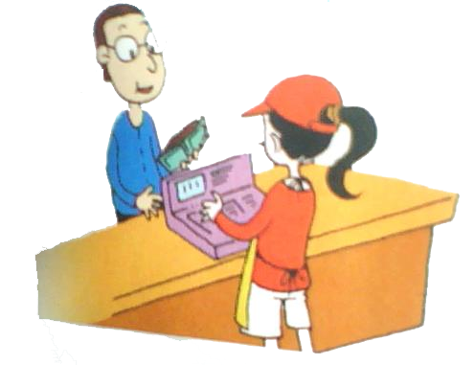
C. Enjoy your meal.
D. How much is it?
E. A cola, please!

Waitress: Hello! Can I help you ?
Daming: _____________
Waitress: And to drink?
Daming: __________________
Waitress: So, a hamburger and a cola.
Daming: _______________
Waitress: .
Daming: Here’s the money.
Waitress: Thank you. _____________

Ⅸ.阅读理解。（2道大题，共15分）
A 阅读语篇课文，根据首字母提示，把短文补全完整通顺。（每题1分，共10分）
Daming’s birthday is coming. Simon a_____ his mum want to have a birthday party for h_____. Simon’s mum is buying things at the s____________. Simon is making a birthday c_______. Simon’s mum can’t carry all the things, so she needs help. Daming comes out to help h_____. Mum tells Daming to hold on to the balloons. However, the oranges are f________ ______, and the balloons are f_________ _____. In the sky, the balloons make “ Happy birthday”. All the people are very h_________.
B. 阅读短文，将正确答案序号填在前面的括号里。（每题1分，共5分）
The birds are going to fly away for the winter. They are sitting in the trees, singing and calling to each other. Wangyong is looking up at them sadly. He doesn’t want the birds to go. Winter is cold and snowy in Wangyong’s Village. Now the birds are flying away and he is sad. “Goodbye, birds,” he says. “Come back again next year.”
（ ）1、_______ is coming.
A. Winter B. Spring C. Autumn
（ ）2、The birds are getting ready to fly somewhere______.
A. warm B. cold C. snowy
（ ）3、In winter, it is________ in Wangyong’s Village.
A. warm B. cold C. hot
（ ）4、The birds are flying away and Wangyong feels(感觉)____.
A. happy B. angry C. sad
（ ）5、The birds will come back in________.
A. winter B. spring C. autumn

Ⅹ.书面表达。根据所给内容进行续写你周末的打算。（本题共5分）
提示：Where are you going to go? What are you going to do?
要求：条理清楚，意思连贯，语句通顺，标点正确，书写规范，不少于40词。
It is Sunday tomorrow．I am going to

六年级英语听力题签
注意：每道听力试题读两遍，听力时间控制在15分钟内。

Ⅰ. 听音，找出句子中含有的单词，将序号写在前面的括号内。
1、It’s thirteen dollars and twenty-five cents, in all.
2、In Dalian, it’s going to be sunny.
3、We were hungry.
4、But then more friends arrive.

Ⅱ. 听音，标号。用数字标出图片的先后顺序。
- A: How much is it? B: It’s thirteen dollars and twenty-five cents.
- I’m going to go out at nine o’clock.
- The birds are singing in the trees.
- I am looking out of the window.
- The balloons are flying away.
- Simon and his mum are going to eat at half past twelve.
- We are having our picnic in the park.
- He is playing but then the telephone rings.

Ⅲ. 听问句，选答句。将正确答案序号填在括号内。
1、What did you do last weekend?
2、What do you want to eat?
3、What’s the weather going to be like in Daqing?
4、How much is it?

Ⅳ. 听短文，判断正误，对的写“T”，错的写“F”。
Hi, Lingling,
I had a very funny day on Saturday. I went to a park with Simon and his mum. We took sandwiches and we wanted to have a picnic. There was a big lake in the park and there were lots of ducks. Then it started to rain. It rained and rained and rained. We ran quickly under a tree. We didn’t want to get wet. Then those naughty ducks went to our picnic and ate all the sandwiches! I took some photos for you. So we went home. We were wet, hungry and angry with the ducks!
From,
Daming

听力部分到此结束！
六年级英语参考答案
Ⅰ. AABA

Ⅱ. 2 4 3 1 8 6 5 7

Ⅲ. ABAC

Ⅳ. F T T T T F

Ⅴ. BABAA BCACA CAAAC

Ⅵ. 1. hot dog, cola 2. ducks 3. supermarket 4. angry

Ⅶ. A组：EBACD
B组：went, wanted, ate, had, drank

Ⅷ. BEDAC

Ⅸ. A组：and, him, supermarket, cake, her,
falling, down, flying, away, happy
B组：AABCB

Ⅹ.书面表达。（本题共5分）
A等，符合要求，逻辑清晰，时态准确，错误不超过2处。（得5-4.5分）
B等，基本符合要求，逻辑基本清晰，时态比较准确，错误处不超过4处。（得4-3分）
C等，基本符合要求，逻辑有些不清晰，时态有些混乱，错误5处以上。（得2.5-0.5分）
D等，不符合要求，逻辑混乱，时态混乱，不成句或者空白未答。（得0分）

备注：卷面满分为100分。（听力30分，笔试70分。）
优秀：90---100
良好：80---89
及格：60---79
不及格：0---59

2014年4月28日

试题考点出处详注：

听力部分
Ⅰ.听音，找出句子中含有的单词，将序号写在前面的括号内。
1、P2-1: Listen, point and find “I want…”.课文第三段句子。
2、P8-1: Listen and repeat.课文第三句。
3、P10-1: Listen, point and find“ had, went, took, ate”.课文第五段句子改编，考查形容词区分。
4、P18-1: Listen, point and find words ending in “-ing”.课文第三段句子。

Ⅱ. 听音，标号。用数字标出图片的先后顺序。
1、P3-2: Listen and say.图2
2、P7-3：Practise.图3
3、P12-1: Listen and repeat. Point to the correct photo.图2
4、P20-1: Listen. Then read and say.图2
5、P15-2: Listen and say.图2
6、P7-2: Listen and say图1
7、P12-1: Listen and repeat. Point to the correct photo.图4
8、P19-2：Listen and say.图2

Ⅲ. 听问句，选答句。将正确答案序号填在括号内。
1、P11-2: Listen and say.功能句2
2、P2-1：Listen, point and find “I want…”.课文第一段句子
3、P8-1：Listen and repeat.课文第2句
4、P3-2：Listen and say功能句2

Ⅳ. 听短文，判断正误，对的写“T”，错的写“F”。
P10-1: Listen, point and find“ had, went, took, ate”.课文

笔试部分
Ⅴ.单项选择。将正确的序号填写在前面的括号里。
1、P11-2: Listen and say.功能句2
2、P20-1: Listen. Then read and say.课文第2句
3、P19-2：Listen and say.功能句2改编，考查but then用法
4、P15-2: Listen and say.功能句1
5、P8-1: Listen and repeat.课文第2句
6、P5-3: Now order your food.第2句改编，考查want to+动词原形
7、P18-1: Listen, point and find words ending in “-ing”.课文第三段句子
8、P18-1: Listen, point and find words ending in “-ing”.课文第一段句子
9、P14-1: Listen, point and find words ending in “-ing”.课文第一段句子
10、P7-2: Listen and say.功能句1改编，考查点钟前介词用法
11、P18-1: Listen, point and find words ending in “-ing”.课文第三段句子
12、P15-2: Listen and say. 功能句2
13、P10- M3U1: 一般过去时语法创编
14、P10-1: Listen, point and find“ had, went, took, ate”.课文第一段句子
15、P18-1: Listen, point and find words ending in “-ing”.课文第四段句子

Ⅵ.根据提示，完成下列句子。
1、P46：M1核心词
2、P11-2：Listen and say功能句3，M2核心词
3、P14-1: Listen, point and find words ending in “-ing”.课文第一段句子，M4核心词
4、P46：M3核心词

Ⅶ.句子理解。
- 根据问句，找出相对应的答句，将序号填入题前括号内。
1、P6: M2U1一般将来时be going to语法创编
2、P12：M3U2现在进行时语法创编
3、P2-1: Listen, point and find “I want…”.课文第一段句子改编
4、P6-1: Listen, point and find “ going to”.课文第一段句子改编
5、P6-1: Listen, point and find “ going to”.课文第一段结合M2U2天气创编
B. 根据提示，选词填空补全短文。
根据M3U1一般过去时动词过去式创编

Ⅷ.情景交际。从所给的选项中选择恰当的句子补全对话, 将答案序号写在横线上。
P2-1: Listen, point and find “I want…”.课文整合、改编

Ⅸ.阅读理解。
A 阅读语篇课文，根据首字母提示，把短文补全完整通顺。
P14- 1: Listen, point and find words ending in “-ing”.课文

- 阅读短文，将正确答案序号填在前面的括号里。
结合一般现在时、现在进行时、一般将来时创编

Ⅹ.书面表达。根据所给内容进行续写你周末的打算。
结合M2U1一般将来时语法设计习作

