三年级英语期末检测试卷
班级：
姓名：
2013---2014学年度第一学期
听力部分
一、听音选 出你所听到的单词，将其序号填入括号内。（每题1分，共10分）
( )6.A. hard B. high
( )7.A. people B. pilot
( )8.A. lake B. like
( )9.A these B. those
( )10.A.clever B.careful

( )1.A. use B. bus
( )2.A. shop B. short
( )3.A. winner B. worry
( )4.A. lovely B. really
( )5.A. fix B.feed
二、听音选择。将正确答案的序号写在题前的括号内。（每题1分，共10分）
( )1.Do you use ______ in England? A. chopsticks B. fork
( )2.It’s _______for Chinese people. A. hard B. easy
( )3.Sam’s ________ are wet. A. shorts B. skirt
( )4.I can jump __________. A. far B. high
( )5. I’m going to _______________. A. do long jump B. do high jump
( )6.This is Linda. She’s going to be a ____. A. driver B. teacher
( )7.This__________, I’ll go to Hong Kong. A. Saturday B. Sunday
( )8I’m thirsty. Can I have have a ______. A. drink B. water
( )9. They are going to go to Shanghai by________. A. ship B. plane
( )10.Iris is going to go to Hainan in _____holiday. A. winter B. summer
三、听音标号，用阿拉伯数字标出图片的先后顺序。（每题1分，共10分）
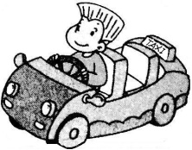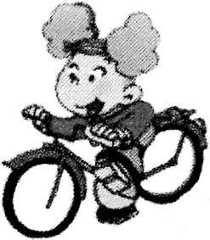
( ) ( ) ( ) ( ) ( )
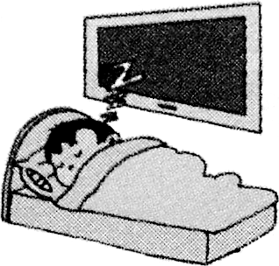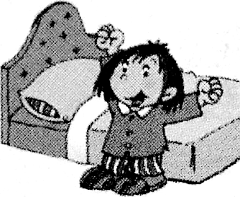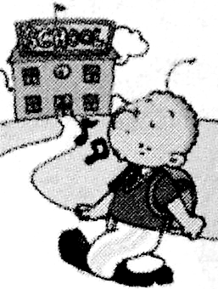
( ) ( ) ( ) ( ) ( )
四、听音选出听到的句子,将序号写在括号里。（每题1分，共5分）
( ) 1. A. What are you going to be？ B. What are you going to do?
( ) 2. A. There are stone animals. B. There is a camel.
( ) 3. A. She’s got a pet cat. B. He’s got a pet dog.
( ) 4. A .Can I run fast? B. I can run fast.
( )5. A .Have you got a stomacher ache? B. Have you got a herdacher?
五、听对话排序（每题1分，共8分）
( ) I’m going to go to Hong Kong.
( ) Are you going to go to Hong Kong?
( ) What are you going to do?
( ) I’m going to swim in the sea.
( ) No, I’m not.
( ) Hi! Where are you going?
( ) My grandma lives there.
( ) We’re going to go to Hainan.
笔试部分
一、按顺序默写26个英文字母,并圈出五个元音字母。（每个0.25分，共8分）

二、根据图片提示将所缺的单词补充完整。（每空2分，共10分）
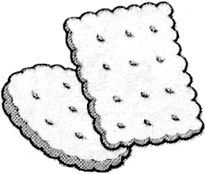
1．We are making ___________ for mum and dad.

2. Can Daming __________fast?
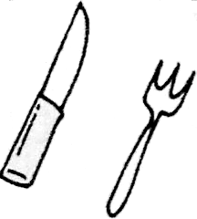
3. In England people use a _________ and ____________.
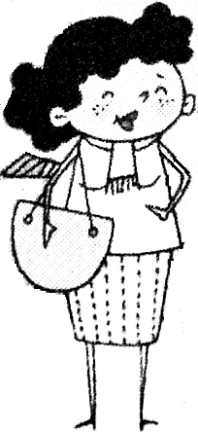
4. Look! That ________ is Lingling’s mother.

三、选择填空。（每题2分，共20分）
1. ( )Amy is _____ the flute. A. playing B. play C.plays
2. ( ) It’s hard ______ Chinese people. A.of B.on C.for
3. ( ) That is ______ shirt. A. Amy B. Amy’s C. Amys
4. ( ) --You are a clever boy. ---_________ A. No. B. Thank you. C. Yes.
5. ( )Can I have _________ ice cream? A.an B.a C. the
6. ( ) Go and make a cake _________. A. in B. instead C. stead.
7. ( )There are two__________. A. mans B. man C. men
8. ( ) Amy is going to ________. A. do high B. do jump C. do high jump
9. ( ) This fish can ___________, A. swim B swimming C swims
10. ( ) __________you sad? A. Is B. Are C. Am
四、圈出不同类的的词。（每题1分，共6分）
1. headache stomachache test 2. swimming play fiying
3. jump elephant horse 4. train nurse doctor
5.appples meat noodles 6. knife chips hamburger

五、选择正确的回答（每题1分，共8分）
1.( ) What are those? A. There are 10.
2.( ) Have you got a teddy bear? B.No, I can’t.
3.( ) Can you jump far? C. They are cars.
4.( ) Has Sara got a cough ,too? D. Yes, she has.
5.( ) How many people are there? E. No, I’m not.
6.( ) What are you going to be ? F. I’m fine.
7.( ) Are you going to go to Hong Kong? G. I’m going to be a teacher.
8.( ) How are you ? H. No, I haven’t.
六、阅读选择正确答案 . （每题1分，共5分）
My name is Frank. I’m eight years old. This is my family. There is one boy. That’s me. There is one girl. She’s my sister. There is a man and a woman. They are my dad and my mum. We’re going to the cinema. We’re going to see a film.
1.( ) How old is Frank.
A. 7. B. 8. C. 9.
2.( ) How many people are there in Frank’s family?
A. Three B. Four C. Five.
3.( ) Are there two boys in Frank’s family?
A. Yes. B. No. C. I don’t know.
4.( ) Are there two women in Frank’s family?
A. Yes. B. No. C. I don’t know.
5.( ) What are they going to do?
A. They’re going to visit the zoo. B.They’re going to the cinema. C.They’re going to the shop.
三年级英语期末检测试卷听力题签
2013---2014学年度第一学期
听力部分
一、听音选 出你所听到的单词，将其序号填入括号内。（每题1分，共10分）
6. high
7. people
8. lake
9. those
10. careful

1. use
2. short
3. winner
4.A lovely
5. feed
二、听音选择。将正确答案的序号写在题前的括号内。（每题1分，共10分）
1.Do you use chopsticks in England?
2.It’s easy for Chinese people.
3.Sam’s shorts are wet.
4.I can jump high
5. I’m going to do long jump.
6.This is Linda. She’s going to be a teacher
7.This Saturday, I’ll go to Hong Kong.
8.I’m thirsty. Can I have have a drink.
9. They are going to go to Shanghai by plane.
10.Iris is going to go to Hainan in summer holiday.
三、听音标号，用阿拉伯数字标出图片的先后顺序。（每题1分，共10分）
1.Amy is riding a bike.
2.I’m going to be a policeman.
3. I’m going to be a driver.
4.Sam is writing a letter.
5. I’m going to be a teacher.
6.The boy is sleeping.
7.Lingling is eating noodles.
8.Da ming is going to school.
9. I’m going to be a doctor.
10.Lingling is getting up.
四、听音选出听到的句子,将序号写在括号里。（每题1分，共9分）
1. What are you going to be？
2. A. There are stone animals.
3. He’s got a pet dog.
4. I can run fast.
5. Have you got a herdache?
五、听对话排序（每题1分，共8分）
A：Hi! Where are you going?
B：I’m going to go to Hong Kong.My grandma lives there.Are you going to go to Hong Kong?
A：No, I’m not. We’re going to go to Hainan.
B：What are you going to do?
A：I’m going to swim in the sea.

四小—-3A期末试卷笔试部分答案及评分标准（2014.1）
- 按顺序默写26个英文字母，并圈出五个元音字母。（每个0.25分，共8分）
略。
二、根据图片提示将所缺的单词补充完整。（每空2分，共10分）
1、biscuits 2、 run 3、 knife fork 4、 woman
三、选择填空。（每题2分，共20分）
1、A 2、C 3、B 4、B 5、A 6、B 7、C 8、 C 9、A 10、B
四、圈出不同类的词。（每题1分，共6分）
1、test 2、play 3、jump 4、train 5、meat 或apples 6、knife
五、选择正确的回答。（每题1分，共8分）
1、C 2、H 3、B 4、D 5、A 6、G 7、E 8、F
六、阅读选择正确答案。（每题1分，共5分）
1、B 2、B 3、B 4、B 5、B

