小长山小学三年级英语期末测试 2014.1
学 校
班 级
姓 名
听力部分（45分）
Ⅰ、听音,选出你所听到的单词，将其序号填入括号内。（10分）
（ ）1. A. cold B. cough （ ）2. A. make B. lake
（ ）3. A .feed B. fast （ ）4. A. pet B. get
（ ）5. A. sea B. easy （ ）6. A. fork B. fix
（ ）7. A. instead B. idea （ ）8. A. shop B. shorts
（ ）9. A. careful B. clever （ ）10. A. ill B. all
Ⅱ、听音,根据所听顺序用数字(1,2,3,4,5)给下列图片重新排序。（10分）
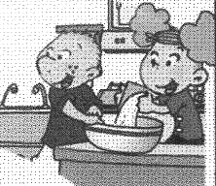
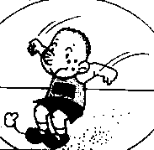
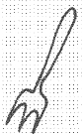
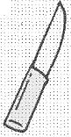
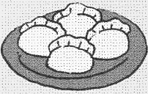
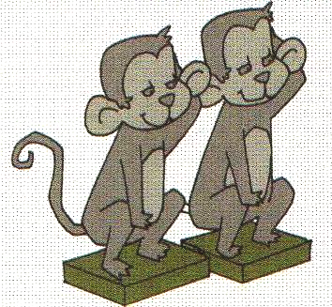

( ) ( ) ( ) ( ) ( )
Ⅲ、听音，根据所听的句子判断图片是否正确，正确的打√，错误的打X。（10分）
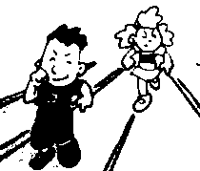
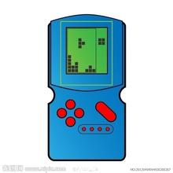
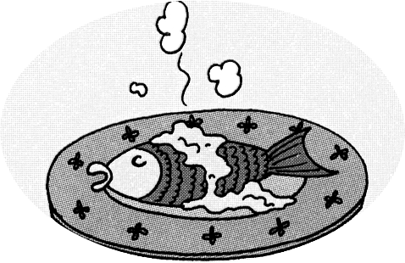
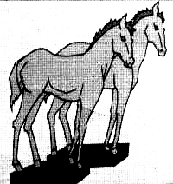
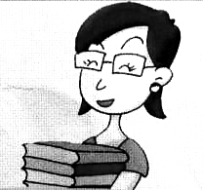

（ ） （ ） （ ） （ ） （ ）
Ⅳ、听音，给下面的句子用数字（1,2,3,4,5）标上序号。 （5分）
( )Lingling is eating noodles.
( ) These ducks are very naughty.
( ) Are you going to go to Hong Kong?
( ) I can go to the shop for an ice cream.
( ) This bird can’t fly.
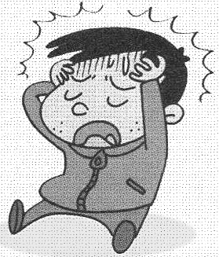
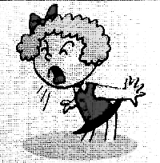
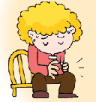
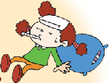
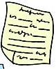
Ⅴ、听音，连线。 （10分）
1、Mingming

2、Lili

3、Fangfang

4、Xiaoyong

5、Dongdong

笔试部分（55分）
Ⅵ、请按顺序规范默写26个大小写英文字母。（5分）

Ⅶ、请根据所给语境写出正确的单词。(10分)
- They_________(使用) a knife and _________(叉) in England.
- It’s ___________(容易的) for English people.
- People __________(划) on this ___________.(湖)
- Don’t ___________.(担心)
- There is a ___________.(马)
- We are __________(制作) a __________.(蛋糕)
- She’s got a pet ____________.(老鼠)
Ⅷ、选择，将正确的答案写在题前的括号内。（10分）
( )1. Amy is ________ the flute.
A. play B. plays C. playing
( )2. He _____ got a present for you.
A. is B. has C. have
( )3. I’m going to _____ long jump.
A. 不填 B. jump C. do
( )4. There ______ some books on my desk.
A. is B. are C. am
( )5. He can _______ in the sea.
A. swim B. swims C. swimming
( )6. There are two ________ in my family.
A. woman B. womans C. women
( )7. I ______ got a good friend.
A. have B. has C. am
( )8. I’m going to play football________ Saturday.
A. on B. in C. at
( )9. __________(远处) Amy’s shorts.
A. That is B. These are C. Those are
( )10. How many ________ are there in the zoo?
A. monkey B. monkeys C. are monkeys
Ⅸ、根据语境，选择恰当的单词填写在横线上。(10分)
visit ，naughty , airport , biscuits , feed

1. The planes are at the______________.
2. We are going to ___________ the Ming Tombs.
3. These ducks are very _____________.
4. Let’s _______ the ducks.
5. I can have these ___________.

Ⅹ、根据问句选答句并连线。（10分）
1. How many stone animals are there? A、They are playing football.
2. What are they doing ? B、There are 24.
3. Have you got a headache? C、I’m going to swim in the sea.
4. Can I watch TV, please? D、No, you can’t.
5. What are you going to do? E、No, I haven’t.

Ⅺ、阅读理解，根据短文内容判断正( T )误( F )。（10分）
On Saturday, Lucy is at home. She is writing a letter and drawing a picture. Then she is colouring the picture. This is for her friend Fangfang. She is very happy. But Lingling is at school. She is reading a book and listening to music. Then she is playing basketball. She is happy, too.
1. Lucy is at home on Sunday. ( )
2. Lucy is writing a letter for Lingling. ( )
3. Lucy is drawing a picture and isn’t coluring it. ( )
4. Lingling is reading a book and listening to music. ( )
5. Lingling is at home, too. ( )
三年级英语听力题签：
注意：每道听力试题读二遍，听力时间控制在25分钟内。
Ⅰ、听音,选出你所听到的单词，将其序号填入括号内。
1. She’s got a cough.
2. People row on this lake.
3. Can you run fast?
4. I’ve got a pet dog.
5. Chopsticks are easy for Chinese people.
6. Let’ s fix the kite.
7. Please go and make a cake instead.
8. I can go to the shop for an ice cream.
9. You are a clever boy.
10. Lingling is ill. She is at home.
Ⅱ、听音,根据所听顺序用数字(1,2,3,4,5)给下列图片重新排序。
1. I’m eating dumplings.
2. In England, people use a knife and fork.
3. They are making a cake.
4. He is going to do long jump.
5. There are two stone monkeys.
Ⅲ、听音，根据所听的句子判断图片是否正确，正确的打√，错误的打X。（10分）
      - There are some stone camels.
      - I’m going to be a driver.
      - The boy can run fast.
      - I’ve got a computer game.
      - This fish can swim.
Ⅳ、听音，给下面的句子用数字（1,2,3,4,5）标上序号。 （5分）
( 1 ) These ducks are very naughty.
( 2 ) I can go to the shop for an ice cream.
( 3 )Lingling is eating noodles.
( 4 ) This bird can’t fly.
( 5 ) Are you going to go to Hong Kong?
Ⅴ、听音，连线。 （10分）
            - Mingming has got a stomach ache.
            - Lili has got a cold.
3.Fangfang has got a cough.
4.Xiaoyong has got a headache.
5.What has Dongdong got? He has got a test today.

听力部分到此结束！

三年级测试答案
听力部分（45分）
Ⅰ、听音,选出你所听到的单词，将其序号填入括号内。（10分）
BBBAB BAABA
Ⅱ、听音,根据所听顺序用数字(1,2,3,4,5)给下列图片重新排序。（10分）
3 5 1 4 2
Ⅲ、听音，根据所听的句子判断图片是否正确，正确的打√，错误的打X。（10分）
X X V V X
Ⅳ、听音，给下面的句子用数字（1,2,3,4,5）标上序号。 （5分）
3 1 5 2 4
Ⅴ、听音，连线。 （10分）
1--- 第4图 2---第5图 3---第2图 4---第1图 5---第3图
笔试部分（55分）
Ⅵ、请按顺序规范默写26个大小写英文字母。（5分）
请英语教师按正确的手写体批改。分为以下几等：
全对 5分
错2个字母以内的得4.5分
错5个字母以内的得4分
错10个字母以内的得3分
错15个字母以内的得2分
错20个字母以内的得1分
超过20个字母不得分

Ⅶ、请根据所给语境写出正确的单词。(10分)
1. use fork 2. easy 3. row lake 4. worry
5. horse 6. making cake 7. mouse
单词全部拼写正确方可得分，其中making 写原形或变化不对的扣0.5分。
Ⅷ、选择，将正确的答案写在题前的括号内。（10分）
CBCBA CAACB
Ⅸ、根据语境，选择恰当的单词填写在横线上。(10分)
1. airport 2. visit 3. naughty 4. feed 5. biscuits
Ⅹ、根据问句选答句并连线。（10分）
1---B 2---A 3—E 4----D 5----C
Ⅺ、阅读理解，根据短文内容判断正( T )误( F )。（10分）
1.F 2. F 3.F 4. T 5. F

