大小2013~2014三年级 英语第一学期期末质量检测
学 校
班 级
姓 名
完成时间：60分钟
听力部分（50分）
Ⅰ、听音,选出你所听到的单词，将其序号填入括号内。
（ ）1. A. airport B. animal （ ）2. A. lovely B. lake
（ ）3. A .hamburber B. dragon （ ）4. A. idea B. instead
（ ）5. A. shorts B. sports （ ）6. A. worry B. sorry
（ ）7. A. cough B. careful （ ）8. A. pet B. wet
（ ）9. A. these B. this （ ）10. A. train B. taxi
Ⅱ、听音,根据所听顺序用数字(1,2,3,4,5)给下列图片重新排序。
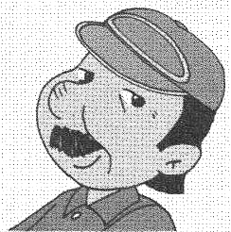
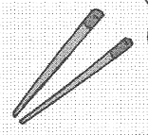
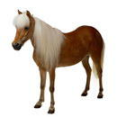
( ) ( ) ( ) ( ) ( )
Ⅲ、听一听，选一选.
( )1.What are you going to see ? A. Tom and Jerry B. Sun Wukong
( )2.What can Amy do ? A. long jump B. high jump
( )3.What are those ? A. stone lions B. stone camels
( )4.Look at the Dragon boats. They’re _______. A. nice B. lovely
( )5.What are you doing ? A. making a cake B. rowing a boat

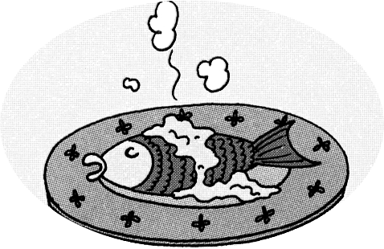
Ⅳ、听音连线。

1.

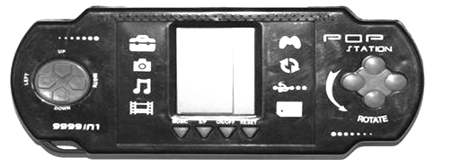
2.
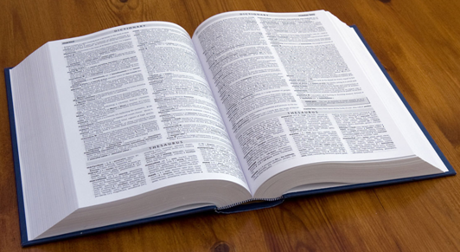

3.

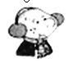
4.



5. E.
Ⅴ、听音，用数字（1，2，3，4，5）给下列句子重新排序。
( ) That’s me.
( ) Look, this is my family.
( ) We’re visiting the zoo.
( ) There are five people in my family.
( ) There is one boy.

笔试部分（50分）
Ⅵ、请根据所给语境写出正确的单词。
- Let’s ___________(喂) the ducks.
- I’m hungry,I want to go to the ___________(商店).
- We will run a _______ (赛跑)，we’ll be the _________(胜利者).
- I see one _____(男人) and two ________(女人) in the house.
Ⅶ、请按顺序规范默写26个大小写英文字母。

Ⅷ、选择，将正确的答案写在题前的括号内。
( ) 1. There is ___ elephant. A. an B. a C. two
( ) 2. Look at those ducks ______there.
A. on B. in C. over
( ) 3. ______ Sam’s trousers.
A. These are B. This is C. These is
( ) 4.Now we ______ a new book.
A. has got B. have got C. got
( ) 5. A:Can you run fast ? B:________
A. Yes, I am. B. Yes, I can. C. No, I don’t.
Ⅸ、根据问句选答句， 把正确的序号写在题前的括号内。
( ) 1. Do you want some rice? A. She is playing the flute.
( ) 2. Has Shanshan got a cat? B. I’m going to be a doctor.
( ) 3 .What is Amy doing? C. Yes, I do.
( ) 4. What are you going to be ? D .No, she hasn’t.
( ) 5. How many stone horses are there? E. There are 24.
Ⅹ、填空.
(一)用is , are填空
- There _____three cats in that house.
- Look, there ______ a kite in the sky.
- Daming ____ going to swim in the sea.
4. _____ you going to dance in the party?
(二)读一读，把答句写完整。
1.-Have you got a test today? -Yes, I _______.
2.-Can he swim? -No, _____ _____.
3.-What are you doing? -I’m ________ (eat/eating) hamburgers.
Ⅺ、连词成句.
1. got / kite / I / a / have / new/(.) _______________________________________________
2. you / in / England / do / use / chopsticks /（？）
_______________________________________________
3. making / we / a / are / cake /(.)
_______________________________________________
Ⅻ、阅读理解，根据短文内容判断正( T )误( F )。
My name is Xiaoqiang. I’m 9 years old. I like music very much. I can play the flute and sing some songs. My friend Sam is an English boy. He is 10 years old. He likes swimming. He can run fast and jump far.
( ) 1. Xiaoqiang likes music.
( ) 2. Xiaoqiang can play the drums.
( ) 3. Sam is a Chinese boy.
( ) 4. They are 9 years old.
( ) 5. Sam can’t run fast.

三年级英语听力题签2013.12：
注意：每道听力试题读二遍，听力时间控制在25分钟内。
Ⅰ、听音,选出你所听到的单词，将其序号填入括号内。
1.airport 2.lake 3.dragon 4.instead 5.shorts
6.worry 7.careful 8. wet 9.these 10.taxi
Ⅱ、听音,根据所听顺序用数字(1,2,3,4,5)给下列图片重新排序。
1. Sam has got a toy horse.
2. There is a mouse.
3. He’s got a headache.
4. We use chopsticks in China.
5. My father is a train driver.
Ⅲ、听一听，选一选。
1.What are you going to see ? We’re going to see Sun Wukong.
2. What can Amy do ? Amy can do long jump.
3. What are those ? They’re stone camels.
4.Look at the Dragon boats. They’re lovely.
5. What are you doing ? We’re making a cake.
Ⅳ、听音连线。
1.This is Lingling’s book.
2.A: Can you eat fish, Amy ?
B: Yes, I can.
3.A: What are you going to do, Ms Smart ?
B: I’m going to watch TV.
4.Sam has got a computer game.
5.A: What is Daming doing?
B: He’s playing football.
Ⅴ、听音，用数字（1，2，3，4，5）给下列句子重新排序。
Look, this is my family. There are five people in my family. There is one boy. That’s me. We’re visiting the zoo.

听力部分到此结束！

