海洋岛学校2013~2014第一学期期末质量检测
三年级 英语 完成时间：60分钟
题号 | Ⅰ | Ⅱ | Ⅲ | Ⅳ | Ⅴ | Ⅵ | Ⅶ | Ⅷ | Ⅸ | Ⅹ | Ⅺ | Ⅻ | 总分
得分
听力部分（50分）
Ⅰ、听音,选出你所听到的单词，将其序号填入括号内。
（ ）1. A. idea B. instead （ ）2. A. cake B. lake
（ ）3. A .easy B. sea （ ）4. A. shorts B. horse
（ ）5. A. man B. woman （ ）6. A. worry B. sorry
（ ）7. A. these B. this （ ）8. A. pet B. wet
（ ）9. A. cough B. careful （ ）10. A. airport B. animal

Ⅱ、听音,根据所听顺序用数字(1,2,3,4,5)给下列图片重新排序。
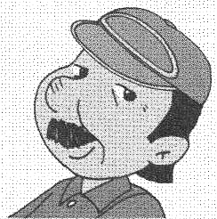
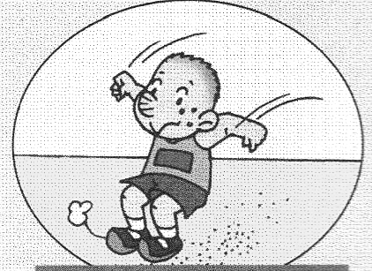
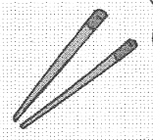
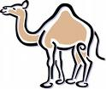
( ) ( ) ( ) ( ) ( )

Ⅲ、听对话，填嘴巴，画笑脸(can)和哭脸(can’t)。
1. have a drink
2. have an ice cream
3. have some biscuits
4. go to the shop
5. watch TV

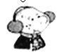
Ⅳ、听音连线。

1.

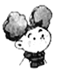
2.
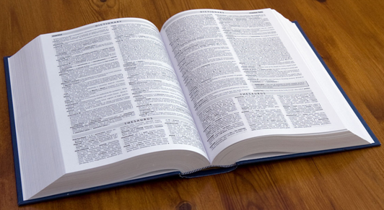

3.
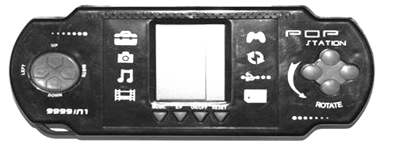
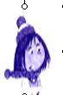
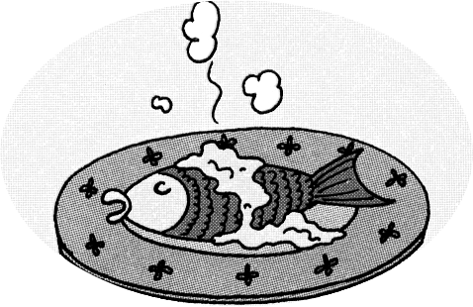
4.

5. E.

Ⅴ、听音，选出你所听到的句子，并把序号写在题前的括号内。
( )1. A. We use a knife and fork. B. We’re making a cake.
( )2. A. What are these ? B. What are those ?
( )3. A. He’s running. B. She’s working.
( )4. A. I’ve got a doll. B. He’s got a dog.
( )5. A. Can I come in ? B. Yes, please.
Ⅵ、听音，用数字（1，2，3，4，5）给下列句子重新排序。
( ) Daming is going to run a race.
( ) I’m going to do high jump.
( ) I’m going to do long jump.
( ) It’s going to be Sports Day on Friday.
( ) What are you going to do , Lingling ?
笔试部分（50分）
Ⅶ、请按顺序规范默写26个大小写英文字母。

Ⅷ、请根据所给语境写出正确的单词。
- It’s ___________(困难的) for English people.
- Sam is ill. He’s got a ___________(感冒).
- A: What are they doing ? B: They are_____(划)a dragon boat.
- ______(全部的 ) the birds are lovely.
5.We’re going to ________ (参观) the zoo.
Ⅸ、选择，将正确的答案写在题前的括号内。
（ ）1. She ______a pet cat.
A. has got B. have got

（ ）2. There_____ three people in my family.

A. am B. is C. are
（ ）3. A:Can you run fast ? B:________
A. Yes, I am. B. Yes, I can.
（ ）4. I can jump far, _______I can’t jump high.
A. and B. but
（ ）5. Please be quiet! Sam is______ his homework now.
A. doing B. do C. does
Ⅹ、根据问句选答句， 把正确的序号写在题前的括号内。
( )1. Do you want noodles? A、I’m reading.
( )2. What are you doing ? B、Yes, please.
( )3. Have you got a test today? C、No, I haven’t.
( )4. What are you going to be ? D、There are ten.
( )5. How many men are there? E、I’m going to be a doctor.
Ⅺ、根据语境，选择恰当的单词填写在横线上。
elephant ，winner , fast food , clever , Hong Kong
- Hamburgers and chips are English ___________ .
2. You are a ___________ boy.
3. We’re going to go to ____________.
4. Ahh! I’m the ___________.
5. Look! There is an __________.
Ⅻ、阅读理解，根据短文内容判断正( T )误( F )。
Hi, I’m Dongdong. There are five people in my family. There are two men. They’re my grandpa and my dad. There are two women, too. They’re my grandma and my mum. There is one boy. That’s me. My dad is a bus driver. I’ve got a toy car. I like it very much. I’m going to be a driver.
( )1. Dongdong is a girl.
( )2. There are five people in Dongdong’s family.
( )3. His dad is a taxi driver.
( )4. Dongdong has got a toy bus.
( )5. He’s going to be a driver.
三年级英语听力题签：
注意：每道听力试题读二遍，听力时间控制在25分钟内。
Ⅰ、听音,选出你所听到的单词，将其序号填入括号内。
1. That’s a good idea !
2. This lake is very beautiful.
3. I’m going to swim in the sea.
4. Those are Amy’s shorts.
5. This is an old woman.
6. Don’t worry! Let me help you.
7. These ducks are very naughty.
8. Sam’s clothes are wet.
9. Be careful! The tree.
10. They’re going to go to the airport.

Ⅱ、听音,根据所听顺序用数字(1,2,3,4,5)给下列图片重新排序。
1. We use chopsticks in China.
2. They’re feeding the ducks.
3. Sam can jump far.
4. There is a camel.
5. My father is a train driver.

Ⅲ、听对话，填嘴巴，画笑脸(can)和哭脸(can’t)。
1、Daming: Dad, can I have a drink, please?
Dad: Yes, Here you are.

2、Daming: Can I have an ice cream?
Dad: No, you can’t. Look, no ice cream.

3、Daming: Can I have some biscuits?
Dad: Yes, you can.

4、Daming: Can I go to the shop?
Dad: No, you can’t. You are ill.

5、Daming: Can I watch TV?
Dad: Yes, you can.
Daming: Thanks ,dad.

Ⅳ、听音连线。
- A: What are you doing,Sam?
B: I’m playing football.
- A: What are you going to do, Amy ?
B: I’m going to watch TV.
- Daming has got a computer game.
- A: Can you eat fish, Lingling ?
B: Yes, I can.
5. This is Ms Smart’s book.

Ⅴ、听音，选出你所听到的句子，并把序号写在题前的括号内。
1. We’re making a cake.
2. What are those ?
3. He’s running.
4. He’s got a dog.
5. Can I come in ?

Ⅵ、听音，用数字（1，2，3，4，5）给下列句子重新排序。
It’s going to be Sports Day on Friday. Daming is going to run a race. I’m going to do long jump. What are you going to do , Lingling ? I’m going to do high jump.

听力部分到此结束！
三年级英语答案及评分标准：
听力部分
Ⅰ、(1×10＝10分) A B B A B A A B B A
Ⅱ、(2×5＝10分) 3--- 5 ---1--- 2 ---4
Ⅲ、(2×5＝10分) 1. 2. 3. 4. 5.

Ⅳ、(2×5＝10分) 1---B 2---A 3---D 4---E 5---C

Ⅴ、(1×5＝5分) BBABA

VI、(1×5＝5分) 2---5---3---1---4
笔试部分
Ⅶ、5分
（备注：要求一律用手写体规范书写26个大小写英文字母，如果个别字母没变体就算错误，4个或4个以内字母合计0.5分，共52个字母合计5分，扣完为止！）
Ⅷ、(2×5＝10分) hard , cold , rowing , All , visit
（备注：画有“——”黑体的部分各扣0.5分。要求一律用手写体书写单词，如果个别字母没变，整体书写扣0.5分。）
Ⅸ、(2×5＝10分) ACBBA
Ⅹ、(2×5＝10分) BACED
Ⅺ、(2×5＝10分)
1.fast food 2.clever 3.Hong Kong 4.winner 5.elephant
（备注：要求一律用手写体书写单词，如果个别字母没变，整体书写扣0.5分。）
Ⅻ、(1×5＝5分) F T F F T

备注：卷面满分为100分。（听力50分，笔试50分。）
优秀：90---100
良好：80---89
及格：60---79
不及格：0---59
2013年1月8日

