一年级英语复习(一)
獐子中心小学 丁毅清
一. 认一认我们的朋友吧

Amy
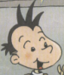
Lingling

Sam
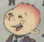
Daming

Taotao
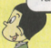
Baobao

Feifei
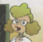
Tingting
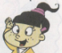
Ms Smart

二、找一家人。仔细看看，谁是双胞胎啊，给他们连起来
Hello goodbye
Goodbye hello
Hi bye
Bye good
Good hi
I’m I am
三、看看谁是好朋友，让他们手拉手吧。
How are you? Bye!
Hello! I’m fine.
Goodbye! Hi!
Hi, I’m Lingling. Goodbye, Amy.
Bye, Sam. Good morning!
Good morning! Hello, I’m Daming.
四、读一读，圈一圈
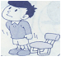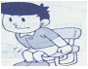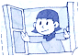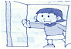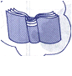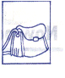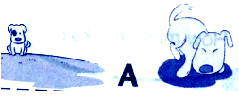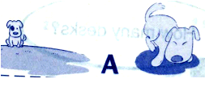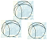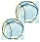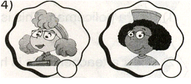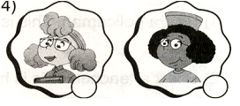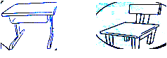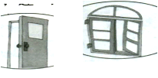
2. Open the window.

4. This is a cat .

5 That is a dog .

6.Two balls .

7. This is my teacher .

8. It's a seat .

9．Point to the door.
.
10.Point to a panda.

1. Stand up
3. It's the book.
五、请为下面的问句找到合适的答句，并连接起来。
1. How old are you ? A. Yes, it is .
2. Is it a monster ? B. I'm eight .
3. What's that ? C. I'm fine. Thank you.
4. How are you ? D. It's a kite .
5.What colour is it ? E. It’s yellow.

六、读一读，连一连
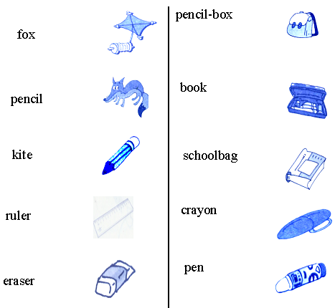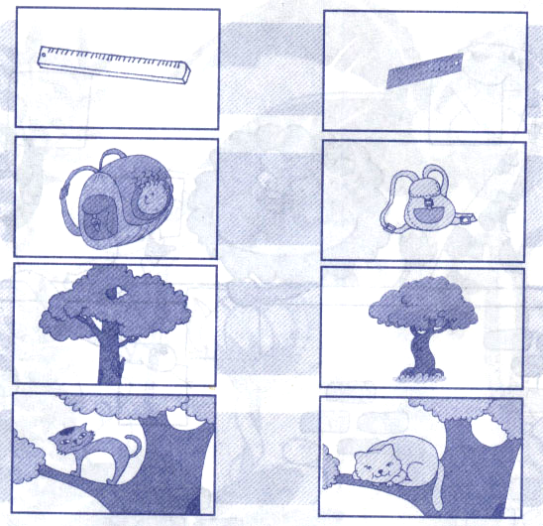

七、好朋友手拉手。
panda dog cats birds girl boy box

dogs pandas bird cat boys boxes girls

