一年级起点第九册（NSE）
Review Module 3教学设计
大长山小学 宋燕
教材分析：
语言功能：复习谈论西方的节日。
教学目标：
a.语言知识目标：1.学生能够会听，说，读，写并会运用本模块单词及短语。
2. 学生能够理解，运用本模块的目标语句。
b.语言技能目标： 了解万圣节和感恩节的习俗及不同的中西节日，谈论人们在节日的活动，并能用简单的句子描述节日。
c.情感态度目标：1.提高学生学习英语的兴趣，培养学生的自信。
2.培养学生合作学习，交流能力。
d. 学习策略:
让学生在实际情境中反复的学习和交流，并充分利小组合作、讨论交流等方法，学会用英语做事。
e.文化意识:
通过学习，让学生了解西方国家的节日。
教学重点： 能够熟练运用本模块的单词及目标语句。
教学难点：运用所学语句描述节日，并能在真实的语境中运用。
学生分析：
学生已经学习过万圣节和感恩节,，学生对于学过的单词和目标语句掌握的较好。在此基础上复习本课的知识，需要教师创设真实的语言环境, 以学生的生活经验为出发点，发展学生的思维，让学生们能够正确熟练地运用，培养学生的兴趣及能力。
教学准备：
课件,Test-paper，单词卡片
教学流程
Step1 Preparation
a. Greetings.
T：Good morning! Boys and girls.
b. Enjoy a poem
(激发学生学习英语的兴趣，创设英语的课堂氛围，引出本课的复习话题)
Step2 Presentation
T: Just now we heard a poem about months, How many months are there in a year？
教师引导学生说出完整的回答:“There are 12 months in a year .”
T: What festivals are there in a year? 学生说出一些他们知道的节日
T：There are many festivals in a year .They are really fun. Today we’ll review Module 3 about festivals.
Step3 Practice
- T: Open your books. Read the text by yourself. Then do exercise(填入所缺单词，补全句子)
- T：Act the dialogue in groups. Then answer the questions:
When is Halloween?
What do children wear at Halloween?
Where do children go?
What do children do?
What do the people give?
(学生回答问题，回顾本课重点。其中重点强调:an的用法，scary ,scare 的区别，give sb sth =give sth to sb)
Then tell the students how to write about Halloween.
T: And we learnt another festival. It’s Easter. What do you want to know about Easter ?
Students ask questions: When is Easter? What’s on the hat?
What do people give children? What is in the big eggs?
T:Ok, let’s read the text by yourself and think ,then answer the questions.
(学生回答完关于感恩节的问题，PPT出示比较本模块两个节日的时间，人们的活动及感受)

T：Take your test –paper, do some exercises.
(选词填空和选择节日的相应信息，巩固归纳本课的知识点，阅读短文，判断正（T）误(F)，培养学生的综合语言运用能力。)
Step4 Production
T:(PPT) It’s on the 25th of December .What festival is it?
S: It’s Christmas.
T: Who can read.
( Christmas is a winter festival. It’s really fun. People wear warm clothes. They have a big dinner. They can see the Christmas man. )
(进一步发散学生思维，培养学生英语语言思维及灵活运用能力。)
T: It’s a Chinese festival. What is it?
S: It’s Mid- Autumn Festival.
T: Can you describe Mid- Autumn Festival? Practise by yourself.
T: Who can say？
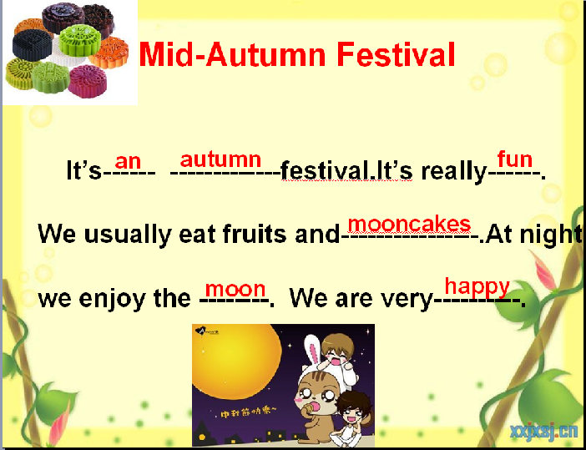
（创设语境让学生能够进一步熟练运用目标语句。）

T: Today we reviewed festivals. Do you know how to talk about a festival?
S: (PPT)When is it? What do people do? ( wear, eat, activities) How is your feeling?
(学生总结，适时的提示，给学生以成就感。)
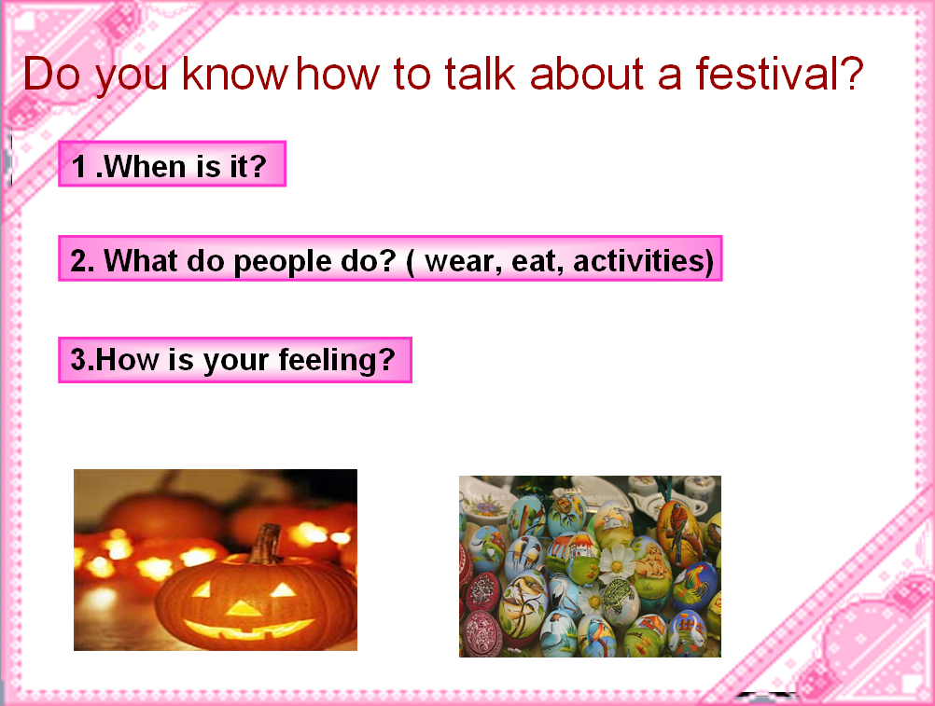
T:Ok, now write a festival. You can choose your favourite festival to describe.
(对于学习困难的学生，给予帮助，也可以参考教材，有能力的学生自己完成，使每一位学生都有所收获。)
Find 2 or 3 students to read their compositions.
Step 5 Summary and homework
a. Summary
T: What have you learned? Who can say?
学生根据板书，总结本课所学。
b. Homework.
必做：
1.M3单词抄写3遍，汉意1遍，功能句抄写1遍，M3单词，功能句听写一遍；
2. 复述M3两个节日
选做： Mid-Autumn Festival
Christmas任选一个描写。

