2013—2014学年度第一学期阶段质量检测
四 年 级 英 语
（ 本试卷共4页，满分105分。答卷时间：80分钟 ）
听力部分（共五大题，40分）
Ⅰ. 听音，圈出你所听到的单词。（每题1分，共8分）
1、A. Mexico B. Indian C. Chinese
2、A. friend B. food C. finished
3、A. cooked B. cleaned C. climbed
4、A. trip B. top C. traditional
5、A. raining B. ride C. running
6、A. cook B. cooked C. cooks
7、A. picture B. print C. painted
8、A. was B. were C. wide
Ⅱ.听音标号。用数字标出图片的先后顺序。（每题1.5分，共12分）
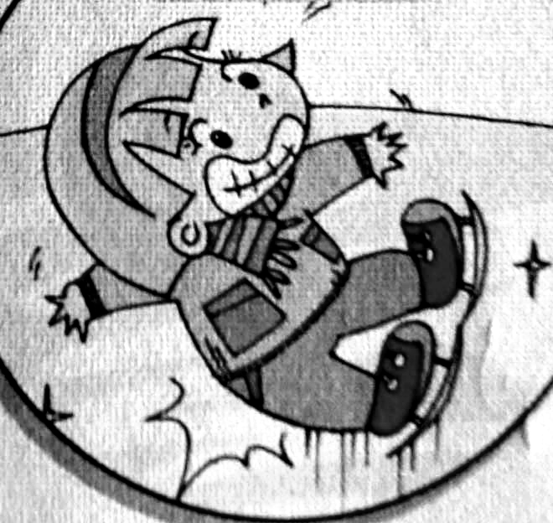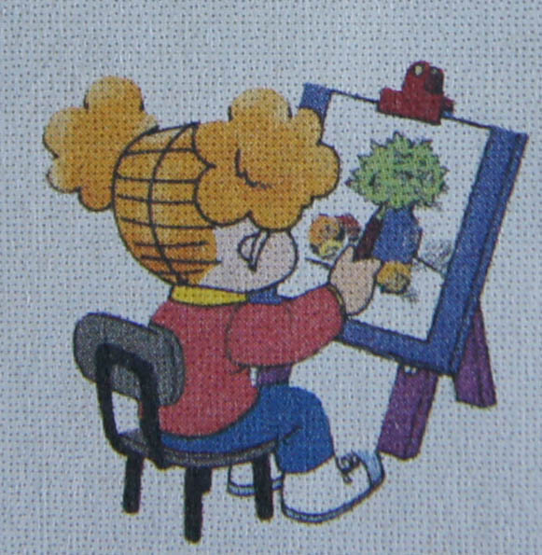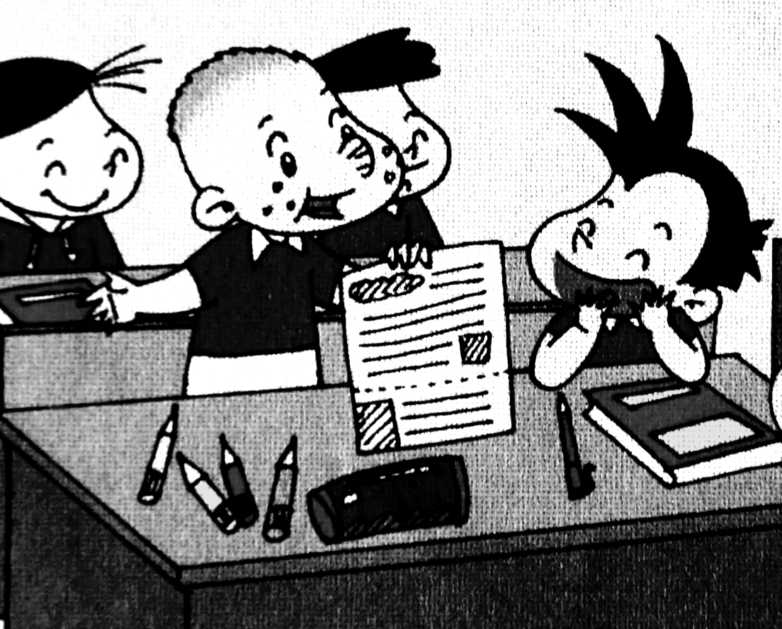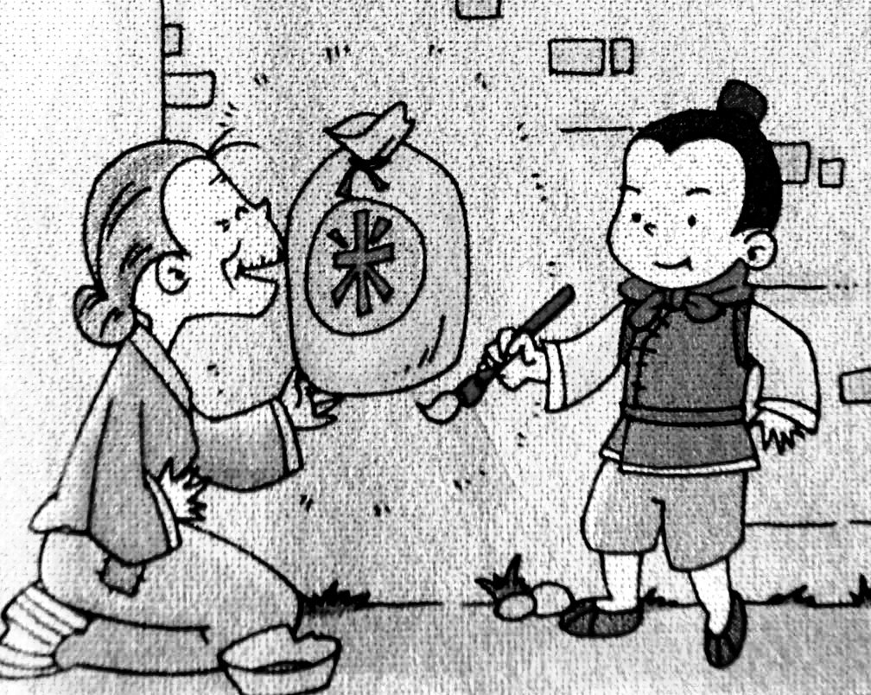
( ) ( ) ( ) ( )
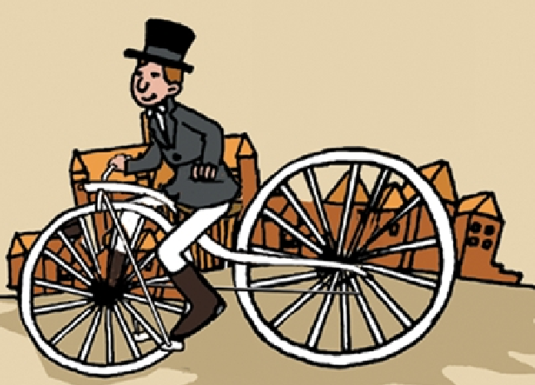
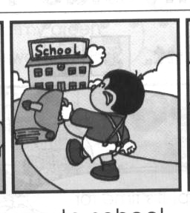
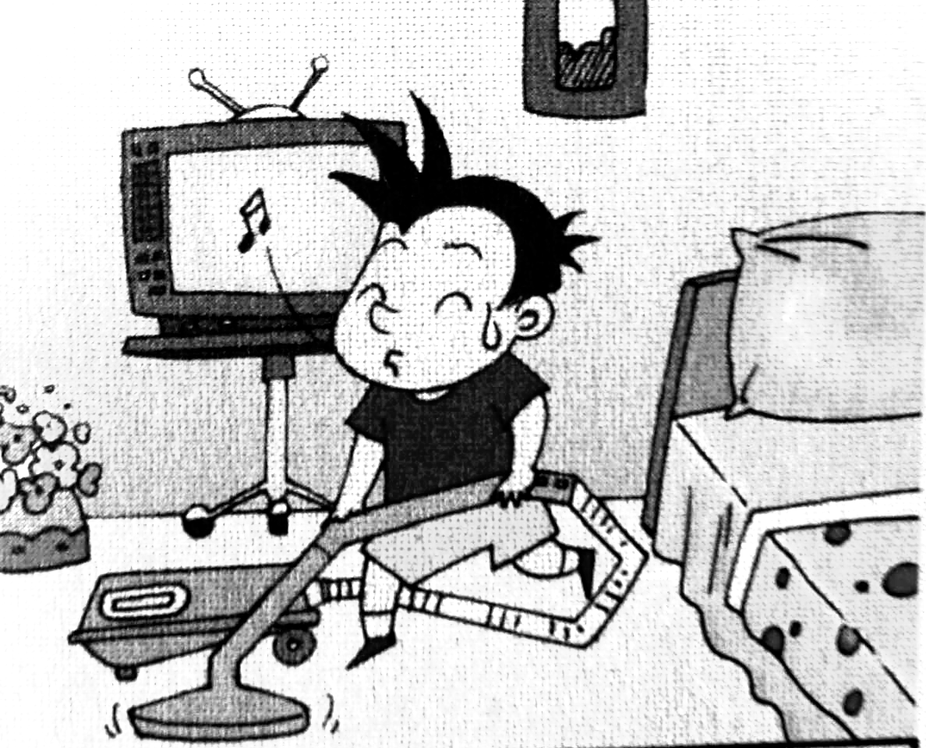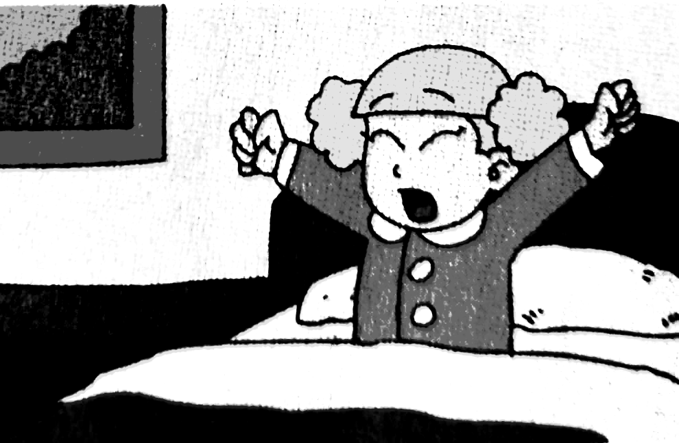
( ) ( ) ( ) ( )
Ⅲ. 听音判断。在正确选项前的括号内打“√”。（每题1分，共8分）
1、（ ）Zara has got a black, long hair . （ ）Zara has got a black, short hair .
2、（ ）Lucy lives in London . （ ）Lucy lives in New York .
3、（ ）Anita likes traditional Mexican food.
（ ）Indrani likes traditional Indian clothes.
4、（ ）Yesterday I cleaned my room. （ ）Yesterday I washed my trousers.
5、（ ）What is Mr. Smart doing? （ ）What did Mr. Smart do?
6、（ ）Lingling didn’t walk to school . （ ）Lingling walks to school.
7、（ ）She usually gets up at half past six. （ ）She didn’t get up at half past six.
8、（ ）Chinese people invented printing. （ ）English people invented bicycle.
Ⅳ. 听小对话，听问题选答案。将正确答案序号填在括号内。（每题1分，共6分）

( ) 1. Where did Tom go yesterday?
A. He went to the zoo. B. He went to the park.
( ) 2. What did Tom see?
A. A panda. B. A monkey.
( ) 3. What is Ma Liang like?
A. He is helpful. B. He is careful.
( ) 4. What time does Lily usually get up in the morning ?
A. At 6:00. B. At 6:30.
( ) 5. Where was Sam yesterday?
A. At home. B. At school.
( ) 6. What did Daming do yesterday?
A. He watched TV. B. He read a book.
Ⅴ. 听短文，根据内容判断正误。正确的写T,错误的写F。（每题1分，共6分）
( )1. Lingling usually gets up at 6:30.
( )2. She didn’t walk to school yesterday.
( )3. She learnt English and Maths yesterday.
( )4. Yesterday was National Day.
( )5. Lingling didn’t watch TV.
( )6. Lingling played with her toys.
笔试部分（共五大题，60分）
Ⅵ. 单项填空。将正确答案的序号填写在前面的括号里。（每题1分，共15分）
( ) 1. _____ Saturday we go to swim. A. In B. At C. On
( ) 2. My trousers ____ dirty, so I washed them. A. were B. was C. are
( ) 3. Where ____ your mother work? She worked in a shop.
A. do B. does C. did
( ) 4.Yesterday Maomao didn’t ____ to school. She ___ to the park.
A. go… went B. went…went C. go…goes
( ) 5. We ____ biscuits and _____ lots of mountains yesterday.
A. ate… see B. eat….see C. ate…saw
( ) 6. This letter is _______ Lucy. A. from B. of C. on
( ) 7. It ___my birthday on Monday. A. was B. are C. were
( ) 8. I will ________eight in April. A. am B. is C. be
( ) 9. I am wearing traditional ____ clothes. A .India B. india C. Indian
( ) 10. Yesterday I _____my trousers. A. wash B. washed C. washes
( ) 11. I learned to _______, But I _______ over many times.
A. skate…fall B. skate…fell C. skated…fell
( ) 12. This play(戏剧)was interesting. The men _____the women’s clothes.
A. wear B. wore C. wearing
( ) 13. What did you do yesterday? I ___________.
A. watch TV B. play football C. stayed at home
( ) 14. We went to the Great Wall. We had a good _______.
A. girl B. happy C. time
( ) 15. A: You are a good boy. Here are some sweets.
B: ______________.
- You’re welcome. B. Thank you. C. Ok!
Ⅶ. 词语运用(共12小题，共15分)
A. 选择方框中词语填空，使句子通顺连贯。（每题1分，共6分）
said, made, took, gold, away, angry

1. The bad man Ma Liang’s magic paintbrush.
2. He painted gold with the magic paintbrush. But it didn’t make .
3. It a snake.
4. The bad man was . The magic paintbrush didn’t help him.
5. He took Ma Liang .
6. “I want a big ship,” the bad man. “You paint it!”
B. 根据提示，用词汇的适当形式完成下列句子。（每题1.5分，共9分）
1. Chinese people invented p _ _ _ _（纸）.
2. Yesterday we went to the zoo and h_ _ （享受） a good time.
3. Where does she _ _ _ _(居住)? She lives in _ _ _ _ _ _.（伦敦）
4. I usually w_ _ _（走路）to school.
5. Did you go to the G_ _ _ _ W_ _ _(长城)?
Ⅷ. 句子理解。（共2大题，计15分）
A. 找出相对应的答句，将序号填入题前括号内。（每题1分，共6分）
( ) 1. What’s the matter? A. No, it didn’t.
( ) 2. What did they do yesterday? B. I’m reading a letter.
( ) 3. Where did you go yesterday? C. They climbed the mountain.
( ) 4. Did the paintbrush make gold? D. I hurt my knees.
( ) 5. How many biscuits did you eat? E. I went to the cinema.
( ) 6. What are you doing? F. I ate thirty biscuits.
B. 根据图文提示，完成下列句子。（1.2.4.5每题2分，第3题1分,共9分）
1. ---Where do you live? （长海）
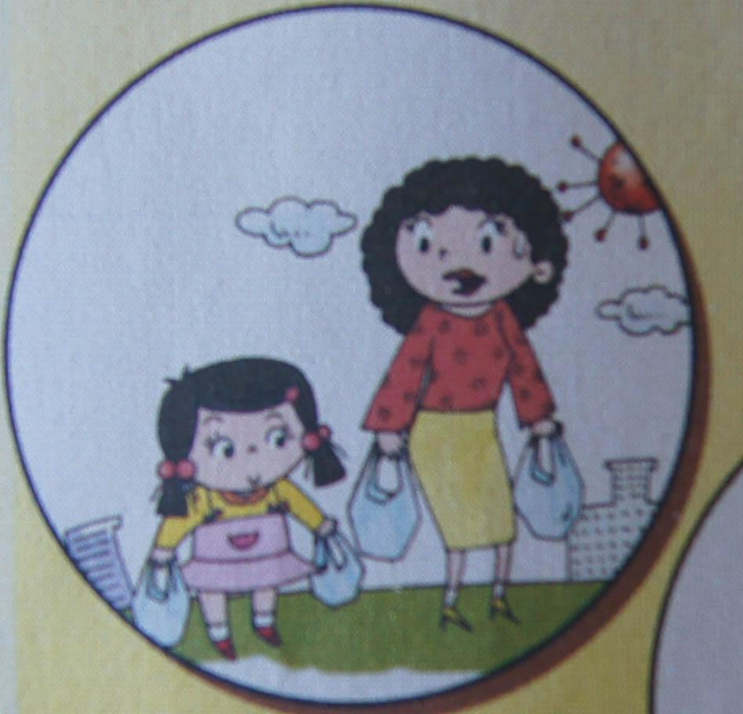
---__________________________________ .
2. ---Who did you help yesterday?
---__________________________________ .
3. It was raining. Daming didn’t _________________yesterday.
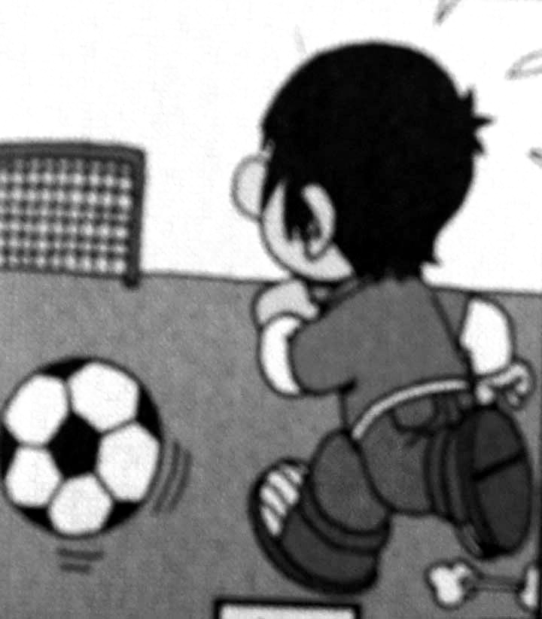
4. Where did you go last summer?
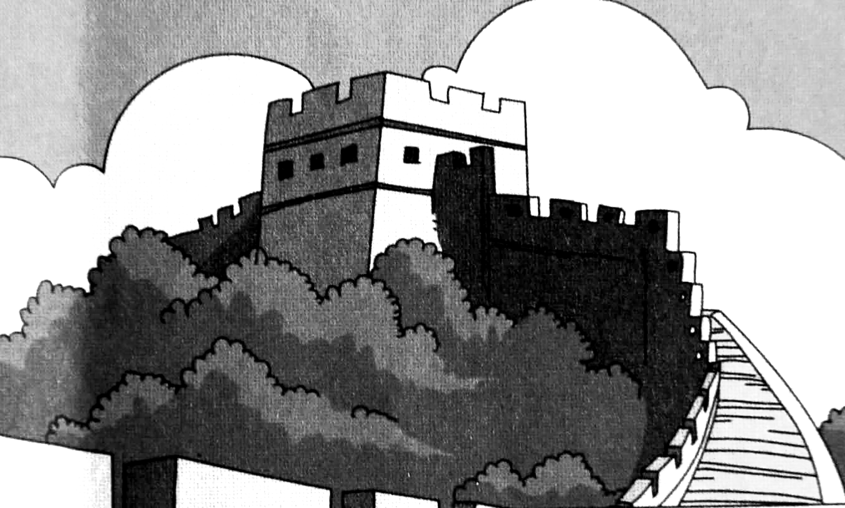
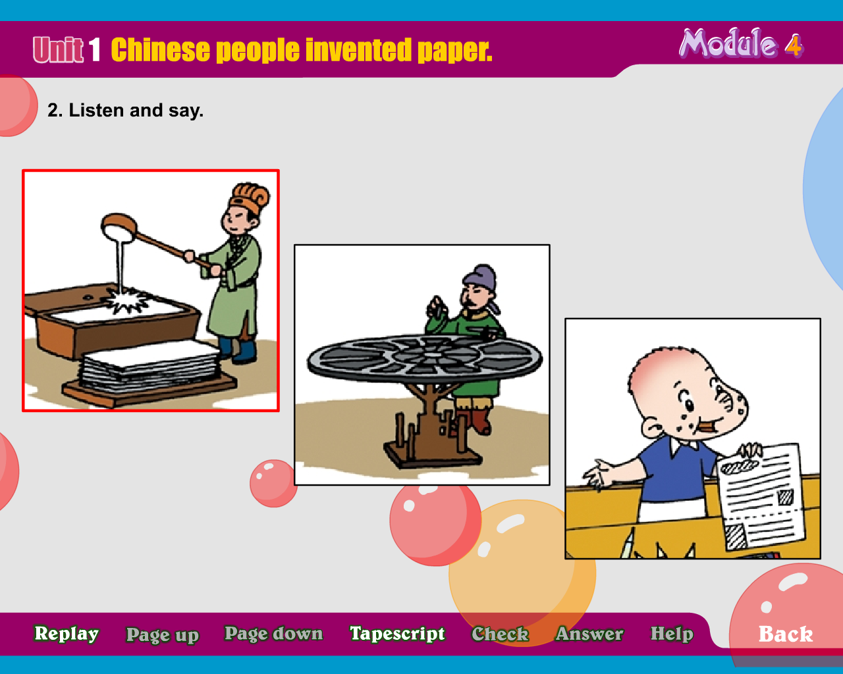
We _____________________________.
5. What did Chinese people invent?
______________________________
Ⅸ. 情景交际。选择答案的序号填写在空格处。(每题2分，共10分)
A. I went to the Big Black Mountain.（大黑山） B. What did you see?
C. I ate lots of apples and biscuits. D. What’s the matter?
E. So, you had a good time

Lily：Hi, Tom, Where did you go yesterday?
Tom: ________________________.
Lily: ?
Tom: I saw lots of big mountains and trees.
Lily: What did you eat?
Tom: .
Lily: .
Tom: Er, not very good.
Lily: ?
Tom: I’ve got a stomach ache. Because I ate lots of biscuits and apples.
Ⅹ. 短文阅读,判断正（T）、误（F）。（每题1分，共5分）
I have a new friend. His name is Mike. This is his photo. He is strong（强壮的）. He has short brown hair. He likes sports. Look, this is his new schoolbag. There are many books in it. Two story-books, three picture books, four English books, and one Chinese book. It’s very heavy.
( ) 1. Mike is my friend.
( ) 2. He has short black hair.
( ) 3. There are seven books in the schoolbag.
( ) 4. He has a heavy bag.
( ) 5. Mike likes painting.
附加题：5分 (第1-3题1分,第4题2分)
1、Children from ___________ are __________________ .
A. American…America B. China …English C. Russia… Russian
2、When is National Day ?
A. On the 1st of October B .On the 1st of June C. On the 25th of December
3、Who invented the paper ? A. Bell B. Cai Lun C. Bi Sheng

4、 A  B C 
Which flag(国旗) is Indian flag ?_________________

