长海县2012~2013第二学期期末质量检测
序号
四年级 英语 完成时间：60分钟
题号 | Ⅰ | Ⅱ | Ⅲ | Ⅳ | Ⅴ | Ⅵ | Ⅶ | Ⅷ | Ⅸ | Ⅹ | Ⅺ | Ⅻ | 总分
得分
听力部分（40分）
Ⅰ、听音,选出你所听到的单词，将其序号填入括号内。
（ ）1. A. silence B. special C. surprise
（ ）2. A. village B.language C. message
（ ）3. A. before B.bored C.back
（ ）4. A. south B. nervous C.space
（ ）5. A. grass B. leaves C. choose
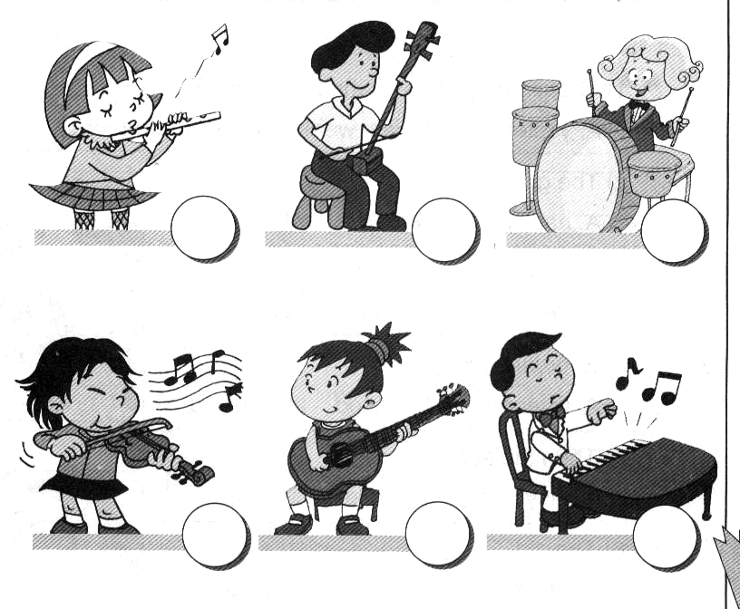
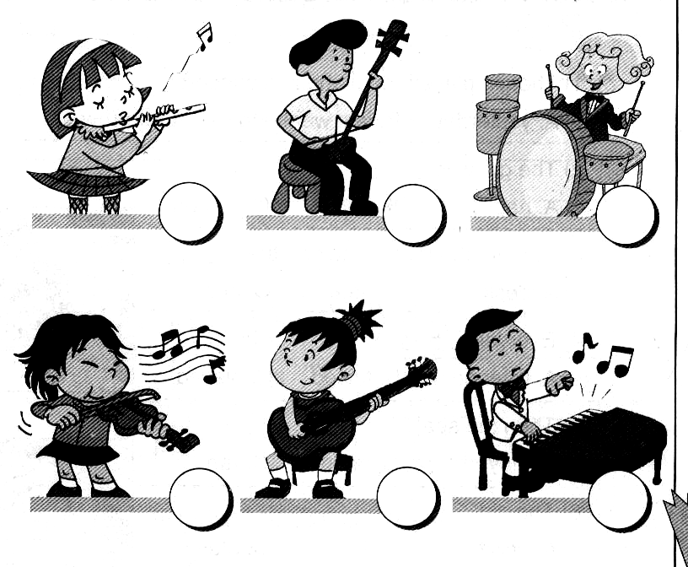
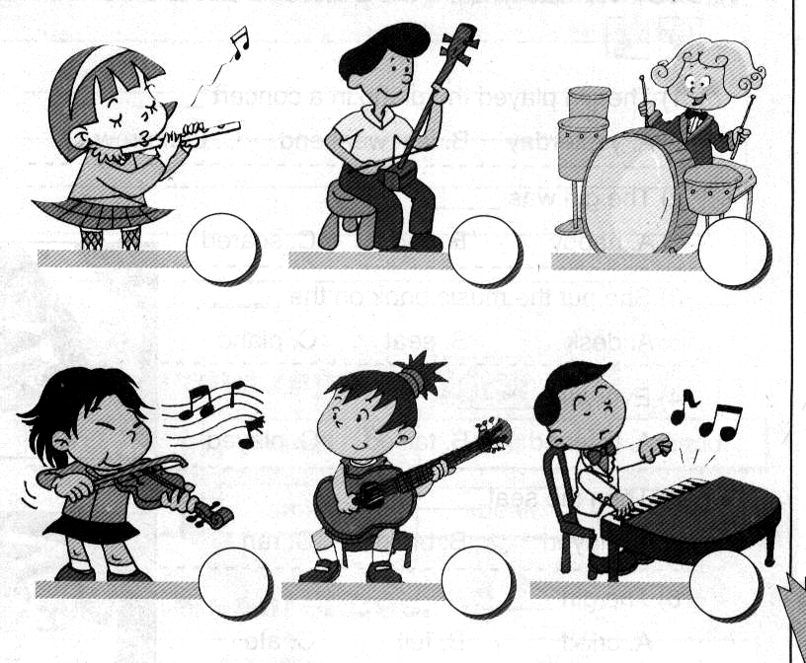
Ⅱ、听音,根据所听顺序用数字(1, 2, 3, 4, 5)给下列图片重新排序。

Ⅲ、听音，判断下列图片是否正确，正确打“√”，错误画“╳”。
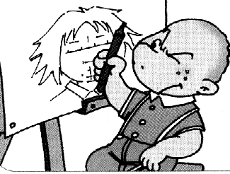
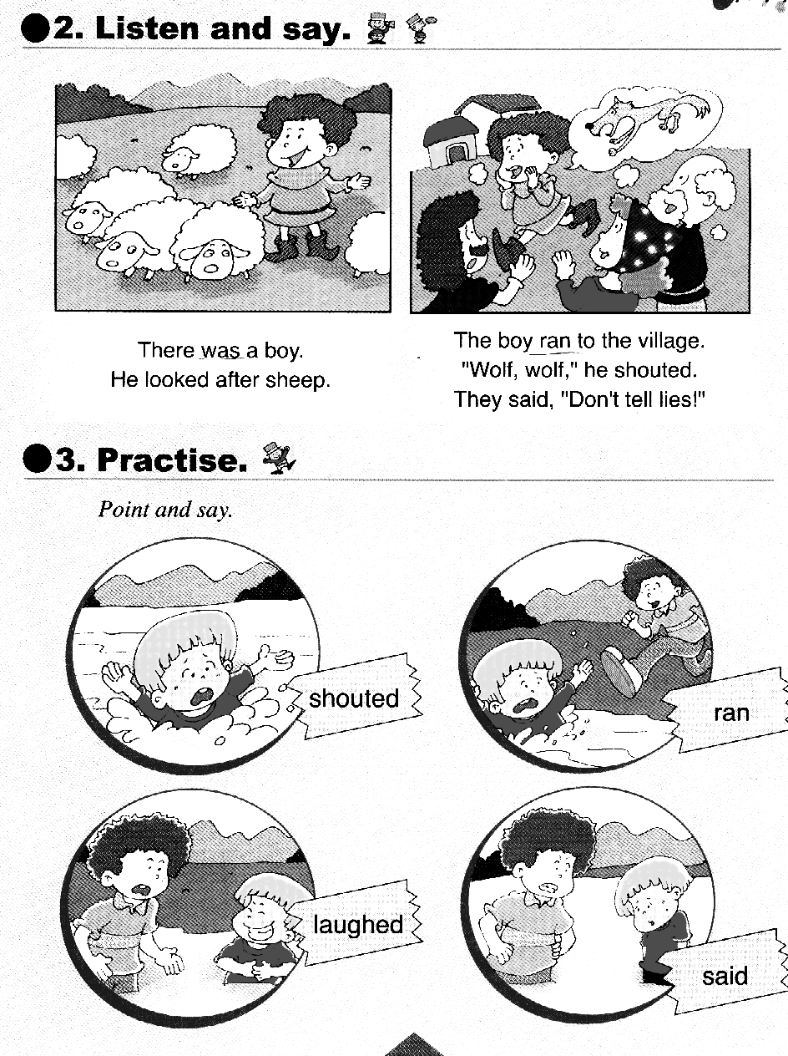
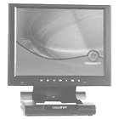
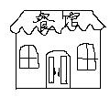
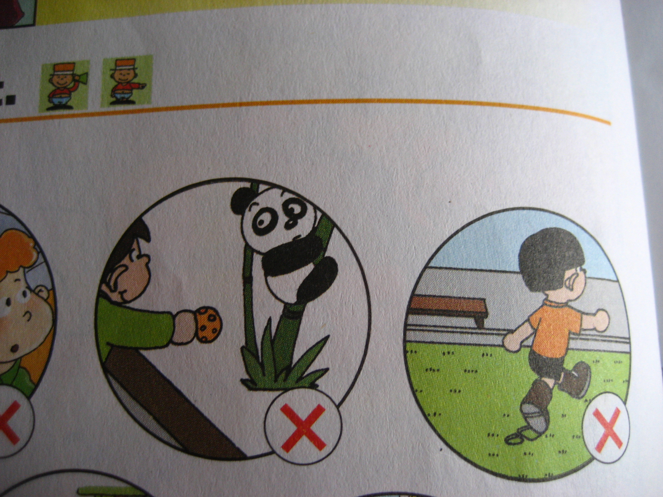

￥9800

1.（ ） 2.（ ） 3.（ ） 4.（ ） 5.（ ）
Ⅳ、听音，根据你所听到的问句，选择相应的答句。
（ ）1. A . No, I can’t. B. That’s a great idea!
（ ）2. A. Because I love pandas. B. I live in China.
（ ）3. A. I will go to the library. B. I went to a supermarket.
（ ）4. A. Some potatoes. B. Last year.
（ ）5. A. She’s clapping. B. She is going to London .
Ⅴ、听音，用数字（1，2，3，4，5）给下列句子重新排序。
（ ）Yesterday she went into a shop.
（ ）Tilly saw a cat. She was scared.
（ ）She bought some cheese. Then she ate the cheese.
（ ）Tilly broke the door and ran away.
（ ）Tilly was a mouse.

笔试部分（60分）
Ⅵ、请根据所给语境写出正确的单词。
1. Here’s a _________ (地图) of Australia. Let’s go to see kangaroos in zoos.
2. Then the boy in the river__________(喊) , “ Help , help! ”
3. It __________(价值为) six ___________ (千)yuan. It’s not ________(便宜).
4. Don’t ________ _________ (撒谎)！
5. This planet has got three ___________(光环) . It’s very beautiful.
6.Beijing is the _________（首都）of China.
7. I’m a good boy. My parents are very ____________(自豪的) of me.
Ⅶ、选择，将正确的答案写在题前的括号内。
（ ）1. It’s very hot. _________ the window, please!
A.Open B.Opened C.Opening
（ ）2. A: Do you like this car? B: No, it’s _________ .
A. beautiful B. expensive C. perfect
（ ）3. The wolf ate all the _________.
A.ship B. sleep C. sheep
（ ）4. ______ the end everyone clapped. I _______happy.
A. In / am B. on / were C. At / was
（ ）5. A:What’s __________now? B: Tom is singing.
A. happen B. happened C.happening

（ ）6. I’m good at English. I’ll _________ the reports.
A. writing B. write C. writes

（ ）7. This planet is _______ from the sun. It’s very cold.
A. near B.come C.far
（ ）8. Canada is ________ the north of America.
A. in B. to C. into
（ ）9. A: Why do you love koalas? B: ________ they are very cute.
A. Because B. So C. And
（ ）10. We’re going to ________ English food.
A. ate B. eat C.eating
Ⅷ、补全对话, 把正确的序号写在相应的横线上。
Amy: Hello! Bob!
Bob: ________________
Amy: Guess!________________
A、Here you are.
B、Is it the moon?
C、What’s this?
D、No, it isn’t.
E、Hi! Amy!
Bob: Is it a banana?
Amy: ___________ It’s round.
Bob: ___________
Amy: No, it isn’t. We can eat it.
Bob: Is it the moon cake?
Amy: Yes, it is. ___________
Bob: Thank you .

Ⅸ、根据问句选答句， 把正确的序号写在题前的括号内。
（ ）1、What did you do yesterday ? A. Yes, it was.
（ ）2、Was it Chinese music? B. We went to a concert.
（ ）3、What did Mum play? C. It looks like a violin.
（ ）4、What’s a pipa ? D. It looks like a guitar.
（ ）5、What’s an erhu? E. She played the pipa.

Ⅹ、根据语境，选择恰当的单词填写在横线上。
England , China , English , farm , postcard

Amy, Sam and Lingling are going to go to ____________. Lingling is going to speak ___________ every day.What about Daming ? Maybe he’ll visit his grandpa’s ____________ in the countryside. Sam and Amy will send Daming a ___________ from England. Daming will send them a postcard from ___________.
Ⅺ、连词成句。
1. play / don’t/ here / football（!）
2. went/ she / shop / the / into（.）
3. Amy / playing / piano/ is / the（.）
4. he / a/ draw / will / picture （.）
5. very / like / I / much / English （.）
Ⅻ、阅读理解。
Simon: Look. This country is China. My cousin Daming lives there.
He lives in the east of China.
Sam: Does he live in Xining?
Simon：No, he doesn’t. Xining is in the west of China.
Sam: Does he live in Shanghai? It’s in the east of China.
Simon: Yes, he does. I want to go to China one day.
Sam: Maybe you can visit your cousin.
Simon: Yes, maybe.
( )1. Daming is Simon's___________.
A. friend B. sister C. cousin
( )2. Daming lives in ______________.
A. England B.China C. America
( )3. A: Is Xining in the east of China? B:___________.
A. Yes B. No C. I don’t know.
( )4. Shanghai is in the ______________ of China.
A.east B.west C.north
( )5. Maybe ________ will go to China one day.
A.Daming B. Simon C.Sam

四年级英语听力题签：
注意：每道听力试题读二遍，听力时间控制在20分钟内。
Ⅰ、听音,选出你所听到的单词，将其序号填入括号内。
1.Silence!
2.He’s writing a message for his mother.
3. The day before yesterday was Sunday.
4. Don’t be nervous.
5. It’s difficult to choose these glasses.
Ⅱ、听音,根据所听顺序用数字(1, 2, 3, 4, 5)给下列图片重新排序。
We’re having a party now. Fangfang is playing the guitar. Tingting is playing the flute. Xiaoyong is playing the piano. Feifei is playing the violin. I’m playing the drums. We are very happy.

Ⅲ、听音，判断下列图片是否正确，正确打“√”，错误画“╳”。
1.This computer costs eight thousand nine hundred yuan.
2. Don’t feed the ducks! 3. The boy looked after pigs.
4. Here’s a restaurant. 5. Sam is painting a banana.

Ⅳ、听音，根据你所听到的问句，选择相应的答句。
1. Let’s make a newspaper . 2. Why do you like China ?
3. Where will you go tomorrow ? 4. When did he go there?
5. What’s Amy doing ?

Ⅴ、听音，用数字（1，2，3，4，5）给下列句子重新排序。
Tilly was a mouse. Yesterday she went into a shop. She bought some cheese. Then she ate the cheese. Tilly saw a cat. She was scared. Tilly broke the door and ran away.
听力部分到此结束！
四年级英语答案及评分标准：
听力部分
Ⅰ、(2×5＝10分) ACABC
Ⅱ、(1×5＝5分) 2--- 3 ---1--- 4 ---5
Ⅲ、(2×5＝10分) ╳ ╳ ╳ √ ╳
Ⅳ、(2×5＝10分) BAABA
Ⅴ、(1×5＝5分) 2---4---3---5---1

笔试部分
VI、(1×10＝10分)
map , shouted , costs , thousand , cheap , tell ，lies , rings , capital , proud
（备注：画有“—”黑体的部分各扣0.5分。其余每空单词必须拼写完全准确方可得1分。）
Ⅶ、(1×10＝10分) ABCCC BCBAB
Ⅷ、(2×5＝10分) ECDBA
Ⅸ、(1×5＝5分) BAEDC
Ⅹ、(1×5＝5分) England, English, farm, postcard, China
Ⅺ、(2×5＝10分) 答案略。
Ⅻ、(2×5＝10分) CBBAB

备注：卷面满分为100分。（听力40分，笔试60分。）
优秀：90---100
良好：80---89
及格：60---79
不及格：0---59

2013年7月8日

