长海县2012~2013第二学期期末质量检测
序号
三年级 英语 完成时间：60分钟
题号 | Ⅰ | Ⅱ | Ⅲ | Ⅳ | Ⅴ | Ⅵ | Ⅶ | Ⅷ | Ⅸ | Ⅹ | Ⅺ | Ⅻ | XIII | 总分
得分
听力部分（50分）
Ⅰ、听音,选出你所听到的单词，将其序号填入括号内。
（ ）1. A. vegetable B. helpful C. beautiful
（ ）2. A. say B. try C. high
（ ）3. A. fast B. fruit C. find
（ ）4. A. Tuesday B. Wednesday C. Thursday
（ ）5. A. ninety B. ninety-nine C. nineteen

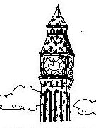
Ⅱ、听音,根据所听顺序用数字(1,2,3,4,5)给下列图片重新排序。

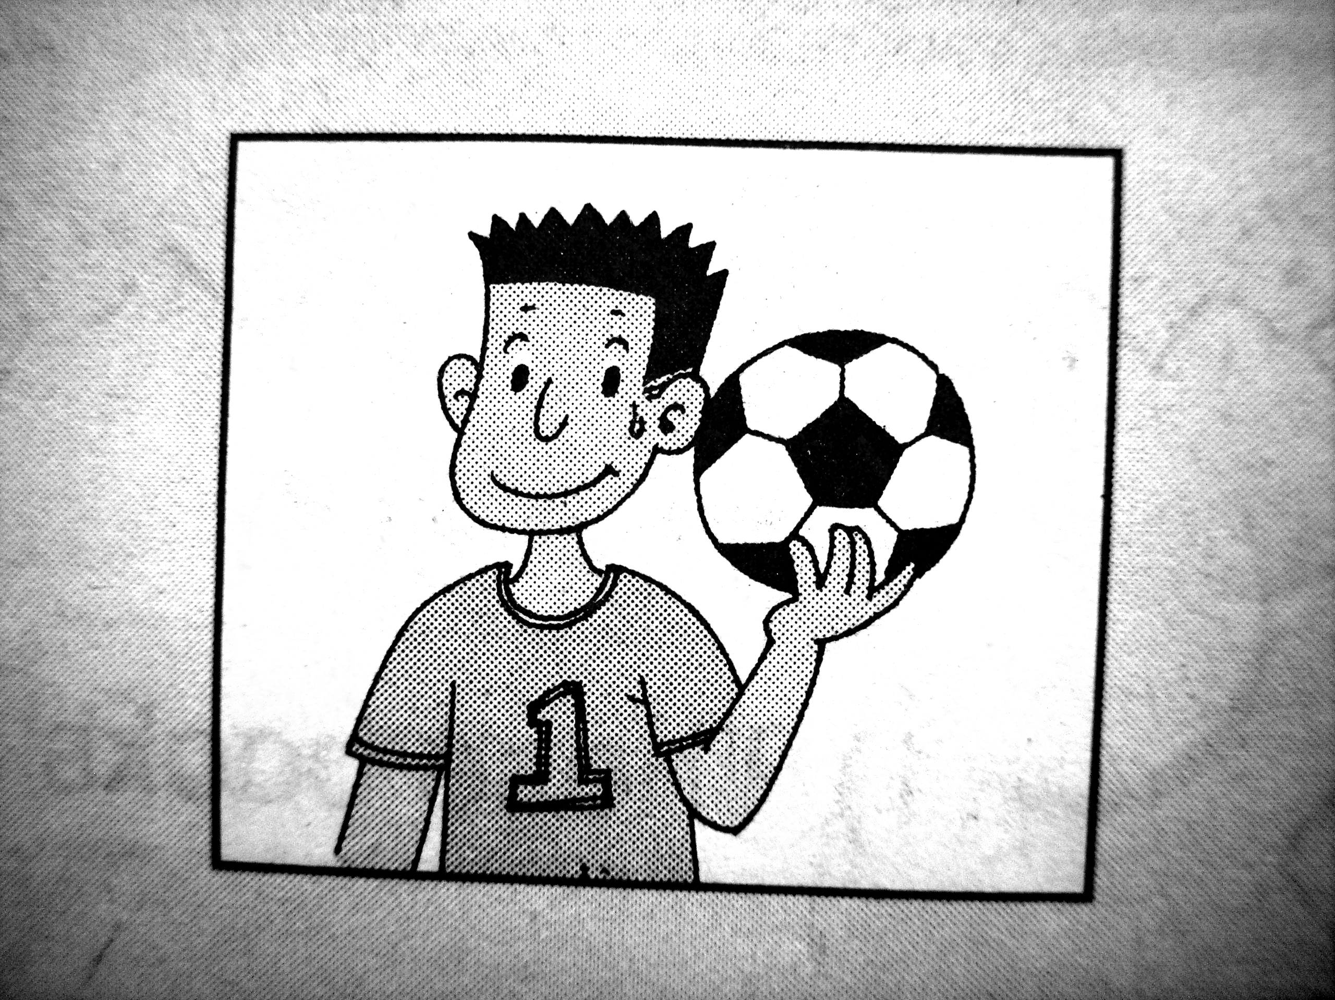
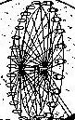
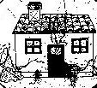

( ) ( ) ( ) ( ) ( )
Ⅲ、听音写数字。
School A | 30
School B

Ⅳ、听一听，选一选，勾一勾(√或ⅹ)。
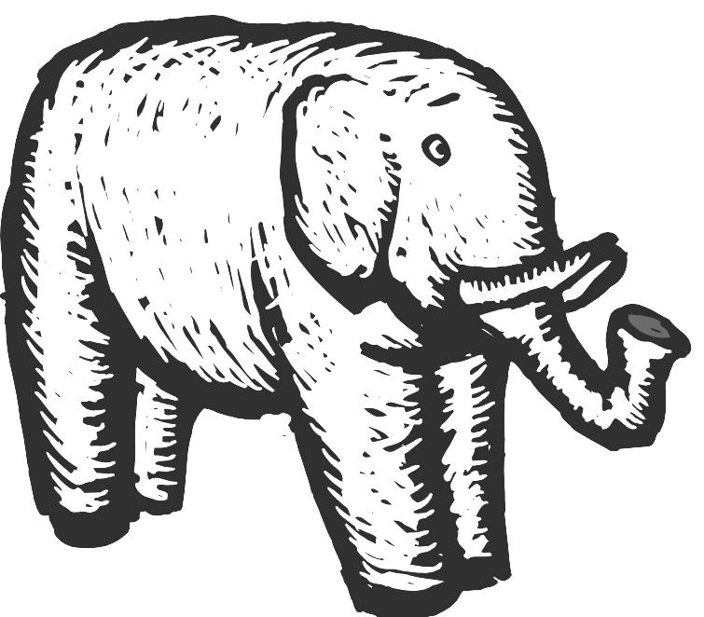

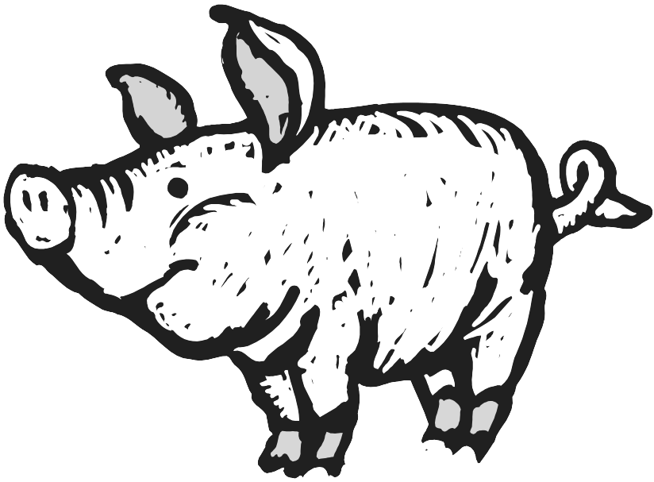


Ⅴ、听一听，连一连，填一填。
Report: Lingling
quite
good
very good
tries hard
Maths
English
Music
Science
not very good
Lingling is a _______ girl, she isn’t ___________ .
VI、听短文，完成下列表格。
-----What will they take to the picnic on Sunday?
A. basketball B. flute C. kite D. computer games
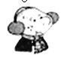 | 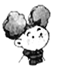 |  | 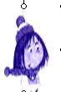
VII、听对话，判断正（√）误（ⅹ）。
( ) ①、Books were on the second floor.
( ) ②、Toys were on the first floor.
( ) ③、Fruit was on the first floor.
( ) ④、Milk was on the first floor.
( ) ⑤、Vegetables were on the second floor.
笔试部分（50分）
Ⅷ、请按顺序规范默写26个大小写英文字母。

Ⅸ、请根据所给语境写出正确的单词。
- I like ___________(牛奶) very much.
- He can sing , ___________(但是) he can’t swim.
- __________( 为什么) not go for a walk?
- This river is very__________(宽的) .
5. ___________ (桃子) are my favourite fruit .

Ⅹ、选择，将正确的答案写在题前的括号内。
（ ）1. We________ pick fruit this weekend.
A. are B. will C. were
（ ）2. I can ________ English.
A. speak B. hundred C. loud
（ ）3. A: ______________ B: I’m from China.
A. What day is after Sunday? B. Where are you from?
（ ）4. Mum and Amy ________in London yesterday.
A. was B. are C. were
（ ）5. Tomorrow I _________ go to school.
A. won’t B. don’t C. am not
Ⅺ、根据问句选答句， 把正确的序号写在题前的括号内。
( )1.Will you phone me ? A、No, he isn’t.
( )2. Is Daming naughty ? B、Yes, I will.
( )3. Was he there? C、No, he wasn’t.
( )4. What will you be ? D、There are forty.
( )5. How many boys? E、Maybe I’ll be a writer.
Ⅻ、根据语境，选择恰当的单词或短语填写在横线上。
plus ， lots of , who , them , work hard

- There are___________ books in the big bag.
2. We ___________ at English.
3. A: What’s ten ________ two? B: It’s twelve .
4. I’m going to help _________ .
5. A: __________is she? B: She’s Lingling .

XIII、阅读理解，根据短文内容判断正( T )误( F )。
I’m Linlin. I’m a quiet girl. I’m eight. I’m short and thin. Look at this photo, they’re my grandparents. They weren’t old then. They were very young. But now they are old. This is their dog. Its hair was short then. Now it’s long. And it’s cute.

( )1. Linlin is a girl and she’s 18.
( )2. Linlin is quiet.
( )3. Her grandparents are very young now.
( )4. They have got a cute dog.
( )5. The dog is short and thin.

三年级英语听力题签：
注意：每道听力试题读二遍，听力时间控制在25分钟内。
听力部分（50分）
Ⅰ、听音,选出你所听到的单词，将其序号填入括号内。
1. These flowers are beautiful.
2. What does it say?
3. I can’t find my pen .
4. Tomorrow is Thursday.
5. It’s ninety-nine.
Ⅱ、听音,根据所听顺序用数字(1,2,3,4,5)给下列图片重新排序。
1. This house is very old.
2. The London Eye goes round and round.
3. He’ll be a footballer in the future.
4. Big Ben is very tall. It’s a very old clock.
5. I’ll read some books. I won’t watch TV.
Ⅲ、听音写数字。
1.--- How many pears are there at School A?
---There are thirty.
2.---How many pears are there at School B?
--- There are fifteen.
3.--- How many apples are there at School A?
--- There are fifty apples.
4.--- How many apples are there at School B?
--- There are forty.

5.---How many peaches are there at School A?
---There are eighteen peaches.
6.--- How many peaches are there at School B?
--- There are twenty.
Ⅳ、听一听，选一选，勾一勾(√或ⅹ)。请把Amy在动物园里看到的动物用“√”勾出，没有看到的动物用“ⅹ”画出。
Amy will go to the zoo this weekend. She’ll see lions, tigers and pandas. But she won't see elephants. Because there aren’t elephants at the zoo. And she also won’t see pigs.
Ⅴ、听一听，连一连，填一填。
Lingling is quite good at English. She’s very good at Maths. She tries hard at Music. She is not very good at Science. Lingling is a nice girl. She isn’t shy.
VI、听短文，完成下列表格。（将其序号填入相应的方框内）
Hi，I’m Sam. On Sunday I am going to have a picnic with my friends. They are Amy, Daming and Lingling. Amy will take a kite to the picnic. Daming will take a basketball. Lingling will take her flute. And me? I will take my computer games. We will play together. And we will be very happy.
VII、听对话，判断正（√）误（ⅹ）。
A:－Where were the books?
B:－They were on the second floor.
A:—And the toys?
B:—They were on the second floor.
A:—And the fruit?
B:—It was on the first floor. And the milk was on the first floor, too.
A:—Were the vegetables on the second floor?
B:—No, they weren’t
听力部分到此结束！
三年级英语答案及评分标准：
听力部分
Ⅰ、(1×5＝5分) C A C C B
Ⅱ、(1×5＝5分) 3 1 4 5 2
Ⅲ、(2×5＝10分)
School A | 30 | 50 | 18
School B | 15 | 40 | 20

Ⅳ、(2×5＝10分) √ √ × × √
Ⅴ、(1×6＝6分)
quite
good
very good
tries hard
Maths
English
Music
Science
not very good
Lingling is a __nice__ girl, she isn’t __shy__ .（2个单词完全准确方可各得1分）

VI、(1×4＝4分)

D | C | A | B

Ⅶ、（2×5＝10分) ① √ ② × ③ √ ④ √ ⑤×
笔试部分
Ⅷ、5分
（备注：要求一律用手写体规范书写26个大小写英文字母，如果个别字母没变体就算错误，4个或4个以内字母合计0.5分，共52个字母合计5分，扣完为止！）
Ⅸ、(2×5＝10分) 1. milk 2. but 3. Why 4. wide 5. Peaches
（备注：画有“——”黑体的部分各扣0.5分。要求一律用手写体书写单词，如果个别字母没变，整体书写扣0.5分。）
Ⅹ、(2×5＝10分) BABCA
Ⅺ、(1×5＝5分) BACED
Ⅻ、(2×5＝10分)
1. lots of 2. work hard 3. plus 4. them 5. Who
（备注：画有“——”黑体的部分扣0.5分。要求一律用手写体书写单词，如果个别字母没变，整体书写扣0.5分。）
XIII、(2×5＝10分) F T F T F

备注：卷面满分为100分。（听力50分，笔试50分。）
优秀：90---100
良好：80---89
及格：60---79
不及格：0---59

2013年7月8日

