二年级下册练习
一、 读一读，选一选
( )1、______are you doing? I’m reading a book..
A.Where B.What C.How
( )2、We are playing_______games.
A.clap B. clapping C.claping
( )3、Daming is_____and Sam is seeking.
A. hideing B.hide C.hiding
( )4、I like_____in winter.
A.run B.running C.runing
( )5、What are you playing? We____playing five-stones.
A. am B. is C.are
( )6、On Sundays,I usually_____basketball.
A.play B.playing C.plays
( )7、My grandma usually______.
A.cooks B.cooking c.cook
( )8、Is Daming doing his homework?__________.
A.Yes,she is. B. Yes,he is. C.No,she isn’t.
( )9、Are you drinking?__________.
A. Yes,he is. B. Yes, you are. C.Yes, I am.
( )10、No one is playing____me.
A. for B.with C.on
二 、 根据图片判断句子是（V）否（X）正确
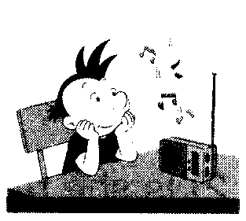
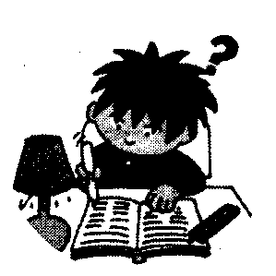
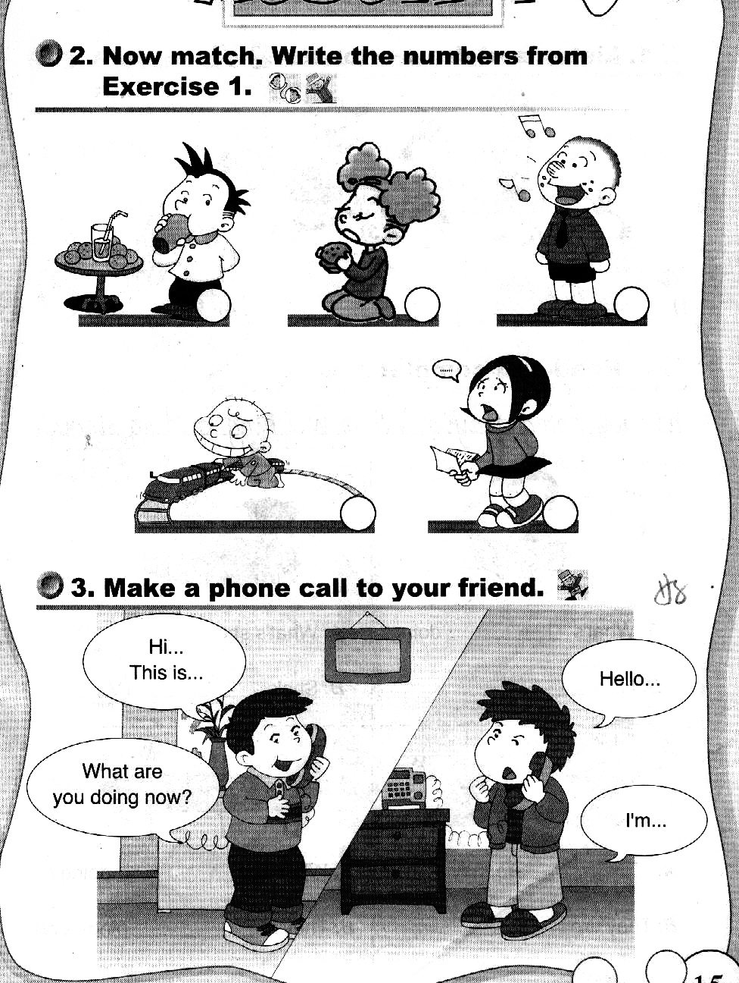
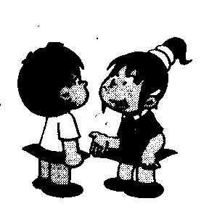
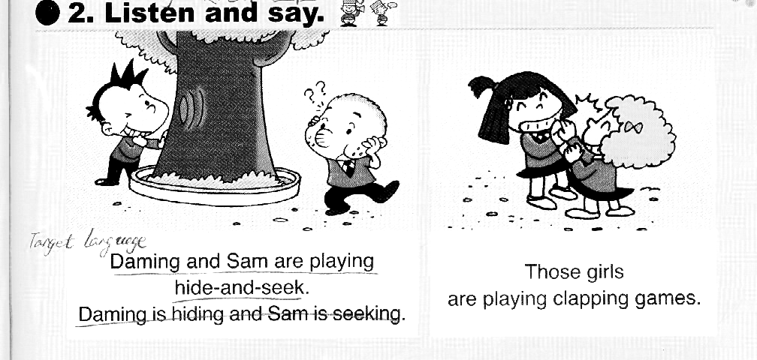

1、 He is listening to the radio.（ ）

2、Those girls are playing clapping games.（ ）

3、He is doing his homework. （ ）

4、He is playing with his train. （ ）

5、I’m talking to you.（ ）

三 、 根据语境选择单词，并抄写在横线上。
weather radio drawing doing tidying

- What are you doing?
I’m a picture of trees.
2. Sam isn’t his room.

3. What’s the like here in summer? It’s hot.

4. Are you your homework now ?
5. My mother is listening to the .

四、 看一看，连一连
- What are you doing? A.She’s listening to the radio.

- What’s she doing? B.They’re playing catch.

- Are you doing your homework? C.No,he isn’t.

- Is Daming doing his homework? D.Yes,I am.

5、What are they playing? E.I’m drawing a picture.

