长海县2012~2013第二学期阶段质量检测 （2013、5）
小学六年级英语 完成时间：80分钟
题号 | Ⅰ | Ⅱ | Ⅲ | Ⅳ | Ⅴ | Ⅵ | Ⅶ | Ⅷ | Ⅸ | Ⅹ | Ⅺ | Ⅻ | 总分
得分
听力部分( 30分)
Ⅰ、 听辨单词，选出你所听到的句子中的单词。
（ ）1. A. dancing B. drawing C. singing
（ ）2. A. around B. arrive C. travel
（ ）3. A. hurry B. hungry C. angry
（ ）4.A. sent B. cent C. send
（ ）5.A. what B. wet C.went

Ⅱ、听句子选图片，根据所听顺序将其序号填写在相应的横线上。
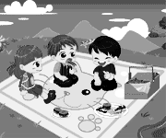
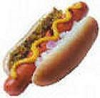
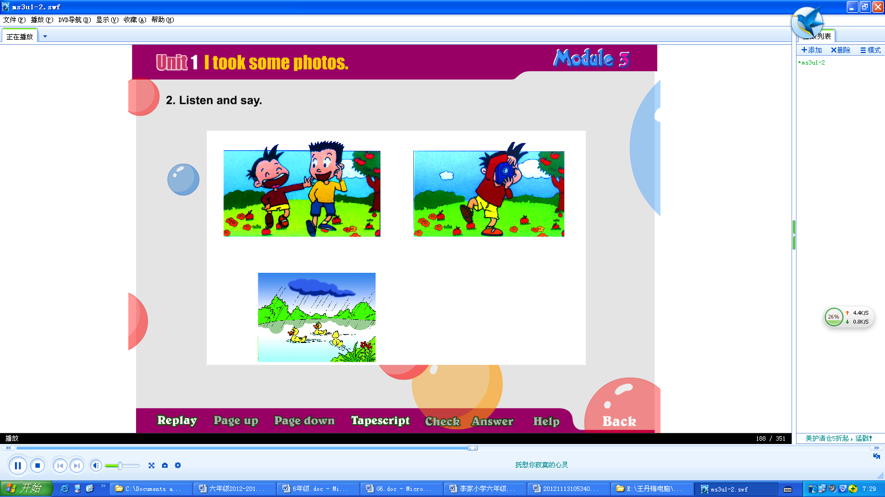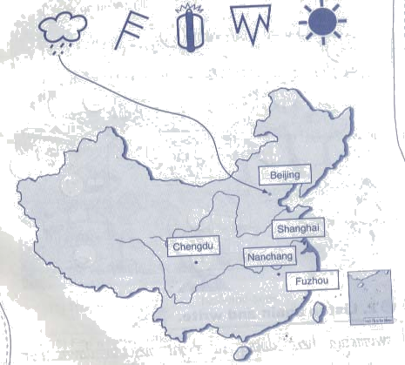
A B C D E

1._______ 2._______ 3._______ 4._______ 5._______

Ⅲ、听问句选答语，将序号填写在前面的括号里。

( ) 1. A. We’re going to eat at eleven. B. We’re going to eat eggs and sausages.
( ) 2. A. Yes, I did. B. Yes, I am.
( ) 3. A. I ate with my mum. B. I ate some sandwiches.
( ) 4. A. Sorry, I can’t. B. No, thank you.
( ) 5. A. It’s $ 3.75. B. There are seven.

Ⅳ、听短文，判断正误。正确写T, 错误写F。
( )1. We had a very funny day on Saturday.
( )2. We wanted to have a picnic.
( )3. We saw lots of birds there.
( )4. Some old people walked around the lake.
( )5. Some children read books under the tree.
笔试部分（70分）
Ⅴ、选择
( ) 1.It’s going to____ tomorrow.
A. rain B. raining C. rainy
( )2. There a big lake and there lots of ducks before.
A.is , are B.were, was C.was , were
( ) 3. Lingling will have American birthday this year.
A. a B. / C. an
( ) 4. I want some . .
A. soups B. soup C.soupes
( ) 5. The balloons are . They are in the sky.
A. flying away B.falling down. C. falling
( )6.---A：How is it ? ---B: It’s five yuan.
A. many B.much C.about
( )7. Now the dog is singing the trumpet.
A.in B.with C.and
( )8. Then we are going to under the tree.
A.ate B.eating C.eat
( )9. He is reading a book, but then his friend .
A.arriving B.arrives C.arrive
( ) 10. I bought a present you.
A.for B.at C.in
Ⅵ、根据意思把句子补充完整。
1.I want a （热狗）. It’s two______ .(美元)
2. The bags are heavy. I can’t （提）them all.
3. In this photo, the sun is ___________. ( 发光 )
4. She’s having a birthday_________ _. （聚会）
5. The oranges are falling down the ________. ( 楼梯)
6. We’re __ __ for the winners. (鼓掌)
7. We were hungry and （生气）with the ducks.
8.This book is about space____ （旅行）.
9.I’m ______（感兴趣的）in singing.
Ⅶ、情景反应, 请将序号填入题前的括号内。
( ) 1.Here’s your food .Enjoy your meal! A. At half past twelve.
( ) 2. What are the children doing? B. Thank you.
( ) 3. When are we going to eat? C. They are jumping in the water.
( ) 4.Where’s your mum? D. My grandpa gave it to me.
( ) 5. Who gave it to you? E. At the supermarket.
Ⅷ、用所给单词的正确形式填空
1. Daming and Simon ____ ___(make) a model ship now.
2. Look, the sky ________ (say) :”Happy birthday, Sam.”.
3. There __________ (be) a park here before.
4.I _________ (take)some apples to the picnic yesterday.
5. I can’t carry________ (they) all.
Ⅸ、按括号内的要求完成下列句子。
1．It’s thirteen dollars and twenty-five cents. (就划线部分提问)

2．She is doing her homework. A friend is coming. (用but then 连接)

3．I bought a book for you.( 同义句 )

4．going to, is , windy , be, it （? ） (连词成句)

5. flying , in , I’m ,the, sky （.）(连词成句)

X、情景交际，补全对话。请将序号填在横线上。
A. We are going to take some orange juice.
B. Amy and Jim.
C. We’re going to have a picnic.
D. At seven.
E. Where are we going to have our picnic?

Daming: What are we going to do this Sunday,Simon?
Simon:
Daming:Great!
Simon: In the park.
Daming:Who are we going to go with?
Simon:
Daming: When are we going to go?
Simon: We are going to take some food and fruits.
Daming:Are we going to take some drinks?
Simon:Of course.
Ⅺ、阅读理解。
判断，正确写“T”，错误写“F”。
（一）
Today is Sunday.It’s Daming’s birthday.Now Peter is standing on the chair.He is putting a birthday card on the wall.Daming is walking around the room.He’s putting the balloons everywhere.Simon is in the kitchen(厨房).He’s making a birthday cake for Daming.Amy is going out of the room.She’s going to the supermarket.She wants to buy some vegetables.Some other children are sitting on the sofa.They are watching TV.They are going to have a birthday party for Daming.How happy they are!
( ) 1.Peter is sitting on the chair.
( ) 2. Daming is making a birthday cake.
( ) 3. Simon is in the kitchen.
( )4. Amy is going to buy some vegetables.
( )5. The children are going to have a picnic.
选择最佳答案
（二）
Kate is a new student .She is twelve. She is from America. She can speak English very well and she can speak a little Chinese. Her parents are doctors.Kate is studying in a school near her home.She has classes from Monday to Friday.On Saturdays and Sundays,she often eats fast food in the K.F.C.She loves colas and hamburgers.She loves fries, too.
（ ）1．Kate is a ____________.
A. Chinese girl B. new student C.doctor
（ ）2．She can _________.
A.speak English well B. a lot of Chinese C. speak little English
（ ）3．Kate goes to school ________.
A. from Monday to Sunday B. on Saturdays and Sundays
C. from Monday to Friday
（ ）4．Kate loves to eat____________.
A.dumplings B.fast food C. noodles
（ ）5.Her parents ___________________.
A. are doctors B. are teachers C. have classes on Mondays
Ⅻ、书面表达。
六一儿童节就要到了，给你的朋友发一个email，告诉他/她你的节日打算。不少于5句话。问题提示：
What’s the weather going to be like?
Where are you going to go?
What are you going to do there?
What’s your feeling（感觉）?
Dear ，
The Children’s Day is coming.

From,

六年级英语听力题签:
※注意：每道听力试题读二遍。时间控制在20分钟以内。

Ⅰ、 听辨单词，选出你所听到的句子中的单词。
1. The birds are singing in the trees.
2. I like walking around the lake after dinner.
3. Mum is angry with my naughty cat.
4. It’s three dollars and seventy-five cents.
5. This shirt is wet.

Ⅱ、听句子选图片，根据所听顺序将其序号填写在相应的横线上。
1. It’s going to rain soon.
2. He took some photos in the park.
3. He’s reading but then the telephone rings.
4. We’re going to have a picnic this weekend.
5. I want a hot dog,please!

Ⅲ、听问句选答语，根据所听顺序将其序号填写在前面的括号里。
- When are you going to have lunch?
- Are you going to have an American birthday party?
- What did you eat for breakfast?
- Who can help me?
- How much is it?

Ⅳ、听短文，选择最佳答案。
We had a very funny day on Sunday. I went to a park with Lingling and her mum. We walked around the lake and saw the ducks there. There were lots of trees in the park. Under the trees, some old people played Chinese chess. Some children read books. We took some sandwiches and we wanted to have a picnic. Then it started to rain. We ran quickly under the tree.

听力部分到此结束！

六年级英语答案及评分标准：
听力部分（30分）
Ⅰ、(1×5＝5分) CACBB
Ⅱ、(1×5＝5分) C---A---E---B---D
Ⅲ、(2×5＝10分) ABBAA
Ⅳ、(2×5＝10分) F T F F T

笔试部分（70分）
Ⅴ、(1×10＝10分) ACCBA BBCBA

Ⅵ、(1×10空＝10分)
hot dog , dollars , carry , shining , party , stairs , clapping , angry, travel, interested
（注意 ：共计10个单词，其中画有“_”黑体的3个单词如果没有形式的变化将扣0.5分， 其余单词必须完全拼写准确方可得1分。）

Ⅶ、(2×5＝10分) BCAED

Ⅷ、(2×5＝10分) 答案略。

Ⅸ、(2×5＝10分)答案略。

Ⅹ、(1×5＝5分) CEBDA

XI、(1×10＝10分) F F T T F BACBA

XII、(5分) 答案略。
请任教六年级的英语老师批阅作文，并自行把握评分标准,做到心中有数。
一等：4----5分（主题鲜明，表述恰当，语言结构准确。）
二等：3分（主题较为鲜明，表述较为恰当，语言结构较为准确。）
三等：0-----2分（主题朦胧，语言表述不清，错词乱句，信息模糊。）

备注：卷面满分为100分。（听力30分，笔试70分。）
优秀：90---100
良好：80---89
及格：60---79
不及格：0---59

2013年5月

