长海县2012~2013第二学期阶段质量检测（2013、5）
小学五年级英语 完成时间：80分钟

听力部分（30分）
Ⅰ.听音，找出句子中含有的单词，将序号写在前面的括号内。（每题1分，共8分）
C. sandwiches
C. bag
C. for
C. driver
C. brown
C. glove
C. sent
C. Stonehenge
B. messages
B. back
B. from
B. drove
B. borrow
B. love
B. set
B. stones
( ) 1. A. sausages
( ) 2. A. black
( ) 3. A. of
( ) 4. A. drive
( ) 5. A. broken
( ) 6. A. solve
( ) 7. A. send
( ) 8. A. five stones


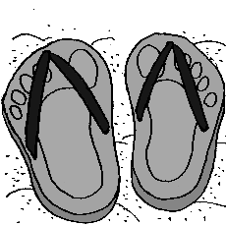

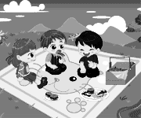
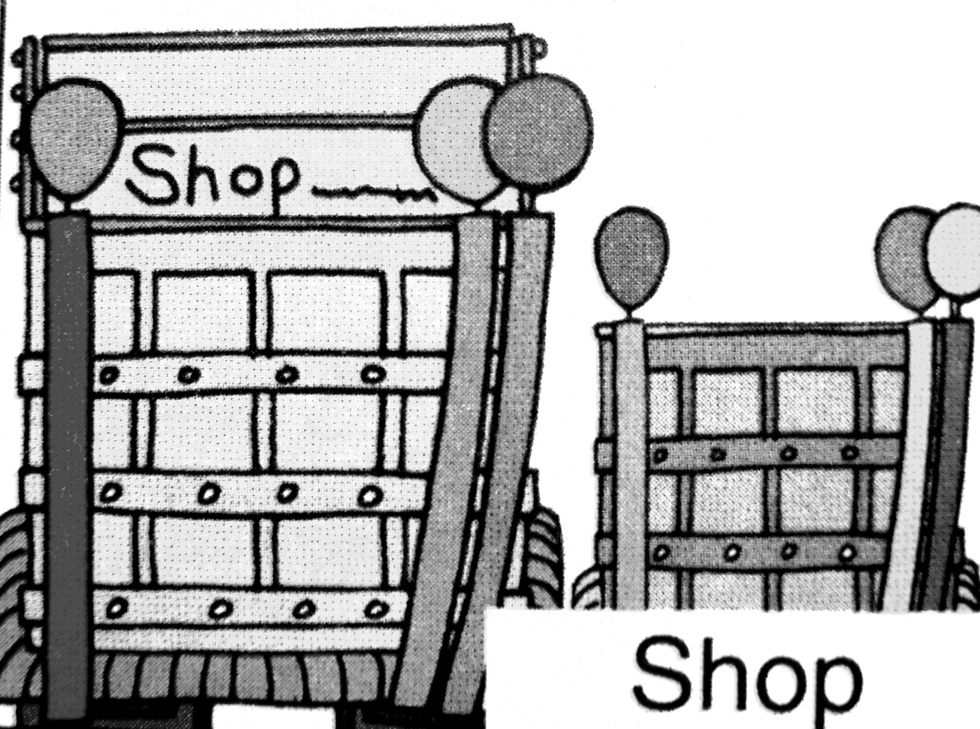
Ⅱ.听音，标号。用数字标出图片的先后顺序。（每题2分，共8分）

( ) ( ) ( ) ( )

Ⅲ.听问句，选答句。将正确答案序号填在括号内。 （每题1分，共8分）
（ ）2.

（ ）1.

A. He works in a shop.
B. He works in a hospital.
C. He worked in a hospital.

A. It’s a school.
B. It’s a library.
C. It’s a bookshop.

（ ）4.

（ ）3.

A. I can go swimming.
B. I can play with the snow.
C. I can play with the leaves.

A. It’s a traditional English dinner.
B. It’s delicious.
C. I like fish and chips.

（ ）5.

A. It’s nice.
B. It’s heavy.
C. It’s light.

（ ）6.

A. By car.
B. It will take two hours.
C. We’ll see lots of stones.

A. It’s mine.
B. It’s Amy’s.
C. My dress is blue.
A. I got it .
B. Yes, I have.
C. Yes, I did.

（ ）7.

（ ）8.

Ⅳ.听短文，判断正误。正确写“T”, 错误写“F”。（每题1分，共6分）
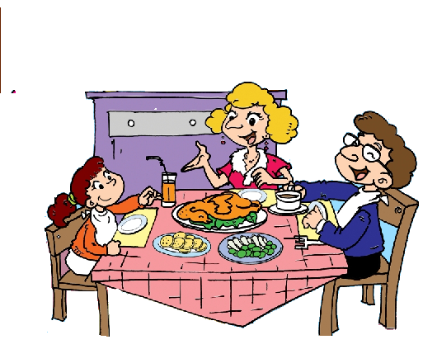
（ ）1. English people usually have breakfast at half past six.
（ ）2. Dinner is usually at seven o’clock.
（ ）3. English families usually eat dinner together on Sundays.
（ ）4. They eat chicken ,potatoes and vegetables for lunch on Sundays.
（ ）5. Many people eat fish on Fridays.
（ ）6. Saturday is special in England.
笔试部分（70分）
Ⅴ.单项选择。将正确的序号填写在前面的括号里。（每题1分，共10分）
( )1. I My school bag is red. I carry it ____ my hand. A. on B. over C. with
( )2. I carry my bag ____ my shoulder. A. with B. on C. over
( )3. I sent you a Maths game. Do you get____? A. it B. them C. us
( )4. In autumn, the leaves fall _____the trees. A. from B.of C. under
( )5. His bag is _____. He can’t take it to China. A. break B. broken C. nice
( )6. In winter, it’s cold. We can wear____and gloves. A. dress B. coats C. shorts
( )7. A: What did you have for lunch yesterday? B: I ______ noodles.
A. was B. had C. have
( )8. A: ______ did your uncle work? B: He worked in a shop.
A. Where B. When C. What
( )9. You ___ talk to your friends in the library. A. won’t B. don’t C. can’t
( )10. What ______ your grandpa before? A. was B. is C. were

Ⅵ.根据提示，用词汇的适当形式完成下列句子。（每空1分，共10分）
A. 用方块中所给单词或短语的适当形式填空。

in a circle return in an office chocolate send

1. Some stones are ____________. And some are on top of others.
2. Her mother works______________.
3. I ______ you American ___________. Did you eat them?
4.Please __________the books in a month, please!

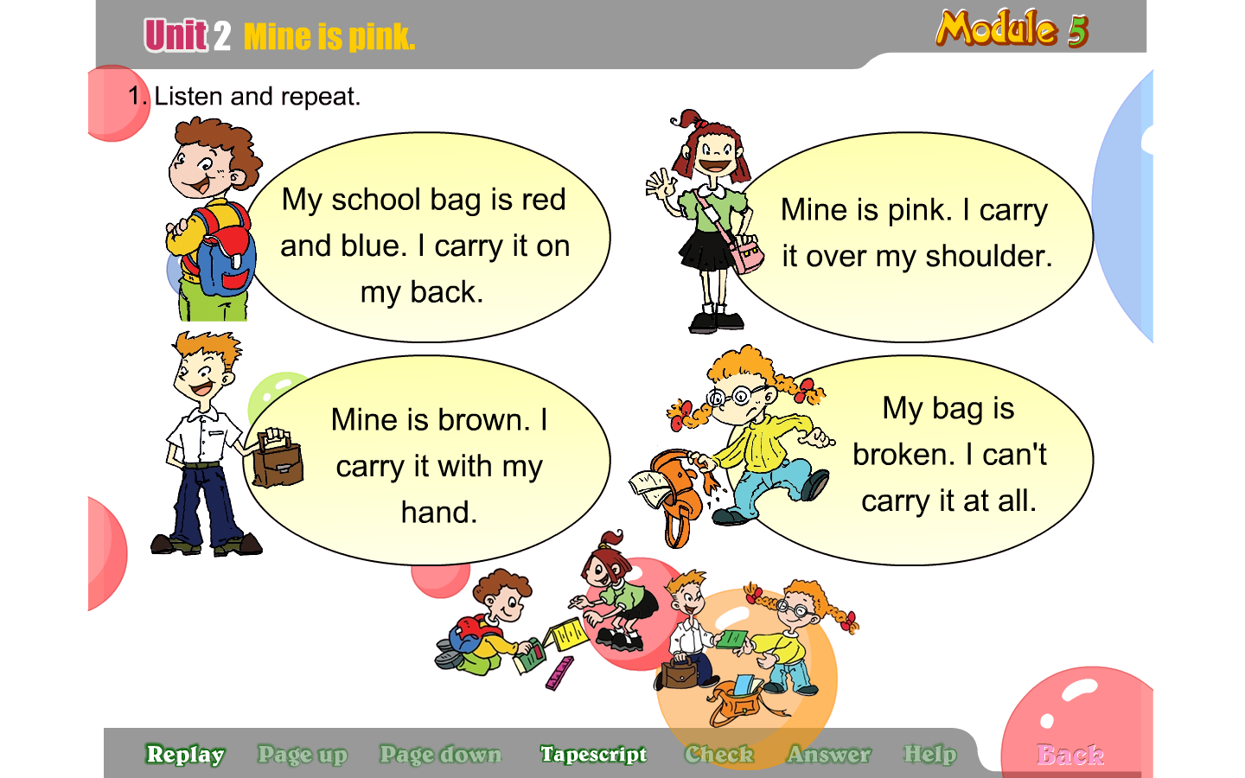
B. 根据句意或图片提示，写出单词的正确形式。（已经给出首字母）
1. You can b_________books, videos from the library.
2．I want to buy a new bag. I want to carry it over my s_________.
3. Summer is my favourite s___________. I can swim.
4. Last summer, I went to the Great Wall. It was a________.Why did people b_______it?

Ⅶ.句子理解。（共2大题，计15分）
A.找出相对应的答句，将序号填入题前括号内。（每题1分，共5分）
( ) 1. Do you like Chinese food, Amy? A. I’ll go to Beijing.
( ) 2. What will you do this summer? B. He has got a computer in his room.
( ) 3. What has he got in his room? C. She played Chinese music.
( ) 4. What music did your mother play? D. No. I didn’t.
( ) 5. Did you read This is London? E. Yes. It’s delicious.

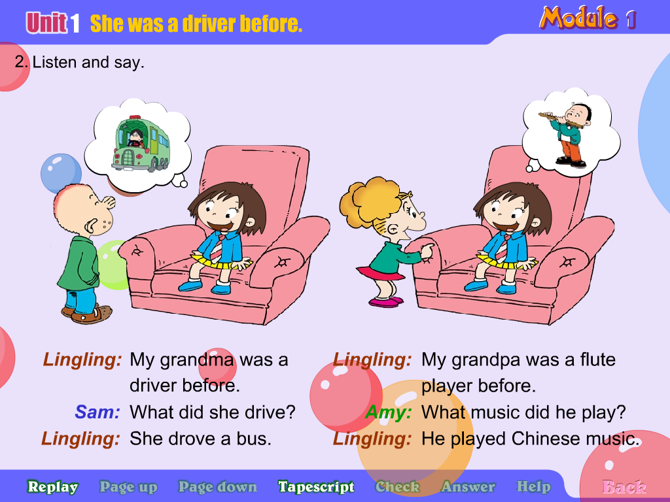
B.根据图文提示，写出句子。（每题2分，共10分）
1.
A：My grandma before.
B: What did she drive?
A: She .

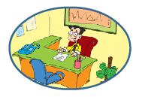
A: Where did he work?
B: .

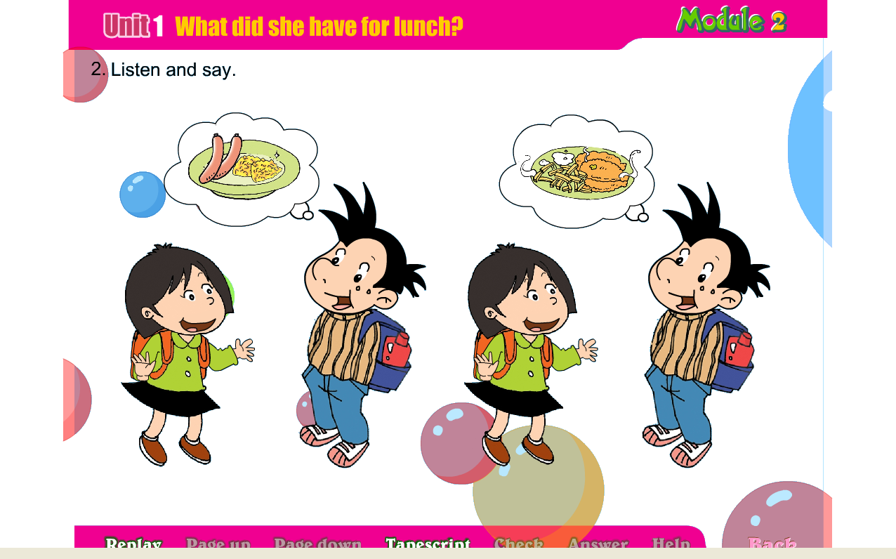
香肠
A：What did she have for lunch?
B: She .

A: What will you see?
B: ______________________________.

Ⅷ.情景交际。选择恰当的句子补全对话, 将序号写在横线上。（每题1分，共10分）
Part A:
A. Shall I go there with you? B. When are we going to go?
C. How will we get there? D. I’ll go to the Xinghai Park.

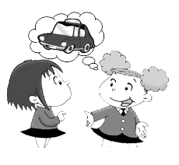
Lingling: Hi, Amy. What will you do this Saturday? Amy: I think __________
Lingling: That’s a great idea. ________________ Amy: All right.
Lingling: ________________ Amy: At 7 o’clock.
Lingling: ________________ Amy: By taxi. It will take half an hour.

Part B:
A. Excuse me. B. But we have got the books.
C. Thank you. D. I’ll look on the computer.
E. Where are they? F. Here you are.

Amy: _______________ Have you got the Snow White videos?
Librarian: _______________ Sorry, we haven’t got the videos. _______________
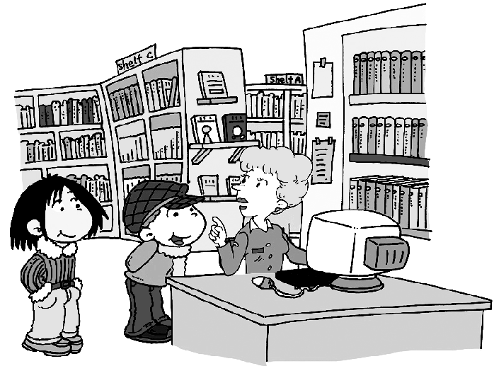
Amy: Oh good. _______________
Librarian: They’re on Shelf B.
Librarian: Your library card, please.
Amy: _______________
Librarian: Please return the books in a week.
Amy: OK! _______________
Librarian: You’re welcome! Goodbye!
Ⅸ.阅读理解。（每题2分，共20分）
A. 阅读短文，判断正误。正确写“T”，错误写“F”。
Today we went to the school library together. We wanted to borrow the Harry Potter videos. But they haven’t got the videos. They had Harry Potter books. We borrowed lots of Harry Potter books. Because Harry Potter is our favourite. We must read fast. Because we must return the books in two weeks.
1.There weren’t Harry Potter books at the library. ( )
2.We can keep the books for two weeks.( )
3.You can borrow lots of books in a bookshop.( )
4.You can’t talk to others at the library.( )
5.We can buy many books we need at the library.( )
B.选择正确的答案。
Yesterday Lucy was very sad, because her cat was in the tree. She called it again and again, but it couldn't get down. Peter was a good boy. He came there and asked Lucy, "What's wrong with you?" Lucy said, "Mimi can't get down from the tree. It's afraid. Look, it's there." "Don't worry, I can help you.” said Peter. Then he climbed up the tree. Mimi saw him and jumped down from the tree and ran away. Lucy was happy and ran after her cat. What about Peter? He was sad! Because he didn't know how to get down!
( ) 1. Lucy was yesterday. A. happy B. sad C. bored
( ) 2. Where was her cat? A. On the tree. B. In the tree. C. Under the tree.
( ) 3. Peter was a boy. A. good B. clever C. bad
( ) 4. Could Mimi jump down from tree?
A. No, it couldn't. B. Yes, it could. C. Yes, it couldn't.
( ) 5. Peter could help others, but he couldn't help himself. Yes or No?
A. Yes. B. No.
Ⅹ.书面表达。（本题共5分）
以Amy的名义给Sam发一封电子邮件，告诉他你儿童节的打算。30词左右。
问题提示：Where will you go? How will you get there? What will you see/do there?
Dear Sam,
_______________________________________________________________________________________________________________________________________________________________________________________________________________________________________
From,

听力材料：
五年级英语，听力部分，共四大题，每题读两遍。
Ⅰ.听音，找出句子中含有的单词，将序号写在前面的括号内。

五年级英语听力题签

Ⅰ.听音，找出句子中含有的单词，将序号写在前面的括号内。
No.1 We had bread and sausages this morning.
No.2 It’s so heavy. I carry it on my back.
No.3 What did you have for breakfast?
No.4 My grandpa drove a taxi before.
No.5 My school bag is brown, what about you?
No.6 Maybe you will solve the mystery someday?
No.7 I sent you an email. Did you get it?
No.8 Some stones are on top of others.

Ⅱ.听音,标号。用数字标出图片的先后顺序。
No.1 You can buy some fruits, food and clothes in a shop.
No.2 My bag is new. I carry it with my hand.
No.3 I love summer. I can wear shorts and sandals.
No.4 In spring, We can have a picnic in the park.

Ⅲ.听问句，选答句。将正确答案序号填在括号内。
No.1 --Amy, where do your parents work? --My mother works in a shop. My father works in a hospital. Q: Where does Amy’s father work?
No.2 You can buy books. But you can’t borrow books. Q: Where is it?
No.3—What’s you favourite season? –I love autumn. The leaves fall from the trees. I can play with them. Q: What can you do in autumn?
No.4 –What did you have for dinner? –I had fish and chips. –Fish and chips? –Yes. It’s a traditional English dinner. It’s delicious. I like it . Q: How is fish and chips?
No.5 –Oh! This bag is not easy for you. –Yes, I can’t carry it at all. Q: What’s the bag like?
No.6 –What are you going to do on Saturday? –We’re going to see Stonehenge by car. It will take three hours. But it will be amazing. Q: How will they get there?
No.7 Lingling, I sent you a present,did you get it?
No.8 –Amy, is it your dress? --No, Mine is blue. It’s Lingling’s. Q: Whose blue dress is it?
Ⅳ. 听短文，判断正误。正确写“T”, 错误写“F”。
In England, people usually have breakfast at seven o’clock. Lunch is usually at half past twelve. Dinner is usually at half past six. Sundays are special in England. Families usually eat lunch together.They eat chicken, potatoes and vegetables. On Fridays, many people eat fish.

