长海县2012~2013第二学期阶段质量检测 （2013、5）
小学四年级英语 完成时间：60分钟
题号 | Ⅰ | Ⅱ | Ⅲ | Ⅳ | Ⅴ | Ⅵ | Ⅶ | Ⅷ | Ⅸ | Ⅹ | Ⅺ | Ⅻ | 总分
得分
听力部分（40分）
Ⅰ、听音，选出你所听到的单词，将其序号填入括号内。（2’×5 ）
（ ）1、 A. choose B. cost c.cheap
（ ）2、 A. glasses B. grass c.great
（ ）3、 A. cap B. class c. clap
（ ）4、 A. potato B. perfect c.present
（ ）5、 A. special B.sheep c. surprise
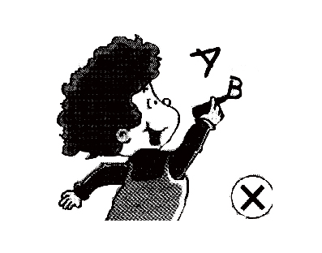
Ⅱ、听音，根据所听顺序用数字(1,2,3,4,5)给下列图片重新排序。（2’×5 ）
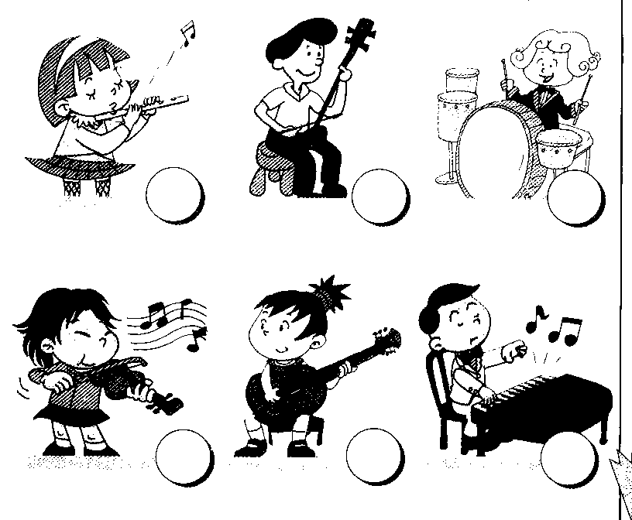
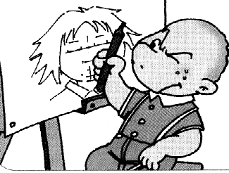

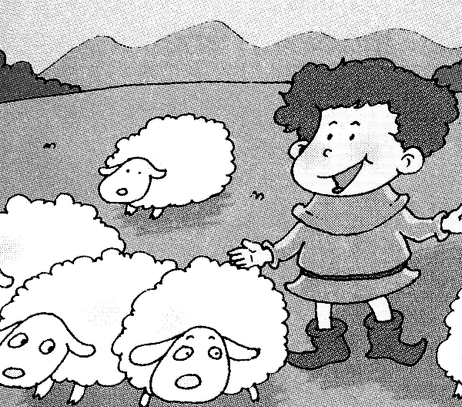

（ ） （ ） （ ） （ ） （ ）
Ⅲ、听音，选出你所听到的句子，并把序号写在题前的括号内。（2’×5 ）
（ ）1、A. Let’s have a class party this Saturday.
B. Let’s make an English newspaper.
（ ）2、A. This computer is beautiful. B. This is a beautiful computer.
（ ）3、A. Don’t touch anything! B. Don’t touch the machines,please!
（ ）4、A. What’s happening now? B. What are you doing now?
（ ）5、A. We were very nervous. B. I was very proud.

Ⅳ、根据听到的问句，选择正确的答语，将其序号填入括号内。（1’×5 ）
1.( ) A. She played the pipa. B. He played the erhu.
2.( ) A. We’re having a party. B. We had a party.
3.( ) A. Tom played the guitar. B. Tom is singing.
4.( ) A. I went there by plane B. I went there last year.
5.( ) A. Yes, it is. B. Yes, it was.
Ⅴ、听短文，连一连。（1’×5 ）
Amy playing the drums
Tom playing the piano
Sam singing a song
Daming playing the guitar
Lingling drawing a picture
笔试部分（60分）

Ⅵ、 选择填空，将序号填在括号里。（2’×5 ）
（ ）1、Let’s ____ a class party.
A. have B. had C. having
（ ）2、Sam and Amy __________ listening to music in the room
A. is B. are C. can
（ ）3、Don’t __________ball games here !
A. plays B. playing C. play
( ) 4、 Look! The boys are laughing and _______________.
A. claping B. clap C. clapping
( ) 5、I will ________ my room.
A. cleaned B. clean C. cleaning
( ) 6、 Let’s ______ in the park.
A. meet B. met C. meeting
( ) 7、 This computer is good _______computer games.
A. to B. for C. with
（ ）8、She ________ a shop yesterday.
A. go to B. is going C. went into
（ ）9、 A:_________ do you get up in the morning? B: At 6:30.
A. Where B. What C. When
（ ）10、 He broke the door and ___________away.
A. ran B. run C. running

Ⅶ、根据句意和汉语提示写出所缺单词。（2’×5 ）
1.Don’t feed the ____________ (鸭子)!

2.Wear the___________ (眼镜),it’s dangerous.

3. The boy looked after ______________ (绵羊).

4. She was very nervous ____________（在……之前）the concert.

5. Don’t walk on the ____________ (草，草地)！

Ⅷ、根据语境用“——”画出句中正确的单词。（1’×5 ）
1. (Touch / Don’t touch) the machine, it’s dangerous!
2. This computer is small and powerful.It’s（perfect / big ）.
3. It costs two ( thousand / thousands )eight hundred yuan .
4. I’ll draw the pictures,I’m good at( English/ Art ).
5. At the end everyone clapped . I was very（ proud / nervous ）.

Ⅸ、情景反应，将序号写在前面的括号里。 （2’×5 ）
（ ）1、What did he play? A. Yes,I am.
（ ）2、Are you painting a picture? B. That’s great idea!
（ ）3、What will you do? C. He played the violin.
（ ）4、Let’s have a picnic this weekend! D. I’m making a cake.
（ ）5、What are you doing? E. I’ll write the reports.
Ⅹ、连词成句。（2’×5 ）
1. played / erhu / Dad / the（.）

2. are / having / party / a / we / (. )
___________________________________
3．will / draw / I / the / pictures ( . )
_______________________________ _
4. now / is / happening / what ( ? )
_______________________________ ____
- feed / the / don’t / ducks ( ! )
_____________________________________

Ⅺ、根据语境选词填空, 将序号填写在下面的横线上。（1’×5 ）
reports stick newspaper fantastic cut make

Daming ,Lingling, Sam and Amy are ging to________an English ____ about their school. Daming will draw the pictures. Amy will write the _____ .Sam will the paper. Lingling will the newspaper together. Their English newspaper will be very ___ .
Ⅻ、阅读理解,判断正误,正确的写“T”,错误的写“F”。（2’×5 ）
Last Saturday,Tom,Lili and I went to the park.We saw some flowers,trees and ducks.We wanted to feed the ducks.But the ducks didn’t eat the food.We were sad（难过的）.Then Tom played the flute ,Lili played the guitar,and I played the drum.The ducks danced on the grass.They were happy. We were happy,too.
( )1、We went to a zoo.

( )2、We saw some flowers,trees and birds.

( )3、The ducks ate the food.

( )4、Tom played the flute.

( )5、Lili played the drum.
四年级英语听力题签:
※注意：每道听力试题读二遍。时间控制在20分钟以内。

Ⅰ、听音，选出你所听到的单词，将其序号填入括号内。
1、It’s difficult to choose. 2、Don’t walk on the grass!
3、Let’s clap for her. 4、This TV is beautiful,it’s perfect.
5、I will give you a special present.
Ⅱ、听音，根据所听顺序用数字(1,2,3,4,5)给下列图片重新排序。
1、There was a boy ,he looked after sheep.
2、This computer is powerful.
3、Dad played the erhu.
4、He is painting a picture.
5、Don’t write on the wall!

Ⅲ、听音，选出你所听到的句子，并把序号写在题前的括号内。
1、Let’s have a class party this Saturday.
2、This computer is beautiful.
3、Don’t touch the machines,please!
4、What’s happening now?
5、I was very proud.
Ⅳ、根据听到的问句，选择正确的答语，将其序号填入括号内。
1、What did he play?
2、What are you doing?
3、What’s happening now?
4、When did you go there?
5、Is it Chinese music?

Ⅴ、听短文，连一连。
It’s Mother’s Day today. The children are very happy. Amy is playing the piano. Tom is singing a song. Sam is playing the drums. Daming is drawing a picture for his mother. And what’s Lingling doing? Oh, she’s playing the guitar.

听力部分到此结束！

