长海县2012-2013第二学期阶段质量检测（2013、5）
小学三年级英语 检测时间：60分钟
听力部分（40分）
Ⅰ、听音圈出所听到的单词（1×6=6分）
1．from more 2. clever naughty
3. cry shy 4. wheel where
5. lazy loud 6. driver writer

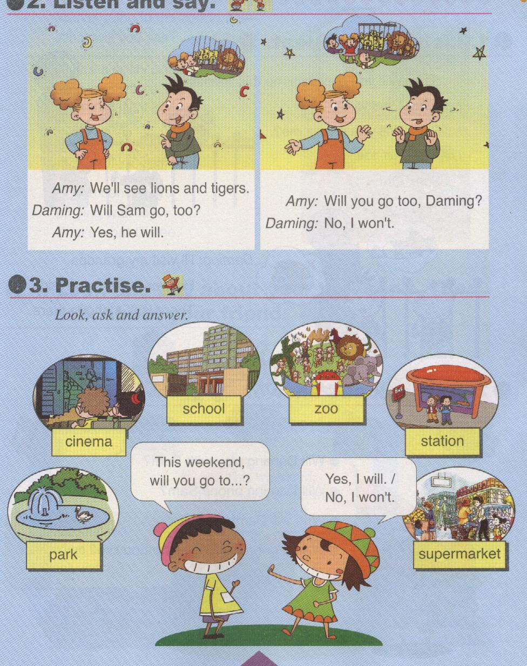
Ⅱ、听音选择正确的图片（2×5=10分）
( )1. A B. C.

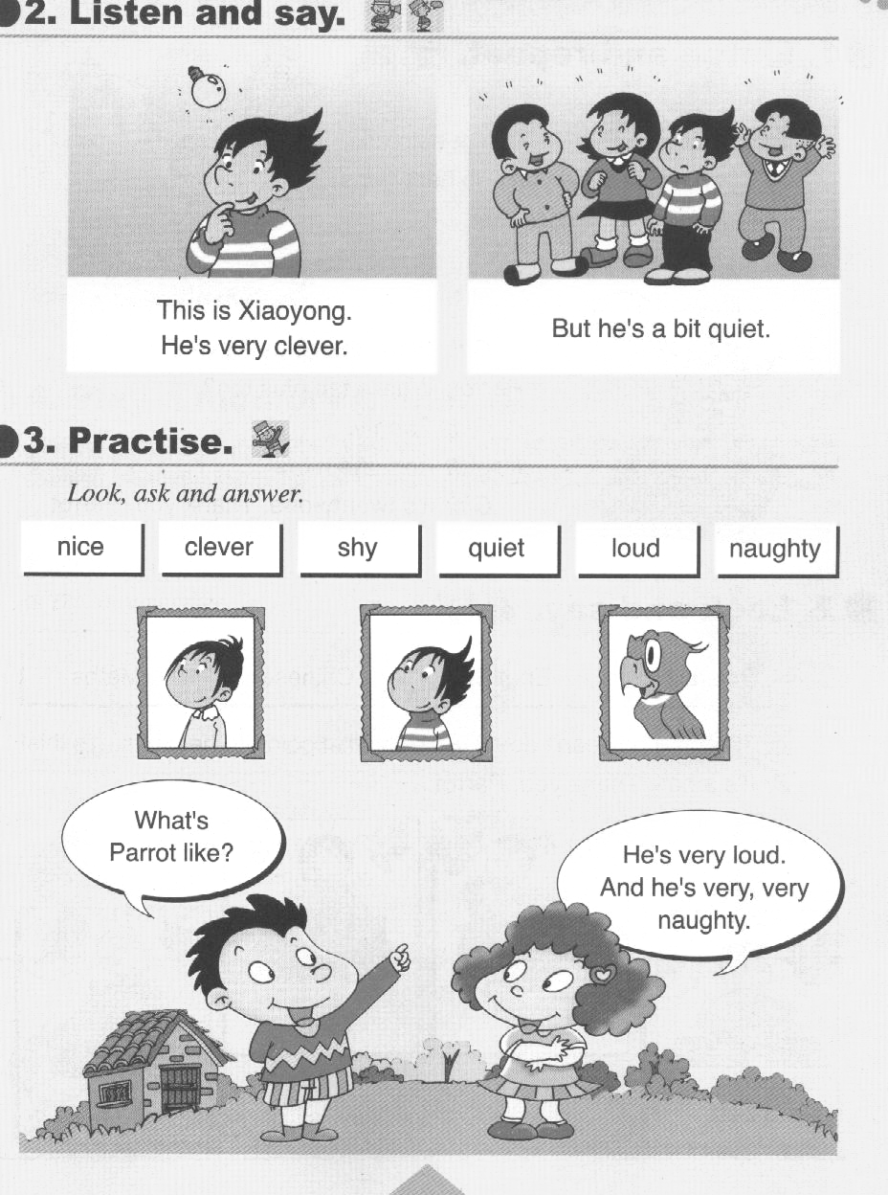
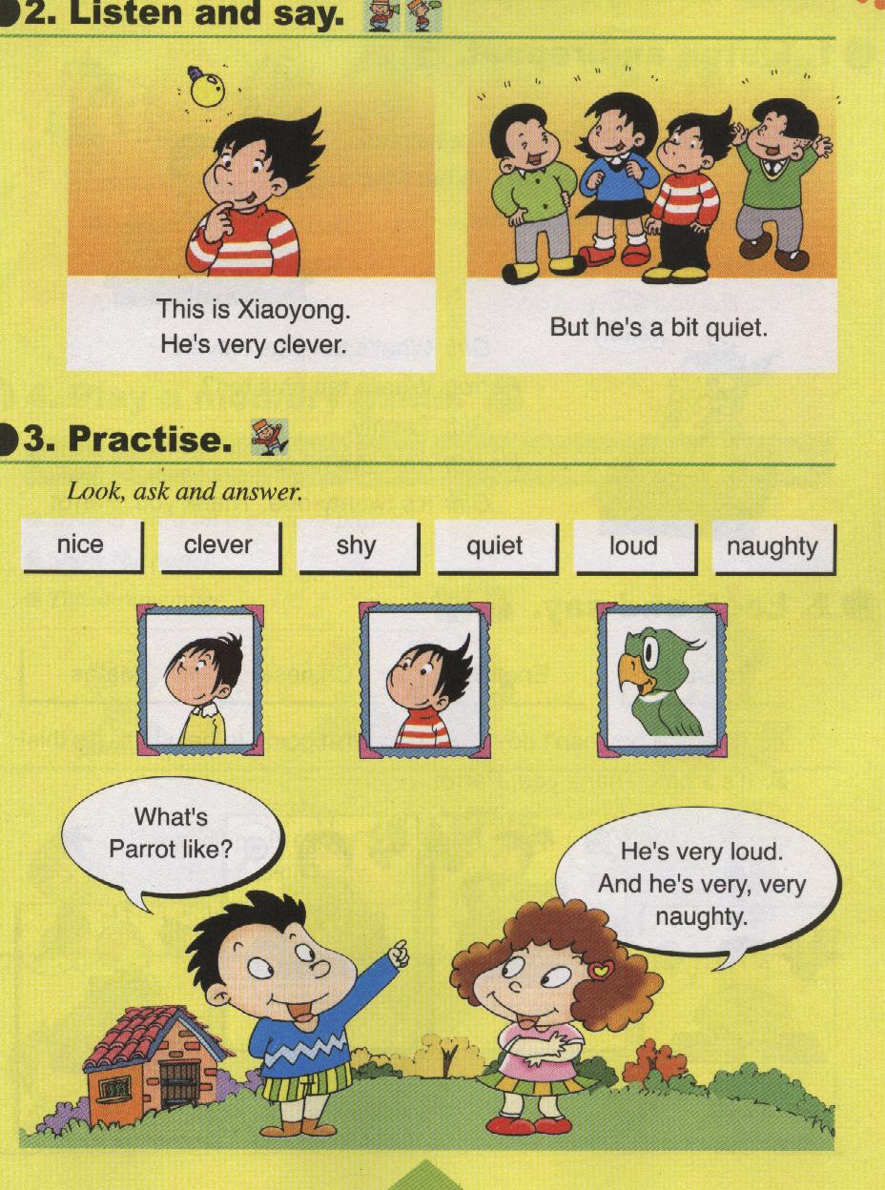
( )2.A . B. C.

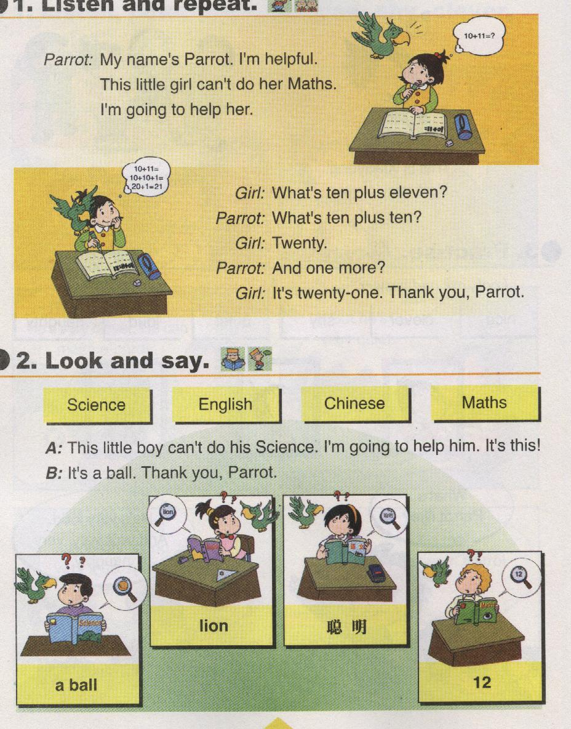

( )3.A B. C.

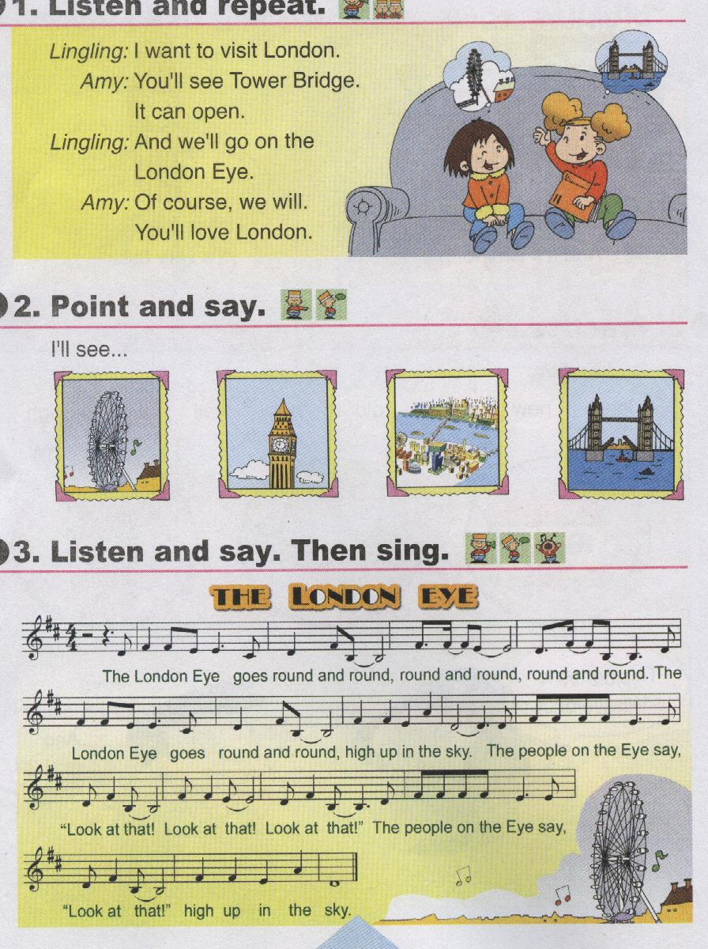
( ) 4. A B C.

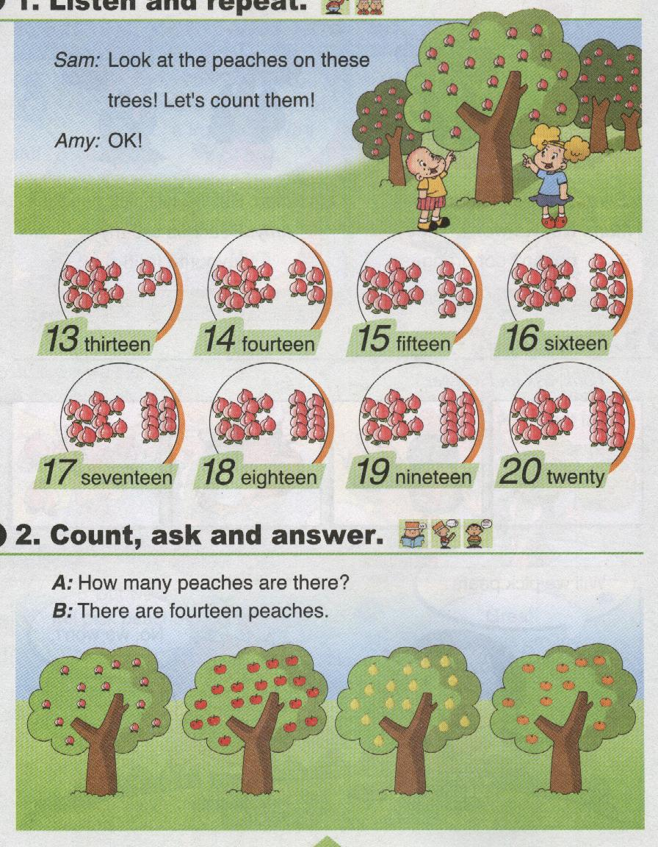
( ) 5. A B C

Ⅲ、听音选择正确的答案（1×6=6分）
1. ( ) A. I’m helpful. B. I’m naughty.
2. ( ) A. Amy is clever. B. Amy is not clever.
3. ( ) A. Big Ben is very short. B. Big Ben is very tall.
4. ( ) A. Yes, he will. B. No, he won’t.
5. ( ) A. He’ll be a film star. B. He’ll be a footballer.
6. ( ) A. It’s four. B. It’s ten.
Ⅳ、听音连线（2×6=12分）
1. Amy English
2. Daming Maths
3. Lingling Chinese
4. Sam PE
5. Xiaogang Science
6. Tom Art
Ⅴ、听音排序（1×6=6分）
( ) And I’ll visit my grandpa.
( ) Will you phone me?
( ) Yes, I will.
( ) He lives in the countryside.
( ) No, I won’t.
( ) Will you play with me this weekend?
笔试部分（60分）
Ⅰ、选择正确的答案，将序号填在括号内（1×5=5分）
( ) 1. I’m going to _____ her.
A. help B. helps
( ) 2. Look ____ this book. It’s _____London.
A. in, about B. at, about
( ) 3. He wants to be _____astronaut.
A. a B. an
( ) 4. --How many ______ are there? -- There is ______orange.
A. oranges, a B. oranges, an
( ) 5. --What will you be in the future? --_______________
A. I’ll a doctor. B. I’ll be a doctor.

Ⅱ、根据汉语提示完成句子（2×5=10分）
1. Amy’s very___________ (友善的).
2. __________(也许) we’ll go to the zoo.
3. We’ll see lions and________(老虎) at the zoo .
4. We will pick _______________(桃子)at the fruit farm.
5. He _____________ （工作）hard.
Ⅲ、选词填空（1×5=5分）
will won’t with to at
1. Will you pick apples this weekend? No, I ___________.
2. I love books. Maybe I ___________ be a writer.
3. I’m happy _________your work.
4. Look __________the birds in the trees.
5. We’re going to speak _______your teacher.
Ⅳ、根据问句选择正确的答句。（2×5=10分）
( ) 1. What is Sam like?
( ) 2. What will you be in the future?
( ) 3. Will Lingling go, too?
( ) 4. How many pears are there?
( ) 5. Is Xiaofang loud?

A. There are sixteen pears.
B. He is very clever.
C. Maybe I will be a doctor.
D. No, she won’t.
E. Yes, she is.
Ⅴ、连词成句（2×5=10分）
1. help / I’m / to / going / her /(.)
_________________________________________
2. river / wide / is / very / this / (. )
_________________________________________
3. pick / oranges / will / we / (?)
_________________________________________
4. my/ fruit/ are/ peaches/ favourite/ (!)
_______________________________________
5. class /naughty/ is / Daming / in / (?)
________________________________________
VI、图文配对，将句子前面的序号填在图下面的标号内（2×5=10分）
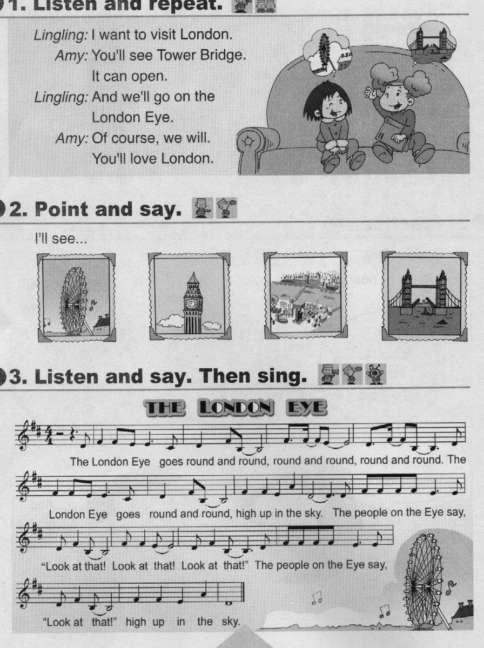
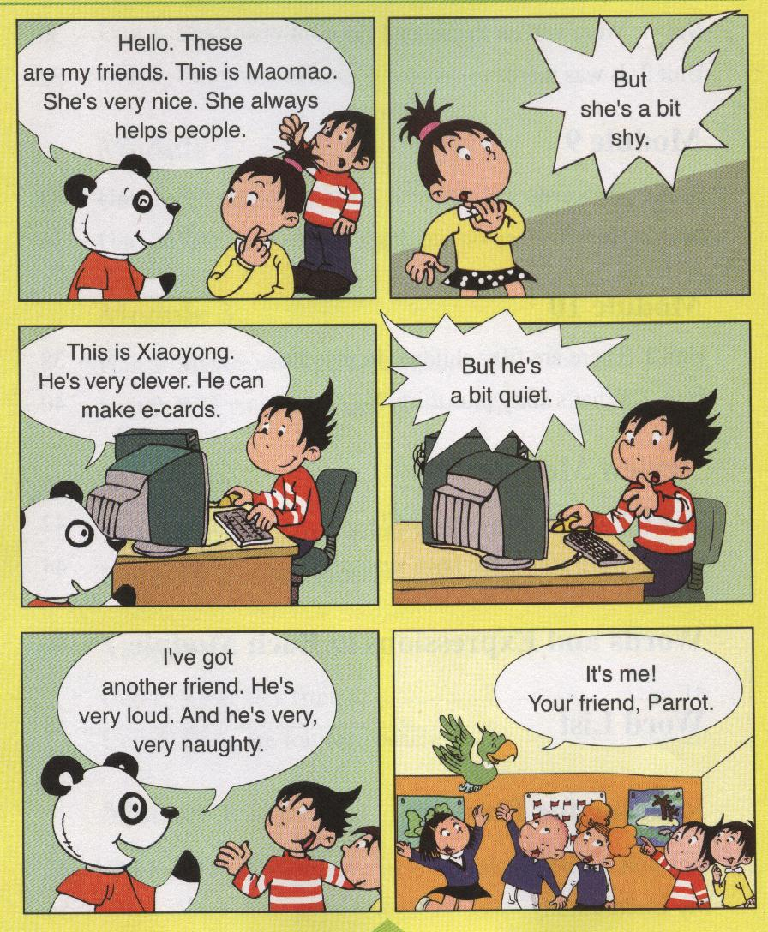
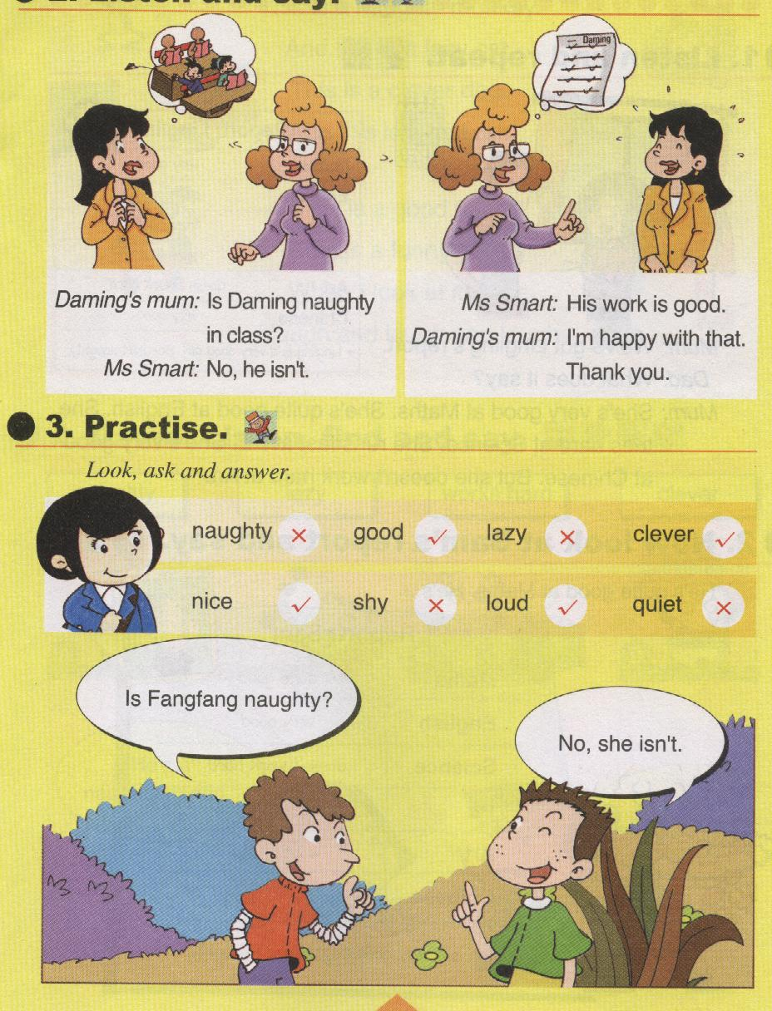
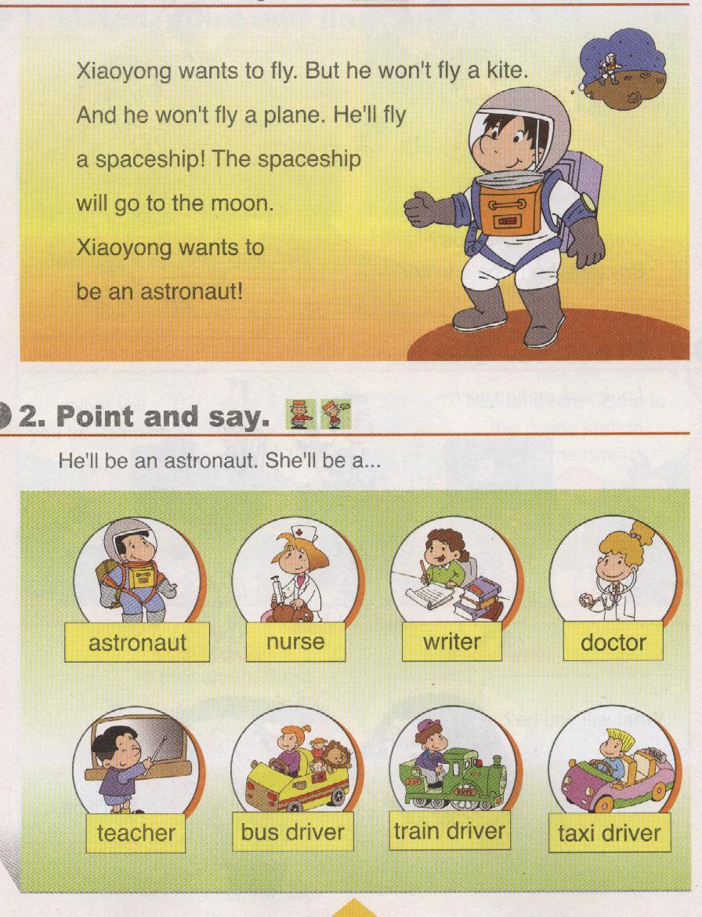
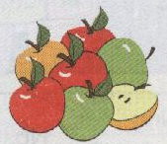
( ) ( ) ( ) ( ) ( )
1. This is the River Thames.
2. Xiaoyong wants to be an astronaut.
3. Maomao is a bit shy.
4. There are some apples.
5. Daming’s work is good.
VII、阅读短文，将正确的选项序号填在括号内（2×5=10分）
I have got two good friends. One is Xiaoyong, the other is Xiaodong. Xiaoyong is very clever, but he is a bit quiet. He can make e-cards. Xiaodong is very loud. He’s very, very naughty. He plays football very well.

( ) 1. I have got _____ .
A. two good friends . B. three good friends
( ) 2.Xiaoyong is ______. A. naughty B. clever
( ) 3. Xiaodong is ______ . A. quiet B. loud
( ) 4. Xiaoyong can _______ .
A. play football B. make e-cards
( ) 5.Xiaodong is good at ______ .
A. football B. basketball

三年级英语听力题签：
Ⅰ、听音圈出所听到的单词
1. - Where are you from? -I’m from China.
2. He’s a naughty boy.
3. She’s very nice. But she’s a bit shy.
4. It’s a big round wheel.
5. He isn’t lazy.
6. Maybe I’ll be a writer.
Ⅱ、听音选择正确的图片
1. - Will you go to the zoo? - Yes, I will.
2. I’m parrot. I’m very loud and naughty.
3. This little girl can’t do her English. I’m going to help her. It’s lion.
4. This is Big Ben. It’s a very old clock.
5. –-- How many peaches are there?
--- There are thirteen peaches.
Ⅲ、听音选择正确的答案
1. I’m helpful.
2. Amy is clever.
3. Big Ben is very tall.
4. - Will he go swimming? - No, he won’t.
5. He’ll be a film star.
6. – What’s two plus two? - It’s four.
Ⅳ、听音连线
- Amy is quite good at Chinese.
- Daming is quite good at Maths.
- Lingling is quite good at English.
- Sam is quite good at Art.
- Xiaogang is quite good at Science.
- Tom is quite good at PE.
Ⅴ、听音排序
1. Will you play with me this weekend?
2. No, I won’t.
3. Will you phone me?
4. Yes, I will.
5. And I’ll visit my grandpa.
6. He lives in the countryside.

