《英语》（新标准）小学一年级起始第12册Module 9Unit1
教学设计

海洋岛学校 张晓霞

Module 9 Unit 1 What’s the matter？

【教材分析】
语言功能：学习正确表达如何询问原因及做出合理的回答。
语言结构：What’s the matter？
Why are you laughing?
Why are you wearing cups on your heads?
教学目标：
- 语言知识目标：
学习目标语句 What’s the matter？
Why are you laughing?
Why are you wearing cups on your heads?
b.语言技能目标：能够听懂会说本模块句型，能运用所学语言正确表达如何询问原因及做出合理的回答。通过游戏和各种学习活动的开展，培养学生的合作能力、竞争意识和综合运用语言知识的能力。
c.情感态度目标：通过本课的学习，使学生了解到学习语言的乐趣，体会到错误发音会影响交际，要有良好的学习习惯与乐观的学习志趣。
教学重、难点：
重点：What’s the matter？Why are you laughing? Why are you wearing cups on your heads? 并能在实际情景中运用。
难点：学生能够流利地使用正确时态来表达如何询问原因及做出合理的回答。
【学情分析】
六年级的学生经过几年的学习，已经由最初对英语的神秘感和简单的兴趣，发展到基本具有稳定的学习兴趣，大部分学生对英语的学习积极性浓厚，基础知识扎实，学习方法得当，综合运用语言能力较强，但少部分学生依然没有形成良好的学习习惯，没有找到有效而合适的学习方法，因而在学习过程中信心不足，参与语言活动的积极性不高，为此，教师要在课堂上运用有效提问的方式，启发学生的思维，激活学生的语言，同时进行相应的读写训练，在教学过程中，更要关注到学生的情感需要。
【设计理念】
小学英语教学的总体目标是发展学生的综合语用能力，语言是思维的外壳，思维往往又是从问题开始的，因此教师要在课堂活动的设计中进行有效的提问，发散学生的思维，用问题牵动学生积极动脑、积极进行语言活动，提升学生的语言思维和语言表达能力。
【教学准备】
单词卡片、多媒体
【教学过程】
Ⅰ、Warm- up
1. Greeting
T：Class begins, hello,boys and girls.
Ss: Hello, teacher.
T: I’m new here, so first, I want to introduce myself, I ’m from Haiyangdao School, my name is Alice. What’s your name? How are you ? How old are you ? Nice to meet you....
T: Ok, everybody! Welcome to Alice’s English class . Now would you like to sing a song with me? Let’s sing together: If you are happy.


(设计意图：师生共同演唱英文歌曲，为本课教学内容作铺垫，并调节课堂气氛)
2. Review
T：Are you happy now? I’m so happy to see you are all very happy. (由歌曲的内容If you are happy自然引入review环节)
T: But look at this boy. Is he happy? He is …I have other funny pictures, what about this boy? He is…（在PPT上出示一组有趣的不同表情的图片，学生说是所他们的表情。如laughing crying angry shouting bored）。
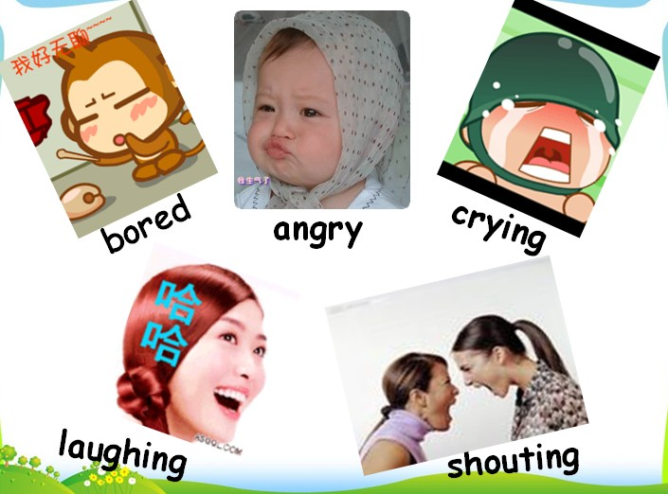
（设计意图：通过谈论图片以及学生现在的感受，激活学生已有的语言知识，熟悉本节课要学习和运用的语言结构和素材，为新知做好铺垫。）

Ⅱ、Presentation
T: Look, they’re our old friends, Now，listen，(播放笑声) Are they laughting ,too? They are so happy, why ? Have you got any questions to ask them ?
呈现课本里的图片，配上笑声，让学生看图片、听笑声质疑。教师适时板书孩子们想要知道的问题。What’s the matter? Why are you laughing? Why are you wearing cups on your heads?
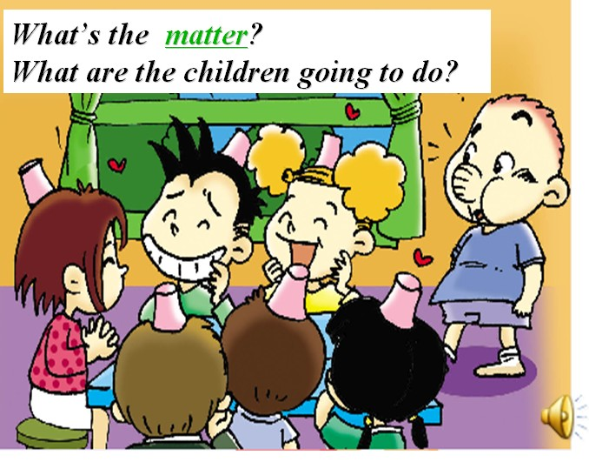
（设计意图：调动学生多种感官，通过观察、倾听，引发思考，主动质疑，发散了学生的思维，增强了其探究新知的意识。）

Ⅲ、 Practice
⑴ Learn the text.
T: Oh, yes ,what’s the matter? What are the children going to do ? Today let’s learn M9U1(板书) , here is a new word “matter”,letter “a” pronounce /æ/，what’s the meaning?what’s the matter? 当我们询问怎么了，有什么麻烦事时我们用what’s the matter? Let’s listen to the CD-ROM and answer the questions.
T : Three questions to learn the text.
Question1:What are the children going to do?
They are going to have a___ . A. basketball team B. baseball team. C. football team
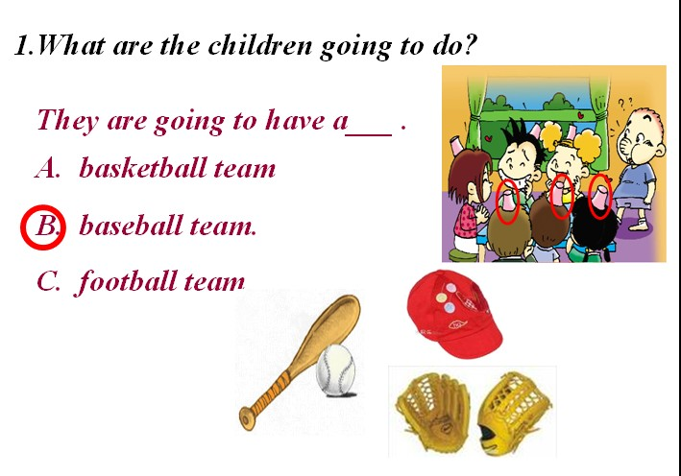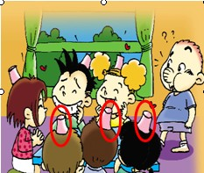
① Ss answer the question.
②Teach the word“baseball”, 学生读baseball，T: do you know other sports balls? Just like football,basketball, 他们都是合成词。
③教师介绍：Baseball is western game， it’s very popular in England，do you want to know some details about baseball?
点图片---- 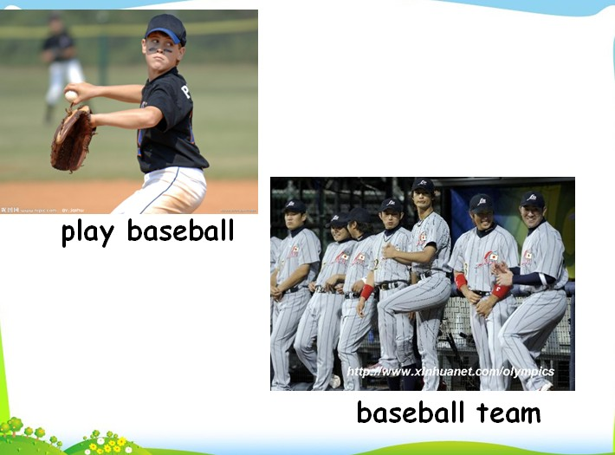
play baseball, baseball team====教单词team ====通过图片帮助学生理解baseball game and baseball team, then ask students,“ when we play baseball ,What do we need for baseball game?”生成——baseball bat, baseball gloves, baseball cap then ask Ss “Are they wearing caps? Why are they wearing cups on their heads? Not caps! Read part 2 ,then answer the questions .
即引出了第二个问题，又了解了异国文化（了解外国的体育运动——棒球）
（设计意图：主线问题，引导学生理解课文中主人公要做什么事情，为课文的深入与理解做好铺垫。）
Question2: Why are they wearing cups on their heads?”
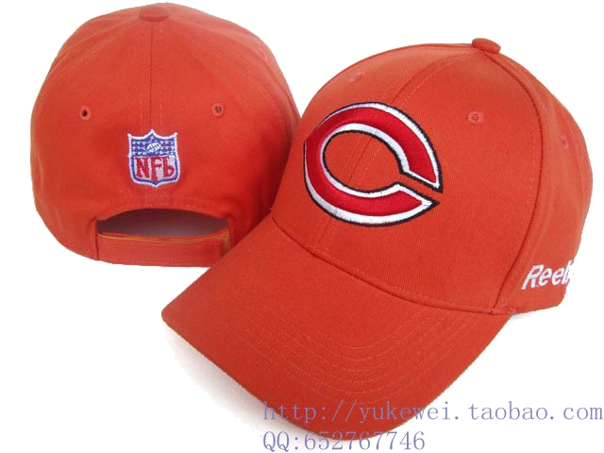
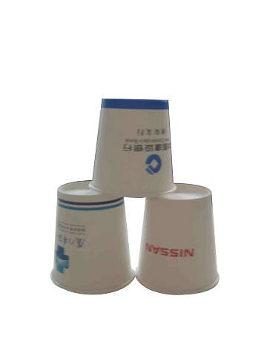
（1）What did Amy say? （2）But what did Ling hear?
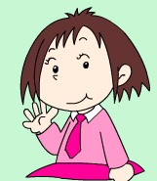
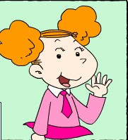
Bring for the baseball. Bring for the baseball.

① Ss answer the question.
②T：Caps is similar to cups ,so lingling made a mistake====教单词mistake=教词组made a mistake（出错误，犯错误）====(超链接)T: there are many similar words in English， it’s easy to make mistakes with English, here are some words, can you read ? 学生一个一个读this one ，let’s read together。
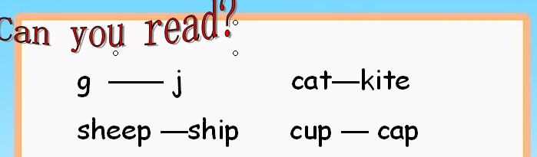
T: So It’s easy to make mistakes with English. What should we do? We should practise a lot. Pay attention, It’s easy to do sth: 做…事情很容易
It’s easy to ______(play) football.
③ T: Let’s look the question again, Why are they wearing cups on their heads?”Because Lingling made a mistake. She brought some cups.（教师适时板书made a mistake, Lingling brought）
④ Teach bing-brought
（设计意图：分散教学难点，通过两个小问题，用对话还原的方式帮助学生理解难点，从而引出——It’s easy to make mistakes with English.）
Question3: What has Sam got in his bag? He has got ________ _____in his bag.
（设计意图：进一步理解课文最后一个段落，通过填充问题的形式，反馈学生对课文情节的深入理解。）
⑵．Listen and repeat
T: read following the CD-Rom , and find out “why”, 领读功能句。
(设计意图：通过模仿跟读，促进学生对课文的理解，对语言的熟悉，为下面的输出做好铺垫。)
(3) 重点强化功能句
Ｔ：当我们询问发生了什么事情时，我们用“What’s the matter?”询问事情的原因用____来提问。Why来问， because 来答。
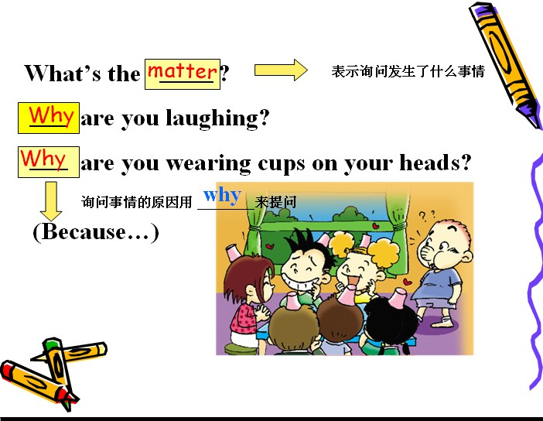

（4）.Retell the story.
The children are going to play ______ . They are wearing______ on their heads. Lingling b ______ the cups. But Amy wanted to say“ ” . It’s easy to make _______ with English . Sam makes lots of mistakes with _____ . He has got the baseball _____ in his bag.

(设计意图：通过复述课文，增进学生对整体课文情境的理解与表达，训练了学生连贯思维与表达能力。)
（5）After retelling the story, what do you know?
The text（课文）wants to tell us .
A . Lingling made a mistake.
B. Sam made mistakes with Chinese.
C. It’s easy to make mistakes with English.
（设计意图：启发学生心智，利用认知冲突，建立对课文深层意义的深入思考，引导学生明白英语学习者在英语学习的过程中很容易出错，只有多看、多听、多练，才能学好，生成——watch carefully, listen carefully, practice a lot…）
Ⅲ、Practice（练习）
Activity1(基础操练):
T: Look at the two children, what’s the matter? Let’s ask them.
Ask and answer in pairs. 根据图片操练What’s the matter? Why…Because…
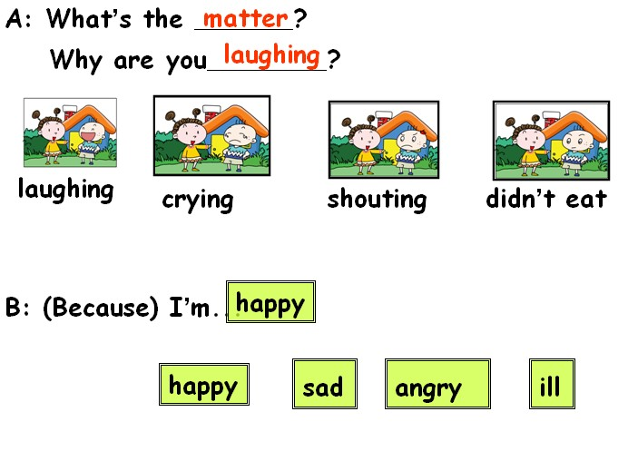
（设计意图：这是一个基础性的操练，学生两人一组，根据图片中人物的表情，做简单的对话。掌握本句式，运用本句式进行简短的交流）

Activity2(拓展操练):
Guessing game:
T: Who is she ? Why is she scared? I ‘ll give you some words to help you.
根据图片中人物的表情，自主发问，并预测原因。先遮盖住图片的一部分，学生根据表情猜原因，之后提供关键词汇，学生再根据提示说出具体原因。
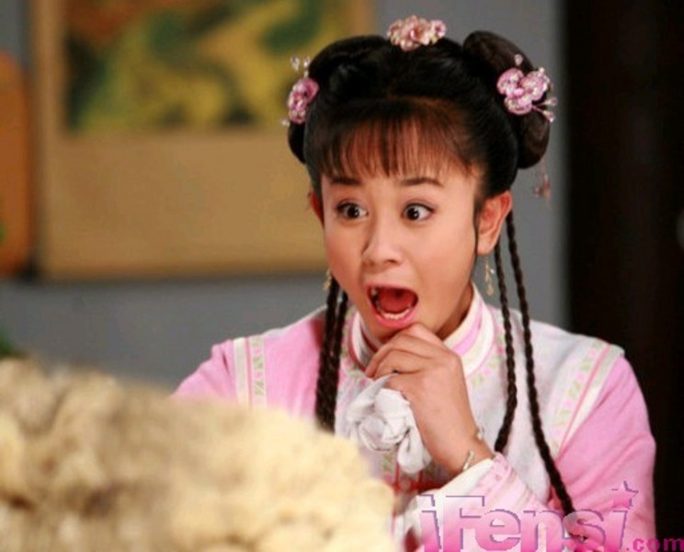
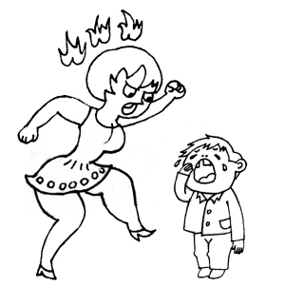
saw
snake
duck
eat
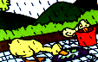
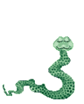

What’s the matter? Why is mum…?
Why is she scared? Because….
Because…
（设计意图：利用图片情境提问，能激活学生已有生活体验，利用信息差及信息转换，激活学生的思维，让学生主动思考，主动运用）
Ⅴ、Production（任务完成）
- Let’s act. 创编情境演一演。
T: When we are in trouble, what should we do ?Now let’s act out. I am A ,who want to be B ? C ?
下去指导下，让学生上台演一演。
教师提供衣服图片及相应的表演对话，先做出示范，然后再提供两个情境，学生在小组内自主选择情境表演，只要是在情境中运用今天的目标语句。看哪组对话编排的充实。
范例：
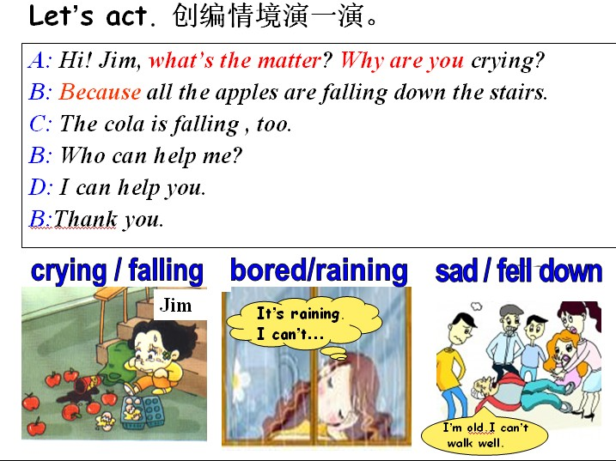
（设计意图：交际式提问，开放性的情境交际，接近学生的最近发展区，联系生活实际、发散思维与创新能力、生成新语言，综合语用能力得到提升。）
2、课外阅读
Read the passage then tick “T” “F”.
Hi, my name is Lilin . I’m Chinese, but I live in England. I speak English very well, but sometimes I make mistakes.
Last Sunday we went to visit a farm. I was very excited. I told my friends I wanted to see a ship. Everyone looked surprised and laughed a lot. My teacher said, “There are no ships on the farm.”
Oh ! I made a mistake. I wanted to say “sheep”, not “ship”. I was so shy. It was very funny. We all laughed.
1. ( ) Lilin lives in China.
2. ( ) Lilin makes mistakes in English.
3. ( ) Lilin went to the sea.
4. ( ) Lilin likes sheep.
5. ( ) There were ships on the farm.
6. ( ) Lilin wanted to say ”sheep”.
T: Everyone will make a mistake, that is normal, so I give you a sentense:
To make a mistake is a human.
金无足赤，人无完人
（设计意图：由听说过渡到读写，通过对课外阅读材料的理解与判断，又进一步感知发音错误引起的误会，进一步理解：It’s easy to make mistakes with English.）
Ⅵ、Summary and Homework（小结和作业）
- Summary
- Why来问，用because 来答。
- Children, how many points does your group got? Which group is the winner?
- Homework
A 层：
熟读单词和课文
B 层：
在熟读的前提下尝试背诵课文
C层：
Try to ask your friends with the sentence “ What’s the matter? Why…..”.
3.课堂升华
T： Children， Children’s Day is coming, best wishes for you, Happy Children’s Day!
class is over, Thank you !
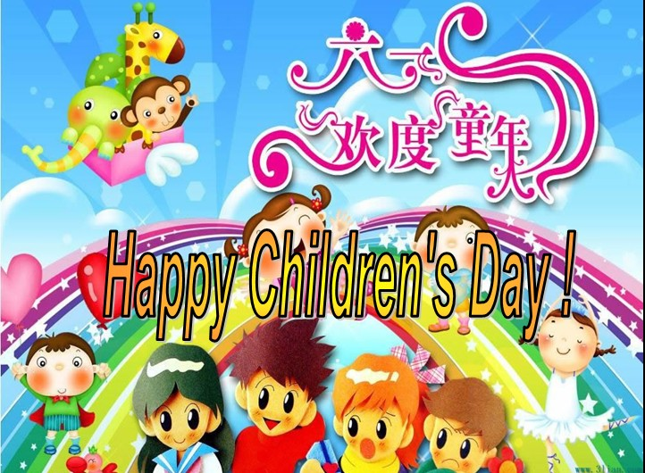

板书设计：
Lingling brought
Module 9 Unit1
What’s the matter?
laughing?
cups
caps
Why are you
wearing cups on your heads?
made a mistake

