Module 4
獐子中心小学 丁毅清
一、Please listen and choose .请听课本活动1的录音，根据听到的内容，为下面的图画选出合适的选项。
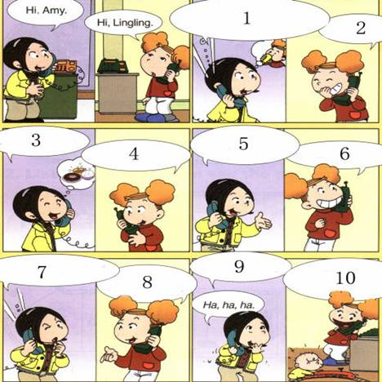
A So, what are you doing?
B What’s he doing?
C And what’s that noise?
D What’s that noise? Are you drinking?
E No, I’ not.
F He’s playing with his train .Listen!
G Are you eating?
H No, I’ not eating.
I I am talking to you!
J Oh, that noise! It’s Tom!
二、Please read， look and choose .请读一读，看一看，选出正确的答案。

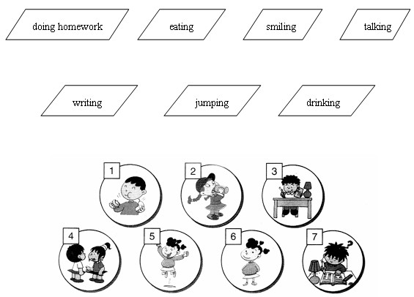
三、Please read and match .请读一读，连一连。
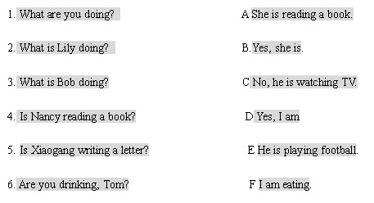
四、Please read choose. 请读一读，选一选。
eating drinking talking playing
- I’m ___________ some milk.
- I’m ___________ basketball.
- I’m ___________ to you.
- I’m ___________ an ice- cream.

