新标准英语一起十二册
Module7 Unit1
He spent about 21 hours in space.
大长山中心小学 杨春莲
Step1. Warming up
1. Greeting：T: Class begins. Ss: Stand up!
T: Hello, boys and girls. Ss: Hello, Ms Yang.
T: How are you? Ss: I’m fine. Thank you.
T: Sit down, please.
2. Warmer:
1) Enjoy a song < Look up at the spaceship>
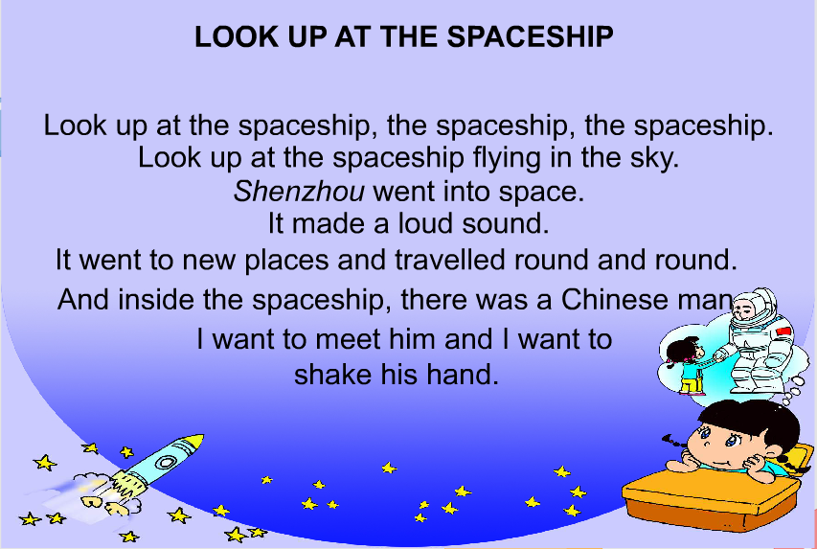

T: Wow, so many teachers are here,I’m very excited. Are you excited? 教授单词excited----exciting (板贴卡片)
Let’s compare them and do the exercise.
T:I want to go into space someday, it’s my dream.
2) Free talk T: Look, what’s this? Ss：Spaceship.
T: The name of the spaceship is Shenzhou V.

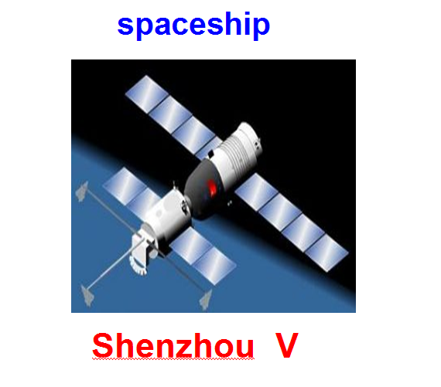

T：Look(指黑板图), this is Shenzhou V，I drew it. Who was inside,do you know?（板书Who） Ss:Yang Liwei was inside. (师贴杨利伟图)

Step2. Presentation
- Show the pictures talk about Yang Liwei.
T: Can you talk about him? (学生谈论之后，师再提供信息)

T: So, When did Shenzhou V fly into space? How long did he spend in space?
And how do his families feel?
- Today let’s learn Module7 Unit1(板题).

Step3. Practice
- Watch the CD-ROM and answer the questions:
Q1: When did Shenzhou V fly into space?
Q2: How long did he spend in space?
- Let the students watch the CD-ROM
- Answer Q1: In October 2003, Shenzhou V flew into space. (生答，师板书When& in October 2003)
T：Where did Shenzhou V fly into? Ss:Space. (师板书Where& into space)
T: Pay attention to “ flew ”， it’s the past form of “fly”. On October 15th, 2003, Shenzhou V flew into space.So,what can you find?
S1:在年、月或年月前用“in”.具体年月日前用“on”.
T：Good,now,let’s try.
- Explain “ in/ on” and do exercises:
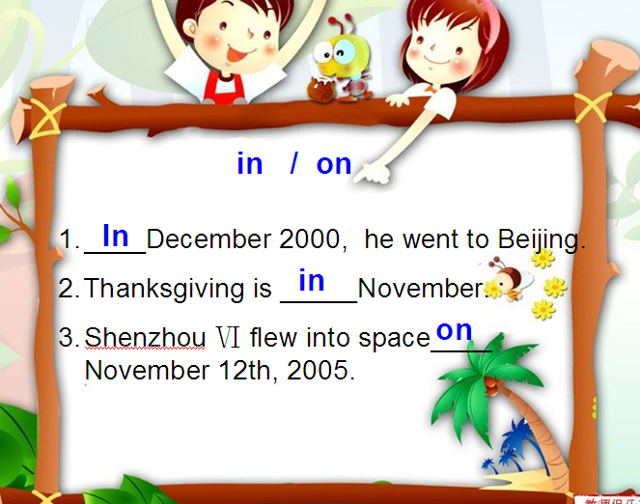

- Choose and say:
- Answer Q2: He spent about 21 hours in space. （生答，师板书How long&课题He spent about 21 hours in space.）
T：Pay attention to “ spent ”， it’s the past form of “spend”.教授单词spend （强调sp发音，拓练spent,speak,spoke.(板贴词卡)
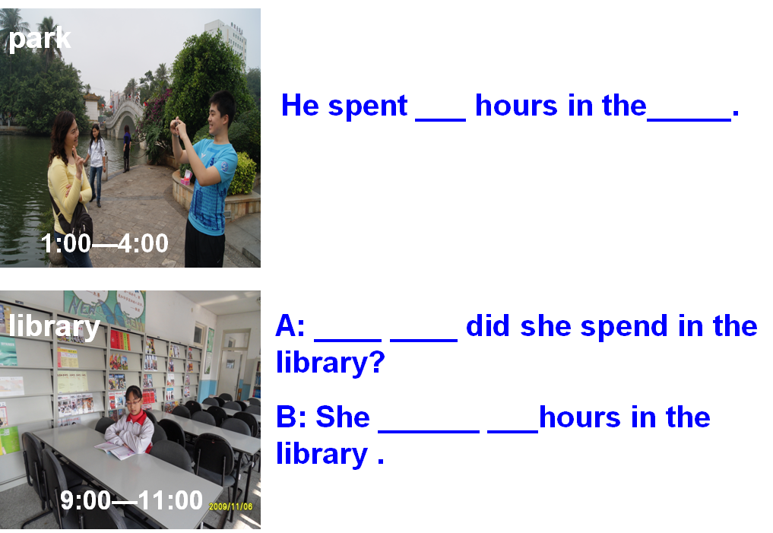
Exercises:

2. Listen ,repeat and answer the questions: (open your books and turn to page 26)
Q3: What did Yang Liwei do in space?
Q4: What were his first words in space?
Let the students listen to the text.
- Answer Q3: He made a video. (生答，师板书What& made a video)
教授单词 video (贴词卡)
- Answer Q4: His first words in space were, “I feel good.”
(师板书 I feel good.)T: How did Yang Liwei feel,S2？ 帮助S2说出：He felt good. T：Good,or we can say:Yang Liwei said”I feel good.”
(师利用情境对生给予表扬，“ You did a good job. So I feel good. Do you feel good, too?) Ss:Yes.
T：Yang Liwei’s son felt good,too. He was very proud of his father.（教授单词“proud”，师贴词卡）
3. Read the text and circle the verbs in past tense. Then report in groups or someone.
1）Let the students read in their groups and circle.
2) The students read and say the past tense.(分段读)
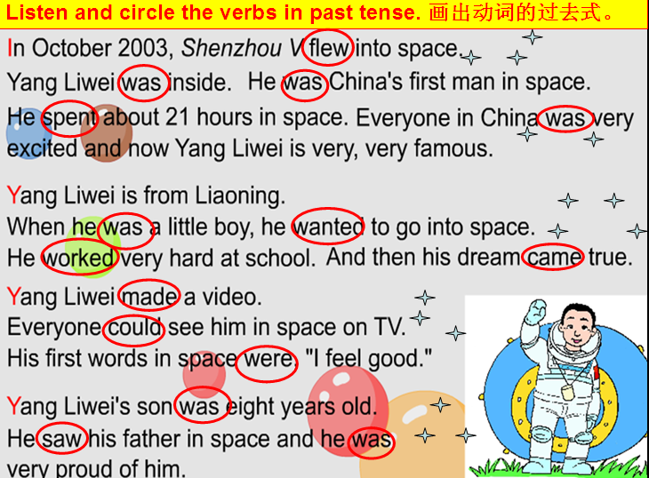

生说同时师出示过去式
3) T: Can you say? 生说动词原形
4）Sum up总结动词过去式变化规律
5) Read and fill in the blanks.(Task paper) (过去式) 师巡视，
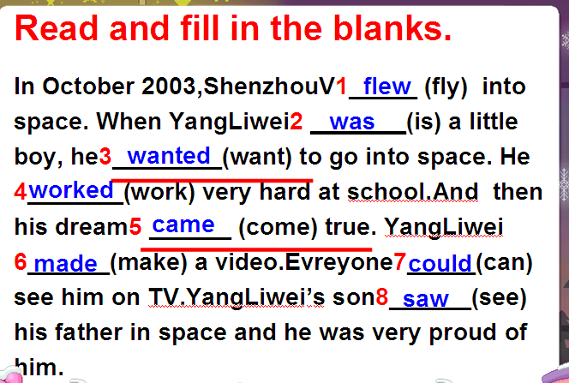

Exchange their task paper,check,then correct their answers.
T：Let’s pay attention to two phrases.
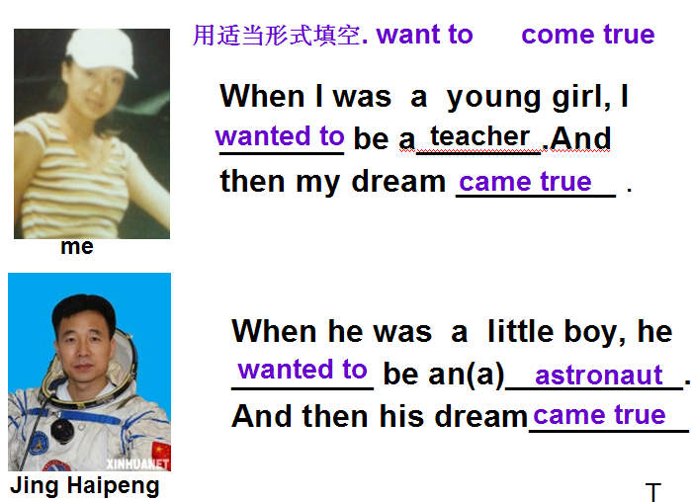
6) Do exercises.

T：Jing Haipeng is so good, now, let’s talk about their space life. First, let’s talk about Yang Liwei’s space trip.
6. Retell the text according to the blackboard. (小组合作，组员分工，或单独复述)

Step4. Production
- Talk Show ( About ShenzhouⅥ、IX)
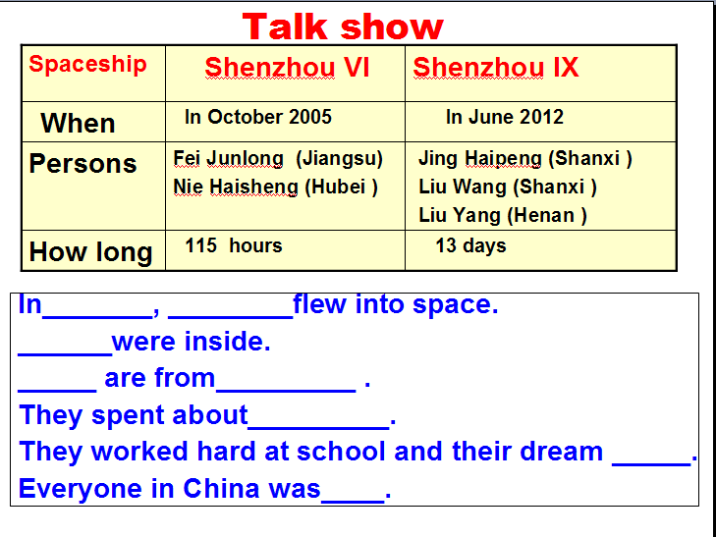

T：I love Liu Yang very much. Look, this is Liu Yang,she’s China’s first woman in space.She wrote a passage in the newspapers,do you want to enjoy it?

- Writing: My trip
- 师给出范文 Our space trip， T：Pay attention to the blue words,what can you find?引导学生总结出蓝色字体强调的要素。
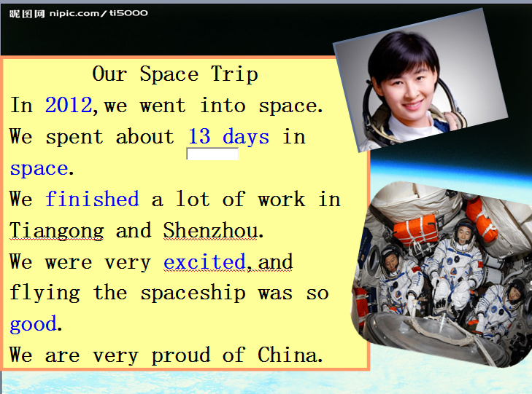

- T：因此用一般过去时描述过去发生的事情，我们可以从以下要素入手（对照黑板思维导图）。

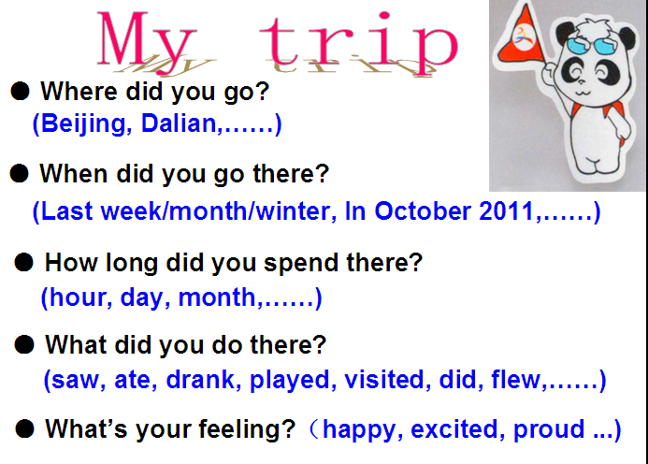

  - Write and show in class.
- 生写作（task paper）
- Show in class.（2~3个学生，利用展台，学生互评，互助纠正）

- Choose the best answers. ( Task paper)
(不做讲解，课后提交，教师批阅)
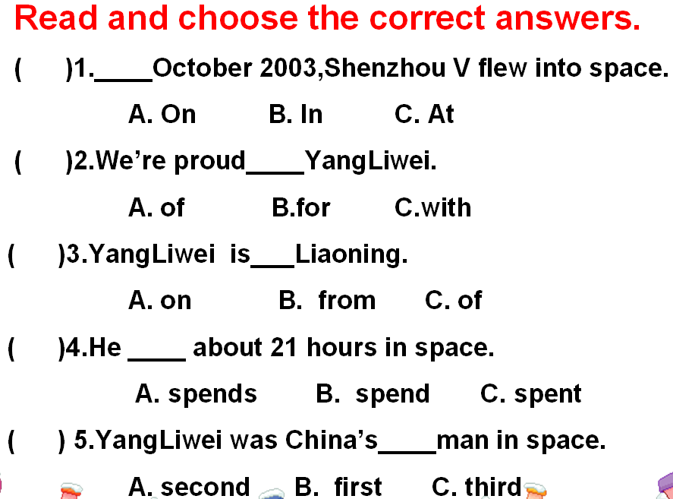

Step5. Summary and Homework
1、Sum up:
1） T: What have we learnt today? Ss总结
T: Yes. 今天我们继续运用一般过去时谈论过去发生的事情，看思维导图，手指杨利伟图片，引读板题：He spent about 21 hours in space.
2） T: Who is the winner? What can you got? Ss：A big star.
T: Look, what have we got?(教师将评价机制上的4颗星星拿到思维导图中的红色区域内，与大星星一起组成五星红旗) Ss: National flag.
T：So, we’ll say----


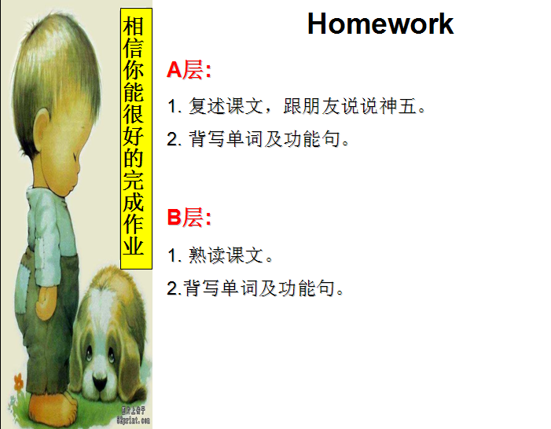
2、Homework

板书设计：

