长海县2012~2013第一学期期末质量检测
四年级 英语 完成时间：60分钟
题号 | Ⅰ | Ⅱ | Ⅲ | Ⅳ | Ⅴ | Ⅵ | Ⅶ | Ⅷ | Ⅸ | Ⅹ | Ⅺ | Ⅻ | 总分
得分
听力部分（40分）
Ⅰ、听音,选出你所听到的单词，将其序号填入括号内。
（ ）1. A. also B. soon C. school
（ ）2. A. wore B. wash C. work
（ ）3. A. break B. bread C.bird
（ ）4. A. monster B. mountain C. medicine
（ ）5. A.dirty B. paintbrush C. practise
Ⅱ、听音,根据所听顺序用数字(1, 2, 3, 4, 5)给下列图片重新排序。 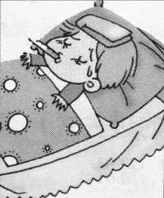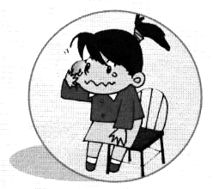 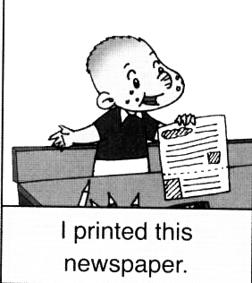  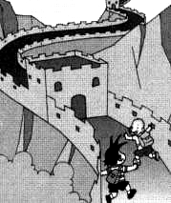
（ ） （ ） （ ） （ ） （ ）
Ⅲ、听音，判断下列图片是否正确，正确打“√”，错误画“╳”。
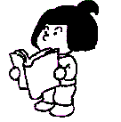
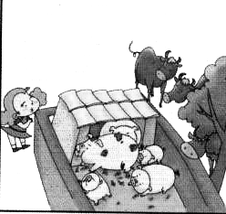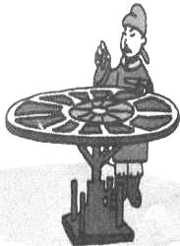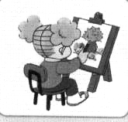
1.（ ） 2.（ ） 3.（ ） 4.（ ） 5.（ ）

Ⅳ、听音，选出你所听到的句子，并把序号写在题前的括号内。
（ ）1. A .He invented this bicycle in 1949.
B. He invented this bicycle in 1939.
（ ）2. A. Where did you go ?
B. What happened to you?
（ ）3. A. She usually learns English and Maths.
B. She didn’t learn English and Maths.
（ ）4. A. He didn’t come back.
B. It didn’t make gold.
（ ）5. A. We were hungry and thirsty.
B. We were hungry and sad.
Ⅴ、听音，用数字（1，2，3，4，5）给下列句子重新排序。
（ ）But he didn’t ride it yesterday.
（ ）He usually rides his bicycle.
（ ）On Sundays, Daming usually plays football in the park.
（ ）But he didn’t play football yesterday.
（ ）It was raining! He stayed at home.
笔试部分（60分）
Ⅵ、根据语境,用括号内所给动词的适当形式填空。
Yesterday was Sunday. I didn’t _________(go) to school. I _________(clean)my room. I______(do) my homework. I _________(phone) grandpa .I_________(eat) an ice cream. I_________(have) a good time.

Ⅶ、请根据所给语境写出正确的单词。
1. Can you___________ (告诉)me about China?
2. The bad man was __________(生气的). He_________（带走）
Ma Liang away.
3. I __________(学习)to skate yesterday.
4. We __________ (买)you a present yesterday.
5. This girl won a gold _________(奖杯).
6. I fell over. I _________（受伤）my ___________(膝盖).
7. Children from America are____________(美国人).

Ⅷ、选择，将正确的答案写在题前的括号内。
（ ）1. Tom usually _________ to school.
A.walk B. walks C.walked
（ ）2. He watched TV ______________.
A. now B. tomorrow C.yesterday
（ ）3. A: What’s the matter? B: ___________.
A. Yes, I did. B. OK. C.I’ve got a cold.
（ ）4. Yesterday ___________ a special day.
A. was B. is C. were
（ ）5. Shanshan _________ got a toothache.
A. had B. have C. has
（ ）6. I _________ my finger last week.
A. cut B. am cutting C. cuts
（ ）7. A: Did you fall? B: No, I ____________.
A. did B. don’t C. didn’t
（ ）8.The monster wanted to eat the children.
The children _______ away.
A. ran B. fly C.put
（ ）9. He can’t ___________ a bike.
A.ride B.rode C.riding
（ ）10. The bad man __________,“I want a big ship.”
A. say B. said C.see

Ⅸ、根据问句选答句， 把正确的序号写在题前的括号内。
（ ）1、What happened to you? A. I played the flute.
（ ）2、What did you see? B. I bumped my head.
（ ）3、Where did you go? C. We saw lots of tigers.
（ ）4、What did you play? D. I live in Dalian.
（ ）5、Where do you live? E. I went to the zoo.

Ⅹ、根据语境，选择恰当的单词填写在横线上。
what , where , who , when , how many

1. A:_________ did Amy go? B: She went to London.
2. A:__________did you do yesterday? B: We played football.
3. A:__________did they come? B: They came last Wednesday.
4. A:__________children were there? B: There were three.
5. A:__________ invented printing? B: Chinese people.

Ⅺ、连词成句。
1. my / helped / I / mum（.）
2. didn’t / he / football / play（.）
3. a / have / stomach ache/ I / got（.）
4. she / what / did / play （?）
5. people/ Chinese/ paper / invented （.）

Ⅻ、阅读理解。
Dear Lucy,
Thank you for your letter.
Happy birthday to you. I am still eight. I will be nine in April. The weather in Beijing isn’t cold. It’s warm. I’ve got a new friend, too. Her name is Lingling. She’s got short, black hair. She’s very nice. Here is a photo of Lingling and me.
From,
Amy

( )1. This letter is from __________.
A. Lucy B. Amy
( )2. A: Happy birthday to you. B:_______________
A. Thank you . B. Very good!
( )3. The weather in Beijing is ________.
A.cold B. warm
( )4. _________is Amy’s new friend.
A.Lingling B.Lucy
( )5. Amy is __________years old now.
A. 9 B. 8
四年级英语听力题签：
注意：每道听力试题读二遍，听力时间控制在20分钟内。

Ⅰ、听音,选出你所听到的单词，将其序号填入括号内。
1、Write to me soon.
2、I wore warm clothes.
3、Did you break your toy?
4、We climbed the mountain.
5、We will practise a lot.
Ⅱ、听音,根据所听顺序用数字(1, 2, 3, 4, 5)给下列图片重新排序。
1、I washed my trousers.
2、Mingming’s got a fever. She stayed at home.
3、We went to the Great Wall.
4、I printed this newspaper.
5、Shanshan is crying.
Ⅲ、听音，判断下列图片是否正确，正确打“√”，错误画“╳”。
1、He fell off his bike.
2、She went ice-skating.
3、Chinese people invented paper.
4、She painted a picture yesterday.
5、He’s watching TV.
Ⅳ、听音，选出你所听到的句子，并把序号写在题前的括号内。
1、He invented this bicycle in 1949.
2、What happened to you?
3、She didn’t learn English and Maths.
4、He didn’t come back.
5、We were hungry and thirsty.
Ⅴ、听音，用数字（1，2，3，4，5）给下列句子重新排序。
On Sundays, Daming usually plays football in the park. But he didn’t play football yesterday. He usually rides his bicycle. But he didn’t ride it yesterday. It was raining! He stayed at home.

听力部分到此结束！
四年级英语答案及评分标准：
听力部分
Ⅰ、(2×5＝10分) BAABC
Ⅱ、(2×5＝10分) 2--- 5 ---4--- 1 ---3
Ⅲ、(2×5＝10分) √ ╳ ╳ √ ╳
Ⅳ、(1×5＝5分) ABBAA
Ⅴ、(1×5＝5分) 4---3---1---2---5

笔试部分
VI、(1×6＝6分) go , cleaned , did , phoned , ate , had
（备注：要求每空单词必须拼写完全准确方可得1分。）
Ⅶ、(1×9＝9分) tell , angry , took , learnt/learned , bought , cup , hurt , knee , American
（备注：要求每空单词必须拼写完全准确方可得1分。）
Ⅷ、(1×10＝10分) BCCAC ACAAB
Ⅸ、(2×5＝10分) BCEAD
Ⅹ、(1×5＝5分) Where , What , When , How many , Who
（备注：如果首字母没大写，整体书写扣1分。）
Ⅺ、(2×5＝10分) 答案略。
Ⅻ、(2×5＝10分) BABAB

备注：卷面满分为100分。（听力40分，笔试60分。）
优秀：90---100
良好：80---89
及格：60---79
不及格：0---59

2013年1月8日

