长海县2012~2013学年度第一学期阶段质量检测
小学英语 六年级 （80分钟完成） 2012. 11
听力部分（30分）
Ⅰ、听音选出你所听到的单词。
（ ）1. A. send B. sent C. get
( ) 2. A. surprise B. special C. speak
( ) 3. A. place B. pleased C. please
( ) 4. A. delicious B. different C. difficult
( ) 5. A. stop B. sleep C. stamp
Ⅱ、听音标号。
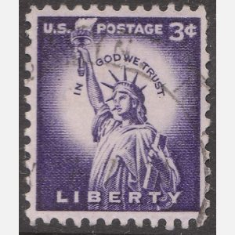

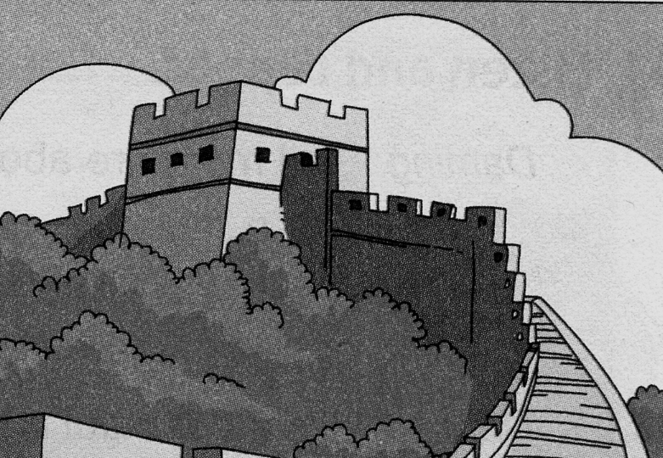

十二月
25
2008年
星期四
圣诞节

A B C D E
1._______ 2._______ 3._______ 4._______ 5._______
Ⅲ、听问句, 选答语。
( ) 1. A. It’s Five-Finger Mountains. B. They are from Canada.
( ) 2. A. Yes, I can. B. Yes, you can.
( ) 3. A. I’m swimming. B. I like swimming.
( ) 4. A. It’s more than two thousand years old.
B. It’s ten thousand li long.
( ) 5. A. Yes, I do. B. No, I haven’t .
Ⅳ、听对话，选择正确答案，并将序号填到横线上。
1. Amy wants to __________ this Sunday.
A. see a clock B. see a film C. visit a museum
2. They will go to _____________.
A. the Museum of History B. Tom’s home C. the cinema
3. The museum is about__________ years old.
A. two B. two thousand C. two hundred
4. The clock is __________ metres high.
A. fifty B. forty C. thirty
5. The Museum of History is near to _____________.
A. Amy’s home B. Tom’s home C. their school

笔试部分（70分）
Ⅰ、根据汉语提示，将句子补充完整。
1、How long is the Great Wall? It’s five thousand ______ (公里)long.
2、The moon is _______ ______(数百万) years old.
3、There are many beautiful ____________(地方) there.
4、I like ___________(收集) toy cars, what about you?
5、Spring Festival is a __________ (特殊的) day in China.
6、Please _______ _____ (写信给) me. Here is my _______(地址).
7、She can _______ _______ _______ (说一些英语).
Ⅱ、单项选择。
( ) 1.Have you got ______ photos of America?
A. some B. any C. a
( ) 2. Do you want _______ my pen pal?
A. to B. be C. to be
( ) 3. I’m going to send______ email _______ my mum.
A. an, to B. an, for C. a, to
( ) 4. These stamps are ____ China and they _____ from 1988.
A. on , are B. in , are C. from , are
( ) 5. ----What _____ she ______ ? ---- She’s writing.
A. does, doing B. is, doing C. does, do
( ) 6. A: Can I write to _____ ? B: Yes, of course.
A. hers B. his C. him
( ) 7.______ you from England?
A. Do B. Are C. Is
( ) 8. National Day is _______ the 1st of October.
A. on B. in C. at
( ) 9. She is clever. She can write _______ English.
A. with B. on C. in
( )10. I want an ______ friend.
A. American B. Chinese C. Canadian
Ⅲ、用所给词的正确形式填空。
1. There _______(be) four dogs in the street.
2. We ________ (eat) lots of seafood yesterday.
3. Let’s __________ (go) swimming.
4. Thanksgiving _________ (come) every year.
5. I want ________ (write) to my pen pal.
Ⅳ、根据问句，选答句。
( ) 1. How old is your brother? A. No, I can’t.
( ) 2. Where did you go yesterday? B. She is flying a kite.
( ) 3. What is Amy doing? C. He’s ten years old.
( ) 4. When is Thanksgiving? D. I went to the library.
( ) 5. Can you walk all of it? E. It’s in November.
Ⅴ、根据情境，补全对话。
A. This is my favourite Chinese stamp.
B. What are you doing?
C. It’s Five-Finger Mountains.
D. When did you get this stamp?
E. Have you got any stamps from China?

A: _________1____________
B: I’m putting my new stamps into my album.
A: __________2_____________
B: Yes, I have.____3_________
A: What’s the name of the mountain in this stamp?
B: _____4______ This mountain is in Hainan Island.
A: __________5______________
B: In 2008.
Ⅵ、阅读理解。
Passage1: 判断正（T）误（F）
Dear Lanlan,
How are you? I want to go to China very much. I think I know something about China from your letters, but I know little about Chinese food. I like hamburgers and cookies(小甜饼) very much. I don’t like noodles. I can cook some delicious pizza. Do you like pizza? I can cook for you. Can you teach me how to make dumplings? I like them very much. What food can I have in China? Please write to me soon.
Yours
Tim
( ) 1. Lanlan is Tim’s friend.
( ) 2. He can cook pizza.
( )3. He can cook dumplings.
( )4. He doesn’t know much about Chinese food.
( )5. He knows something about China from Chinese books.
Passage2: 回答下列问题
Christmas is a very important western（西方的）festival. It is on the 25th of December. People decorate（装饰）their homes. They send Christmas cards to their relatives（亲戚）and friends, and they buy Christmas trees to decorate their homes. They buy presents and put them under their Christmas trees. Some families open their presents on Christmas Eve（前夜）. On Christmas Day, people all say“ Merry Christmas”. There are lights in the streets and shops. Everyone gets together and has a large meal. They have a good time.
1. When is Christmas?
_____________________________________________________
2. What do people put under the Christmas trees?
_____________________________________________________
3. What can you see in the streets?
_____________________________________________________
4. What do people send?
_______________________________________________________
5. What do people say on Christmas?
_______________________________________________________
Ⅶ、写作园地。
假如你是Linda，请你向朋友Emily介绍一下自己的笔友，不少于40个词，语句通顺正确。
Dear Emily,
How are you ? I miss you very much. I have a pen pal. Her name is_____________________________________________________
______________________________________________________

From,
Linda

六年级英语听力题签
※ 注意：每道听力试题读二遍，听力时间控制在20分钟内。
Ⅰ、听音，选出你所听到的单词。
1. People send cards on Christmas.
2．People put special trees in their homes.
3．Tell me more about this place.
4. It’s different from Chinese food.
5. This stamp is from China.

Ⅱ、听音标号。
1. The Great Wall is more than 2000 years old.
2. Daming is sending an email to Sam.
3. This stamp is from America.
4. Christmas is on the 25th of December.
5. People put special trees in their homes.

Ⅲ、听问句，选答语。
1. Where are these stamps from?
2. Can I write to her?
3. What are you doing?
4. How old is the Great Wall?
5. Have you got any stamps from China?

Ⅳ、听对话，选择正确答案，并将序号填到横线上。
Tom: What do you want to do this Sunday, Amy?
Amy: Shall we go to the cinema?
Tom: I don’t want to see a film.
Amy: Shall we go shopping?
Tom: I don’t think so.
Amy: What about you, Tom?
Tom: Let’s go to the Museum of History.
Amy: A museum! Tell me about it.
Tom: It is two hundred years old.
Amy: Oh! Tell me more.
Tom: There is a clock there. It’s about 50 metres high!
Amy: Is it far?
Tom: No, it is near to my home.
Amy: Great!

听力部分到此结束！

六年级英语答案及评分标准
听力部分（30分）
Ⅰ、（1×5=5分） A B A B C

Ⅱ、（2×5=10分） D A C E B

Ⅲ、（1×5=5分） B B A A B

Ⅳ、（2×5=10分) B A C A B

笔试部分（70分）
Ⅰ、（1×12=12分）
1. kilometres 2. millions of 3. places 4. collecting
5. special 6. write to , address 7. speak some English
(每词一分，如没变化扣减0.5分)

Ⅱ、（1×10=10分)
B C A C B C B A C A

Ⅲ、（2×5=10分）
1. are 2. ate 3.go 4. comes 5. to write
（每题每空必须完全准确方可得分）
Ⅳ、（2×5=10分） C D B E A

Ⅴ、（2×5=10分） B E A C D

Ⅵ、（1×10=10分)
P1: F T F T F
P2: 1. It is on the 25th of December.
2. People put presents under the Christmas trees.
3. We can see lights in the streets.
4. They send Christmas cards to their relatives and friends.
5. People all say“ Merry Christmas”.

Ⅶ、（8分)
请批阅作文老师自行把握评分标准,做到心中有数。

备注：卷面满分为100分。（听力30分，笔试70分。）
优秀：90---100
良好：80---89
及格：60---79
不及格：0---59

长海县教师进修学校

2012年11月

