长海县2012~2013学年度第一学期阶段质量检测
小学英语 五年级 （80分钟完成） 2012. 11
听力部分( 35分)
- 听音，选出句子中所含的单词，将序号写在前面的括号内。
B. left
B. went
B. difficult
B. ear
B. scary

( ) 1. A. lift
( ) 2. A. want
( ) 3. A. different
( ) 4. A. year
( ) 5. A. scare

C. let
C. what
C. December
C. hear
C. scared

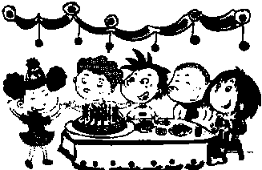
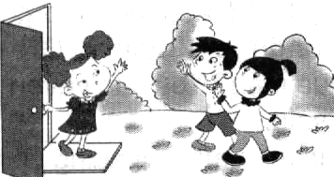
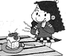
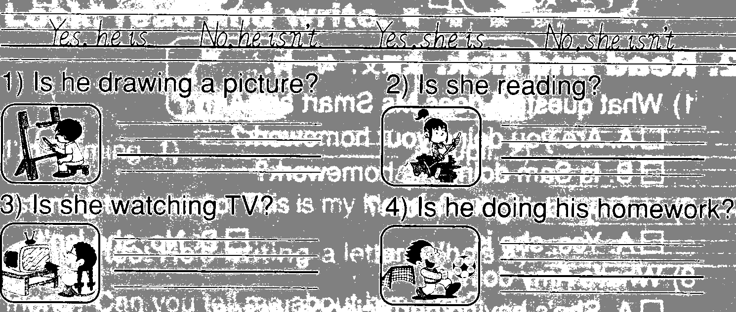
二、听音标号。根据短文叙述的顺序用数字标出图片的先后顺序。

( ) ( ) ( ) ( )
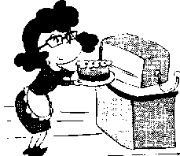
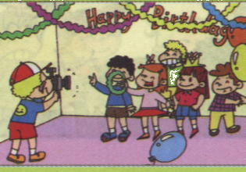
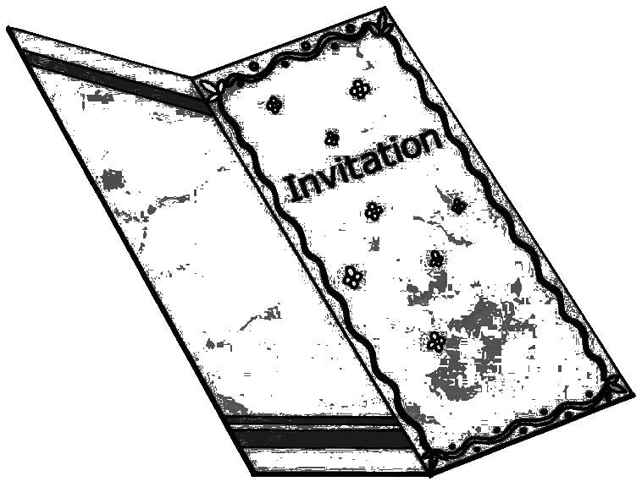
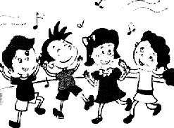

( ) ( ) ( ) ( )
三、听问句，选答句。将正确答案序号填在括号内。
A. It’s Easter.
B. It’s Halloween.
C. I t’s Christmas.
A. At six o’clock.
B. At four o’clock.
C. At three o’clock.
（ ） 1.

（ ）2.

A. What’s the matter?
B. Come on, please！
C. Let me help you.

A. It’s not a dress.
B. It’s a red dress.
C. It’s Laura’s.
（ ）3.

（ ）4.

A. Yes, there are.
B. No, there weren’t.
C. Yes, there were.
A. To go to the big supermarket.
B. To go to the restaurant.
C. To go to the park.

（ ）5.

（ ） 6.

- They are going to stay at home.
- They’re playing at home.
- They are going to play with their friends.

A. Five eggs.
B. Five chicks.
C. Five ducks.

（ ）7.

（ ）8.

四、听短文，判断正误。正确写“T”, 错误写“F”。
（ ）1.This invitation is for Sam.
（ ）2. Christmas is coming.
（ ）3.They are going to have Christmas party at 15 Pear Road London.
（ ）4. The Christmas is going to be hold(举行) on 25th of December.
（ ）5. It will start at 2 o’clock.
（ ）6. The party will take（花费）four hours.

笔试部分（65分）
一、根据中文提示将单词补充完整。
1、What a big _______________(操场) !
2、_____________（有时） there are _____________（饭馆）at the supermarket.
3、I’ve got an _______________(请柬) to Daming’s birthday.
4、They __________(卖) food from lots of .(国家)
5、Tom is_______________ ( 大笑 )now.
6、This black one is __________(我的).
7、 But __________(两者……都) your red T-shirts are __________(湿的).

二、单项选择。将正确的序号填写在前面的括号里。
( ) 1. There were lots ____ trees here before. A. for B. of C. to
( ) 2. There a pond before. A. isn’t B. weren’t C. wasn’t
( ) 3. They wear ___________ clothes and __________ the people.
A. scary / scary B. scary / scare C. scared / scary
( ) 4. Easter is in . A. autumn B. winter C. spring
( ) 5.You can buy many things __________ the supermarket.
A. at B. on C. to
( ) 6. A: Are you going to have lunch together? B:_____________.
A. Yes, I am. B. Yes, we are. C. Yes, it is.
( ) 7.Mum is going to make a cake ______me. A. for B. to C. of
( ) 8.We’re going to ____________ mum tidy the room.
A. helping B. help C. helps
( ) 9.It isn’t your shirt. It’s ___________. A. yours B. her C. hers
( ) 10. Whose skirt is it? It’s __________.
A. Daming’s B. Amy’s C. Sam’s
( ) 11. This one is . I can’t lift it. A. small B. light C. heavy
( ) 12. Many __________ go to the supermarket together.
A. family B. families C. familys
( ) 13.There weren’t ____ trees here many years ago.
A. many B. some C. any
( ) 14. Sam’s shoes ______ wet and dirty. A. is B. are C. am
( ) 15. Amy is going to _______11. A. is B. be C. am

三、根据首字母或中文提示，用词汇的适当形式完成下列句子。
1. This T-shirt isn’t y ____ (你的).
2. There was a p_______(池塘) here _______（以前）.There were some ducks in it.
3. Don’t scare the people at n_________. (夜晚)
4. Are you going to __________(唱歌) and _________(跳舞) at the party?
5. Many s_____________(超市)are very big. There are ____________(饭馆) in it.
6. Do you know _________(为什么)?
7. -----W ___（谁的） English book is it? -----It’s Feifei’s.

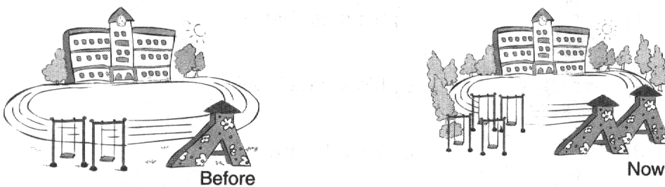
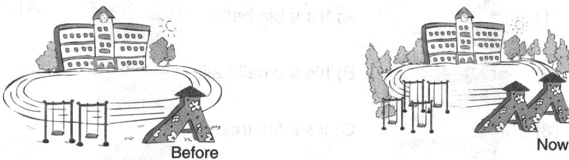
四、句子理解。
A.看图，选择正确的词填空。
there was; there are; my; there are; there weren’t

Look at two pictures. It’s _________ school.
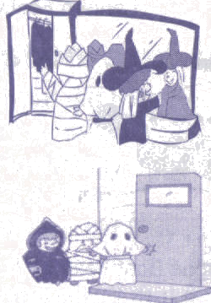
____________ any swings before. But now ____________ four swings here.
____________ one slide before. ____________ two slides here now.
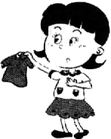
B.根据图文提示，写出句子。
2. A: Where do they go at Halloween?
B: They ____ ___ ________ ________.
1. A: _______ _____ ____ ___?
短裙
B: It’s Amy’s.
4. A: What are we going to do tomorrow?
B: We’re ____ ______ ____ ______ ______. (我们打算一起唱歌跳舞。)
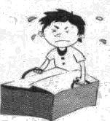
3. A: ______ _____ ____ _______.
I can’t lift it.

5. A: What were there before?
B: _______ ______ (有)some __________.(鸭子)

五、情景交际。选择恰当的句子补全对话, 将序号写在横线上。
A. And there are many sweets, too.
B. Great! Let’s go.
C. I can’t lift it.
D. Oh！What a big supermarket!
E. Let me help you.

Amy: Come on, Lingling. We’re going to go to the supermarket.
Lingling: 1.__________.
Amy: 2. .
Lingling: Yes, it is. There are many biscuits over there.
Amy: 3.____________
Ms Smart: Please help me put the bag in the car.
Lingling: This bag is so big! 4. .
Sam: 5._________
Ms Smart: You are helpful children. Have some sweets.
Amy. Sam, Lingling: Thank you.

六、阅读理解，判断正（T）误（F）。
Yesterday was Ella’s birthday. She had a birthday party at home. There were many friends there, two boys and four girls. Ella has got lots of birthday presents. There was a kite, three toys, two birthday cards and a computer game. She was very happy. She played the computer game with her friends. And they watched TV and ate a big birthday cake. Mum bought some sweets for them. The children like them very much.

( ) 1. There was a birthday party at Ella’s Home yesterday.
( ) 2. Ella wasn’t happy.
( ) 3. There were six friends there.
( ) 4. There weren’t any presents for Ella.
( ) 5. There was a birthday cake and some sweets.

七、小习作。
要求：万圣节刚刚过去，对于万圣节你都知道哪些风俗?
题目自拟，不少于5句话。
___________________________________________________________________________________________________________________________________________________________________________________________________________________________________________________________________________________________________________________________________________________________________________________________________________________________________________________________________________________________________________________________________________________________________________________________________________________________

五年级英语听力题签:
※注意：每道听力试题读二遍。时间控制在20分钟以内。
听力材料：五年级英语，听力部分，共四大题，每题读两遍。
Ⅰ. 听音，选出句子中所含的单词，将序号写在前面的括号内。
No.1 This big man wants to lift this big stone.
No.2 We went to the supermarket last weekend.
No.3 Christmas is on the 25th of December.
No.4 This building is only 1 year old. It’s new.
No.5 Tom saw a scary monster on the TV Show.
Ⅱ.听音,标号。用数字标出图片的先后顺序。
No.1 Amy is going to be 11. She is going to have a birthday party.
No2. Look! It’s an invitation for her party.
No.3 Amy’s mum is going to make a cake for her.
No4. Amy’s friend, Lucy also likes eating a cake.
No5. They are going to sing and dance.
No.6. They are going to take photos.
No7. After that, they’re going to help mum tidy the room.
No8. Amy’s friends are going to go home at three o’clock.
Ⅲ.听问句，选答句。将正确答案序号填在括号内。
No.1 On that day, children wear special hats and find chocolate eggs to eat.
Q: What festival is it?
No.2 Welcome to my party. It’s from nine o’clock a.m to three o’clock p.m.
Q: What time is the party going to be end?
No.3 The bag is so big. I can’t lift it.
No.4 The red dress is not mine.
Q: Whose dress is it?
No.5 I’m going to buy different things from lots of countries.
Q: Where am I going to go?
No.6 Look at the pictures of our school. There were some little trees here before.
Q: Were there lots of big trees here before?
No.7 Tomorrow morning, we are going to play with my friend at home.
Q: Where are they going to play?
No.8 There were five eggs before. But there are five chicks now.
Q：What can you see now?
Ⅳ. 听短文，判断正误。正确写“T”, 错误写“F”。
Christmas is coming. Lingling wrote an invitation for Jim.
Dear Jim,
Christmas is coming, please come to my Christmas party. We are going to have a Christmas tree and lots of sweets.
At 15 Apple Road, London
ON: 24th of December
From: 2 o’clock
To: 5 o’clock
Please reply. 听力部分到此结束！
五年级英语答案及评分标准：
听力部分(35分)
一. (1×5＝5分)) A B C A B
二. (2×8＝16分) 4 8 1 7 5 6 2 3
三. (1×8＝8分) A C C C A B A B
四. (1×6＝6分)) F T F F T F

笔试部分(65分)
一、(1×10＝10分) (每词一分，没大写，没变化扣减0.5分)
1. playground 2. Sometimes ，restaurants 3. invitation
4. sell , countries 5.laughing 6. mine 7. both , wet
- (1×15＝15分) B C B C A / B A B C B / C B C B B
- (1×10＝10分) (每词一分，没大写，没变化扣减0.5分)
1. yours 2. pond , before 3. night 4. sing , dance
5. supermarkets , restaurants 6. why 7.Whose
- A: (1×5空＝5分) B: (0.5×20词＝10分)
A: my, There weren’t, there are, There was, There are
(每空一分，没大写, 扣减0.5分)
B: 1. Whose skirt is it?
2. They go to people’s houses.
3. This box / bag is heavy.
4. going to sing and dance
5. There were , ducks (每词0.5分，没大写，没变化扣减0.5分)
五、(1×5＝5分) B D A C E
六、(1×5＝5分) T F T F T
七、（5分）
请任教五年级的英语老师批阅作文，并自行把握评分标准,做到心中有数。
备注：卷面满分为100分。（听力35分，笔试65分。）
优秀：90---100
良好：80---89
及格：60---79
不及格：0---59 2012年11月

