长海县2012~2013学年度第一学期阶段质量检测
小学英语 四年级 （60分钟完成） 2012. 11
听力部分（40分）
Ⅰ、听音，圈出你所听到的单词。
1、A. Mexico B. Indian C. Chinese
2、A . friend B. food C. finished
3、A. cooked B. cleaned C. climbed
4、A .trip B. top C. traditional
5、A .raining B. ride C. running
6、A .Maths B. watch C. wash
7、A .picture B. printed C. paint
8、A .was B. were C. wide

Ⅱ、听音标号 。
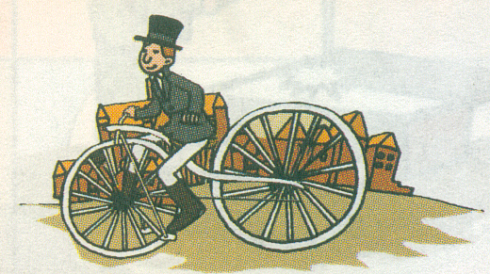
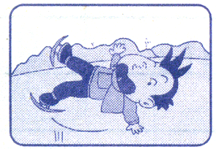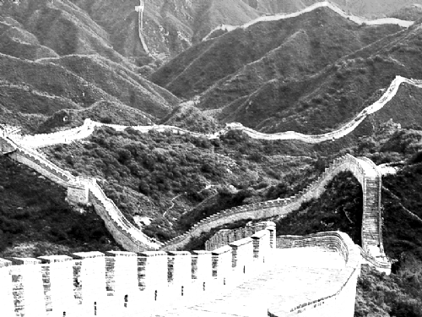
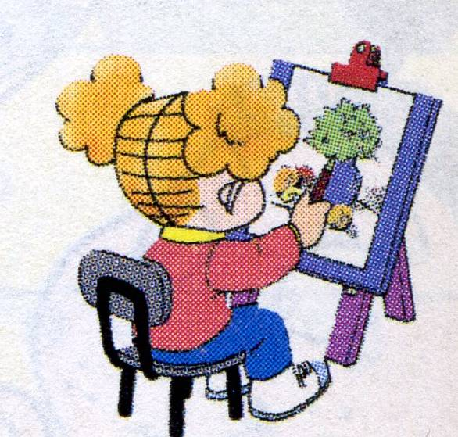
（ ） （ ） （ ） （ ）

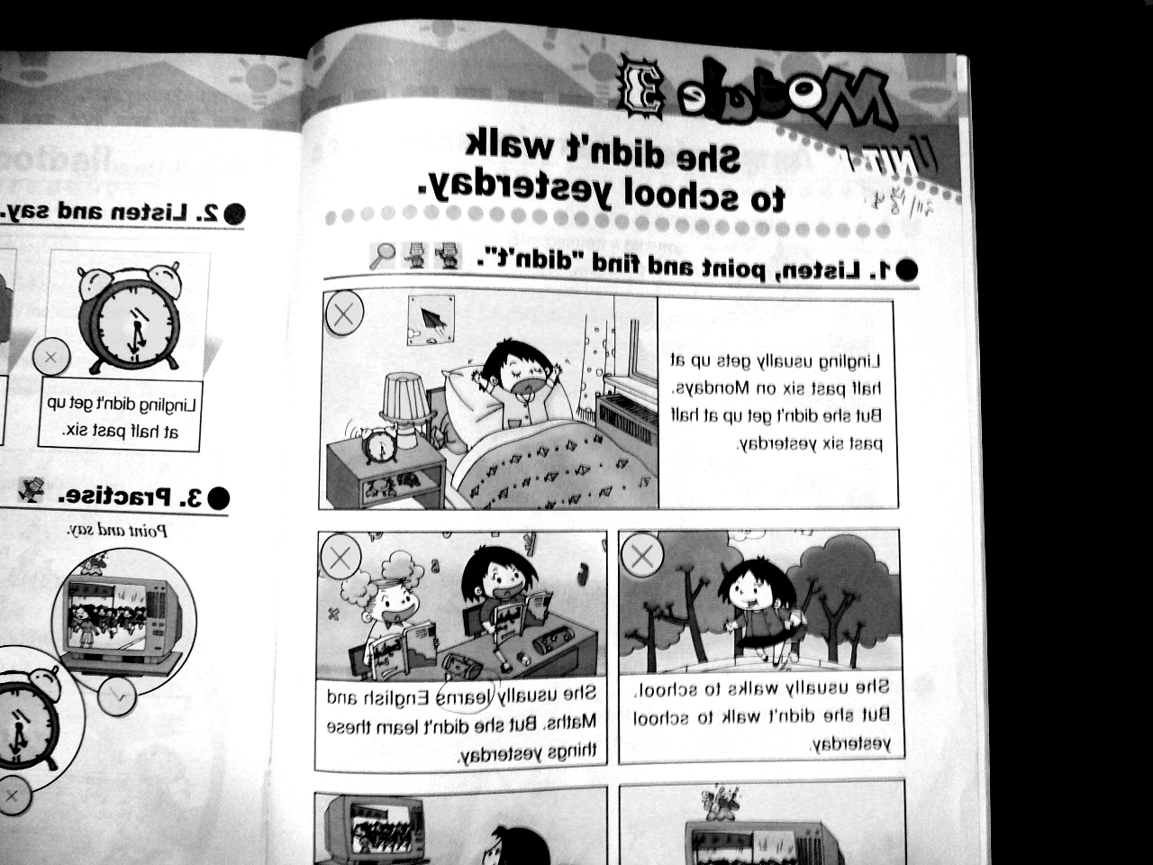
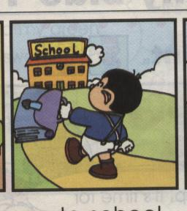

（ ） （ ） （ ） （ ）
Ⅲ、听音, 在你听到的句子前打“√”。
1、（ ）Zara has got a long, black hair . （ ）Zara has got a short, black hair .
2、（ ）Lucy lives in London . （ ）Lucy lives in New York .
3、（ ）Anita likes traditional Mexican food. （ ）Sam likes traditional Indian clothes.
4、（ ）Yesterday I cleaned my room . （ ）Yesterday I washed my trousers .
5、（ ）What is Mr. Smart doing ? （ ）What did Mr. Smart do ?
6、（ ）Lingling didn’t walk to school . （ ）Lingling walks to school .
7、（ ）She usually gets up at half past six . （ ）She didn’t get up at half past six .
8、（ ）Chinese people invented printing . （ ）English people invented bicycle.
Ⅳ、听问句，选择正确的答句。
( )1、A. She’s reading a letter. B. She learned English.
( )2、A. Yes, she did. B. Yes, she does.
( )3、A. They invented paper. B. They invented the bicycle.
( )4、A. He went to the Great Wall. B. He ate apples.
( )5、A. She lives in London. B. Yes, she does.
( )6、A. It’s from London. B. No, it isn’t.
Ⅴ、听音填词，补全短文。
My father usually ______to work. But he didn’t walk to work yesterday. Yesterday _____ Sunday. My father and I _____to the Great Wall .We ____ lots of mountains. We ate biscuits and apples. We _____a picture of the Great Wall. We______a good time.
笔试部分（60分）
Ⅰ、根据提示，写出单词，并把句子补全完整。
1. Write to me __________(不久). __________(告诉) me about China.
2. They were very ___________(脏的).
3. Chinese people invented ___________ (纸).
4. Yesterday was _________________________(国庆节) .
Ⅱ、 选择，将序号写在（ ）里。
( )1、It was my birthday __________ Saturday.
A. in B. at C. on
( ) 2、This is a picture __________ Zara and me.
A. to B. of C. for
( ) 3、Children from America are __________.
A. Russia B. American C. USA
( ) 4、Yesterday I __________ my room.
A. cleaned B. clean C. cleaning
( ) 5、I __________ my friends yesterday.
A. phone B. phoned C. phoneed
( )6、Chinese people invented __________.
A. printing B. printed C. print

( )7、Lingling usually gets up__________half past six __________ Mondays .
A. at / in B. to / on C. at / on
( )8、She usually __________ to school.
A. walks B. walk C. walked
( )9、I didn’t __________ football.
A. playing B. played C. play
( )10、He invented this bicycle __________ 1839.
A. on B. at C. in
( ) 11、 ---Where ____ your mother work? ----She worked in a shop .
A.do B.does C.did
( )12、Yesterday Maomao didn’t ________ to school. She ______ to the park.
A.go… went B.went…went C.go…goes
( )13、I will be eight ________ April .
A.on B. in C. at
( )14、Yesterday I __________my trousers .
A.wash B. washed C . washes
( )15、-----What did you do yesterday ? -----I ___________ .
A. watching TV B. plays football C. stayed at home
Ⅲ、情境交际，把正确答案的序号写在横线上。
- Thank you .
- I went to a book shop .
C. What are you doing ? D. You’re welcome .
E. I’m reading a book .
Amy : Hi, Lingling.______________
Lingling :I’m cooking . And you ?
Amy :____________________
Lingling :Yesterday , I went to a shop and bought some food.What did you do ?
Amy :___________ I bought a book for you . It’s very interesting .
Lingling :_________________
Amy :__________________
Ⅳ、看问句，选答句。
( )1、Where does she live ? A. I ate apples.
( )2、What did you eat? B. I’m reading a letter.
( )3、What are you doing ? C. She lives in London.
( )4、What did you see? D. I saw lots of animals.
( )5、Where did you go? E. I went to the Great Wall.

Ⅴ、看图回答问题，补全下列句子。
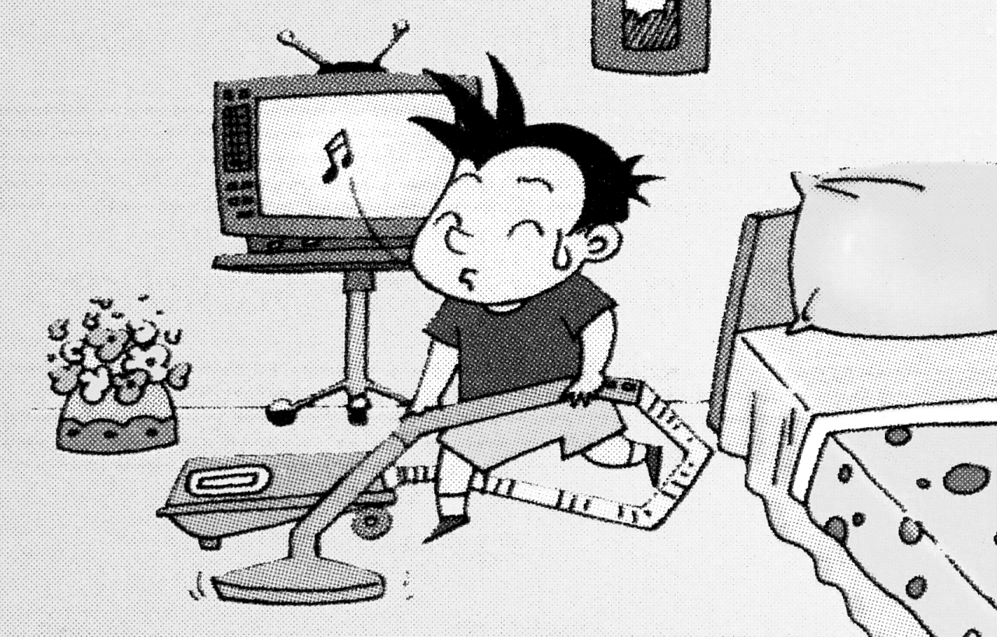
- A: What is Daming doing?

B: He _____________________ his room .


2、 A: What did Tom’s father do ?
B: He ___________________noodles.

- Daming usually _________________________.

VI、阅读理解,判断正（T）误（F）。
Dear Lucy,
I went on a school trip yesterday. I went to the zoo. It was very cold. I wore warm clothes. I visited lots of monkeys, they ate some bananas. I fell over. Sam helped me. I had a good time.
From
Amy

( )1、Yesterday ,Amy went to the zoo.
( )2、Lucy wore warm clothes.
( )3、Amy saw lots of tigers and monkeys.
( )4、Amy helped Sam.
( )5、Amy and Sam ate some bananas.

四年级英语听力题签:
※注意：每道听力试题读二遍。时间控制在25分钟以内。

一、听音，圈出你所听到的单词。
1、This girl is from Mexico.
2、I’ve got a new friend .
3、 Yesterday Daming cleaned his room .
4、I like traditional English food.
5、It’s raining . I can’t go out to play.
6、I didn’t learn English and Maths.
7、Amy printed the newspaper .
8、My birthday was on Tuesday .

二、听音标号 。
1. Last summer, Simon visited China, He went to the Great Wall.
2. Happy National Day!
3. This girl learned to skate.
4. Daming walks to school at seven.
5. She gets up at six o’clock.
6. English people invented the bicycle.
7. Amy painted a picture.
8. He fell over.

三、听音,在你听到的句子前打“√” 。
1、Zara has got a long, black hair .
2、Lucy lives in London .
3、Sam likes traditional Indian clothes.
4、Yesterday I washed my trousers .
5、What did Mr. Smart do ?
6、Lingling walks to school .
7、She usually gets up at half past six .
8、Chinese people invented printing .

四、听问句，选择正确的答句。
1、What’s Lingling doing ?
2、Did Ms Smart phoned Grandma ?
3、What did English people invent ?
4、Where did Sam go yesterday ?
5、Does Lucy live in China？
6、Is this letter from Lucy ?

五、听音填词，补全短文。
My father usually _walks________to work. But he didn’t walk to work yesterday. Yesterday _was____ Sunday. My father and I _went______to the Great Wall. We __saw______ lots of mountains. We ate biscuits and apples. We __bought__________a picture of the Great Wall. We___had______a good time.

听力部分到此结束！.

四年级英语答案及评分标准

听力部分(40分)
  - （1×8＝8分）A A B C A A B A
  - （1.5×8＝12分） 8 6 1 2 5 4 3 7
  - （1×8＝8分） 详见听力题签
  - （1×6＝6分） A A B A B B
  - （1×6＝6分） walks was went saw bought had

笔试部分（60分）
Ⅰ.（1×5＝5分） soon , Tell , dirty , paper , National Day
(每空1分，没大写，没变化扣减0.5分)
Ⅱ.（2×15＝30分） C B B A B A C A C C C A B B C
Ⅲ.（2×5＝10分） C E B A D
Ⅳ. （1×5＝5分）C A B D E
Ⅴ. （1×5词＝5分） is cleaning / cooked / rides (his, a) bike
VI. （1×5＝5分） T F F F F

备注：卷面满分为100分。（听力40分，笔试60分。）
优秀：90---100
良好：80---89
及格：60---79
不及格：0---59

2012年11月

