新标准一起第十一册Module 4 Unit 2 教学设计
小泡子小学：杨蕉宇
[教学目标]
1．语言知识目标：熟练掌握核心词special,hear ,nearly , present,together. 以及重点句型It is a very important festival.
2.语言技能目标：能够运用词汇和使用句型去描述东西方国家的节日
3．情感态度目标：让孩子们学会感谢他们的父母，老师，朋友……
[教学重、难点]
Talking about the festival.
[教学准备] CD, cards ,exercise-book ,ppt
[教学流程]
Step:Warm- up
1.Free talk.
T：Hello. Boys and girls! Can you tell me about Thanksgiving ?
S: Yes, It is in ……..
T: What’s your favourite festival?
S1: My favourite festival is ……
T: When is it?
S1: It’s in …….
T:What do you do on……?
S1：We….
T: My favourite festival is New Year’s Day. So we have three holidays. Maybe we can go to music concert. New Year’s Day is in January.
T: Can you tell me the exactly date?
(Teacher leads the students try to say out “New Year’s Day is on the first of January.”)
2. T:when is Children’s Day / National Day/ April Fools’Day?
teacher leads them to say out “Children’s Day is in June.”/“Children’s Day is on the 1st of June.” “April Fools' Day is in April.”/“April Fools' Day is on 1st of April.”…… …… ……
3.Say a chant and do some practises.(无日填上in ,有日on值勤,序为月日年或为日月年.)
Step2: Presentation .
T: I’ll show some pictures for you? What are they? Tell me in English as quickly as you can!
Ss: Christmas tree, Christmas card, presents,
T: Look, who is he? He is Santa Clouse, people also call him “Father Christmas”.
T: what festival is it?
Ss: Christmas!
T: Yes,I like Christmas. It’s a very important festival.(板书) Today we are going to learn what people do on Christmas in many countries.
Step 3: Practice
1.play the CD-ROM with several questions
T: Before we listen to the text, I’ll give you some questions about it. You should give me the answers after listening. OK?
Q1: When is Christmas?
Q2: What do people put in their homes?
Q3: What can you see in the street?
Q4: What do people give?
Q5: What do people send?
2.Discuss several questions in groups.
3.Lead students to answer these questions and learn new word“present”
4..Listen again and learn the sentence.
5. Read by themselves in groups.
Step4: Production.
1. Complete exercise1 (test paper) and check to answer in groups .
2.Game : guess the festival.(exercise 3)
3.Complete exercise 2 and check in groups.
4. Writing .
Step 5: Summary and homework （小结与作业）
1．What did you learn today?
2. Copy words and drills three times.
3.Complete writing :Write short passages to introduce the custom of their favorite festival.

选择题：
1、Can you tell me about （ ）festivals？A、america B .American C、America
2．Christmas is （ ）the 25th of December . A. on B. at C. in
3. ( ) your favourite food? ----- noodles. A. what B . which C.what’s
4. There are ( ) lights in the streets. A. many B . lot of C. much
5. Thanksgiving is ( ) November? A. in B. on C. at

情景交际。
A．When is it？ B．What’s your favourite festival? C．What do you eat ?
D．Why do you like it ? E．What do you say ?
Lingling: ____________
Laura : Thanksgiving is my favourite festival.
Lingling: _____________
Laura: It’s in November.
Lingling: ____________
Laura: We get together. We have a big ,special dinner.
Lingling: ____________
Laura: We say thank you for all the good things we have .
Lingling: ____________
Laura: We eat turkey(火鸡) and cakes.
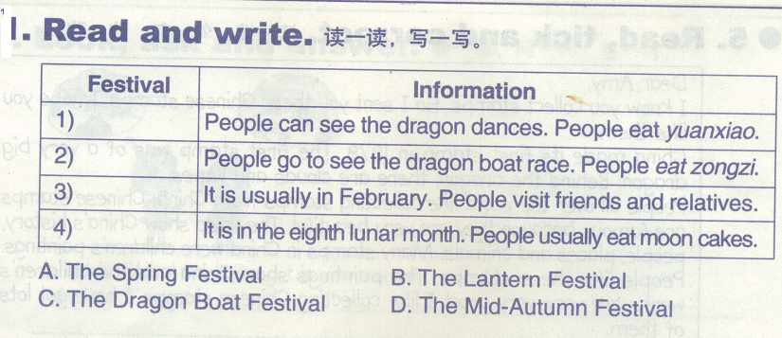
小练笔：
请以“My Favourite Festival”为题写一个你最喜欢的节日。提示词：January 一月，February二月，December十二月 ，Chinese American English have(有) ，watch (看)，eat(吃) play(玩) do make(制作) a lot of ，fun interesting ，happy ，together

