六年级英语第二学期期末综合试卷
听力部分
一． 听音，选出你听到的单词： (5分)
（ ）1．A. travel B. arrive C. around
（ ）2．A. model B. middle C. excited
（ ）3．A. away B. angry C. video
（ ）4．A. Geography B. History C. Science
（ ）5. . A.  B.  C.
二．听音，将正确的序号填在括号中。(5分)

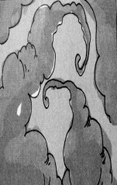
A、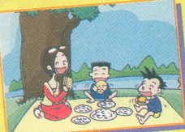 B、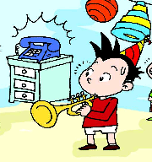 C、 D、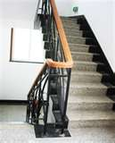 E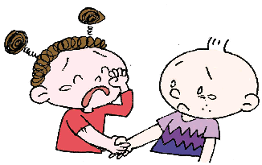
1、_______2、________3、_______4、_________5、________
三、根据所听到的问句，选出正确的答句，将其序号填在括号里。(10分)
( ) 1. Sorry, I can’t.
( ) 2. There are six hundred students.
( ) 3. I want some tea.
( ) 4. B. We’re going to eat at half past five.
( ) 5. A. You mum gave it to me.
四．听短文，选择正确的答案。（10分）
  - 1 After school we often_____together.
A: play ping-pong B: go home C: play games
  - It’s going to _____.
A: be hot B: rain C: be windy
  - I usually go to bed at _____.
A: nine B: half past nine C: ten past ten
  - We don’t go to the cinema on _____.
A: Sundays B: Mondays C: Wednesdays
  - What do you do in the _____
A: evening B: afternoon C: morning
笔试部分：
一、选择正确答案 （10分）
( ) 1._____ middle school are you going to go?
A. What B. Which C. Where
( ) 2. —I bought a book for you. — _________________________.
A. Thank you. B. You’re welcome. C. Sorry.
( ) 3.I’m very _______ _____ that!
A. interested in B. interesting in C. interested at
( ) 4.What _________________!
A. a great book B. great a book C. great book
( ) 5. It’s going to ______ in Dalian .
A. be hot B. be snow C. be rain
( ) 6. She a letter to Sam yesterday.
A. writing B. writes C. wrote
( ) 7. Hold _____ to the balloons. They’re flying _______.
A. in, away B. on, to C. on, away
( ) 8. Now look at this photo. We are our picnic.
A. have B. having C. had
( ) 9. In October 2003, Shenzhou V _________ into space.
A. flies B. flying C. flew
( ) 10. She ______ to middle school this September.
A. went B. is going to go C. go D. goes
二 看图填单词，完成句子)。（10’）
1.My sister is a ___________(女服务生)。
2.We were wet, hungry and __________(生气的) with the ducks.
3.They made a Chinese ____________ (宇宙飞船)
4. I’ve got lots of ________(录像)about Chinese music.
5. We’re going to have a ________ (棒球) match this weekend.
6、Everyone is (鼓掌) .
7.It’s easy to make _________ _________ (犯错误)with English.
8.There are 2500 ___________ ( 学生 ) at the school.
9、Ningkang is very ______(自豪的) of his dad.
三、情景反应（5）
- What are you going to do? A. He is a doctor.
- Are you going to go to middle school ?. B. It’s windy.
- Who is your Dad? C. We are going to study
Geography…lotsof new things.
- What are you going to study at middle school? D. Yes, we are
- What’s the weather going to be like? E.We’re going to have a picnic.
四、补全对话,请把正确选项的序号填在横线上（10）
Sam: ___________? Why are you laughing?
- It’s easy to make mistakes with English.
- What’s the matter?
- What?
- Why are you wearing cups on your heads?
- Great!

Lingling: We’re going to have a baseball team.
Sam: ________________.
Lingling: Amy said,” Bring cups for the baseball game”.
So I brought these cups.
Sam: ____________. And look what I’ve got in my bag.
All: ________?
Sam: The baseball caps.
All: ____________!
五、按照要求，改写下列句子。
1、Amy is reading a book. Mum is cooking.(用but then 连接)

2、balloons, flying, all, are, away, the ( .)

3、We are having a picnic.（一般将来时）

4、I want a hot dog . (划线部分提问)

5、She can sing in English now.(一般过去时)

六、完形填空 （10）
Hi, my name is Lili. I’m_1._____, but I live in England. I 2._____ English very well. But sometimes I 3.______ mistakes. Last Sunday we 4.______ to visit a farm. I was very 5.______. I told my friends I wanted to 6._____ a ship. Everyone looked surprised and I didn’t know why. My teacher said, “Lili, we are 7._____ to a farm, not to a lake 8._____ a sea. There are no ships on the farm.” Then I 9._____ my mistake. I wanted to say “sheep”, not “ship”. It was very 10______.
- A.Chinese B.China C.chinese
- A.say B.tell C.speak
- A.make B.take C.have
- A.go B.went C.want
- A.sad B.angry C.happy
- A.see B.seeing C.saw
- A.go B.going C.went
- A.and B.or C.but
- A.knew B.know C.knows
- A.excited B.scared C.funny
七、阅读理解
I had a very funny day on Sunday .I went to a beautiful lake with my father, mother and sister, There were many fish in the lake. We took bread, colas, water, hotdogs, sweets and bananas. First my father wanted to fish. Sue and I wanted to eat. My mother wanted to fly a kite. At last, my father got fourteen fish. Sue and I were very full. My mother was angry, because there wasn’t any wind. We went home at five o’clock.
1. Where did we go ?
A. We went to a park. B. We went to a lake. C. We went to a zoo.
2.Were there any fish?
A. Yes, there is. B. No, there weren’t. C. Yes, there were.
3. What was the weather like?
A. It is sunny. B. It’s windy. C. It’s rainy.
4. Does the father like fishing?
A. Yes, he is. B. No, he doesn’t. C. Yes, he does.
5. Were there any frogs here?
A. Yes, there were. B. No, there weren’t. C. Sorry, I don’t know.
作文、（5）
下课时间到了，根据提示词，看看你身边的同学和老师都在做些什么？
What are they doing? (不少于50字)
fly read play play hide and seek ship talk jump ….
_________________________________________________________________
_________________________________________________________________
_________________________________________________________________
__________________________________________________________________
_________________________________________________________________
_________________________________________________________________

