长海县2011~2012学年度第二学期期末质量检测
小学六年级 英 语 完成时间：80分钟
题号 | Ⅰ | Ⅱ | Ⅲ | Ⅳ | Ⅴ | Ⅵ | Ⅶ | Ⅷ | Ⅸ | Ⅹ | Ⅺ | Ⅻ | 附加题 | 总分
得分

听力部分( 30分)
Ⅰ、 听辨单词，选出你所听到的句子中的单词。
( ) 1. A. spend B. spaceship C. spent
( ) 2. A. wrote B. wore C. worked
( ) 3. A. sent B. said C. cents
( ) 4. A. away B. arrive C. angry
( ) 5. A. someday B. study C. students

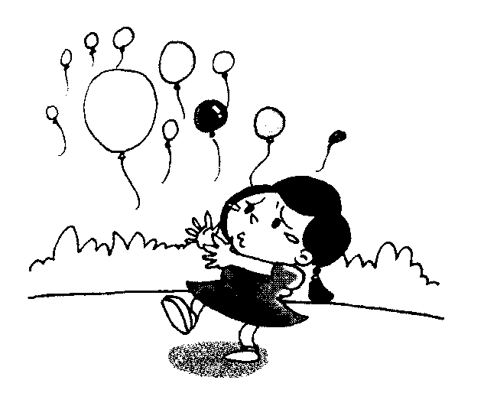
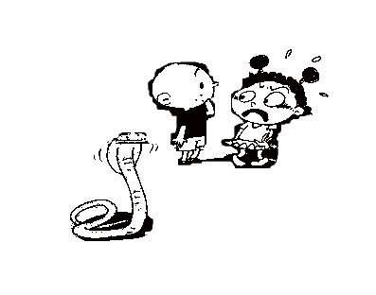
Ⅱ、听句子选图片，根据所听顺序将其序号填写在相应的横线上。
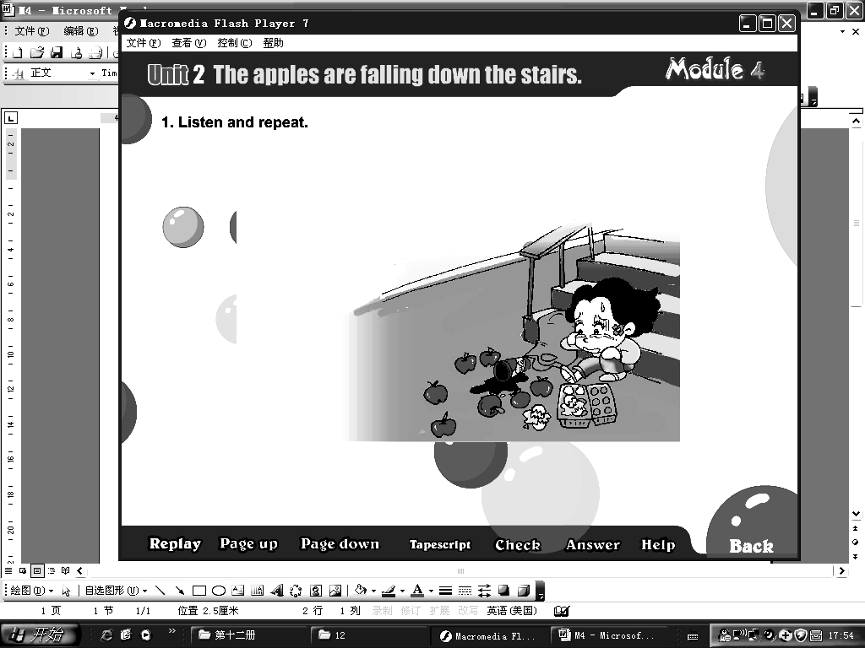
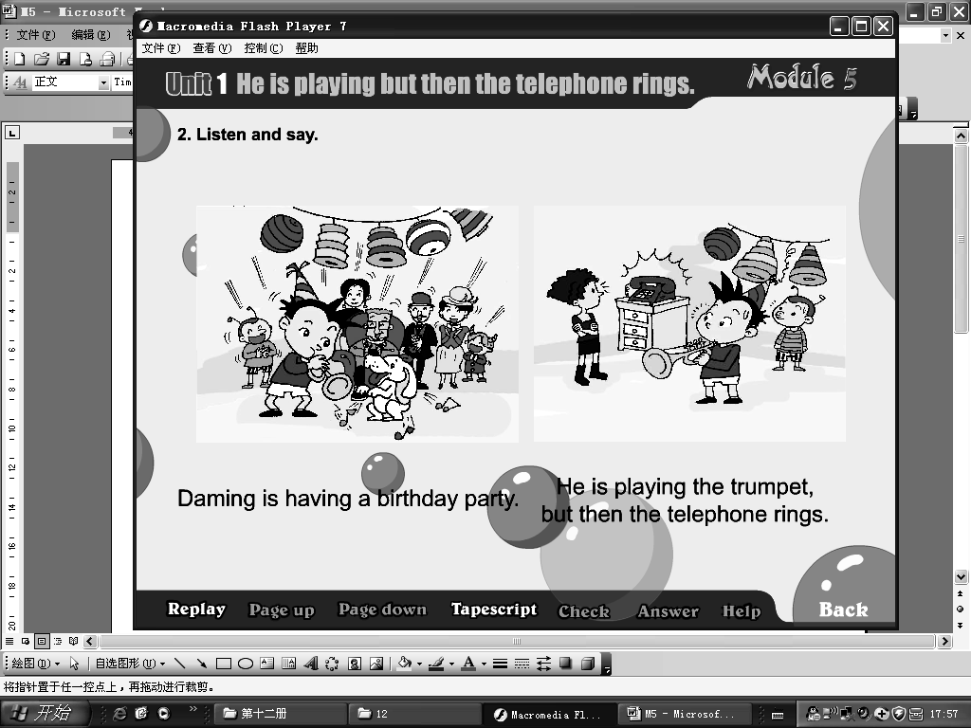
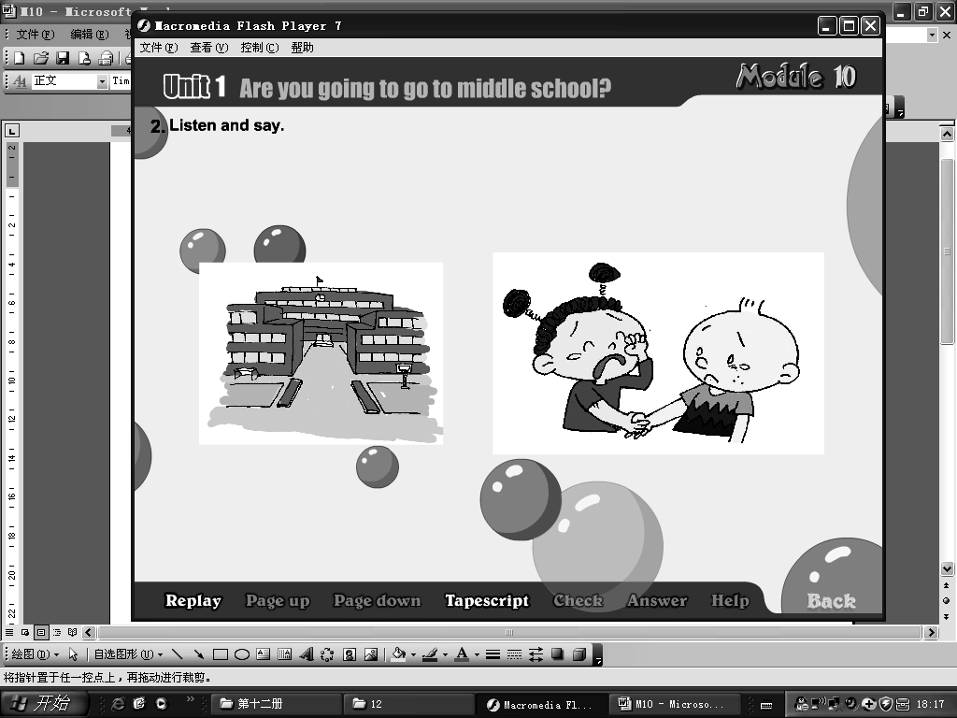

A B C D E

1. ________ 2. ________ 3. ________ 4. _______ 5. _______
Ⅲ、听问句选答语，将其序号填写在前面的括号里。
( ) 1. A. It’s windy. B. It’s going to be sunny.
( ) 2. A. Because I’m happy. B. Because I’m very sad.
( ) 3. A. I want some tea. B. I want some meat.
( ) 4. A.I took some photos. B. I’m reading.
( ) 5. A. No, I didn’t. B. Sorry, I can’t.
Ⅳ、听短文，判断正(T)误(F)。
( ) 1. This is a letter from Amy.
( ) 2. Lingling and her parents went to Hawaii(夏威夷) last week.
( ) 3. Amy and Lingling walked on the beach and swam in the sea .
( ) 4. Hawaii is a wonderful place. Lingling took a photo for Amy.
( ) 5. Lingling’s family had a good time in Hawaii.
笔试部分（共75分）
Ⅴ、选择。
( )1. In Harbin, it’s going to _____________.
A. hot B. snow C. rainy
( )2. Ningkang _______a very famous dad. He is ________ of his father.
A. have , happy B. has , excited C. has , proud
( )3. A: ________ is my football ? B: Under the bed.
A.Why B.Where C. What
( )4. She is singing. Everyone is listening and _________.
A .clap B. claping C. clapping
( )5. Daming _______ a model of a Chinese spaceship yesterday.
A. make B. made C. came
( )6. We are going to ________a baseball team.
A. has B. had C. have
( )7. A: How will you go to your new school? B:_________
A. By bus. B. Yucai Primary School C. In Changhai
( )8. A:______________ B: I fell over.
A. How are you ? B. What’s the matter? C. Good night!
( )9. It’s easy to ________ mistakes with English.
A. making B. made C. make
( )10. It started to rain. We ran home _________.
A. run fast B. quickly C. quick
Ⅵ、请根据所给语境，正确补全下列句子。
1. In this photo, the sun is ____________ (发光).
2. This bag is ___________(重), I can’t ____________(提) it.
3. I am __________(感兴趣) in that book , because it’s very interesting.
4. English will be very ___________(有用) for us.
5. We want to ________ ( see ) some lovely animals at the zoo.
6. Look! Some children ______________（swim）in the river now.
7. Tom_________ ( get) up at 7:30 a.m. every day, so she is always late for school.
8. He __________ (buy ) a new car yesterday.
9. We’re going to ___________ (have ) a picnic in the park tomorrow.
Ⅶ、情景反应, 请将序号填入题前的括号内。
( ) 1.Happy birthday to you ! A. At half past twelve.
( ) 2. Who gave this book to you? B. Thank you.
( ) 3. When are we going to eat? C. My father.
( ) 4. Can you speak English ? D. I flew a kite in the sky.
( ) 5. What did you do yesterday ? E. Yes, I can.
VIII、情景交际，补全对话。
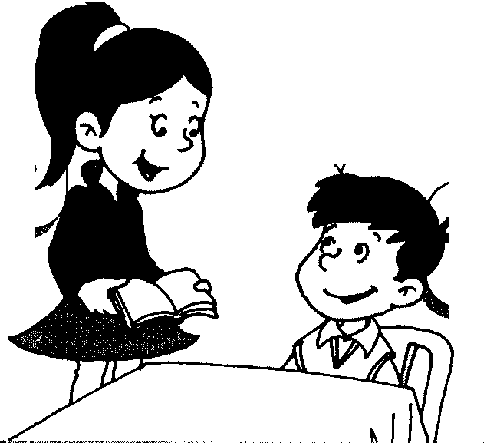

A: _______do you want to eat ?
B:I want some ___________and
some__________ , please.
A: What do you want to _________?
B: I want a _______, please.
_______ _______is it?
A: It’s ￥________, in all.
B: Here ______ ______.

Ⅸ、句型转换。
1. Are you going to go to middle school this September? (作答)
2. having \ are\ we \ our \ picnic\ .（连词成句）
3. I’m watching TV. Sam is eating an apple. ( 用“but then ”连句)
4. I had a very funny day. (改为否定句)
5. There were lots of naughty ducks. (改为单数句子)

Ⅹ、完形填空。根据语境从括号里选择恰当的单词写在横线上。
Helen Keller was born in 1880 in __________（England , America ）. She was blind and ________（deaf , loud ）, and she __________（could , couldn’t ）talk. So it’s very difficult _______（for , to ）her to learn, but she was a very________（clever , bad ）girl, she learned to _______ （reading , read ）and write. “________”（teacher , water ）was Helen’s first word. She ________（ wrote , writes ）books about her life. She _______（is , was ） famous. She helped _______（normal , blind ）people everywhere.

Ⅺ、阅读理解。
Yesterday morning, a rabbit went to a field. She saw many carrots( 胡萝卜). She went home and took a big bag, she put all the carrots in the bag. It was very heavy. She didn’t know what to do, so she sat on the floor.
Just then a dog came and saw all this. He wanted to help the rabbit with the bag. But they still couldn’t move(搬动) the bag. ＂Please wait here!＂the dog said and ran away.
After some time, the dog came back with many friends, the panda, the elephant, the pig and the sheep. The rabbit was very happy. They began to move the bag. This time it was very easy and they helped the rabbit get the bag home.

（ ）1．The rabbit went to ____________ yesterday morning.
A. a park B. a field C. a playground
（ ）2．She saw _________ in the field.
A. potatoes B. fruit C. vegetable
（ ）3．She _________ move the bag because it was very ___________.
A. can’t , heavy B. can , light C. is , heavy
（ ）4．The dog and the rabbit ____________ the bag.
A. could move B. couldn’t move C. are moving
（ ）5． At last, the rabbit was very happy because ___________________.
A. he has friends B. They can move it C. A and B
Ⅻ、写作园地。
请以＂My Family＂为题写一篇英语小作文。要求语句通顺，条理清晰，标点正确，书写规范, 不少于50个单词。
_____________________________________________________________________________________________________________________________________________________________________________________________________________________
_____________________________________________________________________________________________________________________________________________________________________________________________________________________
______________________________________________________________________________________________________________________________________________

附加题
1. A: _______ ______ do you go to the library ? B: Once a week.
2. I’m ________ (tall ) than you .
3. The girl ________ the green dress is my sister.
4. Shenzhou Ⅸ(神九)flew into space ______ June16th, 2012. Liu Yang is China’s first _________ in space.
5. A: Do you like cola or milk? B:__________________
六年级英语听力题签:
※注意：每道听力试题读二遍。时间控制在15分钟以内。

Ⅰ、 听辨单词，选出你所听到的句子中的单词。
1. Yang Liwei spent 21 hours in space in 2003.
2. Amy wrote a letter to her friend.
3. “Blind people are normal people.” she said.
4. I arrived home at six o’clock yesterday evening.
5. There are 49 students in my class.

Ⅱ、听句子选图片，根据所听顺序将其序号填写在相应的横线上。
1、A: I will miss you . B: I will miss you , too.
2、Now I’m very scared. Because there is a snake.
3、He’s playing the trumpet, but then the phone rings.
4、What a mess ! Who can help me ?
5、All the balloons are flying away.

Ⅲ、听问句选答语，将其序号填写在前面的括号里。
Q1: What’s the weather going to be like tomorrow?
Q2: Why are you laughing?
Q3: What do you want to drink?
Q4: What are you doing?
Q5: Did you give it to her ?
Ⅳ、听短文，判断正(T)误(F)。
Dear Amy,
How is everything? We all miss you. Last week, I went to Hawaii(夏威夷)with Dad and Mum. It is really a wonderful place. We walked on the beach, swam in the sea, ate lots of sea food and watched a very beautiful dance. It was so hot in Hawaii, but we had a good time there.
Here is a photo for you. Hope you like it. Please write to me soon.
From,
Lingling

听力部分到此结束！
六年级英语答案及评分标准：
听力部分（30分）
Ⅰ、(1×5＝5分) CABBC
Ⅱ、(1×5＝5分) B—-E---A---D---C
Ⅲ、(2×5＝10分) BAABA
Ⅳ、(2×5＝10分) F T F T T
笔试部分（75分）
Ⅴ、(1×10＝10分) BCBCB CABCB
Ⅵ、(1×10空＝10分)
shining , heavy , carry (lift) , interested , useful , see, are swimming , gets , bought , have
（注意 ：共计11个单词，其中画有“—”的2个单词如果没有形式的变化将各扣0.5分， 其余单词必须完全拼写准确方可得1分。）
Ⅶ、(1×5＝5分) BCAED
Ⅷ、(1×10＝10分) What , fish , rice , drink , cola , How , much , 19 , you , are
（注意 ：共计10个单词，其中画有“—”的2个单词如果没有形式的变化将各扣0.5分， 其余单词必须完全拼写准确方可得1分。）
Ⅸ、(2×5＝10分)
1. Yes, I am. Yes, we are. \ No, I’m not. No, we aren’t.
2. We’re having our picnic.
3. I’m watching TV but then Sam eats an apple. / Sam is eating an apple but then I watch TV.
4. I didn’t have a very funny day.
5. There was a naughty duck.
Ⅹ、(1×10＝10分) America , deaf , couldn’t , for , clever , read , water , wrote , was , blind
XI、(2×5＝10分) BCABC
XII、(5分) 答案略。请任教六年级的英语老师批阅作文，并自行把握评分标准,做到心中有数。
一等：4----5分（主题鲜明，表述恰当，语言结构准确。）
二等：3分（主题较为鲜明，表述较为恰当，语言结构较为准确。）
三等：0-----2分（主题朦胧，语言表述不清，错词乱句，信息模糊。）
附加题、(1×5＝5分)
How often ， taller ， in ， on , woman , I like cola / milk.
备注：卷面满分为100分。（听力30分，笔试75分。）
优秀：90---100
良好：80---89
及格：60---79 2012年7 月1日
不及格：0---59

