长海县2011~2012学年度第二学期期末质量检测
小学五年级 英 语 完成时间：80分钟
题号 | Ⅰ | Ⅱ | Ⅲ | Ⅳ | Ⅴ | Ⅵ | Ⅶ | Ⅷ | Ⅸ | Ⅹ | Ⅺ | Ⅻ | XIII | 总分
得分

听力部分( 35分)
Ⅰ、 听辨单词，选出你所听到的句子中的单词。
（ ）1、 A. play B. player C. place
（ ）2、 A. sausage B. sandal C. sandwich
（ ）3、 A. turn B. read C. return
（ ）4、 A. send B. sent C. sad
（ ）5、 A. hurry B. carry C. cloudy

Ⅱ、听音，根据所听顺序用数字(1,2,3,4,5)给下列图片重新排序。
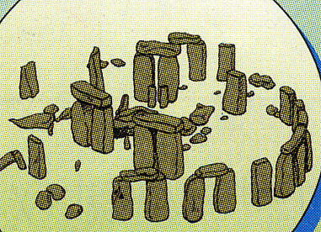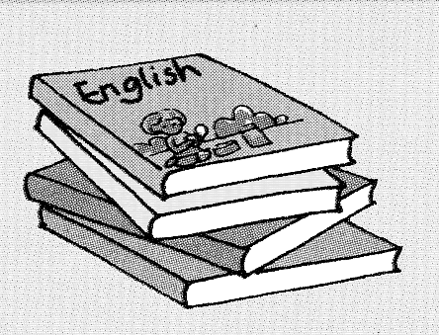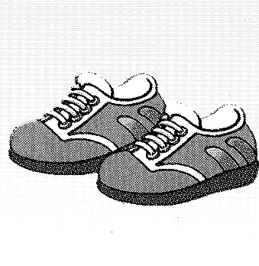
（ ） （ ） （ ） （ ） （ ）
Ⅲ、听问句选答语，将其序号填写在前面的括号里。
（ ）1、A. He was a worker. B. She worked in a factory.
（ ）2、A. These are my shirts. B. I put two shirts in my bag.
（ ）3、A. I had dinner at eight o’clock. B. He has dinner at six o’clock.
（ ）4、A. She likes Chinese animals. B. He played Chinese music.
（ ）5、A. I was a doctor. B. I am a teacher.
Ⅳ、听短文，选择最佳答案。
( )1、 Daming got some presents from_____________.
A. England B. America C. China
( )2、 Daming and ________played the Maths game last Sunday.
A. grandma B. parents C. Lingling
( )3、 A: Can Daming speak English? B:______________
A. Yes, he will. B. No, he didn’t. C. Yes, he can.
( )4、 A: When did Daming read English books? B:______________
A. Last Sunday. B. Yesterday. C. Last week.
( )5、 ___________ will eat delicious chocolates together.
A. Families B. Daming C. Dad and mum
笔试部分（共65分）
Ⅴ、选择。
( ) 1. A:What did she _______ for lunch ? B: She had eggs and sausages.
A. have B. has C. had
( ) 2. You ______ talk to your friends in the library.
A. can B . can’t C. doesn’t
( ) 3. I carry it _______ my back.
A . on B . with C . over
( )4. The leaves fall from the trees. I can play with _______.
A. it B. them C. they
( )5. She ___________ got some CDs.
A. had B. have C. has
( )6. I ___________ a ticket in my bag yesterday.
A. put B. putting C. puts
( )7. A:___________ will you go tomorrow? B: I’ll go to the airport.
A. When B. Where C. Who
( )8. A: Your library card, please. B: __________________
A. Thank you. B. I hope so. C. Here you are.
( )9. My grandpa ______ a flute player before.
A. is B. was C. were
（ ）10. We’ll see lots of big stones. They are ______ a circle.
A. on B. in C. with

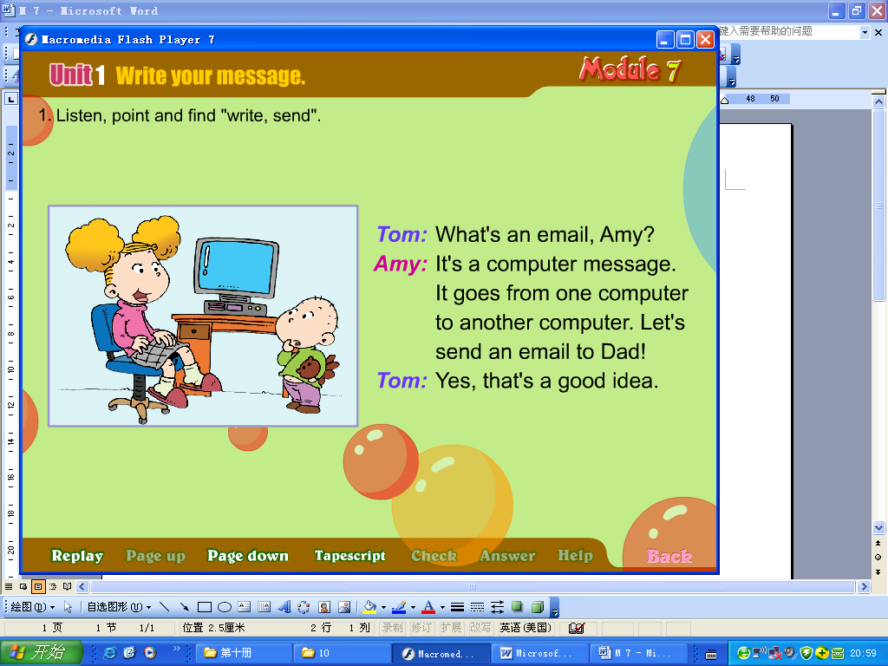
Ⅵ、重组排句， 合理做事。
( ) Click on “Send”.
( ) Click on “Write”. ( ) Now I can send an email .
( ) Click on “Email” ! ( ) Write your message .

Ⅶ、请根据所给语境，正确补全下列句子。
1. Draw a dragon on a ___________（张）of paper.
2. There are four _________________( 季节 )in a year.
3. Chinese people ____________ (建造) the Great Wall.
4. I can ____________(解释) the problem.
5. How are you ? I’m ___________（很好），thank you.
6. Mr___________ (布朗) works in America.
7. You can __________ （借来）books in a library.
8. My school bag is pink. I carry it over my (肩膀).
9. My teacher is very _____________ (繁忙的) every day.
10. I cleaned my ___________ (房间) yesterday.
VIII、连词成句。
1、me / help / will/ you （？） ___________________________________ _
2、broken / bag / your / is (.)
3、bus / drove / a / she (.) ____________________________
4、see / you / will / what （？） _________________________________
5、some / have / got / we / books( .) _________________________________
Ⅸ、情景反应, 请将序号填入题前的括号内。
( ) 1. How will you get there? A. I can go swimming .
( ) 2. Where did your grandpa work? B. It’s my grandma.
( ) 3. What can you do in summer? C. At 8:00 in the morning.
( ) 4. When are you going to leave ? D. By car.
( ) 5. Who is this in the picture? E. He worked in an office.
Ⅹ、根据语境选词填空, 将序号填写在下面的横线上。
A. women B. a lot C. were D. theatre E. lots of

Last week we went to a children’s ___ . The men wore women’s clothes.
The wore men’s clothes. The actors told jokes. It was very funny. We laughed __ . We _________very happy.

Ⅺ、完形填空。根据语境提示补全下列短文。
I am Amy. Last summer I ______（go）to Hainan with my parents. We went there ______ plane and we went there _______July. We _______ (play) on the beach. We _______(visit) very old places. They _______ (be) amazing. I _________ (buy) some beautiful hats. I _______(make) a new friend there. Her name is Linda. I will write_______her. We had a really good time together. I hope I can ______(visit ) Hainan again.
Ⅻ、阅读理解。
Last summer Li Ming visited his friend, Little Peter in the USA. One day, they had lunch at a restaurant. “What do you want?” the waiter(服务生) asked. “I want an egg, some fish and a cake, ” Little Peter said. “What about you?” “I want Beijing Duck,” Li Ming said. “Sorry, we don’t have that,” the waiter said. “My friend, you are in New York, not in Beijing.” Li Ming laughed. Then he said, “Sorry, I thought I was in Beijing.” They all laughed
（ ）1. A: Where was Li Ming? B: He was _____________.
A. in Beijing B. in America C. in London
（ ）2. A: What did Peter want? B: He wanted_____________.
A. an egg, some fish and a cake B. Beijing Duck
（ ）3. A: Why did Daming want that? B: Because ___________.
A. he thought he was in Beijing B. he thought he was in New York
（ ）4. A: Did the restaurant sell Beijing Ducks? B: _________
A. Yes, it did . B. No, it didn’t .
( )5. At last they all laughed. Because it was very _________.
A. mystery B. scary C. interesting
XIII、写作园地。
What’s your favourite season ? 请以＂My Favourite Season＂为题写一篇英语小作文。要求语句通顺，条理清晰，标点正确，书写规范, 不得少于5句话。
_____________________________________________________________________________________________________________________________________________________________________________________________________________________
__________________________________________________________________________________五年级英语听力题签:
※注意：每道听力试题读二遍。时间控制在15分钟以内。

Ⅰ、 听辨单词，选出你所听到的句子中的单词。
1、My father is a drum player.
2、I had a sandwich for breakfast.
3、Please return the books in two weeks.
4、Let’s send an email to dad.
5、I carry it with my hand.

Ⅱ、听音，根据所听顺序用数字(1,2,3,4,5)给下列图片重新排序。
1、I’ve got some books. I read them last week.
2、My shoes are very new.
3、He usually has breakfast at seven o’clock.
4、Next Sunday we’re going to see Stonehenge.
5、My sister works in a hospital.

Ⅲ、听问句选答语，将其序号填写在前面的括号里。
1、Where did she work?
2、What did you put in your bag?
3、When did you have dinner yesterday?
4、What music did he play?
5、What were you before?

Ⅳ、听短文，选择最佳答案。
Hello! I’m Daming. My grandma lives in America. She sent me some presents last week. They are English books, American chocolates and a Maths game. I’m good at Maths, so I played the Maths game with Lingling last Sunday. I can speak English. I read English books yesterday. American chocolates are very delicious. But I didn’t eat them. I’ll eat with my parents. I’m going to go to America this summer.

听力部分到此结束！

五年级英语答案及评分标准：
听力部分
Ⅰ、(1×5＝5分) BCCAB
Ⅱ、(2×5＝10分) 4----1-----5-----3----2
Ⅲ、(2×5＝10分) BBABA

Ⅳ、(2×5＝10分) BCCBA

笔试部分
Ⅴ、(1×10＝10分) ABABC ABCBB
Ⅵ、(1×5＝5分) 4---2---1---5---3 或 5---3---2---1---4 (竖看)
Ⅶ、(1×10＝10分)
piece , seasons , built , solve , fine , Brown , borrow , shoulder , busy , room
（注意 ：其中画有“—”的3个单词如果没有形式的变化将各扣0.5分，其余单词必须完全拼写准确方可得1分。）
Ⅷ、(1×5＝5分) 答案略。 （注意 ：每句必须完全准确方可得1分。）
Ⅸ、(1×5＝5分) DEACB
Ⅹ、(1×5＝5分) DAEBC
Ⅺ、(1×10＝10分) went , by , in , played , visited , were , bought , made , to , visit
（注意 ：每空单词必须完全准确方可得1分。）
Ⅻ、(2×5＝10分) BAABC
XIII、(5分) 答案略。
请任教五年级的英语老师批阅作文，并自行把握评分标准,做到心中有数。
一等：4----5分（主题鲜明，表述恰当，语言结构准确。）
二等：3分（主题较为鲜明，表述较为恰当，语言结构较为准确。）
三等：0-----2分（主题朦胧，语言表述不清，错词乱句，信息模糊。）

备注：卷面满分为100分。（听力35分，笔试65分。）
优秀：90---100
良好：80---89
及格：60---79 2012年7月1日
不及格：0---59

