长海县2011~2012学年度第二学期期末质量检测
小学四年级 英 语 完成时间：60分钟
题号 | Ⅰ | Ⅱ | Ⅲ | Ⅳ | Ⅴ | Ⅵ | Ⅶ | Ⅷ | Ⅸ | Ⅹ | Ⅺ | Ⅻ | 总分
得分
听力部分（40分）
Ⅰ、听音，选出你所听到的单词，将其序号填入括号内。
（ ）1、 A. choose B. cost （ ）6、 A. language B. laugh
（ ）2、 A. before B. because （ ）7、 A. special B. surprise
（ ）3、 A. map B. clap （ ）8、 A. wolf B. west
（ ）4、 A. potato B. planet （ ）9、 A. much B. moon
（ ）5、 A. cousin B. country （ ）10、A. expensive B. everyone
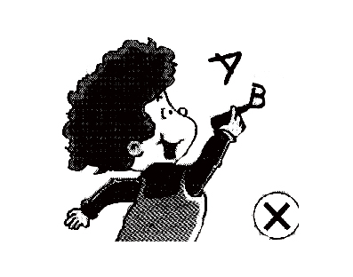
Ⅱ、听音，根据所听顺序用数字(1,2,3,4,5)给下列图片重新排序。
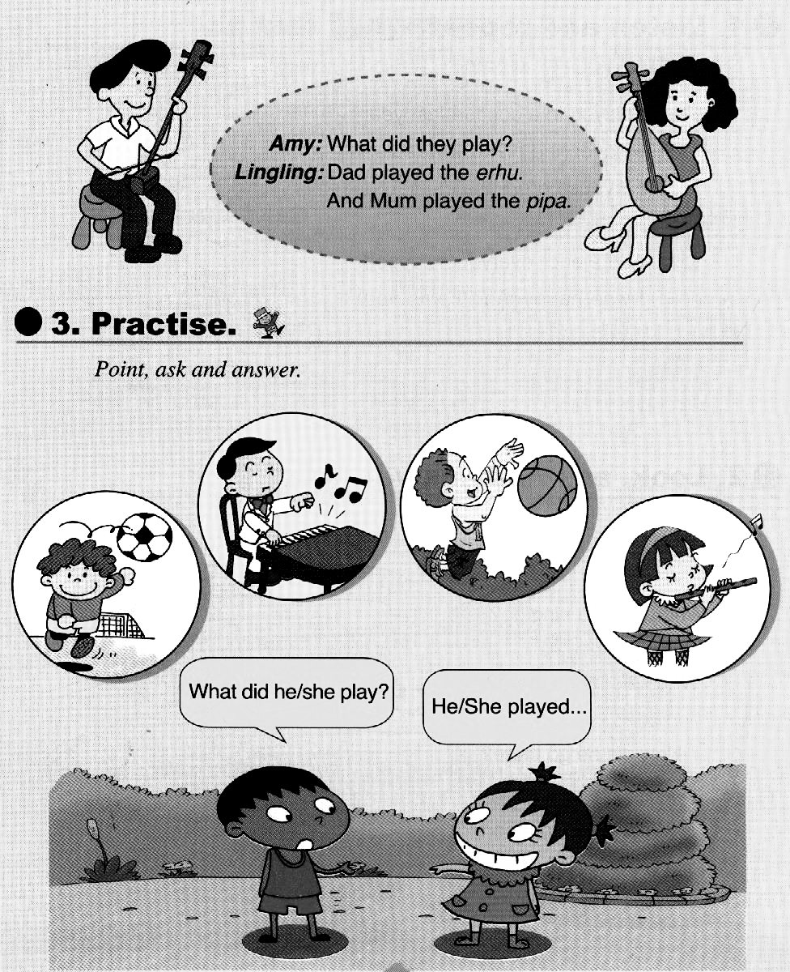
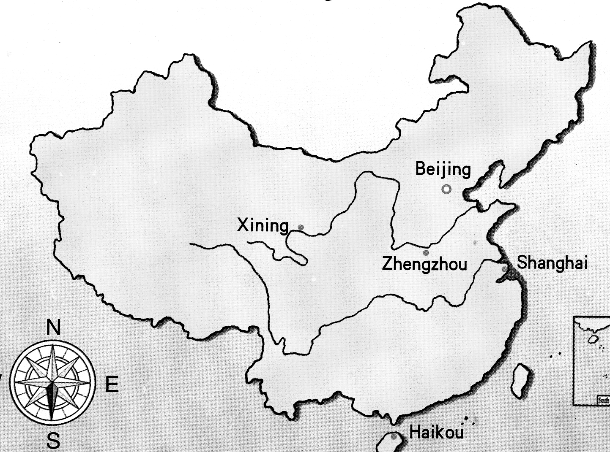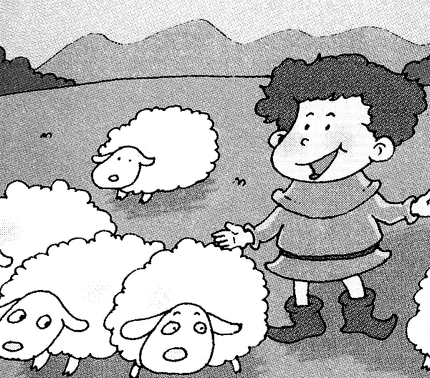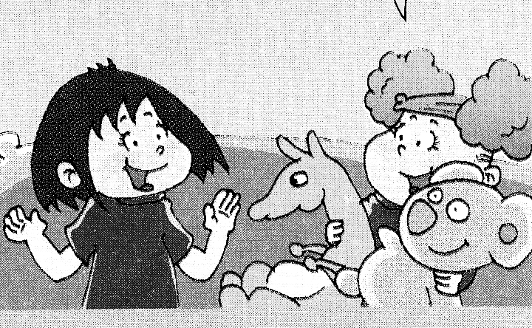
（ ） （ ） （ ） （ ） （ ）
Ⅲ、听音，判断图片是否正确，正确打“√ ”，错误画 “×”。
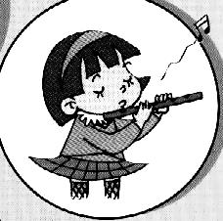
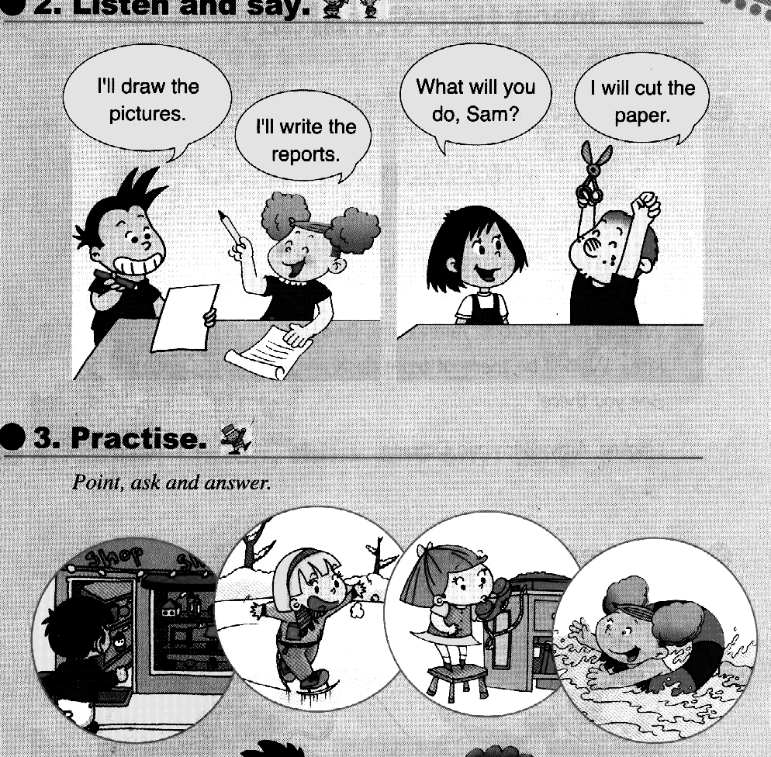
1、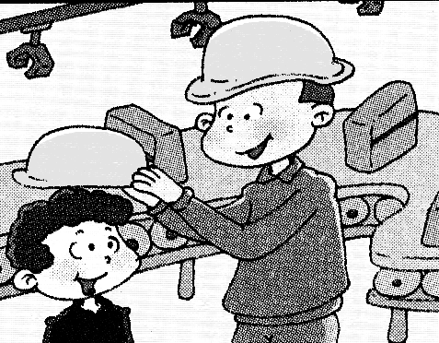 2、 3、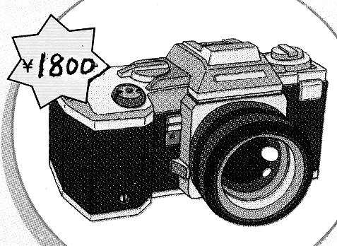 4、5、
（ ） （ ） （ ） （ ） （ ）
Ⅳ、听音，选出你所听到的句子，并把序号写在题前的括号内。
（ ）1、A. Let’s have a class party this Saturday.
B. Let’s make an English newspaper.
（ ）2、A. It’s big and fat. B. It’s small and round.
（ ）3、A. Don’t touch anything! B. Please open the window.
（ ）4、A. I can send a letter. B. I’ll send you a postcard.
（ ）5、A. We were very nervous. B. I was very proud.
Ⅴ、听短文，连一连。
Amy playing the drums
Tom playing the piano
Sam singing a song
Daming playing the guitar
Lingling drawing a picture

笔试部分（60分）
Ⅵ、根据语境用“——”画出句中正确的单词。
1. (Touch / Don’t touch) the machine, it’s dangerous.
2. People in Australia speak（Chinese / English ）.
3. It’s ten ( thousand / thousands ) .
4. Amy is going to ( sent / send ) a postcard.
5. At the end everyone clapped . I was very（ proud / nervous ）.
Ⅶ、根据语境补全句子中的单词。
1、This computer is __________ (便宜).
2、Don’t walk on the __________ (草地).
3、Canada is to the ___________ (北方) of America.
4、_____________( 安静 ), please ! Don’t talk here !
5、The_______（太阳）is very big and very hot.
6、Beijing is the___________(首都)of China.
7、I have nothing to do, I’m very _____________（无聊的）.
8、Will you __________ (粘贴) the newspaper together?
9、Kangaroos eat __________( 树叶) and drink water.
10、Shenzhou Ⅸ（神舟九号）flew into _________ (太空) in 2012.
Ⅷ、选择填空，将序号填在括号里。
（ ）1、Don’t __________ball games here !
A. plays B. playing C. play
（ ）2、The pipa __________ a guitar.
A. look like B. looks like C. look likes
（ ）3、This planet is far _________ the sun.
A. for B. to C. from
( ) 4、 He_________ painting flowers.
A. is B. am C. are
( ) 5、I will ________ my room.
A. cleaned B. clean C. cleaning
( ) 6、 Let’s ______ at the school gate.
A. meet B. met C. meeting
( ) 7、 ________ read in the sun. It’s bad for your eyes.
A. Please B. \ C. Don’t
（ ）8、She ________ a shop yesterday.
A. go to B. is going C. went into
（ ）9、 This TV __________one thousand yuan.
A. costs B. cost C. costing
（ ）10、 He broke the door and ___________away.
A. ran B. run C. running
( )11、Look! The boys are laughing and _______________.
A. claping B. clap C. clapping
( )12、Will you go to the zoo? No, I ___________.
A. didn’t B. won’t C. can’t
( )13、Daming can ___________ the drums.
A. play B. playing C. played
( )14、I’m going to _________ my granddad next week.
A. shouted B. visit C. waiting
( )15、A:_________ do you get up in the morning? B: At 6:30.
A. Where B. Why C. When
Ⅸ、根据问句选答句，将序号写在前面的括号里。
（ ）1、Where’s Qingdao? A. Because they are very cute.
（ ）2、Why do you love pandas? B. It’s in the east of China.
（ ）3、What will you do? C. I went shopping.
（ ）4、What did you do? D. We’re having a party.
（ ）5、What are you doing? E. I’ll write the reports.
Ⅹ、 根据语境选词填空, 将序号填写在下面的横线上。
A. powerful B. expensive C. difficult D. costs E. beautiful

Look at all these computers! It’s __________ to choose! Look ! This computer is ___________ , but it’s too __________. This one is perfect. It’s small and_______. It ________ five thousand yuan.
Ⅺ、 连词成句。
1. played / erhu / dad / the（.）
2. going to / to /London / I’m / go（.）
3．will / draw / I / the / pictures ( . ) ____________________________________
4. now / is / happening / what ( ? ) ___________________________________
5. feed / the / don’t / ducks ( ! ) _____________________________________
Ⅻ、阅读理解。
Last Sunday was a nice day. It was warm. We went to a park and had a picnic on the open field. We ate potato chips and hamburgers. And then we walked in the park and saw lots of beautiful flowers. Later(后来), we drank some milk and listened to music. We had a good time.

( )1、 Where did you go ? A. shop B. zoo C. park
( )2、 When did you go there ? A. last Sunday B. this Saturday
( )3、 What did you do ? A.rode B. bought C. walked
( )4、 The weather was ________. A. cold B. sunny C. rainy
( )5、 We were very ________. A.sad B. happy C. bored
四年级英语听力题签:
※注意：每道听力试题读二遍。时间控制在20分钟以内。

Ⅰ、听音，选出你所听到的单词，将其序号填入括号内。
1、choose 2、because 3、clap 4、 planet 5、cousin
6、 laugh 7、special 8、wolf 9、 moon 10、everyone

Ⅱ、听音，根据所听顺序用数字(1,2,3,4,5)给下列图片重新排序。
1、Don’t draw on the wall.
2、Mingming is playing the piano.
3、It’s a map of China.
4、The boy looked after the sheep.
5、We love Australian animals.

Ⅲ、听音，判断图片是否正确，正确打“√ ”，错误画 “×”。
1、Wear these glasses, please.
2、Lanlan is playing the flute.
3、It costs one thousand eight hundred yuan.
4、My mum played the violin in the concert.
5、Sam will cut the paper.

Ⅳ、听音，选出你所听到的句子，并把序号写在题前的括号内。
1、Let’s have a class party this Saturday.
2、It’s small and round.
3、Please open the window.
4、I’ll send you a postcard.
5、We were very nervous.

Ⅴ、听短文，连一连。
It’s Mother’s Day today. The children are very happy. Amy is playing the piano. Tom is singing a song. Sam is playing the drums. Daming is drawing a picture for his mother. And what’s Lingling doing? Oh, she’s playing the guitar.

听力部分到此结束！

四年级英语答案及评分标准：

听力部分
Ⅰ、(1×10＝10分) ABBBA BAABB
Ⅱ、(1×5＝5分) 3 ----- 1 ----- 4 ---- 5 ----- 2
Ⅲ、(2×5＝10分) × √ √ × √
Ⅳ、(1×5＝5分) ABBBA
Ⅴ、(2×5＝10分) 答案略， 详见听力题签。

笔试部分
Ⅵ、(1×5＝5分)
1. Don’t touch 2. English 3.thousand 4.send 5. proud
Ⅶ、(1×10＝10分)
1、cheap 2、grass 3、north 4、Silence 5、sun
6、capital 7、bored 8、stick 9、leaves 10、space
(备注：如画有“—”的部分无相应的词形变化各扣0.5分，其余单词必须完全准确方可得1分。）
Ⅷ、(1×15＝15分) CBCAB ACCAA CBABC
Ⅸ、(1×5＝5分) BAECD
Ⅹ、(1×5＝5分) CEBAD
Ⅺ、(2×5＝10分) 答案略
Ⅻ、(2×5＝10分) CACBB

备注：卷面满分为100分。（听力40分，笔试60分。）

优秀：90---100
良好：80---89
及格：60---79
不及格：0---59

2012年7月1日

