长海县2011~2012学年度第二学期期末质量检测
小学三年级 英 语 完成时间：60分钟
题号 | Ⅰ | Ⅱ | Ⅲ | Ⅳ | Ⅴ | Ⅵ | Ⅶ | Ⅷ | Ⅸ | Ⅹ | Ⅺ | Ⅻ | 总分
得分
听力部分（45分）
Ⅰ、听音，圈出你所听到的单词。
1. pear orange 2. fourteen fifteen
3. who what 4. writer wide
5. fast last 6. sixty sixteen
7. high round 8. parent grandparent
9. fruit food 10. quiet quite
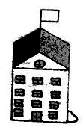
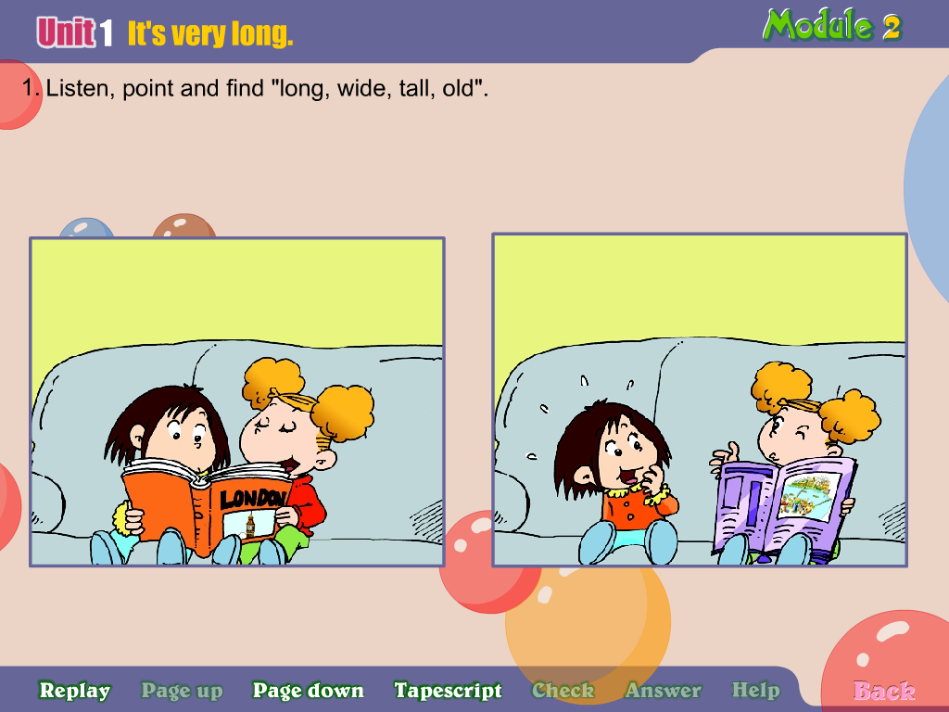
Ⅱ、听音，根据所听顺序用数字(1,2,3,4,5)给下列图片重新排序。
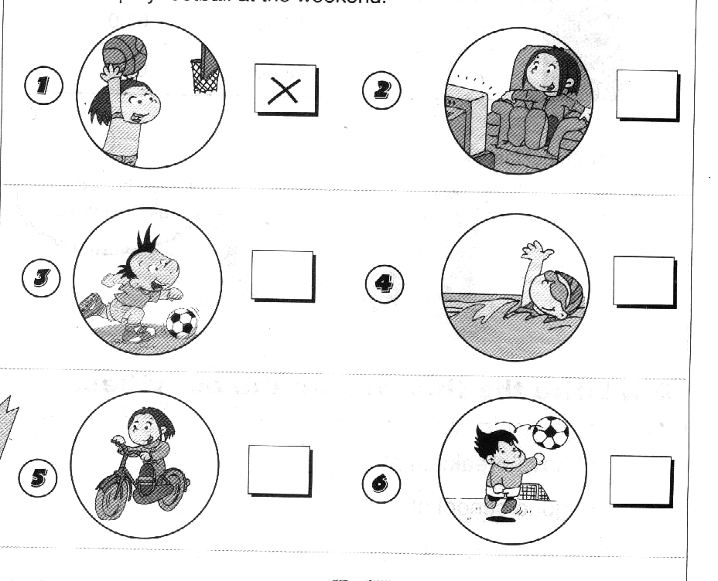
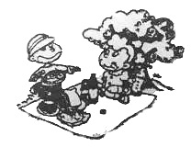
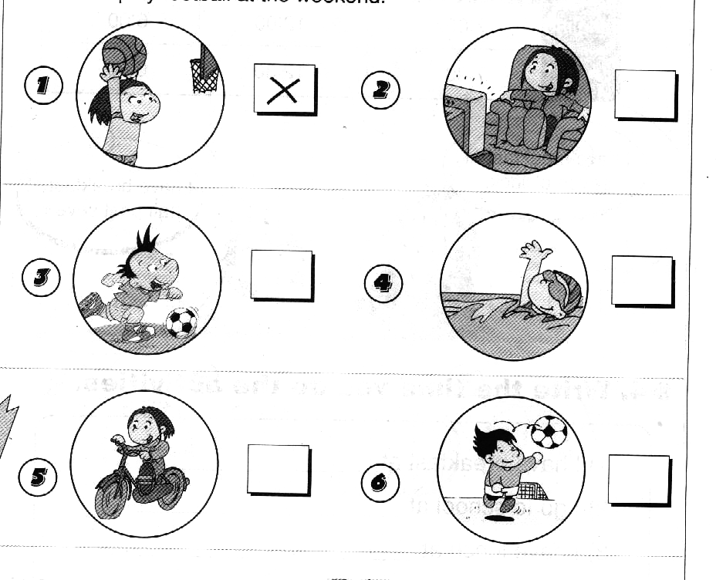

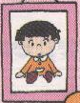
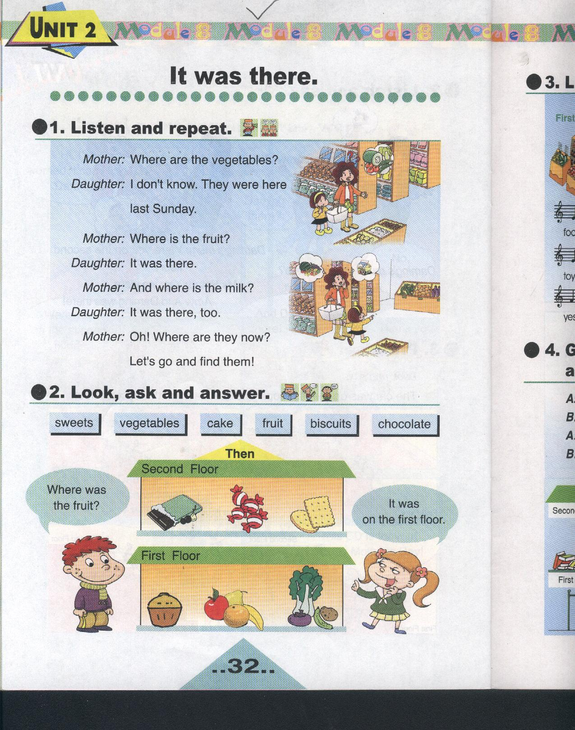
Ⅲ、听音，判断图片是否正确，正确打“√ ”，错误画“×”。
×20
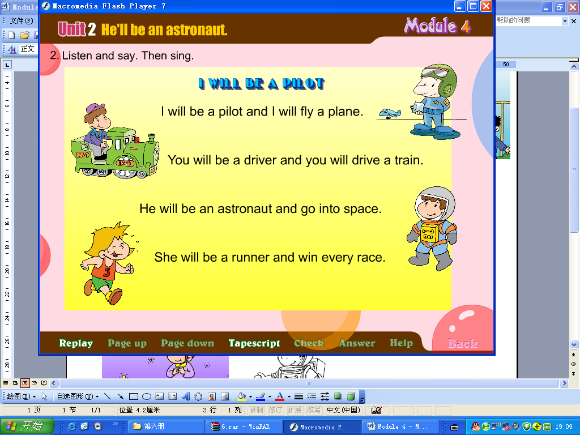
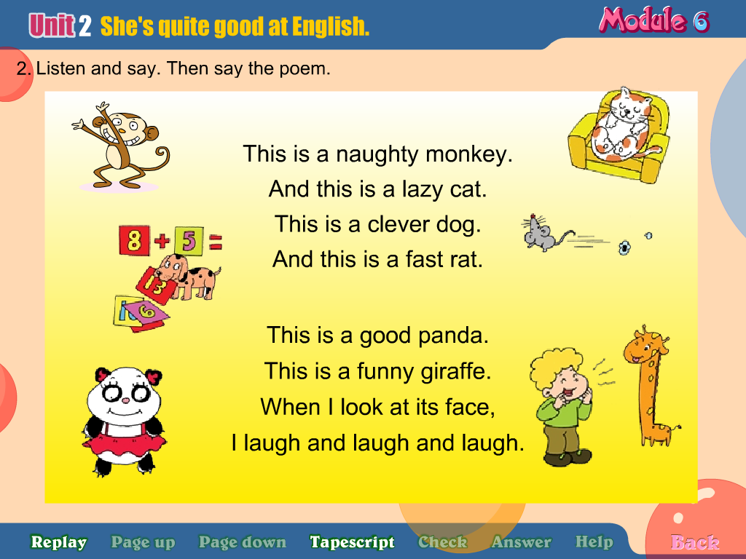
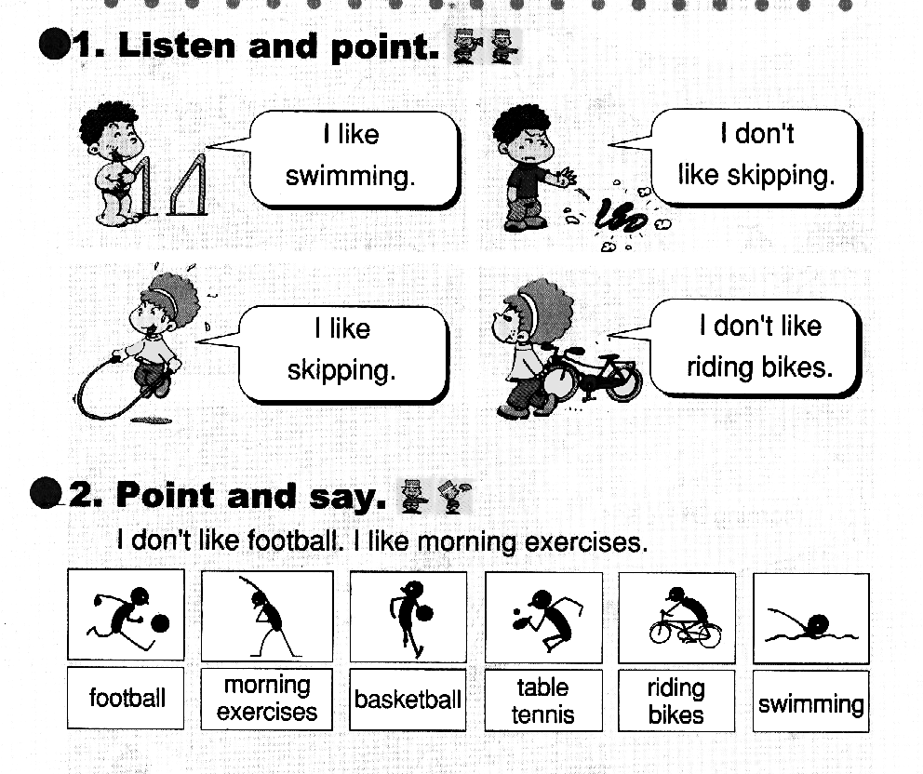
1. 2. 3. 4. 5.

( ) ( ) ( ) ( ) ( )

Ⅳ、听音，补全句子， 把你所听到的单词正确书写在横线上。
pick high sleep tomorrow wide
1. He will ___________ on Sunday.
2. This river is very ___________ and long.
3. We’ll ___________ apples.
4. It’s the London Eye. It’s very ______________.
5. Will you take your ball _______________?
Ⅴ、听音，选出你所听到的句子，并把序号写在题前的括号内。
( )1. A. My hair was long. B. My hair wasn’t long.
( )2. A. Was she there? B. Was he three?
( )3. A. How old were you? B. How old are you?
( )4. A. Were you on the second floor? B. Were you on the third floor?
( )5. A. Will you phone me? B. Will you play with me?
Ⅵ、听音，用数字（1，2，3，4，5）给句子重新排序。
( )And this is Maomao.
( )This is Xiaoyong.
( )She’s quite shy.
( )But he is a bit quiet.
( )He is very clever.
笔试部分（55分）
Ⅶ、请写出下列每组字母的左邻右舍。
1. Pp 2. Yy 3. Gg

4. Kk 5. Ss
Ⅷ、请根据所给语境写出正确的单词。
1. ____________ ( 桃子) are my favourite fruit.
2. She’s very _____________(友善的).
3. We’ll see lions, (老虎) and pandas in the zoo.
4. We were on the _________ (第一) floor.
5. There are _________ (五十)children in my class.
6. They were very_________ (年轻的).
7. This book is ___________(新的)，but that one is ________( 旧的 ).
8. He __________(学习) hard. He isn’t lazy.
9. A: What day is __________ (在…之后) Tuesday ? B: It’s Wednesday .
Ⅸ、选择，将正确的答案写在题前的括号内。
( ) 1. What’s forty plus thirty ? It’s ____________ .
A. 80 B. 70 C. 90
( ) 2. Will you ___________ to the zoo ?
A. go B.goes C.going
( ) 3. I will see ____________ pigs.
A. lots B. lot of C.lots of
( ) 4. There _______ eighteen apples on the tree.
A. is B. are C.was
( ) 5. A: Was he four then ? B:________________
A. Yes, he was. B. Yes, he were. C.Yes, he wasn’t.
( ) 6. Look ___ this book. It’s about London.
A. at B. in C. on
( )7. Will you play with me this weekend? _______
A. No, I wasn’t. B. No, I’m not. C. No, I won’t.
( )8. _______ Monday we will go to school.
A. At B. On C.In
( )9. He _________ in Hong Kong.
A. were B. was C. weren’t
( )10. I’m going to ___________ them.
A. help B. helpful C.helps
Ⅹ、根据问句选答句， 把正确的序号写在题前的括号内。
( ) 1.How many pears are there ? A. Yes, I was.
( ) 2. Is Daming naughty in class? B. I will be a film star.
( ) 3. Were you at the farm yesterday ? C. There are twenty.
( ) 4. Who’s she ? D. No, he isn’t.
( ) 5. What will you be in the future? E. She’s my sister.
Ⅺ、根据语境，选填单词并补全下列句子，将其序号填在前面的括号内。
A. good at B. Tomorrow C. last D. Maybe E. a bit
( ) 1.__________ is Friday. We are going to have a picnic.
( ) 2. ___________ we’ll go to the zoo .
( ) 3. They were here ___________Sunday.
( ) 4. She’s ___________ shy.
( ) 5.She is ______ English.
Ⅻ、阅读理解，根据短文内容判断正( √ )误( × )。
Hello！My name is Mary. I’m twelve. I’m a good girl. These are my friends. This is Maomao. She is very pretty. Maybe she will be a film star. This is Xiaoyong. He is very clever. He can make e-cards. He wants to fly. He wants to be an astronaut. I’ve got another friend. He is very naughty. But he likes reading books. Maybe he will be a writer in the future. His name is Daming.
( )1. Mary is twelve. She has got three friends.
( )2. Daming is very clever.
( )3. Xiaoyong will be an astronaut.
( )4. Mary will be a film star.
( )5. Maomao can make e-cards.
三年级英语听力题签：
注意：每道听力试题读二遍，听力时间控制在20分钟内。
Ⅰ、听音，圈出你所听到的单词。
1. orange 2.fourteen 3.who 4. writer 5. fast
6. sixteen 7.round 8.grandparent 9. fruit 10.quite
Ⅱ、听音，根据所听顺序用数字(1,2,3,4,5)给下列图片重新排序。
1. On Monday, he will go swimming.
2. On Tuesday, he will play football.
3. On Thursday, I will go to school.
4. On Saturday, we will read books.
5. On Sunday, they will have a picnic.
Ⅲ、听音判断图片是否正确，正确打“√ ”，错误画“×”。
1. Maybe I’ll be a writer.
2. A: Will he play football ? B: Yes, he will.
3. There are twenty girls in the class.
4. We’ll see pigs.
5. My hair was short then.
Ⅳ、听音补全句子， 把你所听到的单词正确书写在横线上。
1. He will sleep on Sunday.
2. This river is very wide and long.
3. We’ll pick apples.
4. It’s the London Eye. It’s very high.
5. Will you take your ball tomorrow?
Ⅴ、听音选出你所听到的句子，并把序号写在题前的括号内。
1. My hair wasn’t long.
2. Was she there?
3. How old are you?
4. Were you on the second floor?
5. Will you phone me?
Ⅵ、听音，用数字（1，2，3，4，5）给句子重新排序。
This is Xiaoyong. He is very clever. But he is a bit quiet. And this is Maomao. She’s quite shy.
听力部分到此结束！
三年级英语答案及评分标准：
听力部分
Ⅰ、(1×10＝10分)
1. orange 2.fourteen 3.who 4. writer 5. fast
6. sixteen 7.round 8.grandparent 9. fruit 10.quite
Ⅱ、(1×5＝5分) 4 ----- 3 ------- 2 ------ 5 -------- 1
Ⅲ、(2×5＝10分) ╳ √ ╳ ╳ √
Ⅳ、(2×5＝10分) 1.sleep 2.wide 3.pick 4. high 5.tomorrow
（备注：要求一律用手写体书写单词，如果个别字母没变，整体书写扣0.5分。）
Ⅴ、(1×5＝5分) B A B A A
VI、(1×5＝5分) 4----1----5----3----2
笔试部分
VII、(0.5×10＝5分) Oo , Qq , Xx , Zz , Ff , Hh , Jj , Ll , Rr , Tt
（备注：要求一律用手写体书写每组大小写字母，如果个别字母没变，整体书写扣1分。）
VIII、(1×10＝10分)
- Peaches 2、nice 3、tigers 4、first 5、fifty
6、young 7、new , old 8、works 9、after
（备注：标注“—”黑体的部分如果没有形式的变化，各扣0.5分。要求一律用手写体书写单词，如果个别字母没变，整体书写扣0.5分。）
IX、(1×10＝10分) BACBA ACBBA
X、 (2×5＝10分) C----D----A----E-----B
XI、(2×5＝10分) BDCEA
XII、(2×5＝10分) √ × √ × ×

备注：卷面满分为100分。（听力45分，笔试55分。）
优秀：90---100
良好：80---89
及格：60---79
不及格：0---59

2012年7月1日

