五年级英语月考2012.6
听力部分
一.听句子，选出你所听到的相应信息。10’
( )1、 A、place B、please C、player
( )2、 A、toothbrush B、sausages C、scissors
( )3、 A、parents B、father C、grandparent
( )4、 A、question B、history C、building
( )5、 A、theatre B、thought C、solve
二.听音,选图编号10’
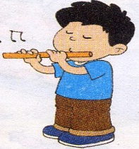
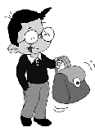
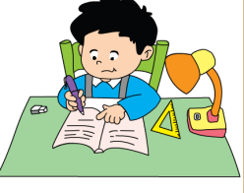
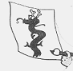

( ) ( ) ( ) ( ) ( )
三.情景反应,请根据所听问句的顺序给答句编号.10’
( ) It’s a computer message.
( ) We’ll get there by bus.
( ) Of course, I will.
( ) My favourite season is spring.
( ) They’re on shelf C .
四.听音排序6’
How I made the kite.
( ) I cut the paper with scissors.
( ) I put strings on it.
( ) I drew a dragon on a piece of yellow paper.
( ) I put sticks on it.
( ) Then, I could fly my kite.
( ) I painted it.
笔试部分
五.根据提示补全句子。10’
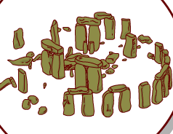
1. My bag is b_______, I can’t c_______ it at all.
2. The women wore _______(男人的) clothes. It was f_______.
3. We will see lots of __________(石头).
4. I carry my school bag on my s__________.
5. Stonehenge is an __________( 令人惊讶的) place.
6. Write your m_________ on the computer.
7. She had _______(鱼)and ________(薯条) for lunch.
六.选择20’
( )1、We are getting ready __________ your visit.
A. to B. for C. from
( )2、A: Mum bought some CDs for me.
B: Did you _________________?
A、look at B、saw it C、watch them
( )3、Please return the books _________ two weeks.
A、in B、on C、at
( )4、Your apple is green. _________ is red.
A、I B、Mine C、My
( )5、Yesterday she ___________ sandwiches and eggs.
A、has B、have C、had
( )6、 Sam saw a very fat woman. He __________ a lot.
A、amazing B、busy C、laughed
( )7、I drew a dragon on a piece of paper ______________.
A. yesterday B. now C. tomorrow
( )8、This black bag ________ nice.
A.am B. is C. are

( )9、A: Your library card, please.
B: __________________
A、Thank you. B、Here you are. C、I hope so.
( )10、We’re going to see Stonehenge _________ Saturday.
A、on B、for C、at
七. 按要求写单词8’
1. they （宾格）________ 2. read (过去式)__________
3. women (单数) ________ 4. have (单三)___________
5. think (过去式)_________ 6. theatre (另一种拼写形式)__________
7. brown (姓氏)__________ 8. return ( 反义词)__________
八. 连词成句10’
1. laughed , lot , we , a
________________________________________________.
2. bag , is , your, broken.
_________________________________________
3. told, the , lots, jokes, of, actors
________________________________________-
4. be, seven, I , o’clock, will , home, at
_________________________________________
九. 阅读、10’
Hello! My name is Lucy. I am eleven years old. I go to school every day. I like drawing. I like drawing animals, trees and flowers. I often go to the park to draw on Sunday. I like reading , too. In my room, there are many storybooks. I often go to the library to read books. Sometimes I borrow some books from the library.
( ) 1. What does Lucy live?
- Sports. B. Drawing. C. Playing
( ) 2. Can Lucy borrow books from the library?
- Yes, she can. B. No, she can’t. C. I don’t know.
( ) 3. Where does Lucy often go to read books?
- The park. B. The library. C. The office.
( ) 4. When does Lucy often go to the park to draw?
- On Saturday. B. On Monday. C. On Sunday.
十．小练笔 6’ （ What did you do last week? 至少5句话）
————————————————————————————————
五年级听力题签
一.听句子，选出你所听到的相应信息。
1、He was a flute player before.
2、I cut the paper with scissors.
3、My parents are all teachers.
4、I read a book about Chinese history.
5、I thought it was a joke.
二.听音,选图编号
1. I carry my bag with my hand.
2. we’ll see lots of very big stones.
3. I played the flute yesterday.
4. I drew a dragon on a piece of yellow paper.
5. I will do homework tomorrow.
三.情景反应,请根据所听问句的顺序给答句编号.
1. Will you help me?
2. What’s an E-mail?
3. Where are they?
4. What’s your favourite season?
5. How will we get there?
四.听音排序
How I made the kite.

I drew a dragon on a piece of yellow paper.
I painted it. I cut the paper with scissors. I put sticks on it. I put strings on it.
Then, I could fly my kite.

