长海县2011~2012学年度第一学期期末质量检测
小学六年级 英语 完成时间：80分钟
题号 | Ⅰ | Ⅱ | Ⅲ | Ⅳ | Ⅴ | Ⅵ | Ⅶ | Ⅷ | Ⅸ | Ⅹ | Ⅺ | Ⅻ | 总分
得分
听力部分( 35分)
Ⅰ、 听辨单词，选出你所听到的句子中的单词。
( ) 1. A. weekend B. week C. what
( ) 2. A. surprise B. special C. speak
( ) 3. A. place B. pleased C. please
( ) 4. A. awake B. around C. about
( ) 5. A. dancing B. different C. difficult

Ⅱ、听句子选图片，根据所听顺序将其序号填写在相应的横线上。

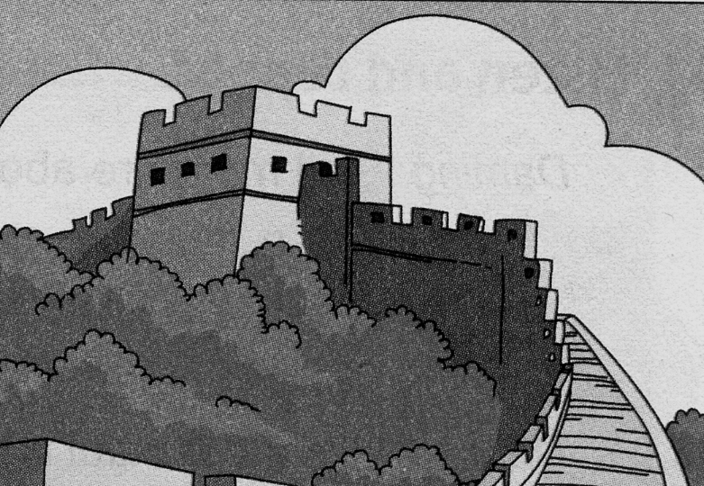
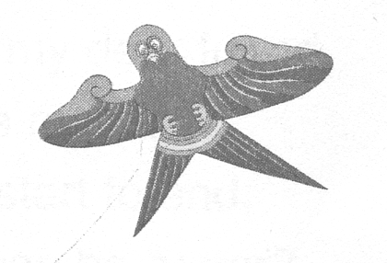
十二月
25
2008年
星期四
圣诞节

A B C D E

1. ________ 2. ________ 3. ________ 4. _______ 5. _______
Ⅲ、听问句选答语，根据所听顺序将其序号填写在前面的括号里。
( ) 1. A. It’s four o’clock. B. I’m four.
( ) 2. A. Yes, I can. B. Yes, you can.
( ) 3. A. I’m swimming. B. I like swimming.
( ) 4. A. It’s more than two thousand years old. B. It’s ten thousand li long.
( ) 5. A. No, they don’t. B. No, it doesn’t.
Ⅳ、听短文，判断正(T)误(F)。
( ) 1. I like collecting stamps.
( ) 2. I have got stamps from Canada.
( ) 3. My favourite stamp has got a picture of the Great Wall.
( ) 4. My favourite place in China is Hainan Island.
( ) 5. This stamp is from 1898.
Ⅴ、听短文，根据短文内容完成下列表格, 在正确的选项空格中划“√” 。
笔试部分（共65分）
 | always | often | sometimes | never | every day
watch TV
go shopping
play football
go swimming
clean her room
Ⅵ、请根据所给语境补全句子中的单词或短语。
1、How long is the Great Wall? It’s five thousand ______________ (公里)long.
2、We give ____________(礼物) and send cards .
3、There were lots and lots of Chinese shops and _______________(饭馆)there.
4、He’s from _____________(美国).
5、Our school starts at 8 o’clock. It ___________(结束) at half past four.
6、Do you often ______ _______ _____________(整理你的书架)？
7、This old __________________(大楼) is our library.
8、 __________________(袋鼠) like jumping.
9、The UN________ ____ _______ _________ (想要维护和平) in the world.
10、Please __________ ______ (写给) me soon.
11、____________ _______(看)this photo, I was six years old then.
12、What’s this _______ ________________ (用英语)?
Ⅶ、选择。
( ) 1. The food was different ________ Chinese food in China.
A. for B. from C. of
( ) 2. Do you want _______ my pen pal?
A. to B. be C. to be
( ) 3. I have got some _______of New York.
A. photo B. photos C. photoes
( ) 4. These stamps are _______ China and they ________ from 1988.
A. on , are B. in , are C. from , are
( ) 5. How long does a snake sleep? It ______ for eighteen ______ a day.
A. sleep , hour B. sleeps , hours C. slept , hours
( ) 6. You can ________ to her in English.
A. write B. wrote C. writing
( ) 7. I ______ got a Chinese kite.
A. has B. have C. had
( ) 8. Have you got ________ stamps from China?
A. any B. some C. a
( ) 9. We say thank you ________ all the good _______ we have.
A. for , thing B. from , things C. for , things
( ) 10. They ________ for twelve hours a day.
A. eating B. eats C. eat
Ⅷ、情景反应, 连一连。
1. When does it sleep? A. No, I haven’t.
2. How many hours do you sleep a night? B. No, they don’t. They are deaf.
3. How long is the Great Wall? C. It sleeps in the day.
4. Do snakes love music? D. It’s ten thousand li long.
5. Have you got a book about America? E. I sleep for eight hours a night.
Ⅸ、根据语境选择单词，将其序号填在横线上。
A. answer B. chopsticks C. finish D. difficult E. city
I met Daming here in New York. I like Chinese food and I’ve got some Chinese _______. But they are very _______for me. I am from New York. It’s a very big _______. Please write to me and I will _______ your questions about America. At first, I will ask you a question. When do Chinese schools start and ______?
Ⅹ、情景交际，补全对话。选择正确的句子，将序号填在横线上。
A. Is China in the UN? B. Haven’t you got buildings like this in China?
C. What’s that? D. Do you want to go inside the UN building?
E. It’s very big and very tall.
Simon: Do you want to visit the UN building? Daming: __________________
Simon: It’s a very important building in New York. Many countries are in the UN.

Daming: _____________ Simon: Yes. China is one of the first countries in the UN.
Daming: Wow! It’s beautiful. __________________ Simon: _________________
Daming: Yes, we have! We’ve got lots of very tall and big buildings in China!

Simon: Really! __________________ Daming: Yes, please.
Ⅺ、阅读理解，判断正(T)误(F)。
One day an old man is selling a big camel. A boy comes to the camel and begins to look at it carefully. Then the old man thinks over and says in the boy’s ears, “Don’t say anything about the camel before I sell it .Then I will give you ten dollars(美元).” “All right！” says the boy happily. After the old man sells the camel, he gives the boy ten dollars and says, “Now, can you tell me how you can find out the bad ear of the camel?” “I don’t know which ear is bad,” says the boy. “Then why do you look at the camel so carefully?” asks the old man. “Because I never saw a camel before.” the boy answers.
( ) 1. The old man is selling a big horse.
( ) 2. The old man promises(承诺) to give the boy some money.
( ) 3. The boy feels very happy.
( ) 4.The old man is very kind. He wants to help the boy.
( ) 5. The boy can find out the bad ear of the camel.
Ⅻ、写作园地。
请以＂My mother＂为题，并参照以下提示词：beautiful, nice, kind, years old , have got, can, often, like doing…写写你敬爱的妈妈， 要求不少于50词。
____________________________________________________________________________________________________________________________________________________________________
____________________________________________________________________________________________________________________________________________________________________
六年级英语听力题签:
※注意：每道听力试题读二遍。时间控制在20分钟以内。

Ⅰ、听辨单词，选出你所听到的句子中的单词。
1、What did you do at the weekend?
2、People put special trees in their homes.
3、Pleased to meet you.
4、A fox sleeps in the day and is awake at night.
5、They are very difficult for me.

Ⅱ、听句子选图片，根据所听顺序将其序号填写在相应的横线上。
- Christmas is on the 25th of December.
- My brother has got a Chinese kite.
3. Daming is sending an email to Sam.
4. People put special trees in their homes.
5. The Great Wall is more than 2000 years old.
Ⅲ、听问句选答语，根据所听顺序将其序号填写在前面的括号里。
1. What’s the time?
2. Can I write to her?
3. What are you doing?
4. How long is the Great Wall?
5. Do snakes love music?

Ⅵ、听短文，判断正(T)误(F)。
My hobby is collecting stamps. I have got stamps from China and America. Look! This is my favourite Chinese stamp. It is a picture of Hainan Island, my favourite place in China. We can see the Five-Finger Mountains and also some coconut trees. This stamp is from 1989.

Ⅴ、听短文，根据短文内容完成下列表格, 在正确的选项空格中划“√” 。
Linda is a pupil in London. She always watches TV every evening. She often goes shopping on Sundays with her mum. She never plays football in the park. She doesn't like it. Sometimes she goes swimming in summer. She cleans her room every day. She says she doesn't want to live in a messy room.

听力部分到此结束！
六年级英语答案及评分标准：
听力部分（35分）
Ⅰ、(2×5＝10分) 1. A或C 2.B 3.B 4.A 5.C
Ⅱ、(2×5＝10分) B D A E C
Ⅲ、(1×5＝5分) ABABA
Ⅳ、(1×5＝5分) T F F T F
Ⅴ、(1×5＝5分)
笔试部分（65分）
 | always | often | sometimes | never | every day
watch TV | √
go shopping |  | √
play football |  |  |  | √
go swimming |  |  | √
clean her room |  |  |  |  | √
Ⅵ、(1×20空＝20分)
kilometers, presents, restaurants, America , finishes, tidy your bookshelf, building ,
Kangaroos, wants to make peace , write to , Look at, in English
（注意 ：共计20个单词，其中画有“_”的9个单词如果没有形式的变化将扣0.5分， 其余单词必须完全拼写准确方可得1分。）
Ⅶ、(1×10＝10分) BCBCB ABACC
Ⅷ、(2×5＝10分) 1----C , 2-----E , 3-----D, 4----B , 5------A
Ⅸ、(1×5＝5分) BDEAC
Ⅹ、(1×5＝5分) CAEBD
XI、(2×5＝10分) F T T F F
XII、(5分) 答案略。请任教六年级的英语老师批阅作文，并自行把握评分标准,做到心中有数。
一等：4----5分（主题鲜明，表述恰当，语言结构准确。）
二等：3分（主题较为鲜明，表述较为恰当，语言结构较为准确。）
三等：0-----2分（主题朦胧，语言表述不清，错词乱句，信息模糊。）
备注：卷面满分为100分。（听力35分，笔试65分。）
优秀：90---100
良好：80---89
及格：60---79 2012年1月1日
不及格：0---59

