Do you like dolls? No ,I don’t.
What do you like? I like jigsaws.
What does sam like? He likes T-shirt.
Here you are! Thank you .
Do we have music? Yes ,we do .
What ’s the time? It’s 2 o’clock./it’s half past 7.
Is it 8 o’clock? No ,it isn’t./ Yes, it is.
Does he play the flute? Yes ,he does./No ,he doesn’t.
What do you do at the weekend? I play football.
What does fangfang do at the weekend? She watches TV.
Where do you play football? I play at the park.
Where do you live? I live in beijing.
How do you go to school? I walk to school./I go to school by bus.
How does your father do to work? He goes to work by bike/car/ship.

I like the ABCsong .it’s my favourite song.
He likes this T-shirt. He doesn’t like this shirt.
We have english in the mornimg. (Maths Chinese PE Science Music Art)
I like PE.
I get up at 7 o’clock in the morning.
I have breakfast at half past 7.
I go to school at 8 o’clock.
I have lunch at 12 o’clock..
I go home at 4:30.
I go to bed at 9 o’clock..
I play football. I watch TV.
She plays football. She watches TV. She goes swimming. She read books.
It’s spring. We wear jackets.it’s warm.
It’s summer. We wear T-shirts and sunglasses. It’s hot.
It’s autumn .we wear sweater. It’s cool.
It’s winter.we wear gloves and coats. It’s cold.
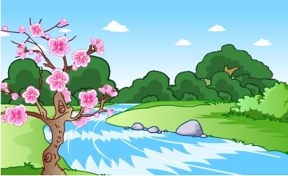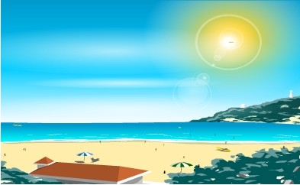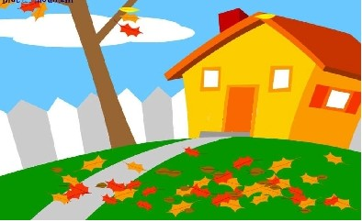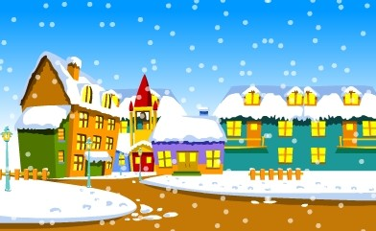
Happy New Year! We eat dumpings at Chinese New Year! We watch TV. We have a big dinner. We eat some sweets.
In England,We have christmas! Chrismas is in winter. We have christmas trees and christmas presents.we sing songs and have a big dinner.

