新标准英语一年级起点第九册Module 6 Unit 1
You can play basketball well. 教学设计
大长山小学 杨春莲

Step.1 Warm-up
- Greeting.
T: Good morning,children. How are you?
T: I’m very well,thank you. Don’t worry,my body is healthy,so I can do lots of things well.(CAI-show them the phrases: lift the bags play basketball play volleyball play the guitar jump high run fast ride a bike row the boat use the computer cook sleep)
T: I can play volleyball,and I can ride a bike well.And you?What can you do?
T: Can you ---?
T: Well done,children!

Step.2 Presentation
(CAI)Show them the phrase:Well done! Elicit the new word:well.
Look and read: well,tell,fell,sell,smell.
*About “well”and “good”,think and choose:
1.It’s a ____cat, it can catch the mouse_____.
2.He isn’t a ____footballer. He can’t play football____.
(帮助学生加深理解:good用于修饰名词,well用于修饰动词-来表达所从事某件事情的能力的提升程度.)
T:Well done,boys and girls.And I want to say “Well done!” to Liu Xiang.
CAI-show the picture of Liu Xiang,T: What can he do?Elicit:He can run fast.
CAI-show the picture of Yao Ming, elicit: He can play basketball well.
T: Can you play basketball well?
T: Oh,you can play basketball well.
Show them the title: Module 6 Unit 1 You can play basketball well.(板书)

Step.3 New Teaching.
- T: Lingling wants to play basketball,too. Now,open your books,listen to the text and find:What can Lingling do well?
T:(After listening)Can you run fast,Lingling?
Elicit the students: No,I can’t.(板书)
T:Can you catch the ball,Lingling? Elicit: Not very well.(板书)
T:Can you jump high,Lingling? Elicit the students:Yes,I can.
T:You can jump really high.That’s true.
CAI-show them the sentence:That’s true.And learn the new word:true.
true, tree, train,trousers
/tr/--/dr/ , dress, drink, driver
- T: Listen to the text again,and repeat.Then tell me :So can Lingling play basetball well?
(After listening)Elicit:Yes,she can.She can play basketball very well.(板书very well)
T: Now,let’s have a match between the boys and girls.You should ask and answer with:Can you---? Yes,I can./ No, I can’t.(比赛规则:男队或女队在相同时间内,以采访人数多的一队获胜,获胜一方会在梯形格中升高一级;教师课件呈现词组以帮助学生完成采访)
- T:Read the text by yourselves,and underline the sentences about “well”.
T:Now,let’s read together.

Step.4 Production
- T:I find some interesting words in the text,so,I write the sentences ,now,to be a judge,and judge my sentences:
1.I want to wearing a coat.
2.Lili can playing the flute well.
(引导学生找出其中的错误,并强化want to,can的用法)
*Read and choose: want, want to
1.I ______ an apple,I _____ eat it.
2.Amy ______ have a birthday pary,so she _______ a beautiful dress.
*T:”can”的后面用动词原形,你还知道哪些词的后面也用动词原形?
Elicit: (CAI) be going to, will, want to , let’s
*Think and choose:
1.I’m going to _____(have,having) a party.
2.Sam will _____(makes,make) a cake.
3.Let’s______(swimming,swim).
4.Can Amy ____(jump,jumping) high?
2. T:Well done,children!Here are some photos I took in the street,what do you want to ask me?(CAI-示照片:骑车人,提包妇女,电脑前的男童,箱中正在售卖的鱼)
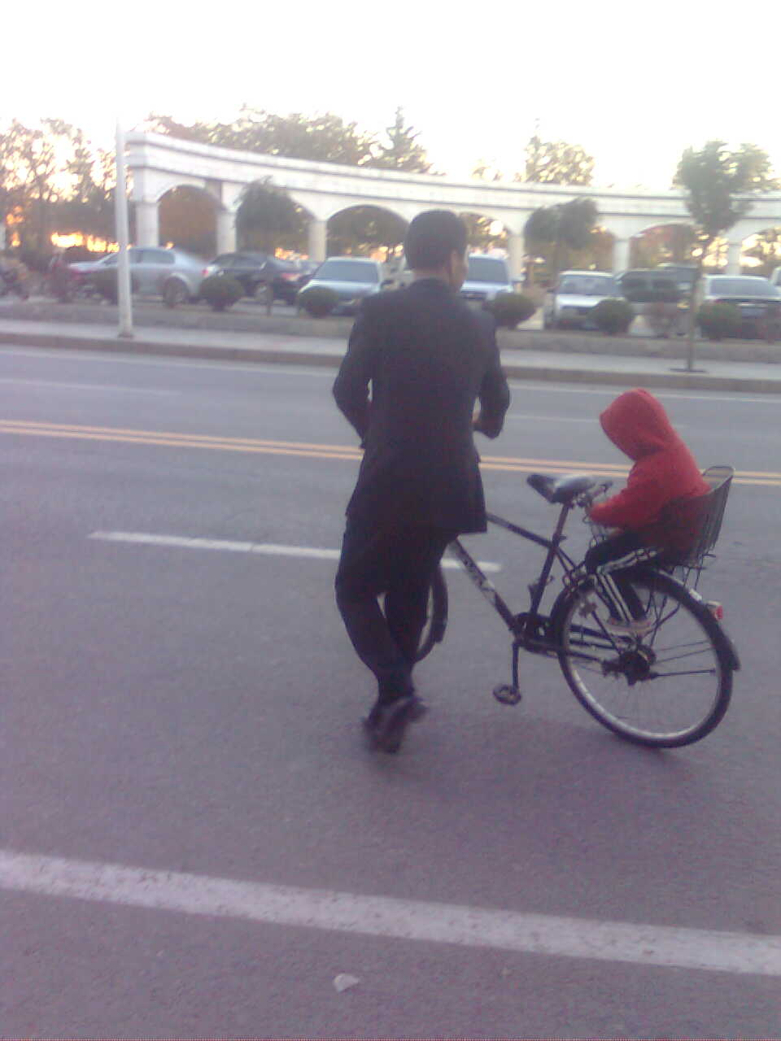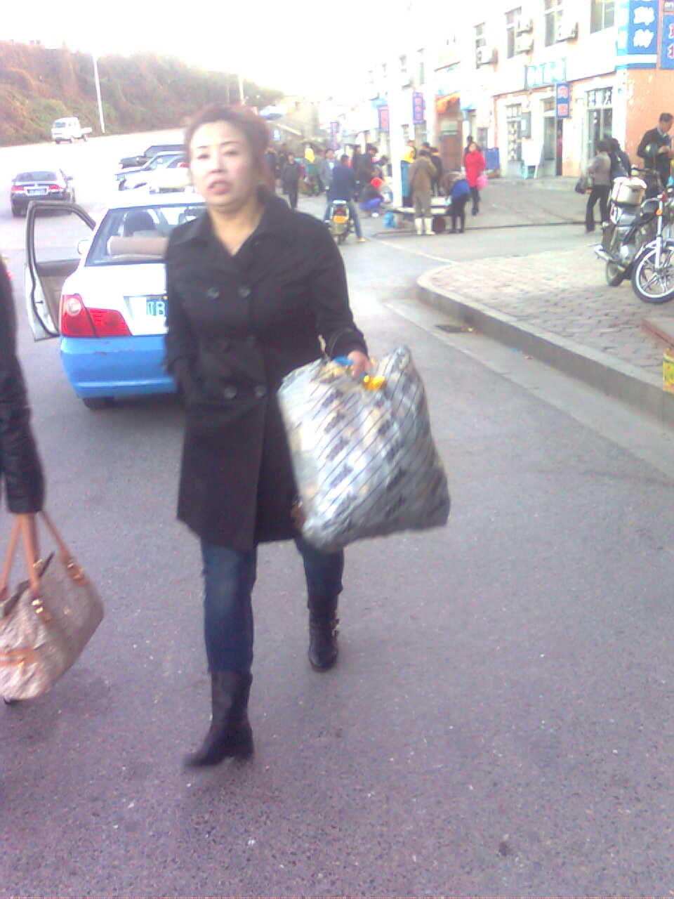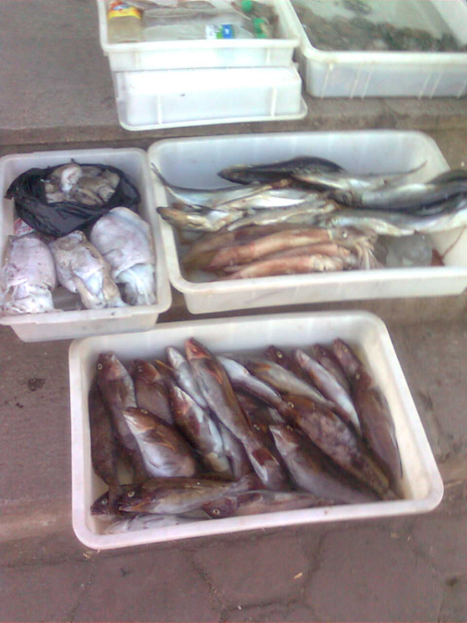
Elicit them ask with:Can he/ she/ they---well?
For example:Can he ride the bike well?
Can she lift the bag well? Can she walk well?
Can they swim well? Can they jump high?
And we should answer:Yes,he/she/they can. No,he/she/they can’t.
3. A memory game.
CAI-show them some pictures, look at the pictures and describe:
“I can --- well.” or “I can’t --- well.” 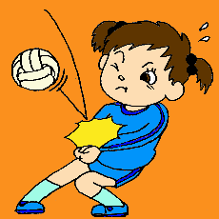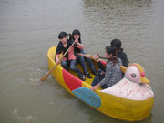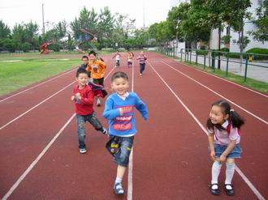
For example: S1: I can play volleyball well.
S2: I can cook well.
S3: I can’t dance well. S4--, etc.
Now,teacher says “Stop! Can you remember what they can/can’t do?” And the students should try hard to get the right answers:
He/She can/can’t---well.
(说出正确答案的人将会为男队或女队争得一次进级)
- Let’s have a test.
1.( )-Can Sam jump high? -No,_____.
A. I can’t B.she can C.he can’t
2.( )Amy can’t ____ a cake well.
A.making B.make C.makes
3.( )-Does xiaoyong watch TV?
-Yes, he ___.
A.do B.can C.does
5.T:Can you help me finish the poem?
The summer runs very fast,
I can’t catch it.
So, I can’t_____,
and I can’t wear .

The autumn jumps,jumps,and jumps here.
I can see it. I can ,
and I can .

So good season,catch it well.

T:Now,let’s read it together.
The summer runs very fast,
I can’t catch it.
So, I can’t swim,
and I can’t wear shorts .

The autumn jumps,jumps,and jumps here.
I can see it. I can row the boat ,
and I can fly the kites .

So good season,catch it well.

Step.5 Summary and homework.
Summary:用can 来表达,询问某人的能力,并会使用well来表达某人能力的提升程度. can/can’t --well; Not very well; very well
Homework: 1.会背写本课新单词,功能句.熟读课文.
2.写作:What can you do well? And what can’t you do well?
3.Activity Books.E.3~5

板书:
Module 6 Unit 1
You can play basketball well. That’s true!

Yes, I can.
Can you run fast? No,I can’t.

Can you catch the ball? Not very well.
Very well.

｛
梯形评价区

