五年级英语月考 2011.6
学校
班级
姓名

听力部分(36分)
一、听句子，选出你所听到的相应信息。（10分）
( )1、 A、place B、please C、player
( )2、 A、lunch B、dinner C、breakfast
( )3、 A、grandpa B、grandma C、grandparent
( )4、 A、summer B、winter C、spring
( )5、 A、theatre B、thought C、solve
二、听音, 选图编号。（10分）
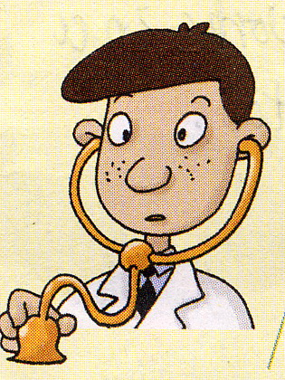
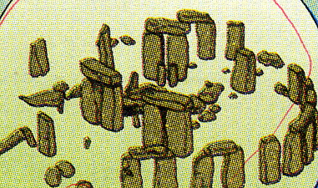
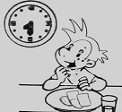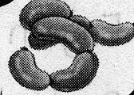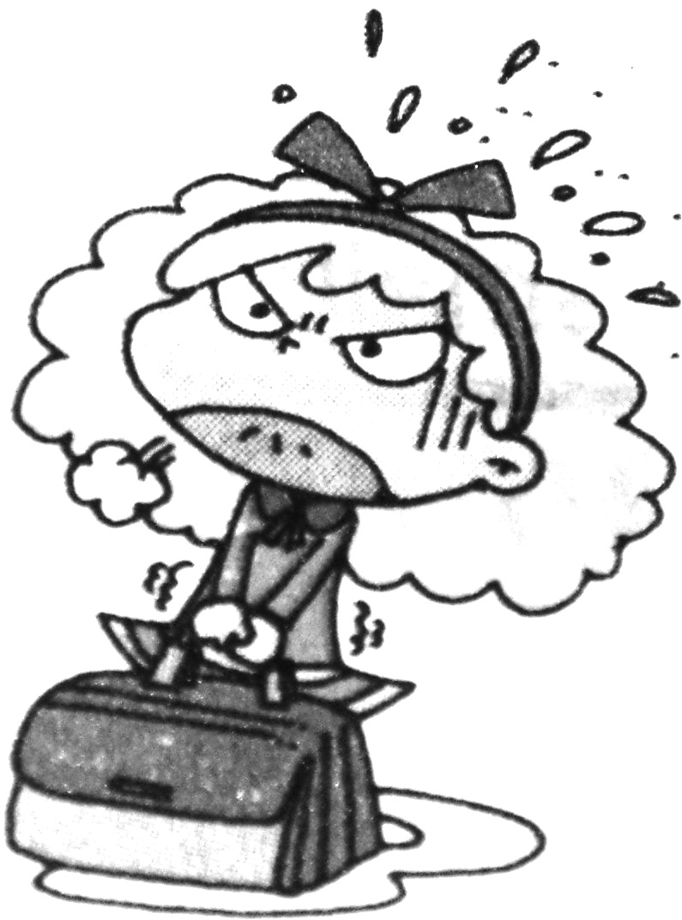
( ) ( ) ( ) ( ) ( )
三、情景反应。请根据所听问句的顺序给答句编号。（10分）
( ) Of course, I will..
( ) We will see lots of stones.
( ) Yes, I am..
( ) It's a computer message.
( ) We’ll get there by bus.
四、听录音排序，将数字写在括号内。（6分）
How I made the kite.
( ) I cut the paper with scissors.
( ) I put strings on it.
( ) I drew a dragon on a piece of yellow paper.
( ) I put sticks on it.
( ) Then, I could fly my kite.
( ) I painted it.
笔试部分(64分)
五、根据提示补全句子。（10分）
1.The actors _______（讲）lots of jokes last week.
2. I carry my school bag on my __________（背部）
3. The helicopter ride over Stonehenge was __________（令人惊奇的）.
4.We will see many __________（石头）.
5.Your bag is __________（损坏的）.
6．My favourite _________（季节）is spring.
7．I will __________（画）a picture tomorrow.
8．I can use ______ very well. （剪刀）
9．I think he ______ ______（有）some chopsticks.

六、选择。（10分）
( )1、I bought you some English books. Did you read ____?
A.they B.them C.it
( )2、We’ll see lots of big stones. They are ______ a circle.
A. in B. on C. of
( )3、The women wore men's _______.
A. cloth B. clothing C. clothes
( )4、Your ruler is red. ______ is yellow.
A. Mine B. My C. I
( )5、This black bag will _______ easy for her.
A.is B.be C.are
( )6、I will go to school _____bus.
A. by B. in C. to
( )7、We are getting ready for your visit__________.
A、yesterday B、now C、tomorrow
( )8、A:___________ will you go tomorrow?
B: I’ll go to the airport.
A、When B、Where C、Who
( )9、This bag isn’t ________. I can’t carry it.
A. big B. heavy C. light
( )10、Thank you ________ your help.
A. to B. for C. with
七、按要求写出单词的正确形式.(8分)
sandwich (复数) __________ library (复数) __________
eat (过去式) __________ think (过去式) __________
return (反义词) __________ brown (姓氏) __________
woman（复数）__________ go(现在分词) __________

八、根据语境，重组对话，排序编号。（5分）
( ) Click on “Email”!
( ) Write your message.
( ) How to send an email?
( ) Click on “Send”!
( ) Now click on “Write”.
九、请按括号内的要求完成下列句子。（10分）
1、think, I, make, kite , Chinese, will , a, I (连词成句)
____________________________________ ___.
2、Will you help me? (肯定回答)
________________________________________
3、did , you , lunch , have , for , what (连词成句)
______________________________________________?
4、The actors told lots of jokes. (就画线部分提问)
_____________________________________________
5、I will go to Dalian next week. (同义句)
______________________________________________

十二、用所给词的正确形式填空。（5分）
- A: My mother was a _________(drive) before.
B: What did she ________(drive)?
A: She _________ (drive) a car.
- Will you help ________(he)?
- .Last weekend, I ________(send) an email to dad.

十三、阅读理解, 选择最佳答案。（10分）
I’m Sam Thomas. I’m twelve years old. I am a student of Grade Six. I have a sister. Her name is May. She’s twenty years old. She is a salesgirl(售货员). She works in a shop. She sells clothes. Our father’s name is David. He is a driver. He works in a factory. He makes toys. Our mother’s name is Nancy. She’s a secretary(秘书). She works in an office. We have a grandfather and grandmother. They’re both retied(退休).

( ) 1、Does Sam’s mother work in an office?
A. Yes, she does. B. No, she does. C. No, she works in a factory.
( ) 2、Where does Sam’s sister work?
A. In a factory. B. In an office. C. In a shop.
( ) 3、Who’s a secretary?
A. Mary B. Nancy C. Sam’s grandmother
( ) 4、What does Sam’s father do?
A. He’s a salesman. B. He’s retired. C. He’s a worker.
( ) 5、Do Sam’s grandparents go to work every day?
A. Yes, they do. B. No, they don’t. C. I don’t know.

十四、小作家。（6分）
What will you do next weekend?

