长海县2010～2011学年第二学期期中质量检测
小学三年级 英语 检测时间：60分钟
听力部分（62分）
一、听音补全句子， 填入所缺单词。（10分）
1. My mother is very _________________.
2. The London Eye is _______________.
3. Sam is _____________ and ______________.
4. We’ll pick ________________.
二、听听他们的性格，选择正确的句子打√。（8分）
1. ( ) A. She’s very helpful. ( ) B. She’s a bit shy.
2. ( ) A. He’s very clever. ( ) B. He’s a bit quiet.
3. ( ) A. He’s very naughty. ( ) B. He’s very nice.
4. ( ) A. She’s very shy. ( ) B. She’s very clever.
三、听音，将图片与句子相连。（6分）
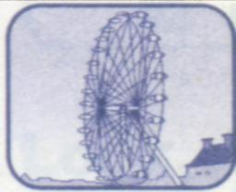
1. It’s very tall.

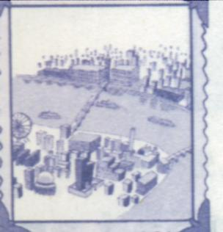
- It’s big and round.

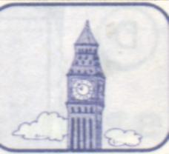
3. It’s long and wide.
四、听音选择正确的答语前打√，完成对话。（8分）
1. Will you phone me?
( ) A. Yes, I will. ( ) B. No, I won’t.
2. Will you play with me this weekend?
( ) A. Yes, I will. ( ) B. No, I won’t.
3. Will you go to the zoo this weekend?
( ) A. Yes, I will. ( ) B. No, I won’t.
4. Will you visit your grandpa this weekend?
( ) A. Yes, I will. ( ) B. No, I won’t.
五、根据听到的对话，选择正确的句子打√。（8分）
1. ( ) A. Daming will play with Sam.
( ) B. Daming will visit his grandpa.
2. ( ) A. Amy will go to the zoo.
( ) B. Amy will go to the park.
3. ( ) A. Sam will read some books.
( ) B. Sam will watch TV.
4. ( ) A. Lingling will go swimming.
( ) B. Lingling won’t go swimming.

六、听音，选择正确的职业， 请将序号写在横线上。（8分）
1. My grandpa is a _________.
A. doctor B. writer C. policeman D. driver

2. My grandma is a _________.
A. nurse B. teacher C. driver D. film star
3. My father is a _________.
A. driver B. teacher C. policeman D. writer
4. My mother is a _________.
A. film star B. nurse C. doctor D. writer

七、听听他们的理想，连一连。（8分）
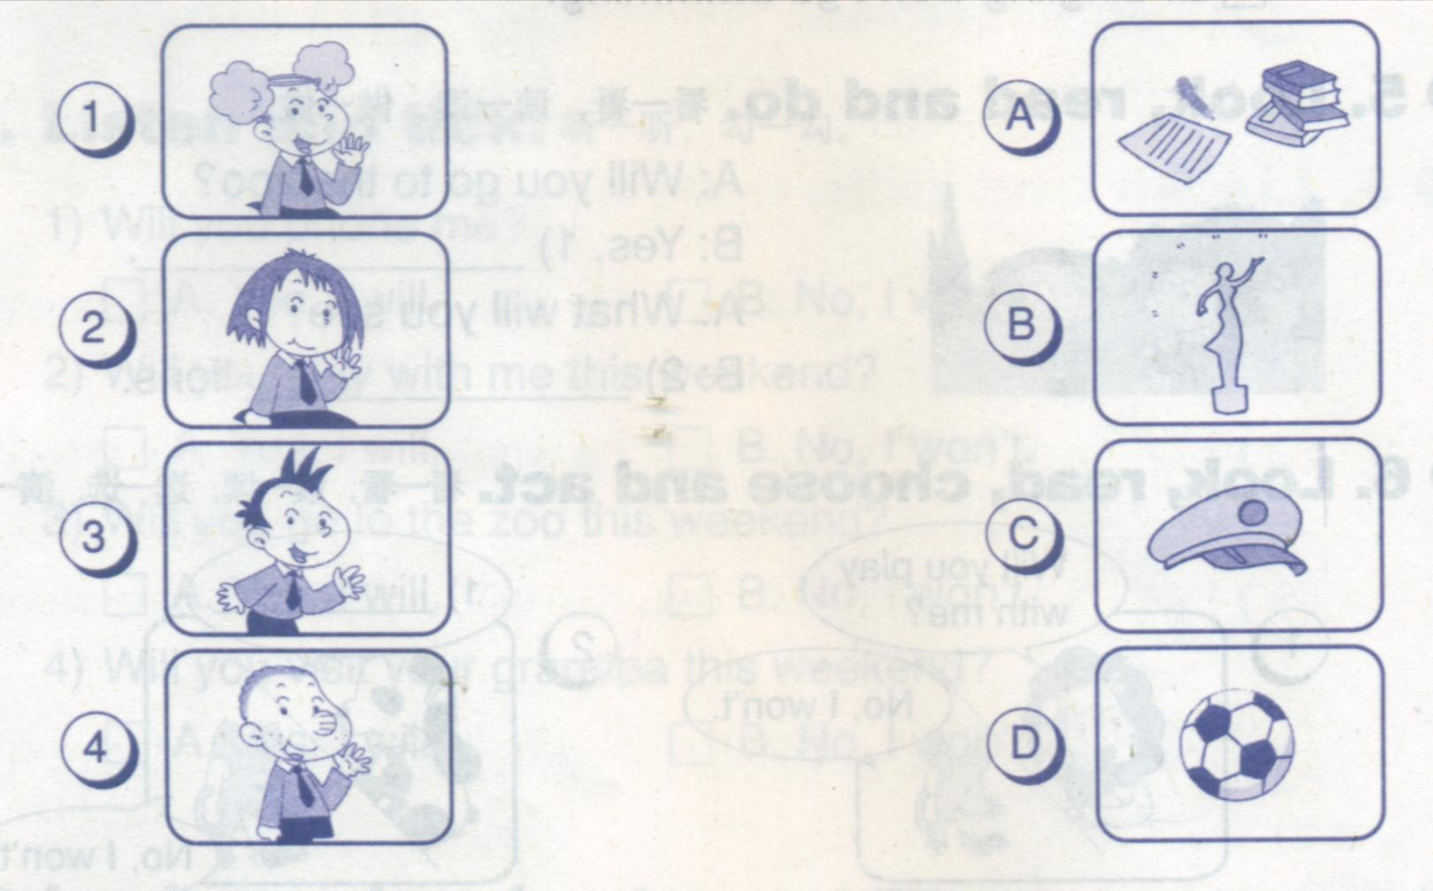

八、听音选择正确的答案打√。（6分）
1. Will Dagang be a film star?
( ) A. Yes, he will. ( ) B. No, he won’t.
2. Will Tiantian be a writer?
( ) A. Yes, she will. ( ) B. No, she won’t.
3. Will Xiaoyong be a bus driver?
( ) A. Yes, he will. ( ) B. No, he won’t.
笔试部分（ 38分）

一、根据汉语意思完成下列句子。（10分）
1. We’ll go to the zoo. We’ll see lions, _________（老虎）and pandas.
2. A:___________（什么）will we pick?
B: We’ll pick some ______________（桃子）.
3. Big Ben is an____________(古老的)___________（钟表）.

二、给问句找到恰当的答句，将序号填在括号内。（8分）
A. I’ll see lots of pigs. B. Maybe I’ll go to the park.
C. No, she won’t. D. Maybe I’ll be a film star.

1. What will you do this weekend? ( )
2. What will you be? ( )
3. What will you see? ( )
4. Will Lingling go, too? ( )

三、选择正确答案，将序号填入括号内。（10分）
( ) 1. What _______you see? A. will B. we’ll C. I’ll
( ) 2. Maybe _____ go to the zoo. A. will B. we’ll C. I am
( ) 3. Will Sam go, too? ____________
A. Yes, he won’t. B. No, I won’t. C. Yes, he will.
( ) 4. –----What will you be? -----Maybe I’ll _______ a writer.
A. be B. am C. will be
( ) 5. He’ll be _______ astronaut. A. a B. an C. is

四、阅读理解，判断T或 F。（10 分）
Xiaoyong wants to fly. But he won’t fly a kite. And he won’t fly a plane. He’ll fly a spaceship! The spaceship will go to the moon.

1. Xiaoyong wants to fly. T F
2. He will fly a kite. T F
3. He will fly a plane. T F
4. Xiaoyong wants to be an astronaut. T F
5. The spaceship will go to the moon. T F

三年级英语听力题签：
注意：每道听力试题读二遍，听力时间控制在 30分钟内。

一、听音补全句子， 填入所缺单词。（10分）
1. My mother is very nice. 2. The London Eye is new.
3. Sam is quiet and shy. 4. We’ll pick fruit.

二、听听他们的性格，选择正确句子打√。（8分）
1. This is Fangfang. She’s very helpful.
2. This is Dagang. He’s a bit quiet.
3.This is Xiaoyong. He’s very naughty.
4. This is Tiantian. She’s very clever.

三、听音，将图片与句子相连。（6分）
1. This is a river. It’s long and wide.
- This is the London Eye. It’s big and round.
3. This is Big Ben. It’s very tall.

四、听音选择正确的答语前打√，完成对话。（8分）
1. Will you phone me? Yes, I will.
2. Will you play with me this weekend? No, I won’t.
3. Will you go to the zoo this weekend? No, I won’t.
4. Will you visit your grandpa this weekend? Yes, I will.

五、根据听到的对话，选择正确的句子打√。（8分）
1. Will you play with me this weekend, Daming?
-------No, I won’t. I will visit my grandpa.

2. Will you go to the zoo this weekend, Amy?
-------Yes, I will.
3. Will you read some books this weekend, Sam?
--------No, I won’t. I will watch TV.
4. Will you go swimming this weekend, Lingling?
---------Yes, I will.

六、听音，选择正确的职业， 请将序号写在横线上。（8分）
1. This is my grandpa. He’s a doctor.
2. This is my grandma. She’s a teacher.
3. This is my father. He’s a policeman.
4. This is my mother. She’s a writer.

七、听听他们的理想，连一连。（8分）
1. I’m Amy. Maybe I’ll be a film star in the future.
2. I’m Lingling. Maybe I’ll be a writer.
3. I’m Daming. Maybe I’ll be a footballer.
4. I’m Sam. Maybe I’ll be a policeman.

八、听音选择正确答案。（6分）
1. This is Dagang. He won’t drive buses. He’ll drive trains.
2. This is Tiantian. She won’t write songs. She’ll write books.
3. This is Xiaoyong. He won’t fly a plane. He’ll fly a spaceship.

听力部分到此结束！

三年级英语答案及评分标准：

听力部分（62分）
一、(2×5＝10分) 答案略。详见听力题签， 每个单词必须完全拼写准确方可得2分。
二、(2×4＝8分) ABAB
三、(2×3＝6分) 答案略。详见听力题签
四、(2×4＝8分) ABBA
五、(2×4＝8分) BABA
六、(2×4＝8分) ABCD
七、(2×4＝8分) 1----B 2----A 3-----D 4------C
八、(2×3＝6分) BAB

笔试部分（38分）
一、 (2×5 ＝10分)
tigers , What , peaches , old , clock
(每个单词必须完全拼写准确方可得2分, 但画有“—”的部分扣0.5分)
二、(2×4＝8分) BDAC
三、(2×5＝10分) ABCAB
四、(2×5＝10分) T F F T T

备注：卷面满分为100分。（听力62分，笔试38分。）
优秀：90---100
良好：80---89
及格：60---79
不及格：0---59

2011年5月8

