长海县2010~2011学年度第一学期期末学业质量检测
小学四年级英语 考试时间：60分钟

题号 | Ⅰ | Ⅱ | Ⅲ | Ⅳ | Ⅴ | Ⅵ | Ⅶ | Ⅷ | Ⅸ | Ⅹ | Ⅺ | Ⅻ | 总分
得分
听力部分( 50分)
Ⅰ、听音，选出你所听到的单词，将其序号填入括号内。
（ ）1、 A. hungry B. angry （ ）2、 A. come B. climb
（ ）3、 A. dirty B. thirsty （ ）4、 A. finger B. finish
（ ）5、 A. hear B. hurt （ ）6、 A. magic B. medicine
（ ）7、A. said B. tell （ ）8、 A. wore B. wear
（ ） 9、 A. took B. food （ ）10、A. mountain B. monster
Ⅱ、听音，用数字（1、2、3、4、5）给下列图片重新排序。
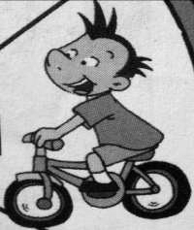 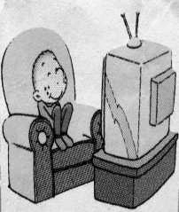 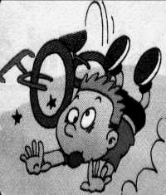 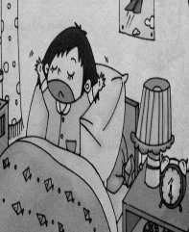 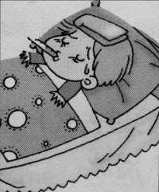（ ） （ ） （ ） （ ） （ ）
Ⅲ、听音，判断下列图片是否正确，正确打“√”，错误划“╳”。
1、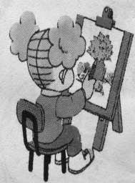2、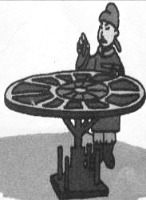3、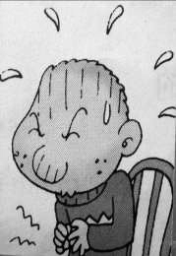4、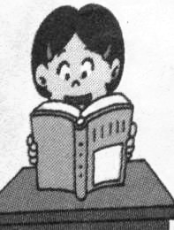 5、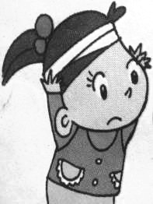
（ ） （ ） （ ） （ ） （ ）
Ⅳ、听音，选出你所听到的句子，并将其序号填入括号内。
（ ）1、 A. I cleaned my room.
B. I finished my homework.
（ ）2、 A. She usually learns English and Maths.
B. She didn’t learn English and Maths.
（ ）3、 A. Where did you go?
B. What did you do?
（ ）4、 A. I saw a scary thing on the TV.
B. Did you see a scary thing?
（ ）5、 A. They ate a watermelon.
B. We bought a watermelon.
（ ）6、 A. I bumped my head.
- I cut my finger.
Ⅴ、听音，按所听顺序用数字（1、2、3、4、）给下列句子重新排序。
（ ）I learnt to skate. It was easy.
（ ）Last Saturday, we went on a school trip.
（ ）I didn’t fall over. It was really fun.
（ ）We went ice-skating. I wore warm clothes.

笔试部分(50分)
Ⅵ、 请按顺序默写26个英文字母,并圈出五个元音字母。

Ⅶ、 请根据所给语境，写出单词的正确形式。
1、Chinese people _________________ (发明) __________ (纸).
2、He didn’t __________ (步行)to school__________________ （昨天）.
3、What _______________ (发生) to you？
4、They went to the ____________ ______________ (长城).
5、Did you ______________ （弄坏）your toy？
Ⅷ、选择。
（ ）1、I _________ got a new friend. Her name is Lingling.
A. has B. have C. am
（ ）2、There ________ four children. The monster wanted to eat the children.
A. was B. is C. were
（ ）3、Tom fell ______ his bike. And I fell ______ the watermelon.
A. off / on B. over/ of C. to/ on
（ ）4、The bad man went to sea in his ship. But he didn’t ________ back.
A. came B. come C. coming
（ ）5、Chinese people didn’t invent the bicycle ______1839.
A. in B. on C. with
Ⅸ、 根据语境选择恰当词语把句意补充完整，并将序号填入横线上。
A. washed B. went C. dancing D. ate E. print

1、We ________ books and newspaper.
2、Sam ________ thirty biscuits. So he’s got a stomach ache.
3、She ________ her trousers last Sunday.
4、We didn’t go to the zoo last week. We ________ to the park.
5、I like traditional Mexican food and traditional ________.
Ⅹ、请为所给问句选择正确的答句，将序号填入括号内。
（ ）1、When did they come? A. Yes, I did.
（ ）2、What’s the matter? B. They came last Monday.
（ ）3、Did you cry, Tom? C. I’ve got a toothache.
（ ）4、Where do you live? D. She’s reading a book.
（ ）5、What’s Amy doing? E. I live in England.

Ⅺ、 连词成句。
1、 play / what / she / did（? ） ____________________________________
2、got / stomach / I’ve / a / ache（.）____________________________________
3、didn’t / it / gold / make （.） _____________________________________
4、did / play / you / football（?） _____________________________________
5、helped / mum / I / my（.） _____________________________________

Ⅻ、 阅读短文，判断正( T )误( F )。
Lili is from China. She’s ten years old. She lives in Dalian. She’s got a new friend. Her name is Lucy. Lucy is from America. She came to China with her mother last week. They went to Shanghai with Lili last Sunday. They took some photos there. They had a good time.

（ ）1、Lili lives in Dalian.
（ ）2、Lucy is Lili’s new friend from America.
（ ）3、Lucy came to China with her father last week.
（ ）4、They went to Shanghai last Wednesday.
（ ）5、They took some photos in Shanghai.
四年级英语听力题签:
※注意：每道听力试题读二遍。时间控制在20分钟以内。

Ⅰ. 听音，选出你所听到的单词，将其序号填入括号内。
1、angry 2、climb 3、dirty 4、finger 5、hurt
6、medicine 7、said 8、wore 9、food 10、mountain
Ⅱ. 听音，用数字（1、2、3、4、5）给下列图片重新排序。
1、Lingling gets up at half past six.
2、Mingming isn’t at school. She’s got a fever.
3、He watched TV yesterday.
4、I usually ride my bike on Sundays.
5、 Sam fell off his bike.
Ⅲ. 听音，判断下列图片是否正确，正确打“√”，错误划“╳”。
1、She painted a picture yesterday.
2、Chinese people invented printing.
3、Sam’s got a cold. He didn’t go to school.
4、－Did Lingling play the flute? -------- Yes, she did.
5、Lanlan bumped her head.
Ⅳ. 听音，选出你所听到的句子，并将其序号填入括号内。
1、I cleaned my room.
2、She didn’t learn English and Maths.
3、Where did you go?
4、Did you see a scary thing?
5、We bought a watermelon.
6、I cut my finger.
Ⅴ. 听音，按所听顺序用数字（1、2、3、4、）给下列句子重新排序。
Last Saturday, we went on a school trip. We went ice-skating. I wore warm clothes.
I learnt to skate. It was easy. I didn’t fall over. It was really fun.
听力部分到此结束！
四年级英语答案及评分标准：
听力部分
Ⅰ、(1×10＝10分) BBAAB BAABA
Ⅱ、(2×5＝10分) 4-----3-----5-----1----2
Ⅲ、(2×5＝10分) √ √ ╳ ╳ √
Ⅳ、(2×6＝12分) ABABBB
Ⅴ、(2×4＝8分) 3------1------4-------2
笔试部分
Ⅵ、(2分) 答案略（教师自行把握赋分标准）
（其中26个字母共是1分，圈画出5个元音字母共是1分。
各以0.5分为基，分2个等级给分。）
Ⅶ、(1×8＝8分) 1、invented paper 2、walk yesterday
3、happened 4、Great Wall 5、break
（备注：上面画有“—”部分的单词如果没有形式的变化将扣0.5分， 其余单词必须完全拼写准确方可得1分。）
Ⅷ、(2×5＝10分) BCABA
Ⅸ、(1×5＝5分) EDABC
Ⅹ、(2×5＝10分) B---C----A----E-----D
XI、(2×5＝10分)
1、 What did she play?
2、 I’ve got a stomach ache.
3、 It didn’t make gold.
4、 Did you play football ?
5、 I helped my mum.
XII、(1×5＝5分) T T F F T

备注：卷面满分为100分。（听力50分，笔试50分。）
优秀：90---100
良好：80---89
及格：60---79
不及格：0---59

2011年1月8日

