长海县2010~2011学年度第一学期期末学业质量检测
小学三年级英语 考试时间：60分钟
题号 | Ⅰ | Ⅱ | Ⅲ | Ⅳ | Ⅴ | Ⅵ | Ⅶ | Ⅷ | Ⅸ | Ⅹ | 总 分
得分
听力部分 （50分）
Ⅰ、听一听， 选一选。
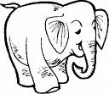
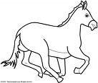
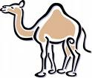
( )1. A. B. C.

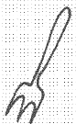
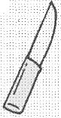
( )2. A. B. C.
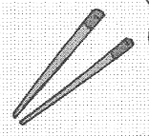




( )3. A. B. C.

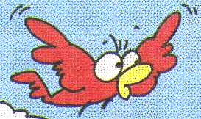



( )4. A. B. C.




( )5. A. B. C.

Ⅱ、听一听， 排一排。

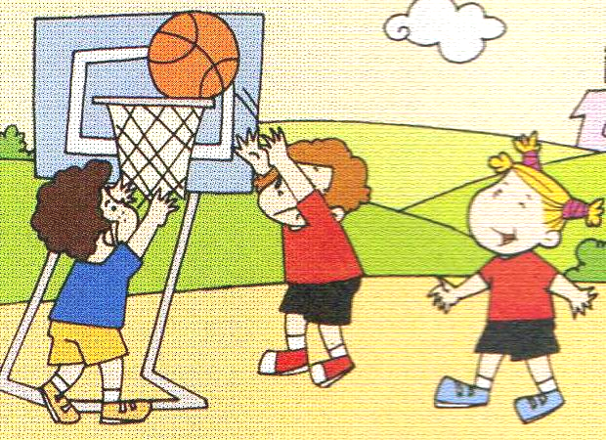


A. B. C. D.

1. _________ 2. _________ 3. _________ 4. _________
Ⅲ、 听一听， 辨一辨。
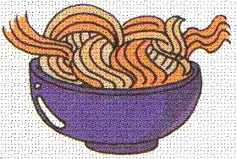
( ) 1. A. It's nice.
B. Yes, it is.
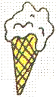
( ) 2. A. Yes. Here you are.
B. Thanks, Mum.


( ) 3. A. No, I haven’t.
B. Yes, I have.
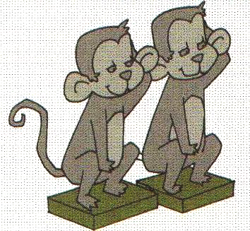
( ) 4. A. These are stone monkeys.
B. There are 2.

( ) 5. A. I’m going to be a bus driver.
- My father is a taxi driver.

Ⅳ、听一听， 连一连。
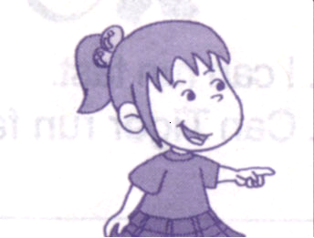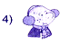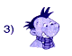
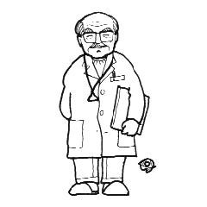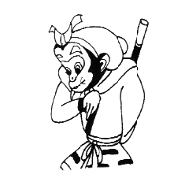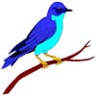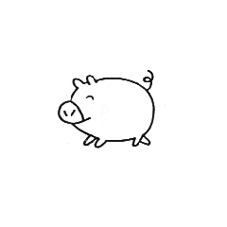
Ⅴ、听一听，补一补。
1、I like English. It’s ______________ to learn English.
2、Amy is _____________. She’s got a ______________.
3、I’m going to ___________ the Ming Tombs on ________________.
4、We’re going to swim in the _____________.
5、There are two _____________ in my family.
6、Amy’s shorts are _____________.

笔试部分 （50分）
Ⅵ、1、请按顺序默写26个英文字母,并圈出五个元音字母。

2、按照正确的英文格式书写下列句子。
How many people are there in your family?

Ⅶ、选择。
（ ）1、These ducks __________ very naughty.
A. is B. are
（ ）2、A: Can I come in ? B:______________.
A. Yes, I can. B. Yes , please.
（ ）3、This is __________shirt.
A 、Sam B、Sam’ C、Sam’s
（ ）4、I can __________ far, but I can’t ________ fast.
A. jump , run B. jumping , running
（ ）5、Please be quiet! Dad ______ working in the room.
A. am B. is C. are
（ ）6、I ________ got a new kite.
A. have B. has
（ ）7、There _________ 20 girls in my class.
A. am B. is C. are
（ ）8、A:_________ are you going , Xiaoyong ?
B: I’ m going to go to Hong Kong.
A、 What B、Where C 、How
Ⅷ、情景反应, 连连看。
1、What are you going to do ? A 、No, I can’t.
2、Can you run fast? B 、I’m going to do long jump.
3、How many books are there? C、 I’m watching TV.
4、Has he got a test today? D、 There are three.
5、What are you doing ? E 、No, he hasn’t.
Ⅸ、根据所给语境， 选填单词补全下列句子。
elephant , those , biscuits , worry , man

1、A: What are ____________? B: They’re dragon boats.
2、There is an _____________. And there is a camel.
3、My father is a tall ___________.
4、Don’t ___________. Let’s fix the kite!
5、I’m hungry. Can I have these____________, please?
Ⅹ、阅读理解，根据短文内容判断正( T )误( F )。
Hello！ My name is Amy. I can jump high, and I can jump far, but I can’t run fast. On Sports Day, I’m going to do high jump. Sam can jump far and jump high, too. And he’s going to do long jump. Daming can’t jump far, but he can run fast. He’s going to run a race.
( ) 1、 Amy can run fast.
( ) 2、 Amy is going to do high jump.
( ) 3、 Sam is going to do high jump，too.
( ) 4、 Daming can run fast.
( ) 5、In this short passage (在这篇短文中) , there is one boy，
and there are two girls.
三年级英语听力题签：
注意：每道听力试题读二遍，听力时间控制在25分钟内。
Ⅰ、听一听， 选一选。（听音，选出与你所听到的内容相符的图片。）
1.There is a horse.
2. I can use a knife.
3. I ’m eating a hamburger.
4.This bird can’t fly.
5. We’re making a cake.

Ⅱ、听一听， 排一排。（听句子，根据所听内容将下列图片排序。）
1. He can jump far.
2. Chopsticks are hard for English people.
3. They are going to play basketball on Saturday.
4. There are two children in the boat. They are feeding ducks.

Ⅲ、听一听， 辨一辨。（认真看图，细听问句，选出正确的答句。）
1. I like noodles. Is it Chinese fast food ?
2. Can I have an ice cream, please?
3. Have you got a headache?
4. How many stone monkeys are there?
5. What are you going to be, Daming?
Ⅳ、听一听， 连一连。（听音识图，把上下相关的图片用线连起来。）
1、Hello, I’m Daming . I’m going to be a doctor.
2、A: Are you going to see Sun Wukong , Amy?
B: Yes, I am .
3、Lingling has got a pet cat.
4、A: It’s a pig. Can you draw it, Sam ?
B: Yes , I can .
5、Lanlan is playing with a bird .

Ⅴ、听一听， 补一补 。（听音补全句子，填入所缺单词。）
1、I like English. It’s ____ easy _____ to learn English.
2、Amy is ____ ill _____. She’s got a _____ cold _____.
3、I’m going to _____ visit ______ the Ming Tombs on _____ Friday_______.
4、We’re going to swim in the ______ sea _______.
5、There are two ______ women _______ in my family.
6、Amy’s shorts are _____ wet ________.

听力部分到此结束！

三年级英语答案及评分标准：
听力部分
Ⅰ、(2×5＝10分) BCCCB
Ⅱ、(3×4＝12分) 1~4：CABD
Ⅲ、(2×5＝10分) BABBA
Ⅳ、(2×5＝10分)
Amy ------Sun Wukong , Lingling----- cat , Lanlan -----bird ,
Sam-----pig , Daming------ doctor
Ⅴ、(1×8＝8分) 答案略。（详见听力题签）
（备注：Friday和 women这2个单词，画有“—”的部分如果没有形式的变化将扣0.5分， 其余单词必须完全拼写准确方可得1分。）

笔试部分
Ⅵ、( 3+1＝4分) 答案略。（教师自行把握赋分标准）
第一小题3分（其中26个字母共是2分，以0.5分为基，分4个等级给分。
圈画出5个元音字母共是1分，以0.5分为基，分2个等级给分。）
第二小题1分，以0.5分为基，分2个等级给分。
Ⅶ、(2×8＝16分) BBCAB ACB
Ⅷ、(2×5＝10分) 1---B , 2----A , 3----D , 4-----E , 5----C
Ⅸ、(2×5＝10分) 1.those , 2.elephant , 3. man, 4.worry , 5. biscuits
Ⅹ、(2×5＝10分) F T F T F

备注：卷面满分为100分。（听力50分，笔试50分。）
优秀：90---100
良好：80---89
及格：60---79
不及格：0---59

2011年1月8日

