小学英语五年级期中阶段练习 考试时间：80分钟
听力部分( 50分)
听音，选出不同类的一项。（5分，每小题1分）
1、( ) A、cake B、chocolate C、flower
2、( ) A、sing B、dance C、swing
3、( ) A、heavy B、toy C、big
4、( ) A、dress B、shoes C、bird
5、( ) A、you B、she C、his
二、听句子,选择正确的答语。(5分，每小题1分)
( ) 1、A、It’s in spring. B、It’s in autumn.
( ) 2、A、They wear scary clothes.
B、They wear toys and flowers on the hats.
( ) 3、A、We are going to play with toys.
B、They are going to play basketball.
( ) 4、A、It’s mine. B、It’s me.
( ) 5、A Yes, I do. B、Yes, I can.
三、听句子选择单词, 请在横线上填入序号。 (10分，每小题1分)
A . feed B. small C. helpful D. festival E. mask
F. give G. birthday H. matter I. wet J. dirty
1.Sam’s shoes are ______. 2. He wore a scary _________.
3.What’s the _________? 4. The people ______ them sweets.
5.Easter is a spring ________. 6. We can _______ the ducks.
7.Lingling’s skirt is______. 8.Are you going to have a cake?
9.There were________ trees before on the playground.
10.You are ________ children.
四、听音判断图片的正误。（10分，每小题2分）
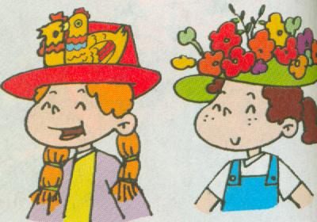
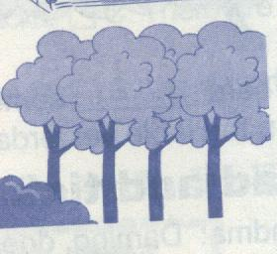
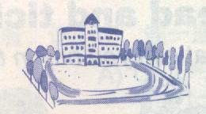
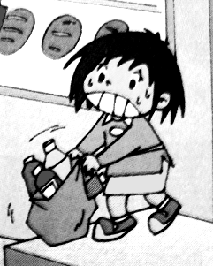
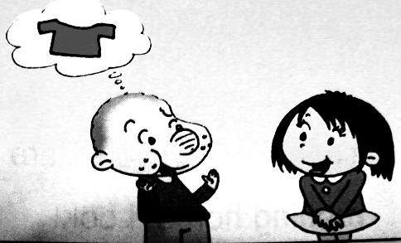

（ ） （ ） （ ） （ ） （ ）
五、听音标号并连线。（10分，每小题2分）
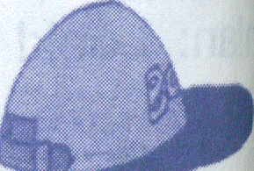
（ ） hat

（ ） cap
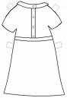
（ ） skirt
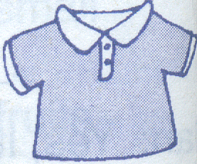
（ ） dress
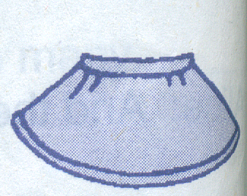
（ ） T-shirt

六、根据课文判断对（Ｔ）错（Ｆ）。（10分，每小题2分）
1、( )Amy and Lingling are going to go to the supermarket.
2、( )There isn’t a big supermarket.
3、( )Lingling can’t lift the bag.
4、( )Amy, Lingling and Sam are helpful children.
5、( )Ms Smart gives them some sweets.
笔试部分（50分）
一、根据中文提示将单词补充完整。（10分，每词1分）
1、There was a ______ .（操场）
2、________（有时） there are _________（饭馆） at the supermarket.
3、 It’s an ______（请柬）to my birthday party. Please ________ .（回复）
4、I was in London for two .（年）
5.、This one is __________. （重的） I can’t _________（抬） it.
6、Tom is_______________ ( 大笑 )now.
7、They sell food from lots of .(国家)

二、单项选择。（10分，每小题1分）
1、（ ）Please help me _______up A. to tidy B. tidying C. tidy
2、（ ）Mum’s going to make a cake ______me. A. to B. for C. with
3、（ ）Yesterday I __________to Sam and Amy’s school.
A. go B. went C. going
4、（ ）I’m playing_______ Amy’s toys. A．/ B. with C. of
5、（ ）There are _______games. A. lots of B. lot of C. a lots of
6、（ ）That coat is_______. A. mine B. my C. me
7、（ ）Let’s _____to the supermarket together. A. to go B. goes C. go
8、（ ）What are you going to______? A. do B. does C. doing
9、（ ）My mother is shopping ___ the computer. A. on B. in C. at
10、（ ）Jack ______ to wear a red shirt yesterday.
A. wants B. wanted C . want
三、回答问题。(10分,每小题1分)
A. 选择正确的单词（5分）
1. Whose is this? It’s . (my , mine)
2. She is good friend. ( my , mine)
3. Is this ruler? (your , yours )
4. It’s not . It’s Lily’s. (your, yours)
5. How old are ？(your , you)
B. 写出正确的单词（5分）
6. I going to be 11.
7. He going to have lunch with his friend.
8. Easter is spring.
9. There ____ any ducks in the pond here before.
10. They are going make a birthday cake for me.
四、完型填空。（10分,每小题2分）
My school ① very different now! There ② a playground before. But there is a very big playground now! And we often ③ games there after class. There weren’t any flowers here before. There are lots of flowers now! So our school is very beautiful now! We ④ watch TV at school before. But we have TVs ⑤ our classroom now.
1、( )A.look B.looking C.looks 2、（ ）A.isn’t B.wasn’t C. weren’t
3、（ ）A.play B.plays C.played 4、（ ）A. can’t B. could C .couldn’t
5、（ ）A. in B. on C. at
五、阅读理解。（10分,每小题1分）
(一) 读短文，判断正误。（5分）
Tom and Amy are going to do some shopping. This is not a big supermarket. There weren’t any clothes here before. Now there are many clothes .It also sells toys, books, CDs and some food. They want to buy some chocolates, sweets and fruits. Because Amy is going to have a birthday party. She is going to be 11 next Saturday. Lingling got an invitation from her. And she is going to make a birthday cake for Amy. Because she can make a cake very well. They will be happy that day!
( )1、Lingling is going to have a birthday party next Saturday.
( ) 2、The supermarket is big.
( )3.、The supermarket sells clothes, toys, books, CDs and food.
( )4、There weren’t any clothes at the supermarket.
( ) 5、Lingling can’t make a cake well.
（二）选择，True or False (5分)
Dear Daming ,
I had a lot of fun today. It was Halloween. It’s an autumn festival. Sam, Amy and I wore scary clothes .I wore a scary hat and black clothes .Amy wore a white mask. It was really scary .We went to Ms Smart’s house. We scared her .She gave us lots of sweets.
Love,
Lingling
1）Halloween is in autumn. True False
2) Lingling wore white clothes at Halloween. True False
3) Amy’s mask was scary. True False
4) They went to Ms Smart’s house. True False
5) They got lots of sweets. True False
五年级英语听力题签:
※注意：每道听力试题读二遍。时间控制在20分钟以内。

- 听音，选出不同类的一项。
1、A、cake B、chocolate C、flower
2、A、sing B、dance C、swing
3、A、heavy B、toy C、big
4、A、dress B、shoes C、bird
5、A、you B、she C、his

- 听句子,选择正确的答语。
1、When is Easter?
2、What do people wear at Halloween?
3、What are you going to do?
4、Whose T-shirt is it?
5、Do you like this park now?

三、听句子选择单词, 请在横线上填入序号。
1. Sam’s shoes are dirty. 2. He wore a scary mask.
3. What’s the matter? 4. The people give them sweets.
5. Easter is a spring festival. 6. We can feed the ducks.
7.Lingling’s skirt is wet. 8. Are you going to have a birthday cake?
9. There were small trees before on the playground.
10. You are helpful children.

四、听音判断图片的正误。
1 .This one is heavy. I can’t lift it.
2 .Sam: Whose T-shirt is it? Lingling : It’s yours.
3. Now there is a big playground.
4. There aren’t tall trees on the playground.
5. There are toy chicks and flowers on the hats.
五、听音标号并连线。
NO 1: Whose hat is it? It’s mine.
NO 2: It’s my cap.
NO 3: Sam wants to wear a red T-shirt.
NO 4: Whose skirt is it? It’s Lingling’s.
NO 5: Amy’s blue dress is wet.

六、根据课文判断对（Ｔ）错（Ｆ）。
自找Module 2 Unit 1的 课文磁带。

听力部分到此结束！

五年级英语答案及评分标准：
听力部分
一. (1×5＝5分) C C B C C
二. (1×5＝5分) A A A A A
三. (1×10＝10分) 答案略。（详见听力题签）
四. (2×5＝10分) √ √ √ × √
五. (2×5＝10分) 2 1 5 3 4
六． (2×5＝10分) T F T T F

笔试部分
- (1×10＝10分)
1. playground 2. Sometimes 3. restaurants 4. invitation 5. reply
6. years 7. heavy 8. lift 9. laughing 10. countries

- (1×10＝10分) C B B B A A C A A B

- (1×10＝10分)
1.mine 2. my 3. your 4. yours 5. you
6. am 7. is 8. in 9. weren’t 10.to
- (2×5＝10分) C B A C A
- (1×10＝10分) × × √ √ ×
T F T T T

备注：卷面满分为100分。（听力50分，笔试50分。）
优秀：90---100
良好：80---89
及格：60---79
不及格：0---59

2010年11月

