小学英语四年级期中阶段练习 考试时间：60分钟
听力部分( 60分)
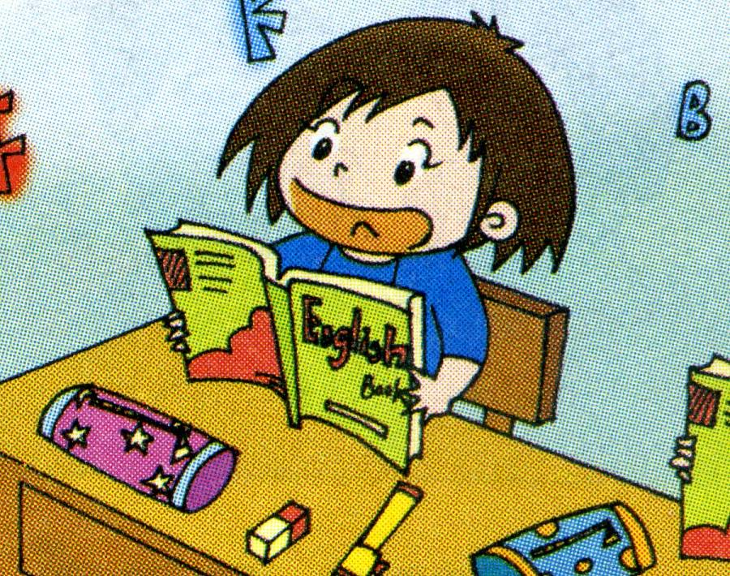
I.听一听，标一标。（共5小题，满分10分）
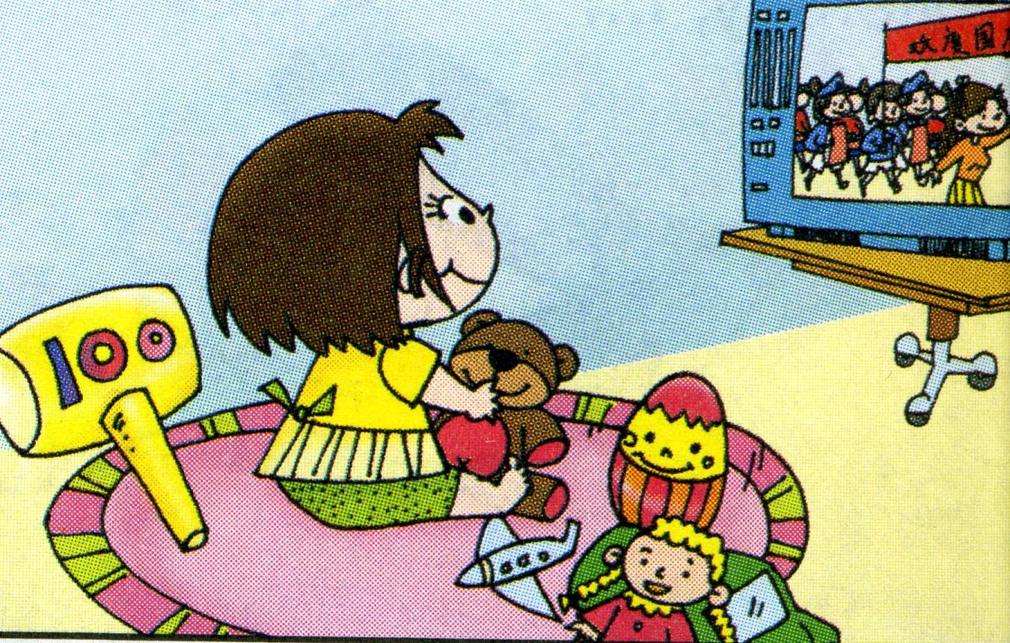

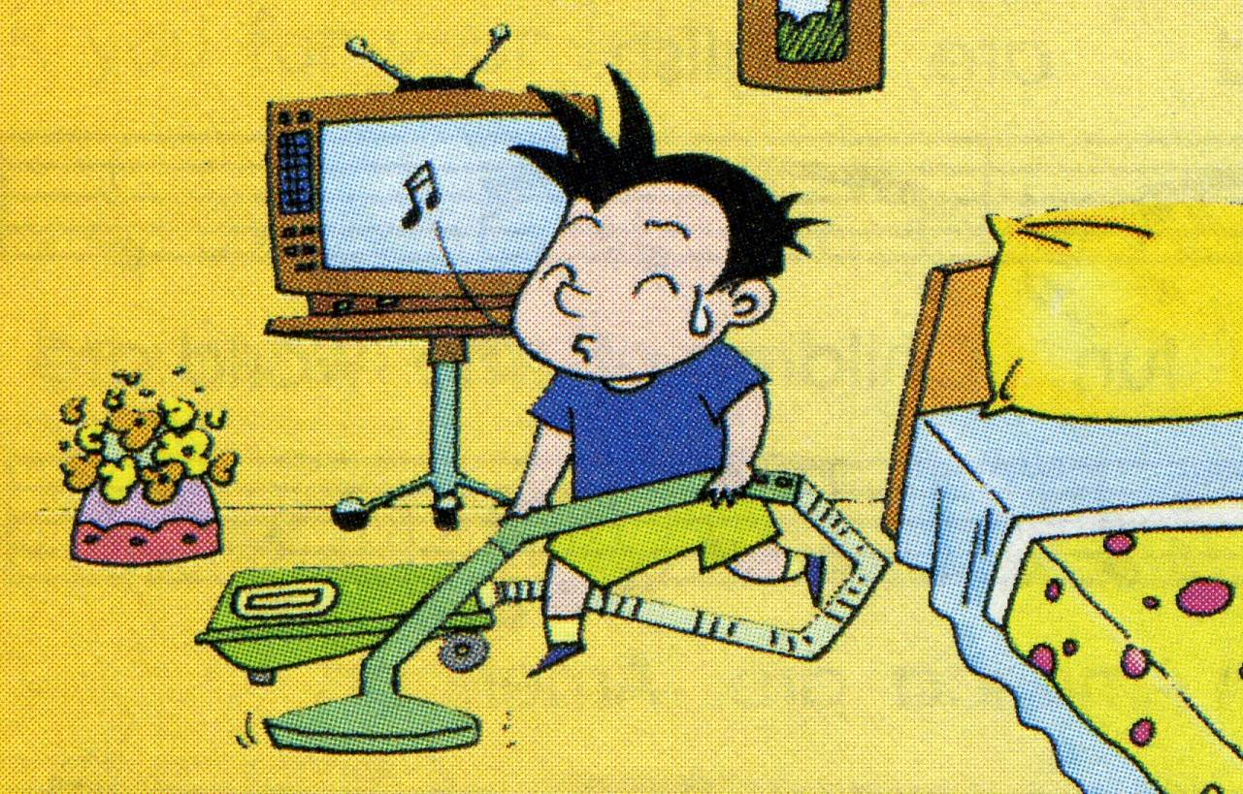
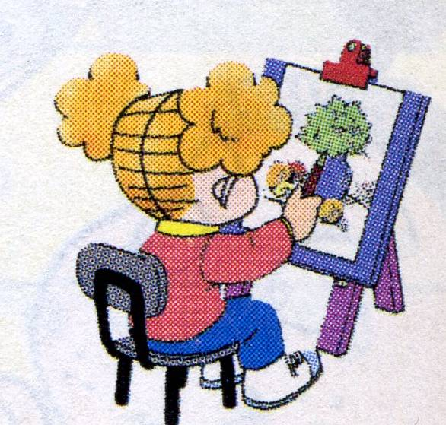

( ) ( ) ( ) ( ) ( )
II. 听一听，圈一圈。（共5小题，满分10分）
1. was were 2. picture photo 3. wear wore
4. paper printing 5. washed watched
III.听一听，勾一勾。（共5小题，满分10分）
1) finish my homework ( )
2) wash her shirt ( )
3) clean her room ( )
4) help Mum ( )
5) learn English and Maths ( )
IV. 听一听，选择正确的单词写在横线上。（共6小题，满分12分）
washed helped listened played watched finished
- I __________ with my toys.
- I __________ my Dad.
- Sam __________ to the radio.
- Amy __________ TV.
- Lingling __________ her homework.
- Daming __________ his trousers.
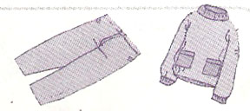
Ⅴ. 听一听,连一连。（共4小题，满分8分）
1) We went on a school trip.
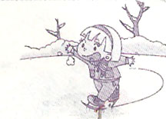
2) I wore warm clothes.

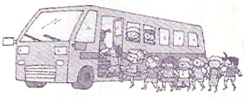
3) I fell over.

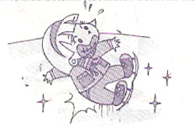
4）I learnt to skate.

Ⅵ. 听一听，根据问句，选择适当的答句。（共5小题，满分10分）
( ) 1. A.I went to the Great Wall. B. I live in London.
( ) 2. A. I saw a big bird. B. I ate chocolate biscuits.
( ) 3. A. Sam watched TV. B. Amy painted a picture.
( ) 4. A. Chinese people invented bicycle.
B. English people invented bicycle.
( ) 5. A Daming went to the Great Wall.
B. Lingling went to the park.
笔试部分 （40分）
Ⅰ. 看一看，写一写。（共6小题，满分10分）
1、I like _______________( 中国的) dancing.
2、Where do you live? I live in ____________.( 伦敦)
3、Daming didn’t go to _________( 学校) ___________.( 昨天).
4、Chinese people __________( 发明 ) _________.（纸）
5、We went to ________ __________ ___________.（长城）
6、Mr. Smart usually __________( 步行) to work.

Ⅱ. 选择。（共5小题，满分5分）
- A:Where ______ she live? B: She ______ in Beijing.
A. do, live B. does, live C. does, lives
- It was my birthday _______ Monday.
A. in B. on C. from
- Lingling will be ten ______ April.
A. in B. on C. to
- I’m John. I like basketball and ________ TV.
A. watched B. watch C. watching
- Daming didn’t ________ football in the park.
A. plays B. play C. played

Ⅲ. 连词成句 。（共5小题，满分10分）
1. my / helped / I / mum (.)__________________________________
2. people / Chinese / paper / invented (.)_______________________
3. she / walk / school / to / didn’t / yesterday (.)__________________
4. this / bicycle / invented / he / in 1839 (.)______________________
5. the / went / we / to / Great / Wall ( . ) ________________________

Ⅳ. 读一读，选一选。（共5小题，满分5分）
My father usually __1______ up at half past six. But he ____2_____ get up at half past six yesterday. He usually___3______ to work. But he didn’t walk to work yesterday. Yesterday ______4__ Sunday. My father and I ___5____ to the Great Wall. We saw lots of mountains. We had a good time.
( ) 1. A. gets B. get
( ) 2. A. didn’t B.doesn’t
( ) 3. A. walked B. walks
( )4. A. was B. is
( )5. A. go B. went

Ⅴ. 阅读理解 ,判断 “T” or “F”. （共5小题，满分10分）
Chinese people invented many important things. They invented paper and printing. So we can print books and newspapers today.
Chinese people didn’t invent the bicycle. Look at the picture. He is on the bicycle. He was English. He invented this bicycle in 1839. Do you know who invented telephone? People say it’s Bell. He invented it in 1876.

（ ）1. Chinese people invented newspaper.
（ ）2. An English man invented this bicycle.
（ ）3. The man invented this bicycle in 1876.
（ ）4. American people didn’t invent printing.
（ ）5. Bell invented telephone in 1839.

四年级英语听力题签:
※注意：每道听力试题读二遍。时间控制在20分钟以内。

- 听一听，标一标。
1. watch TV
2. learn English
3. get up
4. paint a picture
5. clean the floor

II. 听一听，圈一圈。
- We were at Buckingham Palace.
- This is a picture of Zara and me.
- I wore worm clothes.
4. Chinese people invented printing.
5. Yesterday I washed my trousers.

III. 听一听，勾一勾。
Yesterday I finished my homework. But I didn’t wash her shirt. I didn’t clean my room. But I helped Mum. And I learnt English and Maths.

IV. 听一听，选择正确的单词写在横线上。
1. I __played________ with my toys.
2. I __helped________ my Dad.
3. Sam ____listened______ to the radio.
4. Amy __watched________ TV.
5. Lingling _____finished_____ her homework.
6. Daming __washed________ his trousers.

Ⅴ. 听一听,连一连。
1)We went on a school trip.
2) I wore warm clothes.
3) I fell over.

4）I learnt to skate.

Ⅵ. 听一听，根据问句，选择适当的答句。
1. Where do you live?
2 .What did you eat?
3. What did Amy do?
4. Who invented this bicycle？
5. Where did Daming go?

听力部分到此结束！

四年级英语答案及评分标准
听力部分
  - （2×5＝10分） 4 1 3 5 2
  - （2×5＝10分）1. were 2. picture 3. wore 4. printing 5. washed
  - （2×5＝10分） √ × × √ √
  - （2×6＝12分） 详见听力题签
  - （2×4＝8分） 详见听力题签
  - （2×5＝10分） BBBAA
笔试部分
Ⅰ.（1×10＝10分）
1.Chinese 2. London 3. school， yesterday 4. invented , paper
5. the Great Wall 6. walks ( 每词1分，没大写，没有变化-0.5)
Ⅱ.（1×5＝5分） C B A C B

Ⅲ.（2×5＝10分）
1. I helped my mum.
2. Chinese people invented paper.
3. She didn’t walk to school yesterday.
4. He invented this bicycle in 1839.
5. We went to the Great Wall.

Ⅳ. （1×5＝5分）
1． A 2. A 3. B 4. A 5. B.
Ⅴ. （2×5＝10分）
1. F 2. T 3. F 4. T 5. F

备注：卷面满分为100分。（听力60分，笔试40分。）
优秀：90---100
良好：80---89
及格：60---79 2010年11月
不及格：0---59

