小学英语三年级期中阶段练习 考试时间：60分钟

听力部分(60分)

Ⅰ、听音，选择听到的单词，把序号写到前面的括号里。（10分）
( ) 1. A.use B. make C. feed D. jump
( ) 2. A.chopsticks B. chip C. idea D. row
( ) 3. A.people B. lovely C. shorts D. winner
( ) 4. A.hard B. easy C. worry D. naughty
( ) 5. A.hamburger B. instead C. see D. biscuits
Ⅱ、听音，选择听到的句子。（10分）
( ) 1. A. Do you use chopsticks in England?
B. Do you use chopsticks in China?
( ) 2. A. We are making a cake.
B. We are making a cake for you, Mum.
( ) 3. A. These ducks are very naughty.
B. These ducks are coming now.
( ) 4. A. Can you run fast?
B. Can you jump far?
( ) 5. A. Can I have an ice cream?
B. Can I have a cake?
Ⅲ、听音将下列对话标号。（6分）
( ) They’re dragon boats. ( ) Look, Mum.
( ) What are those? ( ) People row on this lake.
( ) That’s a good idea! ( ) Let’s row and feed the ducks.

Ⅳ、 听音画出 或 （10分）
1. have a drink
2. have an ice cream
3. have some biscuits
4. go to the shop
5. watch TV
V、 听音选词填空,把单词正确的抄写在横线上。（10分）
hard fast food knife and fork chopsticks easy
- Chinese people use _________________.
- Chopsticks are ___________ for Chinese people.
- Hamburgers and chips are English ________________ .
- They use a ___________________ in England.
- Chopsticks are _________ for English people.

Ⅵ、听一听，勾一勾。（8分）
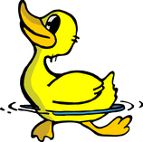
1. A. Yes, it can. B. No, it can’t. C. I don’t know.
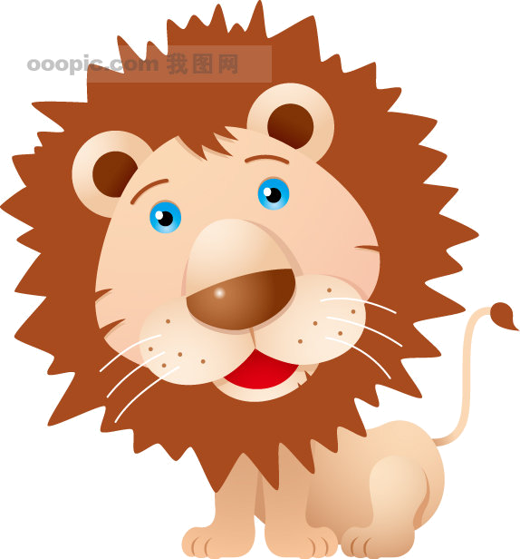
2． A. Yes, it can. B. No, it can’t. C. I don’t know.
3． A. Yes, it can. B. No, it can’t. C. I don’t know.
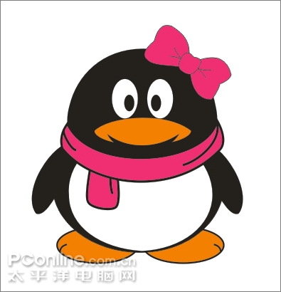
4. A. Yes, it can. B. No, it can’t. C. I don’t know.

Ⅶ、听音连词成句。（6分）
1. fly / bird / This / can /( . ) ______________________________
2. fast / you / run / Can /(?) _______________________________
3. a / cake / making / We’re /(. )______________________________
笔试部分(40分)
Ⅰ、选择正确答案。（10分）
( ) 1. Chips and hamburgers are ______ fast food.
A. English B. Chinese C. England
( ) 2. I like _______. It’s Chinese fast food.
A. noodles B. chips C. hamburgers
( ) 3.Chopsticks are hard _______ English.
A. to B. for C. with
( ) 4. Sam and Amy’s clothes ________ wet.
A. is B. are C. am
( )5. This is __________dress.
A. Sam’s B. Daming’s C. Amy’s
Ⅱ、请为下列问句找到对应的答句并连线。（10分）
1. Are you eating a hamburger? A. She’s eating.
2. What’s Lingling doing? B. Yes, I am.
3. What’s Sam doing? C. No, I don’t.
4. Do you use a fork? D. He’s using a knife.
5. Does Amy want noodles? E. Yes, she does.
Ⅲ、选择下列正确的单词填空。（6分）
reading playing making using listening doing
- Sam and Amy are ____________ a cake.
- Lingling is ____________ her homework.
- Daming is _____________ football.
- Dad is ______________ a book.
- Sam is _____________ chopsticks and he is eating noodles.
- Mum is ________________ to the radio.
Ⅳ、根据实际情况回答问题。（8分）
1. Can you eat apples? ________ , ___________.
2. Can you run fast? _________, ____________.
3. Can you eat a dragon? _________, ___________.
4. Can you swim? ____________ , ____________.
V、读短文，在你认为正确的选项上打√。（6分）
I’m Sam. Today I can’t go out. I’m ill. I can’t play football. Can I watch TV? Yes, I can watch TV. And I can play chess with my dad. Can I have a drink? Yes，but I can’t have an ice cream. I can’t go to the shop for an ice cream. But I can have sweets and a cake.
- Can Sam play football? A. B.
2. Can Sam have a cake? A. B.
- Can Sam play chess? A. B.
- Can Sam have an ice cream? A. B.

三年级英语听力题签:
※注意：每道听力试题读二遍。时间控制在35分钟以内。

Ⅰ、听音，选择听到的单词，把序号写到前面的括号里（10分）
1. Let’s feed the ducks.
2. That’s a good idea.
3. Chinese people use chopsticks.
4. These ducks are very naughty.
5. Can I have some biscuits?
Ⅱ、听音，选择听到的句子（10分）
1. Do you use chopsticks in China?
2. We are making a cake for you, Mum.
3. These ducks are very naughty.
4. Can you jump far?
5. Can I have an ice cream?
Ⅲ、听音将下列对话标号（6分）
(1) Look, Mum.
(2) What are those?
(3) They’re dragon boats.
(4) People row on this lake.
(5) Let’s row and feed the ducks.
(6) That’s a good idea!
Ⅳ、听音画出 或 （10分）
1、Daming: Dad, can I have a drink, please? Dad: Yes, Here you are.

2、Daming: Can I have an ice cream? Dad: No, you can’t. Look, no ice cream.

3、Daming: Can I have some biscuits? Dad: Yes, you can.

4、Daming: Can I go to the shop? Dad: No, you can’t. You are ill.

5、Daming: Can I watch TV? Dad: Yes, you can.
Daming: Thanks ,dad.
V、 听音选词填空,把单词正确的抄写在横线上（10分）
1、Chinese people use __chopsticks__ .
2、Chopsticks are _easy__ for Chinese people.
3、Hamburgers and chips are English _fast food___.
4、They use a __knife and fork___ in England.
5、Chopsticks are __hard____ for English people.
Ⅵ、听一听，勾一勾（8分）
1. A: Can this dog swim?
B: Yes, it can.
2. A: Can this duck fly?
B: I don’t know.
3. A: Can this lion jump far?
B: Yes, it can.
4. A: Can this bird fly?
B: No, it can’t.
Ⅶ、 听音连词成句（6分）
1. This bird can fly.
2. Can you run fast?
3. We’re making a cake.

听力部分到此结束！

三年级英语答案及评分标准：
听力部分
Ⅰ、(2×5＝10分) C--------C------A------D------D
Ⅱ、(2×5＝10分) B B A B A
Ⅲ、(1×6＝6分) 3 1 2 4 6 5
Ⅳ、(2×5＝10分)
1. 2. 3. 4. 5.
V、(2×5＝10分) 1. chopsticks 2. easy 3. fast food 4. knife and fork 5. hard
Ⅵ.(2×4＝8分) A C A B
Ⅶ、( 2×3＝6分) 详见听力题签
笔试部分
Ⅰ、( 2×5＝10分) A A B B C
Ⅱ、( 2×5＝10分) 1.B 2.A 2.D 4.C 5.E
Ⅲ. (1×6＝6分) making doing playing reading using listening
Ⅳ、(2×4＝8分) 第1题为Yes, I can. 第3题为No, I can’t.
第2/4题回答Yes, I can. 或是 No, I can’t. 书写正确即可。
V、 (1.5×4＝6分) B A A B

备注：卷面满分为100分。（听力60分，笔试40分。）
优秀：90---100 良好：80---89
及格：60---79 不及格：0---59

2010年11月

