长海县2009~2010第一学期期末质量检测
小学三年级英语 考试时间：60分钟

题号 | Ⅰ | Ⅱ | Ⅲ | Ⅳ | Ⅴ | Ⅵ | Ⅶ | Ⅷ | Ⅸ | Ⅹ | 总分
得分
听力部分 （50分）
Ⅰ、听音，选图编号。
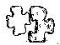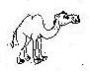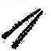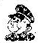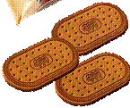
biscuits
camel
jigsaw puzzle
chopsticks
bus driver

Ⅱ、听一听，连一连。
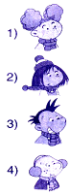
A、I’m going to do long jump.

B、I’m going to do high jump.

C、I’m going to swim.

D、I’m going to run a race.

E、I’m going to play football.

5）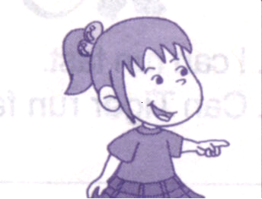
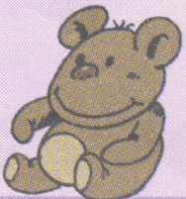
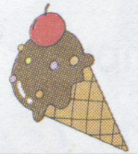
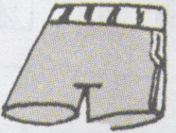

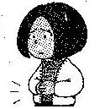
Ⅲ、听音辨图，判断下列图片的正（√）误（×）。

（ ） （ ） （ ） （ ） （ ）
Ⅳ、听音，将下列对话重新排序。
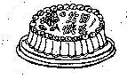
( ) Yes. Good idea!
( ) Let’s make a cake for Mum and Dad.
( ) What are you doing ?
( ) Please be quiet ! I’m working.
( ) We’re making a cake.
Ⅴ、听音补全句子，填入所缺单词。
- That young ___________ is my English teacher.
- This bird _________ fly.
- What are these? They’re ____________.
- Where’s Sam ? He’s ______. He’s got a ______. He’s at home.
- They are_____________ a dragon boat on the lake.
- It’s ________for English people to use a knife and _________.
- I can _________ a plane in the sky(天空).
- Don’t worry ! Let’s ________it !
笔试部分 （50分）
Ⅵ、选择。
（ ）1、She __________a pet cat.
A. there is B. has got C. have got
（ ）2、There_______（有）five books on the desk and there______（有）a football under the desk.

A. are, is B. has, have C. is, are
（ ）3、A: Can I come in ? B:______________.

A. Yes, I can. B. Yes , please. C. Yes, you can.
（ ）4、I _______ eating chips and hamburgers . It's English fast food.
A. am B. is C. are
（ ）5、It’s got a very long nose. It’s big and fat. What is it ?
A. a mouse B. a lion C. an elephant
（ ）6、How many people __________ in your family ?
A. there are B. there is C. are there D. is there
（ ）7、Look ________those ducks over there.
A 、 for B、 at C、 with
（ ）8、I can ________in this puddle.
A、 swimming B、 swim C 、swiming
（ ）9、There is _______animal over there.
A 、a B、the C、an
（ ）10、There are six _________ in the room.
A. men B. man C. mens
Ⅶ、仔细读一读，圈出句子中正确的单词。
1、This / These are Sam’s shoes. They are dirty(脏的).
2、Have / Has you got a bike?
3、You can jumping / jump far.
4、Look! Amy is play / playing the flute.
5、What are you going to do on / in Sunday?
Ⅷ、情景反应, 连连看。
1、Do you want noodles? A 、Yes, I can.
2、Can you run fast? B 、Yes, please.
3、How many boys are there? C、 No, I’m not.
4、Has he got a computer game? D、 There are ten.
5、Are you going to run a race? E 、No, he hasn’t.
Ⅸ、按照正确的英文格式书写下列句子。
These ducks are very naughty. Let’s feed them with some bread.

Ⅹ、阅读理解，判断正( T )误( F )。
Hello! I'm Sam. I’m from England. My family are going to go to Hong Kong tomorrow(明天) . We are going to get up at 5 o’clock .We are going there by plane. Mum is going to visit my grandma. Dad is going to swim in the sea. I’m going to swim in the sea, too.
1、 They are going to go to England. T F
2、Sam’s family are going there by train. T F
3、Sam is an English boy. T F
4、Sam is going to swim in the sea. T F
5、Dad is going to visit my grandpa. T F
6、There are three people in Sam’s family. T F
三年级英语听力题签：
注意：每道听力试题读二遍，听力时间控制在20分钟内。
Ⅰ、听音，选图编号。（用数字1-----5 来编号）
1、Chopsticks are hard for English people.
2、You can have these biscuits.
3、We’ve got a jigsaw puzzle.
4、There is a camel.
5、I’m going to be a bus driver.

Ⅱ、听一听，连一连。
1、Hi! I’m Amy. I’m going to do high jump.
2、A: What about you, Lingling ? B: I’m going to swim.
3、Daming is going to do long jump.
4、Xiaohua can run fast. She’s going to run a race.
5、A: Is Sam going to play football on Sports Day? B:Yes, he is.

Ⅲ、听音辨图，判断下列图片的正（√）误（×）。
1、A: Can I have an ice cream? B: Yes. Here you are.
2、I’ve got a new kite.
3、These are Daming’s trousers.
4、She’s writing a letter now.
5、Fangfang has got a headache.

Ⅳ、听音，将下列对话重新排序。（用数字1-----5 来编号）
Sam: Let’s make a cake for Mum and Dad.
Amy: Yes. Good idea!
Mum: What are you doing ?
Sam and Amy: We’re making a cake.
Dad: Please be quiet ! I’m working.
Ⅴ、听音补全句子，填入所缺单词。
- That young ____woman_______ is my English teacher.
- This bird ____can’t_____ fly.
- What are these? They’re _____horses_______.
- Where’s Sam ? ------He’s ___ill_____. He’s got a ____cold____.
He’s at home.
- They are____rowing____ a dragon boat on the lake.
- It’s ____easy____ for English people to use a knife and ____fork_____.
- I can ____see_____ a plane in the sky(天空).
- Don’t worry ! Let’s ____fix___ _it !

听力部分到此结束！

三年级英语答案及评分标准：

听力部分
Ⅰ、(2×5＝10分) 3------4-------1-------5-------2
Ⅱ、(2×5＝10分) 1-----B , 2-----C , 3-----A , 4-----E , 5------D
Ⅲ、(2×5＝10分) √××√×
Ⅳ、(2×5＝10分) 2-----1------3------5------4
Ⅴ、(1×10＝10分) 详见听力题签，每空1分，单词拼写完全准确方可得分，但3和5小题中的“-s”“-ing” 各0.5分。
笔试部分
Ⅵ、(2×10＝20分) BABAC CBBCA
Ⅶ、(1×5＝5分) These , Have , jump , playing , on
Ⅷ、(2×5＝10分) 1-----B , 2----- A , 3----- D , 4-----E , 5------ C
Ⅸ、(3分) 阅卷教师自行把握三个等级标准：3分， 2分， 1分
Ⅹ、(2×6＝12分) F F T T F T

备注：卷面满分为100分。（听力50分，笔试50分。）
优秀：90---100
良好：80---89
及格：60---79
不及格：0---59

2010年1月8日

