长海县2009~2010第一学期期末质量检测
小学四年级英语 考试时间：60分钟

题号 | Ⅰ | Ⅱ | Ⅲ | Ⅳ | Ⅴ | Ⅵ | Ⅶ | Ⅷ | Ⅸ | Ⅹ | 总分
得分
听力部分(58分)

Ⅰ、听辨单词, 选出你所听到的句子中的单词。
（ ）1. A. printing B. bicycle
（ ）2. A. knee B. finger
（ ）3. A. cried B. climbed
（ ）4. A. angry B. dirty
（ ）5. A. toothache B. headache

Ⅱ、图文配对, 选出每组与你听到的意思相符的图片。

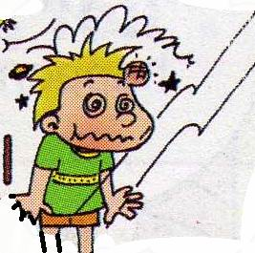

( )1.
( )2.

A B
A B
( )4.
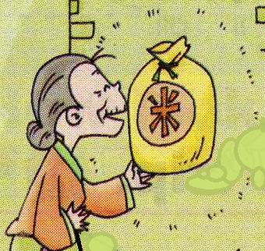
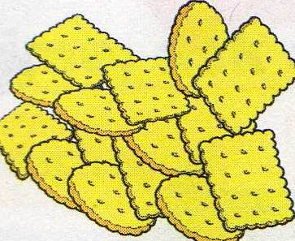

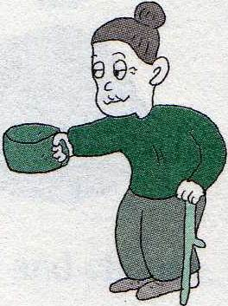
( )3.

A B
A B
A B
A B
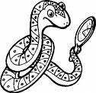
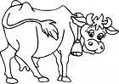
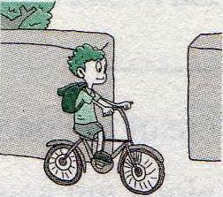
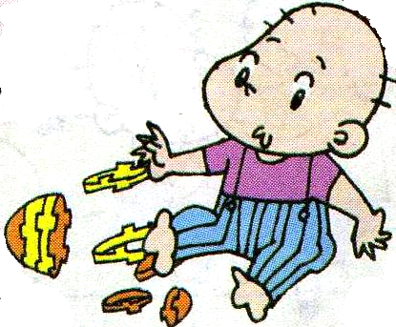
( )6.
( )5.

Ⅲ、仔细听一听，萨姆昨天做了什么（√）？没做什么（×）？
-------What did Sam do yesterday?
1、went to school ( ) 2、did my homework ( )
3、bought some books ( ) 4、played football ( )
5、helped my mum ( ) 6、listened to music ( )
7、watched TV ( ) 8、went to the zoo ( )
9、saw some big tigers ( ) 10、had a good time ( )
Ⅳ、对话理解, 根据所听对话内容将下列图片按其发生的顺序重新排序。

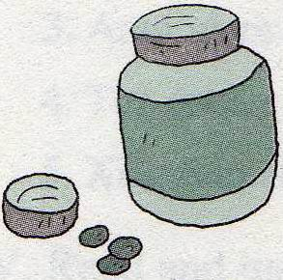
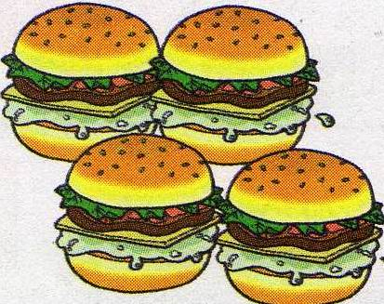
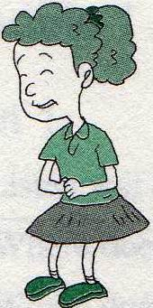
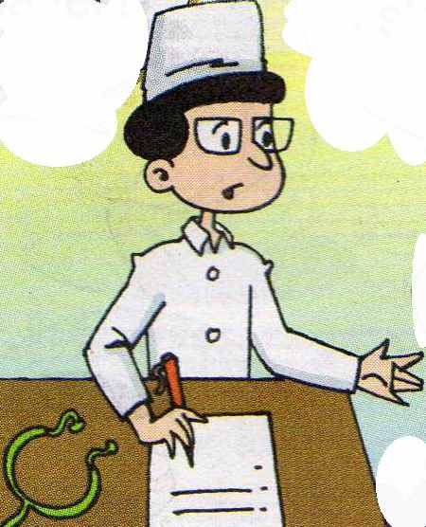


A B C D E

1、________ 2、________ 3、________ 4、_________ 5、_________

V、听音补全句子，填入所缺单词。
1、 It’s warm in__________.
2、 This girl ________ a gold cup.
3、 I _________ my trousers yesterday.
4、 Today is my birthday. Mum _________ a cake for me.
5、 A cat saw a rat( 耗子), but the rat _________away.

笔试部分(42分)
Ⅵ、选择。
( )1、Wang Fei ________ got a new friend.
A、have B、has C、had
( ) 2、She didn’t ________to school yesterday.
A、walked B、walk C、walking
( )3、Amy __________ English and Maths yesterday.
A、learn B、learns C、learned
( )4、A:__________ did you go to Beijing ? B: I went there last year.
A、What B、Where C、When D、How
( )5、There ________ three children.
A、is B、were C、has D、was
Ⅶ、情景反应。读一读，连一连！
A栏 B栏
1、What happened to you ? A、No, I didn’t.
2、Did you phone Grandma ? B、I fell over. I hurt my leg.
3、Where did you go yesterday? C、They came last Wednesday.
4、Where do you live? D、I went to the park.
5、When did they come? E、I live in Dalian.

Ⅷ、请按括号内的要求完成下列句子。
1、I cleaned my room yesterday. (否定句)

2、cooked , mum , noodles ( . ) (连词成句)

3、She played the flute. (就画线部分提问)

4、did , your , finish , you , homework ( ? ) (连词成句)





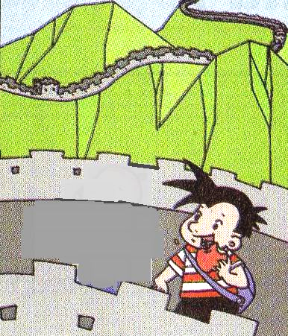



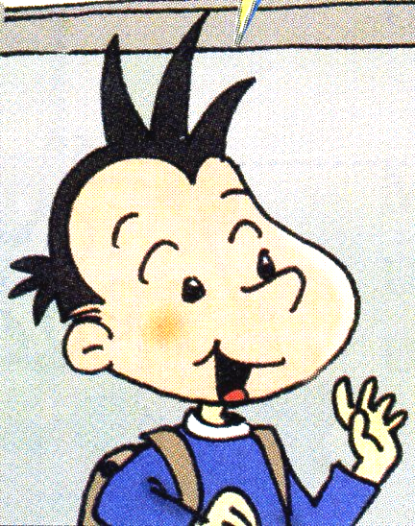
Ⅸ、根据图表内容回答问题。
Usually
Yesterday
Name

Q1、Did Daming do his homework yesterday?
Q2、 What did Lingling do yesterday?

Q3、 Does Sam usually play football?

Q4、 Where did Daming go yesterday?

Q5、 What happened to Sam yesterday?

Ⅹ、阅读下面这封信，选择正确答案。
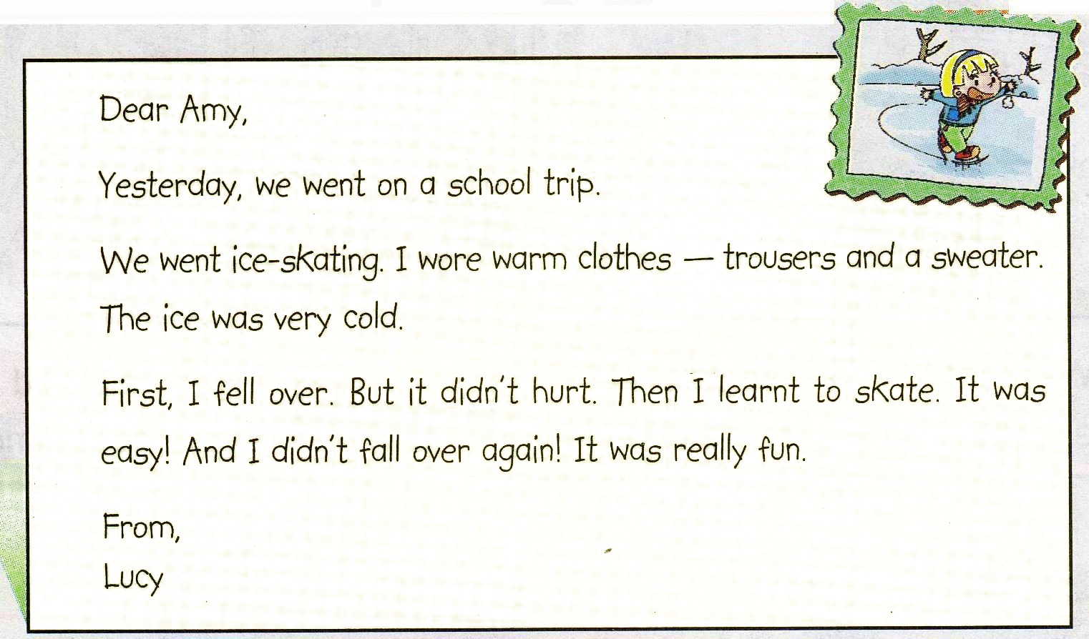
( )1、This is a letter from ________ .
A、Amy B、Lucy C、Lingling
( )2、It was __________ yesterday.
A、cold B、warm C、hot
( )3、Amy ___________ ice-skating with Lucy yesterday.
A、didn’t go B、goes C、went
( )4、Lucy ___________ at last (最后).
A、fell over B、hurt her knees C、could(能) skate well
( )5、Lucy __________a good time yesterday.
A、didn’t have B、have C、had
四年级英语听力题签:
※注意：每道听力试题读二遍。时间控制在15分钟以内。

Ⅰ、听辨单词, 选出你所听到的句子中的单词。
1. Chinese people invented paper and printing.
2. He cut his finger yesterday.
3. We climbed the mountain last Sunday.
4. The bad man was angry .The magic paintbrush didn’t help him.
5. I’ve got a headache.

Ⅱ、图文配对, 选出每组与你听到的意思相符的图片。
1. She’s got two big eyes and short hair.
2. He bumped his head.
3. The old woman didn’t have food.
4. I ate some chocolate biscuits yesterday evening.
5. The magic paintbrush made a snake.
6. Did the boy break his toy? Yes, he did.

Ⅲ、仔细听一听，萨姆昨天做了什么（√）？没做什么（×）？
------------What did Sam do yesterday?
Hello! I’m Sam. Yesterday was National Day. It was a special day. I didn’t go to school. I did my homework. I bought some books with Amy. I didn’t play football. I helped my mum. We listened to music, but we didn’t watch TV. I went to the zoo with Dad. I saw some big tigers. They are scary. I had a good time.

Ⅳ、对话理解, 根据所听对话内容将下列图片按其发生的顺序重新排序。

M：What’s the matter?
W：I’ve got a stomach ache.
M：What did you eat yesterday?
W：I ate four hamburgers.
M：That’s too many!
W：What should I do?
M：Go home and take this medicine. And you will be well soon.
W：OK, thank you very much.

V、听音补全句子，填入所缺单词。
1、 It’s warm in_____April_____.
2、 This girl ____won____ a gold cup.
3、 I ____washed_____ my trousers yesterday.
4、 Today is my birthday. Mum ____made_____ a cake for me.
5、 A cat saw a rat, but the rat ____ran_____away.

听力部分到此结束！

四年级英语答案及评分标准：
听力部分
Ⅰ、(2×5＝10分) ABBAB
Ⅱ、(2×6＝12分) BBAABB
Ⅲ、(1×10＝10分) 1---4---7: × ； 2---3----5----6----8----9----10： √
Ⅳ、(2×5＝10分) BEDCA
Ⅴ、(2×5＝10分) 详见听力题签，每空2分，单词拼写完全准确方可得分。但如果能写出准确的动原， 可得1分。

笔试部分
Ⅵ、(2×5＝10分) BBCCB
Ⅶ、(2×5＝10分) 1-----B , 2----- A , 3----- D , 4-----E , 5------ C
Ⅷ、(2×4＝8分)
1、I didn’t clean my room yesterday.
2、Mum cooked noodles.
3、What did she play? (以上“_____”的部分是批阅的基点)
4、Did you finish your homework?
Ⅸ、(2×5＝10分)
1、No, he didn’t.
2、She went swimming./ She swam.
3、Yes, he does.
4、He went to the Great Wall. (以上“_____”的部分是批阅的基点)
5、He fell off his bike.
Ⅹ、(2×5＝10分) BAACC

备注：卷面满分为100分。（听力52分，笔试48分。）
优秀：90---100
良好：80---89
及格：60---79
不及格：0---59

2010年1月8

