长海县2009~2010第一学期期末质量检测
小学五年级英语 考试时间：80分钟

题号 | Ⅰ | Ⅱ | Ⅲ | Ⅳ | Ⅴ | Ⅵ | Ⅶ | Ⅷ | Ⅸ | Ⅹ | Ⅺ | 总分
得分
听力部分(35分)

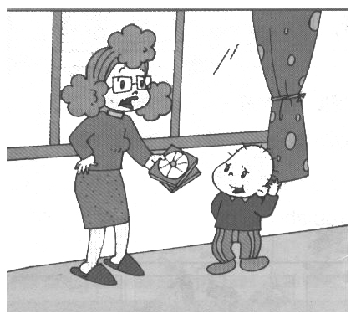
Ⅰ、听音辨图, 判断所听到的句子是否与图意相符，相符画“√”，不符画“×”。
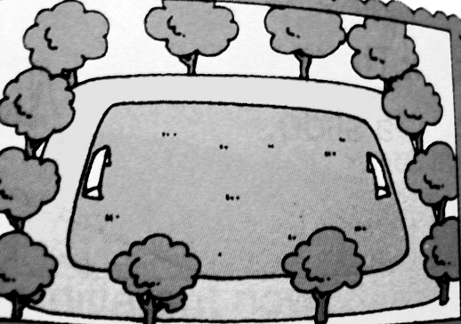
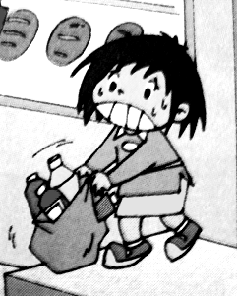
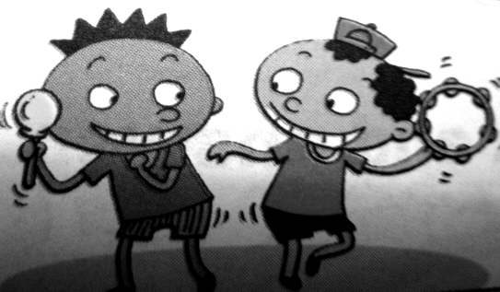
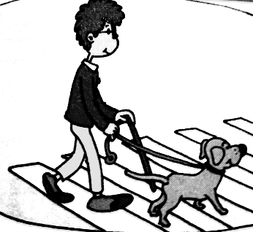
( ) ( ) ( ) ( ) ( )
Ⅱ、情景反应。请根据所听问句的顺序给答句编号。
( ) It’s hers.
( ) No, I’m not.
( ) Yes, he is.
( ) It’s in autumn.
( ) Yes, I can.
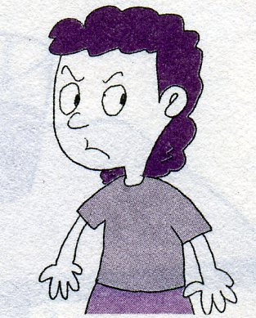
Ⅲ、听音选图，图文匹配。
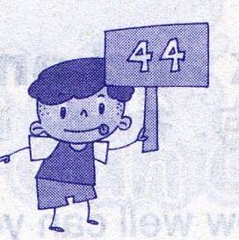
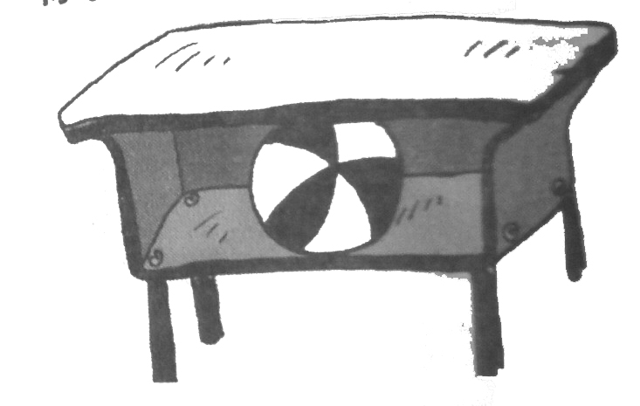
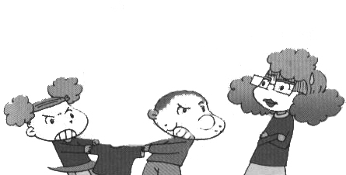
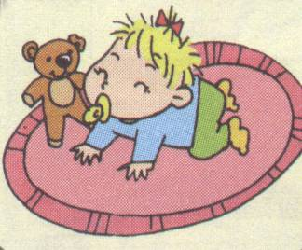

1
2
3
4
5

（ ）It’s ________________.
（ ）I’ve got _________________ points.
（ ）You should be _______________.
（ ）She _______________ walk then.
（ ）There is a ____________ in the desk.
Ⅳ、Lucy的生日快到了，仔细听短文，请帮Lucy补写一封生日请柬。
Dear Amy,

Lucy is going to be ___________.
Please come to her party.
At : ________________ Heping Street
On: ______________, 2nd of May
From: ______________ a.m.(上午)
To: __________________ p.m.(下午)
Please reply.

笔试部分(65分)

Ⅴ、选择。
( )1、There ________ only a slide here before.
A、were B、was C、is D、are
( )2、A: Hi, Linda. Is this blue shirt yours?
B: Yes, it’s _________. Thank you.
A、yours B、hers C、mine D、his
( )3、You _________listen in class.
A、shouldn’t B、should C、couldn’t
( )4、Sam’s shoes __________ wet and dirty.
A、are B、was C、is
( )5、Many English supermarkets are very big. They ______ different things.
A、sells B、sell C、has got

Ⅵ、请按括号内的要求完成下列句子。
1、 should , your, tidy , you , toys ( . ) (连词成句)

2、 There weren’t any swings here before. (肯定句)
3、 Can you play chess now? (一般过去时)

4、 She will learn English tomorrow . (用be going to改写成同义句 )

Ⅶ、情景反应。连连看。
1、What do you want? A、They scare the people.
2、What do children do at Halloween? B、I want a skirt.
3、Can you play computer? C、That’s OK.
4、What are you going to do tomorrow? D、Yes, I can.
5、 I’m sorry. E、We’re going to play football.

Ⅷ、完型填空。
Yesterday, it ___1___ raining . Zara __2___ go out. She stayed at home.
She was sad. She helped her mum ____3___ a cake. After that, she was hungry, she ___4__the cake with Mum. She was ____5_____, she drank some water. Then the rain___6___. Zara went out to play and she was____7____.

( ) 1、 A、is B、was C、can
( ) 2、 A、could B、can’t C、couldn’t
( ) 3、 A、make B、eat C、buy
( ) 4、 A、eat B、ate C、eating
( ) 5、 A、angry B、hungry C、thirsty
( ) 6、 A、stoped B、stop C、stopped
( ) 7、 A、happy B、bored C、sad

Ⅸ、阅读理解, 选择最佳答案。
Hi! My name is Wang Hua. I’m twelve years old. I’m a pupil in Yucai school. I’m in Class Three, Grade Five. This is my school day.I usually get up at six o’clock in the morning, and then I have breakfast at half past six. I go to school at 7:00. I walk to school every day. My school starts at 7:30. We have four lessons in the morning and four lessons in the afternoon. My favourite subject is English. We sit in lines in the classroom. We often do morning exercises. We can have fun at break time. We play games together on the playground. School finishes at half past four in the afternoon and I go home at 5:00. After dinner I do my homework and then I go to bed at ten o’clock.This is my school day. We should study hard every day.

( ) 1、Wang Hua is________________ pupil.
A、a Chinese B、an English
( ) 2、Wang Hua has breakfast at ____________.
A、7:30 B、7:00 C、6:30 D、 6:00
( ) 3、We have ____________lessons in a day.
A、four B、eight C、six
( ) 4、We sit ______________in the classroom.
A、around tables B、in lines C、in a line
( ) 5、Wang Hua goes to school________________.
A、on foot B、by bus C、by car

Ⅹ、小作家。
以“Ｉ”为题仿写一篇小短文，真实地描叙一下自己的成长经历.
不少于30词。
Hello! I’m a boy. Now, I’m twelve years old. I’m in Class 1, Grade 5. When I was a little child, my dad took some photos for me then. In this photo, I was 6 years old. I could sing a song , but I couldn’t swim then. Now I can swim well, but I can’t speak English a lot, I should study hard.
_______________________________________________________________________________________________________________________________________________________________________________________________________________________________________________________________________________________________________________________________________________
___________________________________________________________________

Ⅺ、★附加题★ (10分)
1、There __________ any water in the cup now.
2、Sam’s grandparents miss _________ (他)very much.
3、Twenty-five and fifty-six is ___________________.
4、Can you play very well, or not _______ __________?（试着补全歌词）
5、My room is tidy now. Mum ____________( tidy ) it yesterday.
6、They got fifty points. (就划线部分提问)
_______ _________ points ______ they _________?
五年级英语听力题签：

※注意：每道听力试题读二遍。时间控制在10分钟以内。

Ⅰ、听音辨图, 判断所听到的句子是否与图意相符，相符画“√”，不符画“×”。
1、We’re going to sing at the party.
2、Now there are tall trees here.
3、This bag isn’t heavy. I can lift it.
4、This special dog can help the blind people.
5、You shouldn’t be late for school.

Ⅱ、情景反应。请根据所听问句的顺序给答句编号。
1、Are you sad?
2、Can you run fast?
3、Whose book is it?
4、Is Sam going to swim ?
5、When is Halloween?

Ⅲ、听音选图，图文匹配。
A、It’s mine.
B、I’ve got forty-four points.
C、You should be kind.
D、She couldn’t walk then.
E、There is a ball in the desk.

Ⅳ、Lucy的生日快到了，仔细听短文，请帮Lucy补写一封生日请柬。
Hello！My name is Lucy. I’m going to be 12 years old. I’m going to have a birthday party at home. I live at 17 Heping Street. It’s On Sunday, 2nd of May. It’ll be from 9 o’clock in the morning to 3 o’clock in the afternoon. Please come to my party.

听力部分到此结束！

五年级英语答案及评分标准：
听力部分
Ⅰ、(2×5＝10分) ×√×√×
Ⅱ、(2×5＝10分) 3-----1----4----5----2
Ⅲ、(1×10＝10分) 2-----4-----5----3-----1
mine , forty-four , kind , couldn’t , ball
(上述单词拼写完全准确方可得分)
Ⅳ、(1×5＝5分) 12 ， 17 ， Sunday , 9:00 , 3:00
笔试部分
Ⅴ、(2×5＝10分) BCBAB
Ⅵ、(3×4＝12分)
1、You should tidy your toys.
2、There were some swings here before.
3、Could you play chess then /before?
4、She is going to learn English tomorrow. (以上“_____”的部分是批阅的基点)
Ⅶ、(2×5＝10分) 1-----B , 2----- A , 3----- D , 4-----E , 5------ C
Ⅷ、(2×7＝14分) BCABCCA
Ⅸ、(2×5＝10分) ACBBA

Ⅹ、小作家。略 (9分)
请任教五年级的英语老师批阅作文，并自行把握评分标准,做到心中有数。
一等：7----9分（主题鲜明，表述恰当，语言结构准确。）
二等：4-----6分（主题较为鲜明，表述较为恰当，语言结构较为准确。）
三等：0-----3分（主题朦胧，语言表述不清，错词乱句，信息模糊。）

Ⅺ、★附加题★ (1×10=10分)
isn’t , him , eighty-one , at , all , tidied , How , many , did , get

备注：卷面满分为110分。（听力35分，笔试65分，附加题10分。）
优秀：90---110
良好：80---89
及格：60---79
不及格：0---59
2010年1月8

